NAME: Sidewinder HOLT: Protector SOUL NAME: Jobert/abeedo EARTHNAME: Joe Casarez
MATE: CHILDREN/RELATIVES: (coh)
MATURITY: Young Adult REAL AGE: 1.23.91/17 YEAR/PORTAL OF ARRIVAL: 122/Hall SEX: Male

STR: 11 CON: 14 SIZ: 6 INT: 13 POW: 17 DEX: 18 APP: 15 Total: 94
SKILLS MAGIC POWERS WEAPONS / ARMOR / BOND ANIMAL
language memory: 26 % magic feeling: 34 % attack with 1 handed axe (metal) : 78 %
animal lore: 49 % sending: 78 % damage 1d6 cutting parry: 58 %
elf lore: 49 % dragon bonding: 68 % attack with________________________________: ___%
healing lore: 39 % healing: ___% damage_______________________________parry: ___%
mechanical lore: 39 % (anti-heal: ___% missile throwing hatchets : 68 %
mineral lore: 26 % (flesh shape: ___% damage 1d4 cutting range short
plant lore: 39 % (shielding: ___% missile___________________________________: ___%
world lore: 39 % plant shape: ___% damage___________________range______________
communicate: 66 % rock shape: ___% missiles carried__________________________________
wolf/anim comm: 60 % (metal shape: ___% shield_________________________________use: ___%
perception: 70 % (gem shape: ___% armor type______________elem:___bash:___cut:___othr:___
stealth: 70 % bone shape: ___% supplies carried / other skills / etc
climb: 78 % water shape: ___%
dodge: 68 % firestart: * 17 %
jump: 70 % levitation: ___%
swim: 58 % finding: ___%
throw: 68 % animal sense:** 68 % BOND ANIMALname: Mirage species: dragon sex: m
manipulate: 74 % mindsnare: ___% STR: 18 CON: 18 SIZ: 12 INT: 13 POW: 14 DEX: 13 APP: 7
ride dragon: 72 % hypnosis: ___% climb: ___% jump: ___% swim: ___%
hunt: 80 % astral projection: ___% stealth: ___% dodge: ___% percp: ___%
weaving (large): 56 % deep sensing: ___% comm: ___% ______:___% ______:___%
dance/music: 66 % self shaping: ___% attack____________:___% attack________________:___%
tracking: 60 % * self-heat/cool: 68 % disposition
trapping: 70 % ** animal control: 34 % magic or other abilities group levitation 50%,invisible 50%
tinkering: 62 % :___% natural armor:___________elem:___bash:___cut:___othr:___
Personality Notes: Lives in a...:
Likes and Dislikes: Friends:
Habits and Places Preferred: Hunting Methods:
Bond Beast Personality:
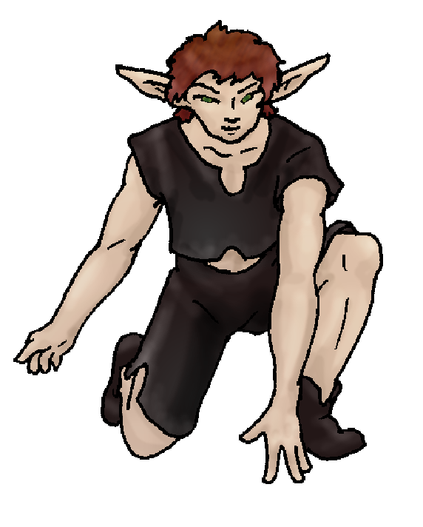 Character Sketch
Hair: browns
Eyes: hazel
Skintone: medium
Bond Beast Habits/etc:
BondAnimal
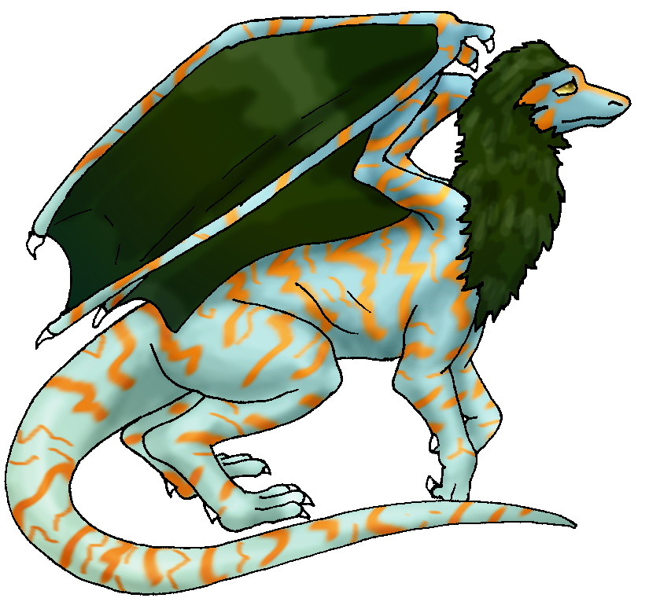 Fur/Skin: aqua/orange, pine
Eyes: gold

About you as an elf
Your Name Means: Sidewinder, a dangerous snake well known for its unusual mode of travell… well you’ve got a dragon that levitates you (since he’s only barely big enough to lift off with you on his back)! Snakes are cold-blooded, often feeling oddly ‘room temperature’ which is how you appear to feel, though you’ve got normal temperature most of the time, you can adjust yourself to literally be impervious to both heat and cold outside.
Your Appearance Is: Balanced and reasonably tall, hardy but not burly in appearance, you’ve got medium-toned skin, long fleshy ears, and a mop of brown hair over your hazel eyes. You choose plain dark clothing best for hiding in shadows.
You Are Located: in the Protector Holt, in the deep south-east of the continent where elves live. Your den is on a somehat bleak stony hillside near one of the taller peaks – chill winds blow and all the trees are reasonably up-swept looking. That said, behind the visible hill where your den is formed from a natural stone cave, there is a valley with extremely pleasant ground, fruit trees and berry bushes dotting the area. Good hunting, of almost any size prey is found here.
Your Basic Statistics Mean: You’re tall and average in strength, healthy and have an average dexterity. All in all you’re a pretty ‘average’ guy – you’ve got enough smarts to catch on quick, are attractive enough to catch the eye of lady elves, and your magic power works when you need it to.
Your Skills Include: A lowish memory of Earth, enough to give you flashes of inspiration to build traps or structures, but not much more. Your selection of lores and knowledge extends largely toward elves and animals and what to do with them both. Who’s seeing whom, who’s mad, what animal leaves which kind of droppings or dens in what locations. Those are important to you, while many other things just aren’t. You know enough not to eat unripe fruit, step onto dangerous looking terrain, and you don’t much care what kind of stone you live under, only that it’s safe and warm inside the cave. You enjoy your time with people enough that you can easily convey your mood and any discussions with them but also you understand animal body and sound language, not to a huge extent but you can tell when rutting season has started and which bucks to take down once they’ve mated. You have well-rounded physical and survival skills, moving through your territory with ease though you can hunt nearly anywhere. Whether it’s climbing a tree or swinging across a stream, you’ve got it covered. You hunt well with an axe and throwing hatchets, usually having at least two or three of the small hand-length but sharp edged throwing tools at your belt at all times. You have a good skill with creating items from nearby materials, reeds and fallen sticks or petrified wood and stone. Traps, baskets and even larger things like complicated pulley-ropes for getting up and down sheer cliffs are things you’ve made. The traps you create are generally larger than leg-traps, for instance you’ll dig for a day to fix up a pit trap for a large stray serpent-nose beast (as big as they are, you can still outsmart them with a simple sharp stick in the rear as they plunge ahead into your traps!) and when you create one of those, the whole tribe’s usually invited to help divvy up the kill, because it’d rot with only you to eat it. Your skill at tracking is very strong, but also you have the ability to make animals follow you so you know your territory enough to purposefully lead dangerous prey through it. When you’re all done hunting for the tribe, it’s time to party and tell stories!
Your Magic Powers Are: You have an average Magic Feeling power, the ability to detect where magic has been done, and by who. It’s not all that necessary for your needs, so you tend not to bother with it. Your telepathic Sending power is typical, you use it to announce hunting, trapped beasts, or just to ask where the party is tonight. Good at distance-thoughts, you keep up with gossip this way. You have the ability to bond to a different creature than most, and it is very odd for many people that you have a dragon friend, not a wolf or feline. Aside from those things, you’ve got two major and two associated powers that you use frequently. While you can only start a fire by hard concentration on very dry tinder, your fire-shaping power actually allows you to almost automatically heat or cool yourself to adjust to whatever the climate gives you. Whether that means walking through knee-high snow with not a sniffle or sneeze, or running down the hot summer hillside without breaking a sweat, that’s what this power does for you. You can turn it off, though it’s easier to just let it keep you at the right temperature all the time. Other than that, you have a fairly strong ability to sense the animal life around you – from a mouse to a moose or bigger, in a distance around thirty paces up, down and around you, every animal near you gives off a bit of magical “ping” to your senses. This is actually why you chose to live in such an isolated den, the animals that are around you can also be quite maddening when there are so many of them. Down in the forest, there are plenty of things to give your senses a go, but up on the slate cave hills, not so much. Associated with this power, though, is a weaker but confidently used power of command: you can select one animal from a bunch, or just taunt the whole smaller group of them into following you, running away from you, or whatever you need at the time. This is not a terribly reliable power, but generally once you’ve got the critter’s attention you can keep it without magic. This helps you lead dangerous animals away from populated areas, or food animals into netting or hunting places.
Your Bond Animal Is: Mirage, a dragon! Native only to this world, but not in the way you’d think… You have learned from talking to Mirage at length, that all the eggs of the dragons who live here came through a portal – like you did, from … well, from a video game, they came through from the internet, whatever that is. Your dragon’s egg dropped and was actually delivered to you by another elf, and Mirage hatched before you started southward to where the Protector Holt was founded. Mirage is an odd looking creature, with both hide and fur, in a pale aqua shade danced with long bright-orange stripes, and having dark pine-green wingsails and neck fur. His eyes are a bright golden color. He’s small, though he stands around shoulder to shoulder with you, he’s just not big like the big cats or wolves around here. He is however on a par with their strength and health! He’s not very agile, so you tend not to actually fly on him – he does have the ability to float you and perhaps one other elf-sized creature (or killed prey, that’s usually what he lifts) with him using magic, and also the unusual power to turn invisible. Neither of those powers are ones you’d demand he use frequently, because it wears him out even more than you when you’re trying to light a real fire. He’s clever and talkative – mentally anyway, they don’t speak but for hisses, growling and other such animal-like noises.
Special Information: There is another Holt full of elves who ride dragons, the Dragonclan, but it’s all the way across the world – the very opposite corner of the continent from your home! Perhaps some day you’ll visit them, or meet them halfway, after all you have a dragon that can fly you beside him!
You are known as a Deathsleep (Winter/Seventhsign) elf, with the star-symbol of the Arrowhead in the night sky. Elves of this personality zodiac are represented by the Longtooth cat, the color Black, the sensitive Orchid elements. Usually elves in this sign are Canny, secretive, Dangerous, Flirtatious.

princeofsands_1234@hotmail.com Date: Wed, 13 Dec 2006 19:43:28 -0500

Necessary Stuff
Your Full Name: Joe Albert Casarez Nickname or Title jobert Birthday 1/23/91 Act HOW Old? random
Your Gender male, You like it this way
You Prefer the opposite sex
You are in single and loving it

Appearance Stuff
You're about 5'8 feet tall, and you'd like to be the same
Your build is and you'd like to be none
Hair Color brown Change? none
Hair Style/Curl messy Change? none
Eye Color hazel Change? Glasses? off
Skin Tone light tan Change? none
Are you 'Attractive'?yes Change? none
Are you 'Strong'? yes Change? weaker
Are you 'Smart'? no Change? none
Are you 'Nimble'? sort of Change? none
You'll be getting pointy ears - you want them medium

Circle (likes) or Cross Out (dislikes)
Where do you like living? farm/ranch

Climates you like cold

What You Want Out of Life rough it/camp joke draw/create slack off hunt raise kids raise pets and animals surround yourself with technology
retire early and relax fiddle with toys and tools

Other:

Favorites...
Colors black
Animals dragons
Music/Bands system of a down
Foods
Sports if any football
Time of Day night
Season winter

Fears and Hates heights (somtimes)

Any pets you'd like to drag along? snake
Any people you'd like to have with you? (supply them a sheet!)

