NAME: Trove HOLT: Protector SOUL NAME: (Ber) EARTHNAME: Amber Jerowski
MATE: CHILDREN/RELATIVES: (coh)
MATURITY: Young adult REAL AGE: 8.28.88/20 YEAR/PORTAL OF ARRIVAL: 122/Hall SEX: Female

STR: 14 CON: 16 SIZ: 4 INT: 15 POW: 18 DEX: 19 APP: 15 Total: 101
SKILLS MAGIC POWERS WEAPONS / ARMOR / BOND ANIMAL
language memory: 30 % magic feeling: 38 % attack with 1 handed spear : 76 %
animal lore: 45 % sending: 82 % damage 1d6 impale parry: 66 %
elf lore: 45 % bonding: 72 % attack with________________________________: ___%
healing lore: 60 % healing: self only 40 % damage_______________________________parry: ___%
mechanical lore: 30 % (anti-heal: ___% missile bow/arrows : 86 %
mineral lore: 30 % (flesh shape: ___% damage 1d4 impale range med-long
plant lore: 40 % (shielding: ___% missile___________________________________: ___%
world lore: 40 % plant shape: ___% damage___________________range______________
communicate: 60 % rock shape: ___% missiles carried__________________________________
wolf/anim comm: 66 % (metal shape: ___% shield_________________________________use: ___%
perception: 72 % (gem shape: ___% armor type______________elem:___bash:___cut:___othr:___
stealth: 74 % bone shape: ___% supplies carried / other skills / etc
climb: 76 % water shape: ___%
dodge: 76 % firestart: ___%
jump: 74 % levitation: ___%
swim: 64 % finding: 100 %
throw: 67 % animal bond: ___% BOND ANIMALname: varies species: varies sex:
manipulate: 57 % mindsnare: ___% STR: CON: SIZ: INT: POW: DEX: APP:
ride animal: 76 % hypnosis: ___% climb: ___% jump: ___% swim: ___%
hunt: 70 % astral projection: ___% stealth: ___% dodge: ___% percp: ___%
tanning/weaving: 34 % deep sensing: ___% comm: ___% ______:___% ______:___%
dancing: 68 % self shaping: ___% attack____________:___% attack________________:___%
music/sing: 50 % :___% disposition
trapping: 50 % :___% magic or other abilities
sports: 68 % :___% natural armor:___________elem:___bash:___cut:___othr:___
Personality Notes: Lives in a...:
Likes and Dislikes: Friends:
Habits and Places Preferred: Hunting Methods:
Bond Beast Personality:
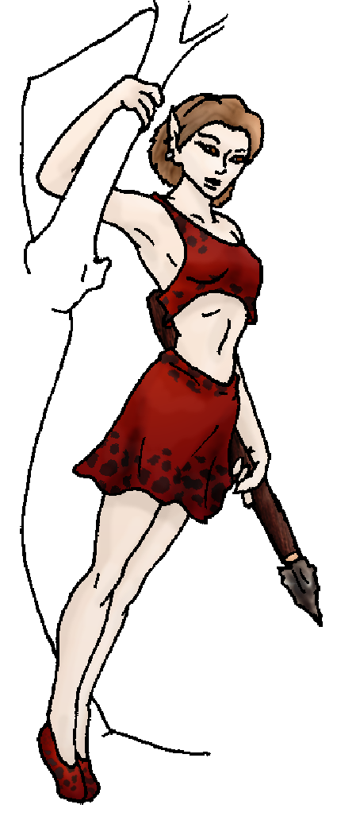 Character Sketch
Hair: lt brown
Eyes: brown
Skintone: fair
Bond Beast Habits/etc:
BondAnimal
Fur/Skin:
Eyes:

About you as an elf
Your Name Means: Trove, as in treasure trove! If there’s something lost, you can find it. If there’s something interesting out there, you will be at its side in minutes. That’s not saying you collect or hoard, but others sure do seem to like the things you unearth.
Your Appearance Is: Petite but muscular, with fair skin under deep red naturally-colored hide clothing, you even sport this look during winter – cold? Doesn’t bother you. You keep your light brown hair cut short, it helps when you move through the trees or water and doesn’t catch on anything. You’ve got pleasant, small, dark brown eyes.
You Are Located: In the Protector Holt in the south-east of the continent, your den is a bramble mess of woven branches that only you could possibly find. To the untrained or unexpecting eye, it’s just yet another batch of berry plants. But to you, who can find your way through even the heaviest, thorny thicket, it’s the entrance to a small, but warm and dry cave where you have sleep furs, some weapons, extra clothing, and little else.
Your Basic Statistics Mean: You’re very small but pack a mean punch. Healthier than most, and unexpectedly strong for such a small elf, you carry yourself with ease and quickly move through any terrain. You’re quite pretty, when anyone gets a look at you. You’re clever, but don’t bother with mind games or puzzles – you’ve got hunting and running to do! Your magical power is average.
Your Skills Include: If anyone is a physical elf in this place, it’d be you. It’s not to say that you have no interest nor knowledge of gossip, traditions or the like, but you’ve got little use for such things. You have a working knowledge of who is where, what constitutes a friendly animal and what is a good plant to eat, though you have a strong sense for healing and patching things up on you, animals, or other elves. Constantly in motion, you use your survival skills daily – hunting, running through the woods, evading predators, and even playing chase games with other elves. You can hit any terrain running (or leaping, climbing, swimming) and with ease you can often outdistance faster flat-runners. Because you are so active, you’ve developed several competitive sports which others like to challenge you to. You’re skilled with a short spear for up close hunting, as well as a bow and arrow for distance prey, and you rarely lose a kill to a predator – you’re quick on your feet. You enjoy gathers and dancing, but aren’t particularly skilled in song and music. Depending on whether you have a temporary animal bond, you ride better than adequately – though you’re often found just running pace beside a wolf pack.
Your Magic Powers Are: As all elves have, you’ve got a reasonably strong sense of Magic Feeling. With it you can spot items shaped by individuals or where someone’s been using other magic – used in tandem with your Finding power this can be extremely useful. Your telepathic Sending ability is good, tending to use it at a distance rather than up close. Aside from that, you’ve got the ability to bond animals temporarily rather than finding a permanent (till its death) bond. With it, you can locate almost any kind of animal, communicate with it what you need it for, and get things done. A bird normally skittish could be used to carry a message too far to Send. A badger might be able to dig under ground to locate a buried weapon. And of course, larger animals might be fit to ride. However that’s not where your abilities end. Unconsciously you use a healing ability on yourself – you’ve broken ankles, fingers and even your hip while running headlong through the forest – but you’ve never had to really slow up pace because of it. This power came up very early in your time on the Otherforest, and you’ve never really had to think about it since. Scrapes, bruises, and even cuts or burns heal within hours, and if you let yourself rest a broken bone can set itself within a night. You imagine that you could survive quite a lot of things… But don’t dare really try to injure yourself! And beyond that, your main, very strong power of Finding works to locate just about anything. Pictured in your mind, or even from another person’s description, you can locate a lost earring, a weapon, even hidden squirrel acorns from last winter. There’s nothing trivial about this ability – with your magic Feeling power you can home in on any given person’s items, much more easily than if you had to find them cold. To your vision, far beyond just seeing plenty of color and motion, your eyes magically glimpse auras around almost everything. Where Magic Feeling sees certain colors in brightnesses indicating how strong or weak the shaper or mage who used an item was, your Finding ability can then ‘cast back’ toward that person, creating an almost-visible link in the air between the person and their lost item. Very handy, that. People don’t play hide and seek with you. ☺
Your Bond Animal Is: You don’t have a permanent bond, but as above, you can select from almost any animal which you can magically control. Bigger animals and smarter ones are actually easier to control than small mindless ones. You rarely keep control over any one animal longer than a few hours. You do however have a pet ferret, one which probably is looking at breeding with Mink’s many, many ferrety friends around the Holt…
Special Information: Even from the moment you came through the Hall of Portals in the swampland north of here, you could ‘see’ the Protector Holt lands far away – they called to you very strongly, perhaps stronger than almost all the others with you. They depended on you many times to get them through dangerous or difficult terrain, on the journey from Dare’s Valley down south half a continent away.
You are known as a Thaw (Newyear/Firstsign) season elf, with the star-pattern of the Wolf in the night sky, the quiet hunting Owl animal totem, the color Silver, and the element of Ice/Water. Elves of this personality sign often exhibit Bravery, Hardiness, Patience, Luck. This is just a measure of an elf’s personality, not a hard and fast rule, nor necessarily ‘when’ you arrived.

brisk18507@yahoo.com Date: Sun, 10 Dec 2006 21:32:26 -0500

Necessary Stuff
Your Full Name: Amber Jerowski Nickname or Title Ber Birthday August 28 1988 Act HOW Old? 18
Your Gender female, You like it this way
You Prefer the same sex
You are in dating someone

Appearance Stuff
You're about 5 feet tall, and you'd like to be the same
Your build is Athletic and you'd like to be same
Hair Color brown Change? none
Hair Style/Curl short Change? none
Eye Color brown Change? Glasses? off
Skin Tone white Change? none
Are you 'Attractive'?yes Change? none
Are you 'Strong'? yes Change? none
Are you 'Smart'? yes Change? none
Are you 'Nimble'? yes Change? none
You'll be getting pointy ears - you want them elegant

Circle (likes) or Cross Out (dislikes)
Where do you like living? quiet neighborhood

Climates you like cold river

What You Want Out of Life do a triathalon

Other:

Favorites...
Colors Red
Animals Elephants
Music/Bands Alanis Morisette
Foods Potatoes
Sports if any Soccer
Time of Day evening
Season winter

Fears and Hates censorship, oppresion

Any pets you'd like to drag along? Megs (ferret)
Any people you'd like to have with you? (supply them a sheet!)

