NAME: Fife HOLT: Protector SOUL NAME: (Archiviste) EARTHNAME: Daniel Mayrand
MATE: CHILDREN/RELATIVES: (coh)
MATURITY: Adult REAL AGE: ? YEAR/PORTAL OF ARRIVAL: 122/Hall SEX:male

STR: 10 CON: 14 SIZ: 6 INT: 16 POW: 18 DEX: 17 APP: 13 Total: 94
SKILLS MAGIC POWERS WEAPONS / ARMOR / BOND ANIMAL
language memory: 32 % magic feeling: 28 % attack with dagger (metal) : 74 %
animal lore: 42 % sending: 82 % damage 1d3 cutting/impale parry: 54 %
elf lore: 58 % cat bonding: 72 % attack with________________________________: ___%
healing lore: 32 % healing: ___% damage_______________________________parry: ___%
mechanical lore: 74 % (anti-heal: ___% missile crossbow / metal bolts : 84 %
mineral lore: 64 % (flesh shape: ___% damage 1d6 impale range long
plant lore: 48 % (shielding: ___% missile fishing line/hooks : 74 %
world lore: 32 % plant shape: ___% damage 1d2 +entangle range close
communicate: 68 % rock shape: 18 % missiles carried__________________________________
wolf/anim comm: 68 % (metal shape: 36 % shield_________________________________use: ___%
perception: 72 % (gem shape: ___% armor type______________elem:___bash:___cut:___othr:___
stealth: 70 % bone shape: ___% supplies carried / other skills / etc
climb: 62 % water shape: ___%
dodge: 70 % firestart: ___%
jump: 70 % levitation:* 18 %
swim: 54 % finding: ___%
throw: 64 % animal bond: ___% BOND ANIMALname: Sunset species: big cat sex: female
manipulate: 61 % mindsnare: ___% STR:17 CON: 11 SIZ: 14 INT: 11 POW: 10 DEX: 22 APP: 10
ride big cat: 78 % hypnosis: ___% climb: ___% jump: ___% swim: ___%
hunt: 70 % astral projection: ___% stealth: ___% dodge: ___% percp: ___%
tinker/construct: 76 % deep sensing: ___% comm: ___% ______:___% ______:___%
instrument craft: 68 % self shaping: ___% attack____________:___% attack________________:___%
music/sing: 78 % * telekinesis: 72 % disposition
trapping/making: 76 % * soundshape: 54 % magic or other abilities
literacy: 68 % :___% natural armor:___________elem:___bash:___cut:___othr:___
Personality Notes: Lives in a...:
Likes and Dislikes: Friends:
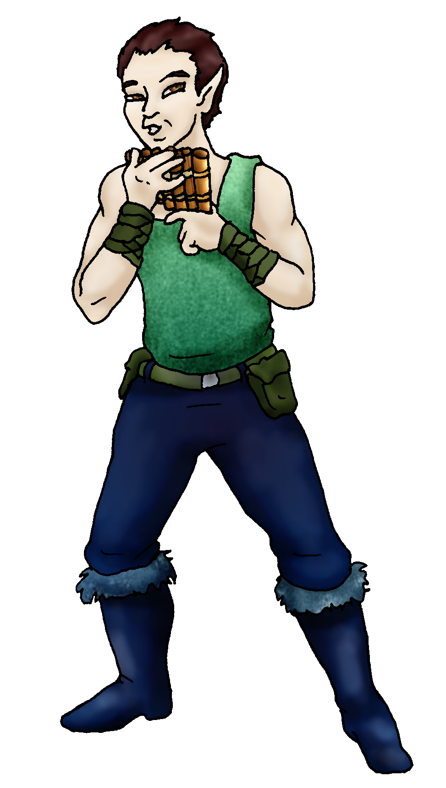
Habits and Places Preferred: Hunting Methods:
Bond Beast Personality:
Character Sketch
Hair: dark brown
Eyes: brown
Skintone: fair
Bond Beast Habits/etc:
BondAnimal
Fur/Skin: tan/beige, black mks
Eyes: yellow

About you as an elf
Your Name Means: Fifes are of course small flutes – you create and play all manner of flute, brass or other wind instruments and have made a name for yourself in the process.
Your Appearance Is: Fair skinned with a preference for darker blues and greens, you’ve got short darkbrown hair, brown eyes, and shorter ears than typical elves.
You Are Located: in the Protector holt, on the south-east corner of the continent. Your den is situated on the wide hilly grass-covered terrain to the east of the wide inland sea. It is warm and reasonably dry here, there is a scrub desert on the eastern bit, and more hilly and swampy toward the sea to the west, and the sea to the south. Your home is made of reeds and adobe, and is constantly being changed and added onto. Pretty soon it’s likely you’ll have a whole villa to yourself! There is plenty of airy light, the posts which you use to support the roof have been brought by plant-shapers and are essentially alive, so you can hang a lot of weight on certain parts, leaving wall space open.
Your Basic Statistics Mean: You’re average in size, health and strength, able to keep up with the hunting groups but you’re not going to compete in any extra ways. You’re a bit plain compared to many of the colorful folks around the Holt, but you’re smarter than many others. Your agility is mostly in your hands. Your magical power is strong.
Your Skills Include: You have a better than average memory of Earthly things, however you use this knowledge to aid in manufacturing items or constructing objects. Your mental knowledges and lores center around the creation of such things – from whistles and fishing equipment on up to housing. You know what kind of plants give the best materials, where to look for the ores you can shape, and how to assemble just about anything. Pretty much all your survival skills are average, you’re able to swim, climb, track and trap, hunt, and avoid being injured out in the wild. You have more interest in making and setting interesting traps, as well as collecting items from waterways (not just fish, but polished stones, algae, even shellfish and the like) for food or other uses. You can hunt pretty well with a crossbow having shaped bolts of metal, and also use a magically sharp hunting knife. You’re quite adept at riding your big cat, though she’s not a very big big cat, and thus you know your way around on foot pretty well too… Where you shine are your instruments and playing them. You have a collection of everything from finger-harps to harpsichords, flutes to a complicated trombone (thank goodness you can shape metal, otherwise that thing would just be impossible!), you don’t necessarily make drums – there are others who do that more often. Like most elves of Protector you’re literate to a very good degree, and use your skills in writing to jot down musical notes to yourself.
Your Magic Powers Are: Your average Magic Feeling power allows you to detect that magic has been used to shape items or been performed nearby, but aside from that you glean little more from it. Your telepathic Sending power is strong and vibrant, your mental voice is a harmony of sounds. You’ve got a cat-bonding power which brought you your mount, Sunset. Beyond those typical things, you have the ability to shape stones enough to move the ores they carry to the surface. There, you collect them and can use your Metalshaping power on them to mold them to your needs. You can take a fist-sized batch of ore and make an object from it in around an hour, but this does tire you out. So you concentrate on knowing exactly what you’ll need it to look like, before you even start. You also have a touch of Flight power, but it’s only enough to start off your other sub-powers: you can use Telekinesis to lift things or manipulate them from a distance as if you were holding them, this power is pretty strong, and you can keep it up for quite some time. You can lift things up to your own weight with ease, or smaller things with almost no effort. The heavier the object is, the shorter a time you can hold it up. But your Levitation is coupled with another power, Soundshape, which you can use to actually produce noises, cancel sounds out to become silent, or make specific people hear things quite close to their ears without anyone else hearing it. Obviously, your main use for this is to aid in your music-making!
Your Bond Animal Is: Sunset, a pretty typical cougar-colored big cat, with yellow-tan fur bearing black-brown markings on her face, ears, tail tip and paws. She is far from the biggest cat in the woods, but she’s quite quick on her feet, and is stronger than her size would show. She is gentle and loyal, and tolerates the noisy stuff you make with a cat’s boredom intact. She does however tend to get herself caught in your devices and machines before you test them…
Special Information: Your home is south from a deep forest – one where elves must occasionally do battle with fierce, bizarre spiderling-creatures. Their origins are more peaceful, but still they’re spider things, and you are certainly not the only elf in this Holt who’d rather see them gone entirely! So you put your trapping skills to good use, without having to actually enter their domain – other people set the traps, ones who aren’t quite so squicked from the sight of these spider-taur … things… Thankfully though, they don’t come out where you live, on the plains. There isn’t enough cover for them and they seem to like climbing on trees. Fewer trees = fewer spider things.
You are known as a Longdays (Summer/Thirdsign) season elf, with the pattern of the Falling Star in the night sky. Elves of this ‘zodiac’ sign are represented by the Rabbit, the color light green and the useful Wide-Boll tree (which are scattered everywhere around the world, and are ideally suited for an elf or two to den in!). Elves of this sort are often known for their Humor, Sensuality, Creativity, Generosity.

Daniel Mayrand" dmayrand@gmail.com
=> these informations are based on myself, not a "fictional" character.
Necessary Stuff = * absolutely necessary!
Your Full Name => Daniel Mayrand * Nickname or Title => Archiviste * I know you from... (ie: devart, coh, nexus, pi, etc) => City of Heroes Forum Boards
Birthday => nope. Act HOW Old? => late thirtyish...
* Your working E-mail address => dmayrand@gmail.com
* Your Gender => Male And... (CHOOSE) => You like it this way You Prefer ... (CHOOSE) => The opposite sex You are: (CHOOSE) => Done with relationships
Appearance Stuff (I need at least a few of these)
You're about how tall? => 5' 10" and you'd like to be (CHOOSE) => The Same
Your build is? => Pear-shaped. and you'd like to be (CHOOSE) Healthier
Hair Color? => Brown Change? (CHOOSE) No Changes
Hair Style? => Brush Change? (CHOOSE) No Change
Hair Length? => Very, very short Change? (CHOOSE) No Change
Eye Color? => Brown Change to what? => Stays the same Glasses? => On/Need em!
Skin Tone? => Pale Change? (CHOOSE) No
* Consider how you feel about yourself and how others may view you.
Answer yes or no, and then choose your changes if any.
Are you 'Attractive'? => Nope Change? No
Are you 'Strong'? => Nope Change? No
Are you 'Smart'?=> Yep Change? No
Are you 'Nimble' or 'Agile'? => Nope Change?No
You'll be getting pointy ears! => Short ears
Where do you like living? (Choose as many as you like)
=> Fewer People => With the Same Old Friends => Quiet Neighborhood
Climates you like (choose as many as you like, list what you reallydon't like in the 'other' section!):
=> Seasonal => Mild => Cloudy => Sunny => Dry
Terrains you like (choose as many as you like, if you really don't like something say so too):
=> Flatland => Plains => Scrubland => Hilly => Meadow => Grassy
What You Want Out of Life… (choose as many as you like! list what youreally don't like in the 'other' section!)
=> Slack off => Make music => Read => Surround yourself with technology
* Favorites:
Colors => Blue and Green
Animals => Cat
Music/Bands=> Too many to list here...
Foods=> Too many to list here...
Sports if any=> None.
Time of Day=> Evening
Season=> Summer
Other info (anything left out, anything important you want to share): => Nope...
Do you have any Fears and Hates?
=> Arachnophobia and Claustrophobia
Any pets you'd like to drag along? PLEASE describe (at least genderbreed, appearance) => Nope.
Any people you'd like to have with you? (supply them the link!)=> Nope.
Did someone recommend this link to YOU? PLEASE tell me who they are! :D You did, and several times, on the COH Forum Boards... 8)
--
Daniel Mayrand
Stock used: rocky ridge 06 / downward – druidwu stock

