NAME: Seaspray HOLT: Protector SOUL NAME: (Dr) EARTHNAME: Argelia Lorence
MATE: CHILDREN/RELATIVES: (coh)
MATURITY: Young Adult REAL AGE: 8.22.69/39 YEAR/PORTAL OF ARRIVAL: 122/Hall SEX: Female

STR: 14 CON: 12 SIZ: 4 INT: 17 POW: 18 DEX: 21 APP: 16 Total: 102
SKILLS MAGIC POWERS WEAPONS / ARMOR / BOND ANIMAL
language memory: 17 % magic feeling: 36 % attack with small knife (defend only) : 35 %
animal lore: 51 % sending: 82 % damage 1d3 cutting parry: 70 %
elf lore: 78 % wolf bonding: 72 % attack with________________________________: ___%
healing lore: 34 % healing: ___% damage_______________________________parry: ___%
mechanical lore: 34 % (anti-heal: ___% missile hunting net (small) : 70 %
mineral lore: 34 % (flesh shape: ___% damage 1d2 smash, entangle range close
plant lore: 51 % (shielding: ___% missile___________________________________: ___%
world lore: 44 % plant shape: ___% damage___________________range______________
communicate: 86 % rock shape: ___% missiles carried__________________________________
wolf/anim comm: 70 % (metal shape: ___% shield_________________________________use: ___%
perception: 72 % (gem shape: ___% armor type______________elem:___bash:___cut:___othr:___
stealth: 78 % bone shape: ___% supplies carried / other skills / etc
climb: 70 % water shape:* 72 %
dodge: 88 % firestart: ___%
jump: 108 % levitation:* 82 %
swim: 80 % finding: ___%
throw: 70 % animal bond: ___% BOND ANIMALname: Luna species: wolf sex: f(?)
manipulate: 73 % mindsnare: ___% STR: CON: SIZ: INT: POW: DEX: APP:
ride wolf: 84 % hypnosis: ___% climb: ___% jump: ___% swim: ___%
hunt: 78 % astral projection: ___% stealth: ___% dodge: ___% percp: ___%
tailoring: 86 % deep sensing: ___% comm: ___% ______:___% ______:___%
dancing: 74 % self shaping: ___% attack____________:___% attack________________:___%
music/sing: 64 % * weathersense: 36 % disposition
net fishing: 76 % :___% magic or other abilities
literacy: 78 % :___% natural armor:___________elem:___bash:___cut:___othr:___
Personality Notes: Lives in a...:
Likes and Dislikes: Friends:
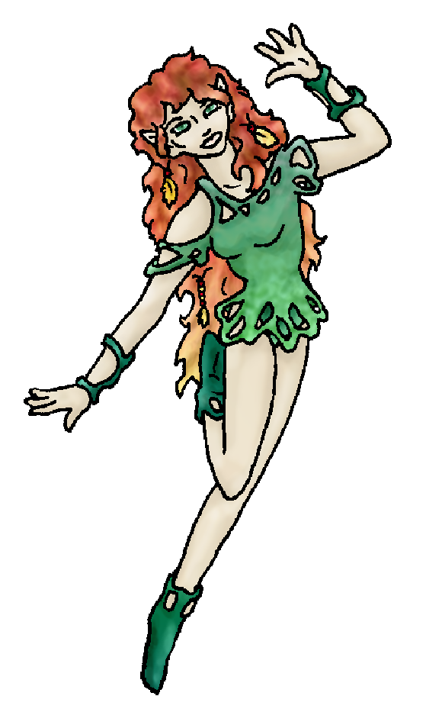
Habits and Places Preferred: Hunting Methods:
Bond Beast Personality:
Character Sketch
Hair: red-brn-blond
Eyes: green
Skintone: fair
Bond Beast Habits/etc:
BondAnimal
Fur/Skin:
Eyes:

About you as an elf
Your Name Means: Seaspray is where you’re usually found, in the warm coastal waters off the shore – in the air, but near the water. You have a way of showing up just like an unexpected wave too, flying low to the ground below where people look, and suddenly you’re right there with them.
Your Appearance Is: Fair skinned, petite and long limbed; you have very long, heavily curly hair that mixes all shades of brown, red, gold and flax in a beautiful way. Your eyes, like your clothing, are green. Your own leather and silk tailoring skills went into creating the playful outfits you wear.
You Are Located: in the deep south-east, the Protector Holt is your home. You live right on the coast – not the inland bay, like many others, but actually on the ocean’s beach right at the equator. You just can’t get any more sun, surf and warm wind than this place. Your home is constructed of driftwood and palm fronds, airy and shady enough that you can get out of the heat of the sun if you really want to. It is on a sandy stretch of grass, behind it is a lush jungle, while directly out of your hut is a wide stretch of sand and stone beach. Both rocky and sandy beachs are near you.
Your Basic Statistics Mean: You are small in size, but pretty strong, slender but still healthy. You are considered quite beautiful, very intelligent, and very nimble. Your magical power is average in strength.
Your Skills Include: You have a very low memory of Earth things, so you’re often kind of confused by other people’s references about ‘biplanes’ or ‘IP addresses’. You don’t care, you’re here now. While most of your informational skills are moderate you concentrate a lot of effort on knowing who you’re with. Your ability to tell anything about anyone just by looking at them – if not just by talking to them for a minute or two – is very strong. You can offer words of comfort or joy, or sometimes get someone back on the ground from having their head in the clouds over an issue. Your physical and survival skills are nothing to sneeze at, but you don’t tend to do a lot of romping around in hard conditions. You prefer to remain where you are or at the most ride your wolf Luna off to a gather or a nearby elf’s home. However since you are extremely adept with flight and water control you can leap quite easily into the air, as well as survive in difficult water conditions. You don’t tend to hunt much, prefering to use a net to catch fish. From up in the air, flying, you can see where schools of fish are, carefully move your net into the water, and shape the water around it so they can’t tell it’s there. You do have a small metal and bone knife that you use to clean the fish, or defend yourself from a predator. Where you really shine are your social and gathering skills. You sing and dance brightly, enjoying the fun music that elves create with somewhat primative instruments. You play a gourd-rattle and sometimes a string of jingling bells, but more often you’re up in the air dancing. You are, like many in this Holt, quite literate, you write a lot either in notes or in letters to others, even those in distant lands; letters carried by wandering elves, or those odd Ice Trader people who have a big boat that circles the world’s oceans. Everyone in the Holt must contribute something – and your contribution is that of tailoring clothing. Your designs are very fun, made more for special occasions than simple hunting or protective gear. You enjoy putting different kinds of materials together, silk lined leather, furs and feathers, and also the dyes that you use bring to mind festivities and partying. No one would ever say you don’t pull your weight around here, those outfits are things that any elf would love to wear!
Your Magic Powers Are: You have an average ability with Magic Feeling, a power which when you need it to, can show you the aura around a shaped item or even a person – each color or feel of the aura is a different type of shaping magic. Your telepathic Sending is reasonably strong, though you use it more often to think with a group of nearby elves, than to distant ones. You have a good ability with Wolf bonding, and your earth-pet has come in a new shape (see below) to bond with you. Aside from those things, you have powers of air and water – you can Fly on the breeze as easily as a leaf in the air, moving like a hummingbird – quickly and gracefully. You can also lift around your own weight while flying, but not for very long. Generally speaking you’ll fly somewhere because it’s quicker, and you can carry a large basket full of dancing clothes to the party. You can also shape Water, which is handy where you live. You can purify salty or stagnant water with your power, make it healthy or drinkable. Also you can manipulate the current below the surface – you can tell where fish, stones, large items and plants are just by ‘feeling’ through the water with your magic. You can cause a current to slow or stop, even change direction for a short time but it goes back to normal quickly. Shaping water isn’t easy work, but you do it without getting tired. You can cause bits of spray to erupt nearby, hang in the air like they’re frozen, or you can also take a small amount of water (a bucket full) and actually make it do things – cause it to flow into animal shapes, rise and fall into spouts, or even splash someone. Also, with this power, you can suck the water away from things when they’re soaking – like your clothing for instance. People always wonder, you’re all but in the water every moment, but you never seem to be soaking wet!
Your Bond Animal Is: Luna, your puppy from earth apparently was reborn here as a wolf! (I don’t know anything else about the dog, so I will say: it’s the same coloration and personality, but is big enough to comfortably ride, and it is accepted by the wolf-pack as one of their own.)
Special Information: You, like some others in the Holt, have a good relation with the Ice Traders – your clothing designs are very clever, and they love the dyes you use to make the cloth, silk or fur colorful. You can trade them a few lengths of cloth for some good spices from around the world! Also, you’ve met one of their musicians, and some time he needs to come to the parties here in Protector – even though he’s not Human or Elf, he seems to really enjoy the Latin music that you faintly remember.
You are known as a Longdays (Summer/Thirdsign) elf, though you didn’t necessarily arrive here during Summer. Elves of this ‘zodiac’ sign are represented by the Rabbit, the color light green, and the useful Wide-Boll tree which many elf-homes are shaped out of. The star-pattern “Falling Star” is high in the night sky during this season. Elves of this nature are filled with Humor, Sensuality, Creativity, Generosity.

Date: Mon, 08 Jan 2007 15:44:47 -0500

Necessary Stuff
Your Full Name: Argelia Lorence Nickname or Title Dr Birthday 8/22/1969 Act HOW Old? 22
Your Gender female, You like it this way
You Prefer to keep your sexuality to yourself
You are in a solid relationship

Appearance Stuff
You're about 5'0" feet tall, and you'd like to be the same
Your build is skinny and you'd like to be same
Hair Color red/brown/blonde Change? mixture
Hair Style/Curl long/curly Change? longer
Eye Color brown Change? green Glasses? off
Skin Tone pale Change? darker
Are you 'Attractive'?yes Change? prettier
Are you 'Strong'? yes Change? none
Are you 'Smart'? yes Change? brilliant
Are you 'Nimble'? yes Change? everything
You'll be getting pointy ears - you want them elegant

Circle (likes) or Cross Out (dislikes)
Where do you like living? bustling city

Climates you like mild warm cloudy sunny dry sea level plains beach rainforest meadow grassy

What You Want Out of Life surf bask in the sun make music fly like an eagle create clothing read give advice and listen

Other: I am from Mexico originally

Favorites...
Colors green
Animals dogs
Music/Bands Any Latin
Foods Again, any Latin
Sports if any Futball
Time of Day afternoon
Season summer

Fears and Hates Snakes

Any pets you'd like to drag along? Luna (My boxer puppy)
Any people you'd like to have with you? (supply them a sheet!)

