NAME: Chinook HOLT: Protector SOUL NAME: (audrey) EARTHNAME: Audrey G
MATE: Black Bear CHILDREN/RELATIVES: (coh)
MATURITY: Young adult REAL AGE: 8.18.84/24 YEAR/PORTAL OF ARRIVAL: 122/Hall SEX: Female

STR: 14 CON: 14 SIZ: 4 INT: 15 POW: 20 DEX: 18 APP: 14 Total: 99
SKILLS MAGIC POWERS WEAPONS / ARMOR / BOND ANIMAL
language memory: 30 % magic feeling: 40 % attack with javelin (bone) : 64 %
animal lore: 70 % sending: 100 % damage 1d3 impale parry: 32 %
elf lore: 55 % bonding: 80 % attack with________________________________: ___%
healing lore:breaks 60 % healing: ___% damage_______________________________parry: ___%
mechanical lore: 30 % (anti-heal: ___% missile thrown javelin : 74 %
mineral lore: 30 % (flesh shape: ___% damage 1d3 impale range medium
plant lore: 40 % (shielding: ___% missile wind-thrown objects : 74 %
world lore: 45 % plant shape: ___% damage varies, 1-4d6 smashing range short
communicate: 68 % rock shape: ___% missiles carried__________________________________
wolf/anim comm: 70 % (metal shape: ___% shield_________________________________use: ___%
perception: 80 % (gem shape: ___% armor type______________elem:___bash:___cut:___othr:___
stealth: 76 % bone shape: 40 % supplies carried / other skills / etc
climb: 78 % water shape: ___%
dodge: 76 % firestart: ___%
jump: 86 % levitation: Wind 100 %
swim: 68 % finding: ___%
throw: 64 % bird command: 80 % BOND ANIMALname: Val, Miki, Sasha species: felines, wolf
manipulate: 66 % mindsnare: ___% STR: CON: SIZ: INT: POW: DEX: APP:
ride animal: 72 % hypnosis: ___% climb: ___% jump: ___% swim: ___%
hunt: 76 % astral projection: ___% stealth: ___% dodge: ___% percp: ___%
home weaving: 66 % deep sensing: ___% comm: ___% ______:___% ______:___%
dancing: 64 % self shaping: ___% attack____________:___% attack________________:___%
music/sing: 58 % :___% disposition
trapping/fishing: 76 % :___% magic or other abilities
literacy: 60 % :___% natural armor:___________elem:___bash:___cut:___othr:___
Personality Notes: Lives in a...:
Likes and Dislikes: Friends:
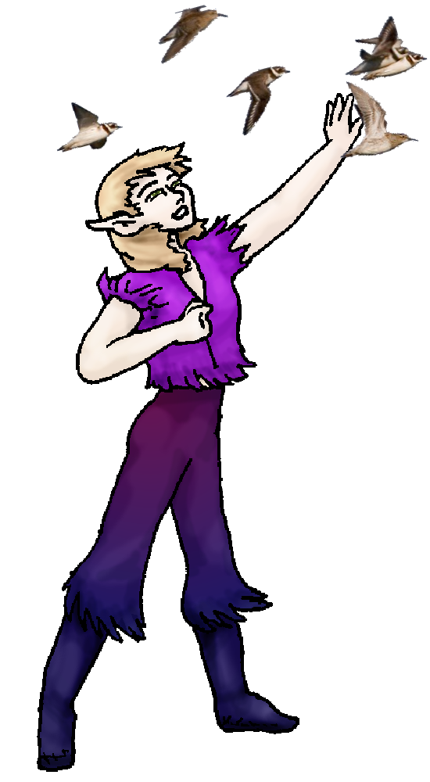
Habits and Places Preferred: Hunting Methods:
Bond Beast Personality:
Character Sketch
Hair: pale brown
Eyes: hazel green
Skintone: fair
Bond Beast Habits/etc:
BondAnimal
Fur/Skin: (varies)
Eyes:

About you as an elf
Your Name Means: Chinook is a warm, downward wind which comes from mountainsides down to plains level. http://en.wikipedia.org/wiki/Chinook_wind While the name in Elfin might not sound like this, it’s meaning is explicitly clear – wind, from the mountains!
Your Appearance Is: small and compact, with fair skin that’s shown off nicely by your dark violet-blue leathers, you have shortish pale brown colored hair that adopts sunlit yellow and silver along with russet and brown, and hazel eyes often squinting into the sun.
You Are Located: In the Protector Holt, south-east corner of the continent. Your den is located high up in the North Peak, where it often snows though the Holt is equatorial. Your command over wind allows you to float and survey the territory from above, and the den you share with your mate BlackBear has several entrances, one of which is quite high and isolated in the cliffside. The den is shaped from stone, reasonably warm and dry inside but often snowy outside. You have a work space for items you’re helping weave, though you often go down to the elf’s home you’re working on so you don’t have to lug large wicker items down by hand.
Your Basic Statistics Mean: You are indeed small, but quite strong for your size, and sturdy. While your agility is average, you’re considered pretty, and quite smart. Your magical power is very high.
Your Skills Include: your memories of Earth are weak, but typical, you can sometimes recall a design that you incorporate into a chair or hut-roof. Where your mind is at is mostly on the animals, birds and health of the Holt. You can track migration patterns over the seasons, by which birds are roosting or just visiting, and hunt easily when there is need. You have a very strong grasp on bones – being a Bone Shaper – but also you’ve got a good idea on how to manually set breaks or make sure that a wound isn’t going to fester. That’s vital during hunts, and while you’re not a magical Healer, you are quite talented and hunting parties value your presence. Your physical and survival skills are well rounded, you’d never find yourself lost in the Holt, big as it is, because you could simply orient yourself properly and fly a bit to get your bearings. You can tromp through most areas without leaving much of a trace. Because you’ve got several earthly-animals with you, transformed to the location just like you and your mate are, your riding skill is more varied because you can hop on nearly anything and hang on properly. While you do hunt normally with a slender javelin or two, you are more fond of fishing or trapping prey. You are adept at throwing a javelin better than stabbing with it, and you’ve been known to use a flurry of picked-up objects such as sand, small stones, even other animals, to throw at something either for distraction or to knock it out. For your typical duties toward the Holt however, you’re a good weaver of home objects such as wicker chairs and walls for huts. This is a purely physical activity, unless you decide to use bones to shape for it… which would creep most elves out… Like many elves here, you’re literate to a good degree and can keep notes if you need to about who is getting what item or where a hut needs to be planted.
Your Magic Powers Are: You’ve got a strong raw power score, thus your basic abilities with certain things are quite high. Your Magic Feeling, the ability to detect where magic has been used to shape an object or flown by on the wind, you can ‘see’ different colors around things. Your telepathic Sending power is extremely strong, born of living up in the mountains where pretty much everyone else lives lower than you. You have a straight, to the point sending power that can single out one person or broadly announce to many, and people describe your mind-voice as being warm like the wind you’re named for. You have a very strong bonding ability in general, so your ‘pets’ enjoy an intimate connection to you through magic. However, you also have a more specific power, that of Controlling Birds – birds are creatures of the wind, and you control the wind! While they’re not bonded to you mentally, they will often obey your requests. You can learn information from them as well as command them to do something physically. This works broadly, you can stand on the top edge of your home den, and spot a flock of birds at the edge of your vision, and still control them fairly well. Not every bird in a flock will obey, of course, but single and family units will definitely come to your aid if you need them to. Your strongest power is that of Wind Shaping. While it’s not true levitation, you can use this power to coax the air currents underneath you and ‘fly’ – briefly, though, because it’s not a very exact way of travel. (Imagine those little clouds underneath Dragonball characters… not very easy to command a puff of air!) But you do have tremendous lifting strength with it, and it almost comes entirely unconsciously to you to do this power. In order to test yourself, you’ve attempted to lift ever bigger rocks and items, and so far you’re at a boulder around 2 elf-heights tall and around… It’s still not wearing you out, but where are you going to put a boulder that size if you lifted it! Your weaker but very important power of Bone Shaping is one you use on the move a lot. You can shape injured bone – it’s painful but you also have more standard ‘medical’ knowledge to help ease the pain. You also use this power to heal broken bones on animals, when they’re not being hunted there is no reason to allow them to continue to hurt. With this power too, you can create hunting traps, fish hooks, and even small items like buttons, your javelins, and other weapons or instruments. It takes about half an hour to shape a bone the length of your forearm into something useful. This power alone wears you out a little, while your others hardly ever do.
Your Bond Animal Is: Your earthly pets have come with you – only in a different form. The cats are huge, mountain-lion shaped things which carry their old coloration and attitudes. The dog, similarly large and known as a dog-wolf, many of which have come to the Protector Holt elves, but few are truly accepted in the WolfPack below. But he’s got enough to do up here with you and your mate, and the true wolves down there would never outright attack him, they know he’s your bond animal.
Special Information: While some Animal Bonders who can control a variety of creatures don’t like hunting them – you’re not tuned so closely to the animals that you command. Your birds are just temporary, mostly mindless as they do your bidding.
You are known as a Hotdays (Late Summer/Fouthsign) elf, with the star-pattern “Lightning Bolt” in the evening sky. Elves of this ‘zodiac’ sign are represented by the burly Bear, the colors Yellow/Gold and summer-grown Longstem grass elements. Elves of this nature – though they don’t have to be born or arrive to the world under the season itself – are given to fits of Laziness, Nettling, but are also given Stealth, and Hope.

Date: Sun, 07 Jan 2007 09:53:53 -0500

Necessary Stuff
Your Full Name: Audrey, global = @audrey (CoV) Nickname or Title Mrs. G
Birthday 08-18-84 Act HOW Old? 30
Your Gender female, You like it this way
You Prefer the opposite sex
You are in a solid relationship

Appearance Stuff
You're about 5 feet tall, and you'd like to be taller
Your build is average and you'd like to be skinnier
Hair Color sandy brown Change? mixture
Hair Style/Curl long and straight Change? shorter
Eye Color hazel Change? no Glasses? off
Skin Tone white as it gets Change? darker
Are you 'Attractive'?yes Change? prettier
Are you 'Strong'? yes Change? stronger
Are you 'Smart'? yes Change? smart
Are you 'Nimble'? no Change? everything
You'll be getting pointy ears - you want them elegant

Circle (likes) or Cross Out (dislikes)
Where do you like living? fewer people old friends quiet neighborhood

Climates you like seasonal mild mountainous

What You Want Out of Life see the world rough it/camp heal the sick bask in the sun go fishing slack off raise kids fly like an eagle read
raise pets and animals learn retire early and relax

Other:

Favorites...
Colors Blue/ Purple/ Red
Animals Dogs and cats
Music/Bands all, cant find much i dont like
Foods italian is always good
Sports if any play softball, watch football
Time of Day evening
Season summer

Fears and Hates afraid of the dark

Any pets you'd like to drag along? dog sasha, 2 cats val and miki
Any people you'd like to have with you? (supply them a sheet!)Husband Chris

