NAME: Prestige HOLT: Protector SOUL NAME: EARTHNAME: Badge
MATE: CHILDREN/RELATIVES: (coh)
MATURITY: young adult REAL AGE: ? YEAR/PORTAL OF ARRIVAL: 122/Hall SEX: M

STR: 14 CON: 14 SIZ: 5 INT: 17 POW: 20 DEX: 19 APP: 15 Total: 105
SKILLS MAGIC POWERS WEAPONS / ARMOR / BOND ANIMAL
language memory: 27 % magic feeling: 40 % attack with javelin (held) : 76 %
animal lore: 34 % sending: * 100 % damage 1d3 impale parry: 66 %
elf lore: 61 % wolf bonding: 80 % attack with________________________________: ___%
healing lore: 51 % healing: ** 40 % damage_______________________________parry: ___%
mechanical lore: 51 % (anti-heal: ___% missile thrown javelin : 86 %
mineral lore: 34 % (flesh shape: ___% damage 1d4 impale range med-long (levit)
plant lore: 44 % (shielding: ___% missile___________________________________: ___%
world lore: 44 % plant shape: ___% damage___________________range______________
communicate: 74 % rock shape: ___% missiles carried__________________________________
wolf/anim comm: 57 % (metal shape: ___% shield_________________________________use: ___%
perception: 80 % (gem shape: ___% armor type______________elem:___bash:___cut:___othr:___
stealth: 59 % bone shape: ___% supplies carried / other skills / etc
climb: 66 % water shape: ___%
dodge: 78 % firestart: ___%
jump: 88 % levitation: 80 %
swim: 66 % finding: ___%
throw: 66 % animal bond: ___% BOND ANIMALname: species: n/a sex:
manipulate:/art 67/87 % mindsnare: * ___% STR: CON: SIZ: INT: POW: DEX: APP:
ride animal: 48 % hypnosis: ___% climb: ___% jump: ___% swim: ___%
hunt/trap: 76 % astral projection: ___% stealth: ___% dodge: ___% percp: ___%
tailoring/design: 72 % deep sensing: ___% comm: ___% ______:___% ______:___%
dancing: 78 % self shaping: ___% attack____________:___% attack________________:___%
music/sing: 68 % *command mind: 80 % disposition
wacky plans: 74 % **mind-heal: 40 % magic or other abilities
literacy: 78 % :___% natural armor:___________elem:___bash:___cut:___othr:___
Personality Notes: Lives in a...:
Likes and Dislikes: Friends:
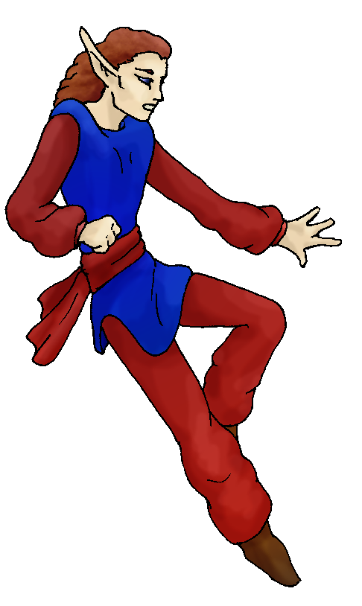
Habits and Places Preferred: Hunting Methods:
Bond Beast Personality:
Character Sketch
Hair: lt brown
Eyes: blue
Skintone: fair
Bond Beast Habits/etc:
BondAnimal
Fur/Skin:
Eyes:

About you as an elf
Your Name Means: Prestige – it’s not that you necessarily lead or command all the time, it’s that people follow you because they want to. Something about how you carry yourself, and the way that a lot of the new arrivals simply knew to look to you for whatever fun was going to go on that day, all those things lend to your name.
Your Appearance Is: With fair skin, usually covered by silken garments of brilliant red and blue, having slightly curled brown hair and eyes a shade of blue between sky and water. You’re one to watch, without being bizarrely overattractive or particularly distinctive.
You Are Located: In the Protector Holt, south-east corner of the continent and land of a thousand interesting things to do and see. Your particular den is situated close to the coastline, still a day of full travel away from the actual ocean, but near a number of large bays. To the north-west are strong peaks, though they dwindle to the basin where the huge inland sea is. The land near your den is more wetland and rainforest than much of the Holt, catching the winds off the sea and also blocking some of the fog that remains year round even at this tropical area. The den is shaped by other elves, a large canopy-tree joined by many others by layers of branches and vines. It’s much easier for fliers like yourself to reach this den, as the tree is almost 200 feet tall. Your shaped den is airy, but secure, rather more like a strong nest with still-growing branches forming every wall.
Your Basic Statistics Mean: You’re a very strong, healthy elf, average of height but with elegant grace and easy to look at. Your keen intelligence often comes through in your bizarrely hatched schemes and items to play with. Your magical power is well above average, though there are elves who can match you.
Your Skills Include: You have a surprisingly average memory of Earth, which is why it’s odd that you hatch such interesting plans or create odd images. You concentrate on people rather than elements – so your skill with determining animal identity or looking over stone to see whether it’s good for carving is below average. However, what you might lack there is more than made up for by your ability with people, gossip, mechanical design, and perceiving the world around you. Though you’re not all ‘mental’ – your abilities to survive in the wild are all strong – though sometimes, when you can dodge an incoming attack, you don’t. Your forte in skills is in your artistic and theoretical ways though. Artwork and design of both clothing and items are strong in you, as is your literacy level. You can whip up a pretty good piece of clothing (though your skill pales before some others). You have all but neglected your ability to ride an animal, prefering to fly instead anyway. Something you can do that others often don’t, is ‘plan’. With the scouting you’ve done of the whole area, you know there are weird dangers and things which keep coming back to haunt the elves of the Holt. You’ve got this ‘plan’ where you assemble as many people as possible, put them into groups, and start whittling away at these dangers… They always seem to come back, but while you can get people to cooperate for it, these events hone everyone’s skills as much as give them a great social event. You’re not much for regular hunting, prefering a quick scamper through the forest, or even just laying traps for small prey. When you do hunt, you use a slender but very sharp shaped wooden javelin, usually much easier for you to throw it from the air, from overhead and use some of your power to aid its accuracy.
Your Magic Powers Are: With your strength of raw Power, your magical abilities follow suit. Your Magic Feeling is keen, to the point of being able to match a person’s aura color with the colors they wear when you’re designing their clothing. This sight (and smell, and sound) is so natural to you, sometimes you don’t recognize that others can’t always see it too. Your telepathy, Sending, is very strong. No one ever doubts it when you’ve sent to them, your mind voice is clear, bold, like the colors you wear. Your range with this telepathy is wide and direct, you can send to many elves at once without confusing yourself. You do have a strong ability to bond a wolf-friend, however at this time none has come to you. (see below) Aside from those normal things, you have several powers. You can heal, this power is not uncommon, and your ability with it is below average in strength, but it’s been more than enough to be able to heal your nearby hunting companions or someone who’s come by and been hurt, in a pinch. Also, you can use your strong sending to aid this power, and produce the ability to heal psychological wounds, putting worry to rest, anxiety at ease. These are ‘quick fixes’ though, mental healing takes a long time to be fully effective, and you often can’t devote that kind of time to one person. It’s up to them to change things, or help themselves, when you’re done. Your stronger powers however are more obvious: also with your strong sending, a variation on hypnosis or mind-snaring is used when you Command elves nearby. Though you’re quite strong with this power, its range is rather limited, so you must keep track of where everyone is. With it, you can organize more easily, see who’s drifting off or what spots need better coverage. It’s not quite ‘seeing through’ everyone’s eyes, but more like getting ‘detailed reports’ on everyone in the area, and being able to respond in kind, en masse. This is not the related ‘coersion’ power, which takes a mind and actually bends it to the user’s will. This is a power which allows you to use the existing mind energy to ‘organize’, instead of ‘make’ someone do things. And of course, finally, your ability to fly. Many elves can fly, it’s no secret you’re not alone up there! Your power means you can stay afloat longer than most, even if at times you will be stressed. You can lift items at the same time as float yourself, up to five elves along with you for a short time. Just lifting yourself, you barely ever tire of it. When you must exert, it won’t last longer than half an hour or so before you must rest a bit.
Your Bond Animal Is: as above, you don’t have a permanent wolf-friend or other animal that calls you their ‘own’. However…. There is a weird, purple colored impish monkey-like creature which has been spotted in your area. Where a purple monkey came from, no one’s sure. Several people have seen it, it appears to reside near your den… But no one’s ever seen you and it together…
Special Information: Upon arrival? You knew the place was going to be fun. It was going to be excellent to explore, and there were so many people here that you knew instantly that you could get them to follow you. They don’t necessarily even have to be asked, told or clued in. They just do it. It was that easy to get a name, certainly, when Snowdrift gave you the name Prestige she even seemed comedically miffed about it: after all, she’s the one who started the whole elf-thing in the first place, and to have an upstart practically fall out of the sky and grab the reins … You enjoy this life with gusto.
You are known as a Leaffall (Autumn/Fifthsign) elf, having a personality that suits the bold Ram totem, the colors Red/Orange, the durable Maple tree, the elegant Waterfall and River starsign is in the night sky at this time. Elves of this personality bent are often Commanding, noisy, sometimes filled with Pride, but almost always Social. This is just a faint touch on who you really are, not everyone fits every facet of their ‘sign’.

Fri, 08 Dec 2006 05:57:56 -0500

Necessary Stuff
Your Full Name: Badge Nickname or Title Birthday Act HOW Old?
Your Gender male, You like it this way
You Prefer to keep your sexuality to yourself
You are in a solid relationship

Appearance Stuff
You're about feet tall, and you'd like to be the same
Your build is Athletic and you'd like to be none
Hair Color Brownish Change? none
Hair Style/Curl Wavy Change? none
Eye Color Blue Change? Glasses? off
Skin Tone White Change? none
Are you 'Attractive'?yes Change? none
Are you 'Strong'? yes Change? none
Are you 'Smart'? yes Change? none
Are you 'Nimble'? yes Change? none
You'll be getting pointy ears - you want them medium

Circle (likes) or Cross Out (dislikes)
Where do you like living? alone old friends new friends bustling city
busy town quiet neighborhood isolated village farm/ranch

Climates you like mild warm rainy foggy cloudy sunny sea level flatland
plains canyons hilly mountainous towering cliffs beach river rainforest
forest meadow grassy rocky

What You Want Out of Life see the world rough it/camp heal the sick
surf joke bask in the sun find a soul-mate draw/create build and construct
make music fly like an eagle create clothing read learn retire early
and relax fiddle with toys and tools

Other:

Favorites...
Colors Red and blue
Animals Monkey
Music/Bands
Foods Chinese
Sports if any
Time of Day midnight
Season autumn

Fears and Hates

Any pets you'd like to drag along?
Any people you'd like to have with you? (supply them a sheet!)

