NAME: Perch HOLT: Protector SOUL NAME: hulkers EARTHNAME: Spar Orr
MATE: Wolfsong CHILDREN/RELATIVES: (coh)
MATURITY: Adult REAL AGE:5.17.65/43 YEAR/PORTAL OF ARRIVAL: 122/Hall SEX: Male

STR: 15 CON: 17 SIZ: 7 INT: 15 POW: 18 DEX: 19 APP: 14 Total: 105
SKILLS MAGIC POWERS WEAPONS / ARMOR / BOND ANIMAL
language memory: 30 % magic feeling: 36 % attack with exotic blade (metal/ivory) : 78 %
animal lore: 45 % sending: 82 % damage 1d6 cutting/impale parry: 78 %
elf lore: 60 % wolf bonding: 72 % attack with club (wooden) : 68 %
healing lore: 75 % healing: 90 % damage 1d6 smashing parry: 34 %
mechanical lore: 30 % (anti-heal: ___% missile thrown staff (short) : 68 %
mineral lore: 30 % (flesh shape: ___% damage 1d4 smashing range short
plant lore: 40 % (shielding: 36 % missile___________________________________: ___%
world lore: 40 % plant shape: ___% damage___________________range______________
communicate: 68 % rock shape: ___% missiles carried__________________________________
wolf/anim comm: 66 % (metal shape: ___% shield_________________________________use: ___%
perception: 82 % (gem shape: ___% armor type______________elem:___bash:___cut:___othr:___
stealth: 74 % bone shape: 54 % supplies carried / other skills / etc
climb: 64 % water shape: ___%
dodge: 74 % firestart: ___%
jump: 64 % levitation: ___%
swim: 64 % finding: ___%
throw: 78 % animal bond: 72 % BOND ANIMALname: Hunter species: Hawk sex: m
manipulate: art 67 % mindsnare: ___% STR: CON: SIZ: INT: POW: DEX: APP:
ride animal: 76 % hypnosis: ___% climb: ___% jump: ___% swim: ___%
hunt: 76 % astral projection: ___% stealth: ___% dodge: ___% percp: ___%
weaponshape: 68 % deep sensing: ___% comm: ___% ______:___% ______:___%
dance/music: 66 % self shaping: ___% attack talons : 65 % attack beak : 55 %
falconry: 72 % :___% disposition
trapping: 76 % :___% magic or other abilities
literacy: 60 % :___% natural armor:___________elem:___bash:___cut:___othr:___
Personality Notes: Lives in a...:
Likes and Dislikes: Friends:
Habits and Places Preferred: Hunting Methods:
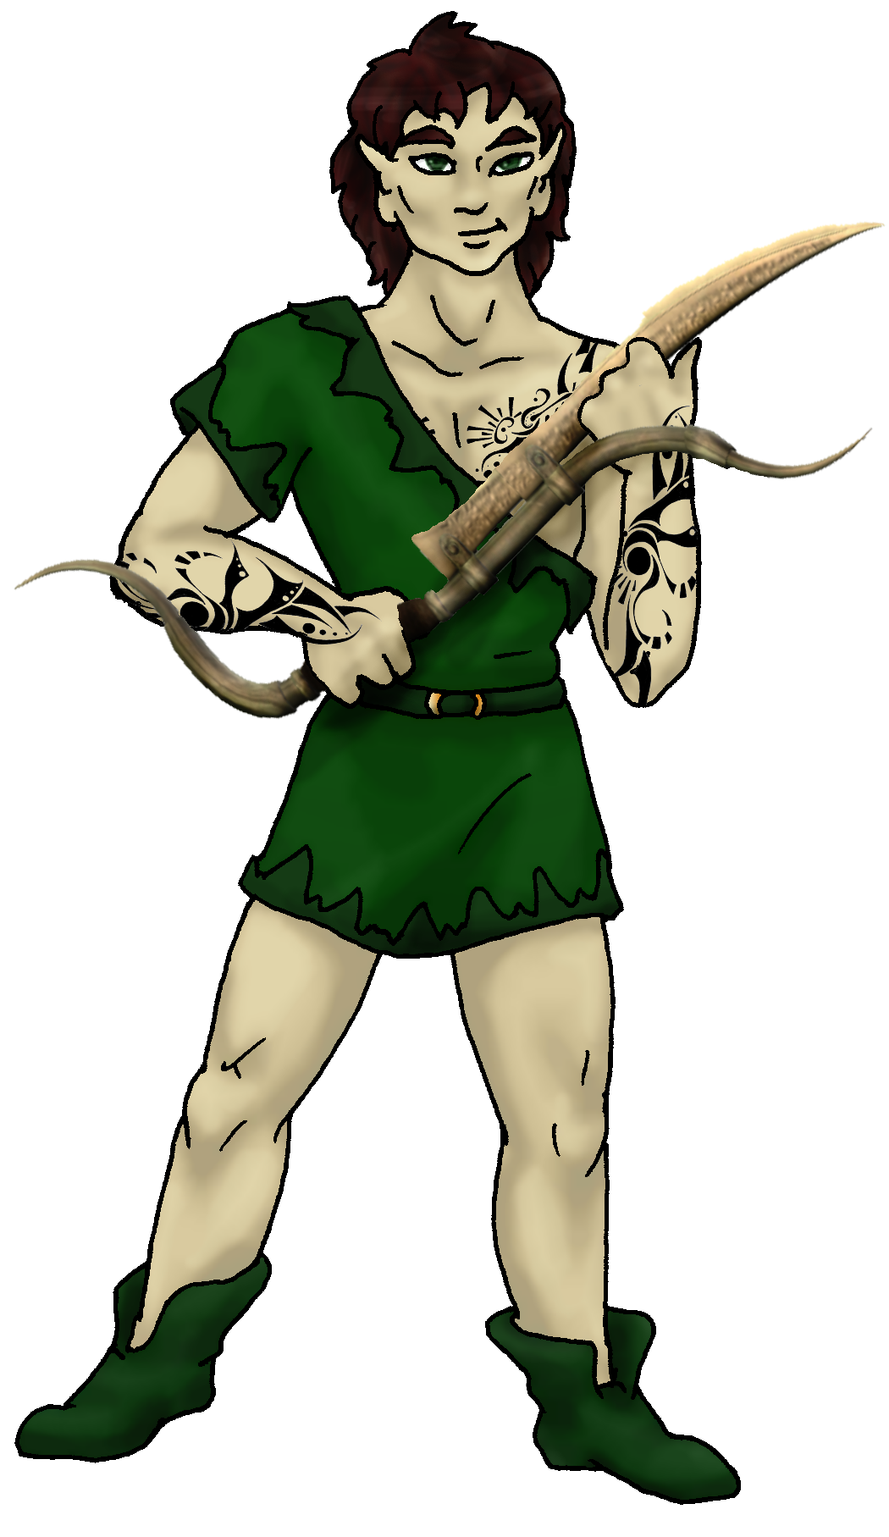
Bond Beast Personality:
Character Sketch
Hair:dk brown
Eyes: green
Skintone: fair, tattoos
Bond Beast Habits/etc:
BondAnimal
Feathers: grey, brown
Eyes: yellow

About you as an elf
Your Name Means: It’s very rare to see you without your hawk sitting upon your shoulder or forearm, and if you’re not careful he’ll bring several of his close personal friends to hang out on you too. It’s a good thing you can heal yourself, because those talons are sharp.
Your Appearance Is: tall and broad-shouldered, with suntanned skin bearing exotic tattooing done to honor your healing abilities. You’ve got short, fluffy dark brown hair, and deep green eyes to match your typical green leather clothing.
You Are Located: In the Protector Holt, on the south-east corner of the continent. Your den is near your mate Wolfsong’s, situated in a rich forest near hillsides and canyons. While her spot is more tree-den type, yours is built into a natural cavern reinforced by stone-shapers. There is room enough for you to work on shaping and artwork but also a secluded spot for you to work on injured hunting parties.
Your Basic Statistics Mean: You’re bigger and stronger than most in the Holt, and can usually keep up physical activities much longer than others. You’re considered pretty smart and typically attractive, with above-average agility. Your magical power is strong.
Your Skills Include: as most Otherforest arrivals do, you’ve got a vague memory of Earthly things. You have used this knowledge to spice up your weaponry ideas, and occasionally the charcoal drawings you make resemble things you can only recall in dreams of this world. As far as your knowledge goes, you’ve got a great handle on the healing arts outside of your magical powers – you know how to set bones, stitch cuts, treat illnesses and the like. This helps you conserve your magical power, if you don’t have to use it, you can always make an herbal mix or paste, use bandages or the like. You like to keep up on the doings of the elves in the Holt, knowing who lives where and what they like to do – but you’re no gossip. You don’t use any of the information you have to do much more than play the occasional prank on folks. You know enough about the animals in your area to avoid the dangerous ones and pick up hunting trails on the rest. Your hunting and physical skills are good, particularly you’ve got a great eye for a trail or details visually. Artistic pursuits are strong for you, using charcoals and sometimes paints, but also putting together sculptures and such – out of the scraps left over from your bone-shaped weapons. Bows, sturdy but light weight traps, knife hilts and inlay – anything with bone that you can manipulate with your magic, you show a flair to produce a work of art in addition to a functional weapon. Like most elves of the Holt you’re literate to a reasonable degree, jotting down notes on who wanted what, or if you know someone has broken a weapon and needs it replaced. For your own weaponry, though you often choose to lay traps for small prey, you also hunt using an interesting metal and ivory blade-spear. It’s points can snag prey even if it’s twisting around, and the bigger ivory point can be detached to provide a secondary javelin stabbing weapon. You can use a blunt weapon pretty well, either thrown or for smashing, but you prefer to play ‘ball games’ with them instead. With your animal bonding comes the uncommon skill you have in falconry. You’ve trained your bird friends to hunt with you, though sometimes they just catch and fly off – you don’t mind, there’s always enough to go around.
Your Magic Powers Are: as all elves have, you can sense where magic has been performed, your ability with this is moderate but you can use it enough to sense who has shaped a weapon or item before you. Your ability to telepathically Send your thoughts is strong and direct, though you prefer to think together with a few close friends than big groups. Though you have a wolf-bonding power, your magic brings you hawks – and primarily one you’ve named Hunter for the obvious reason. Apart from those things which most elves use, you’ve got a very strong power to Heal – you can knit bone, seal wounds with a thought and a touch. With this, you can much more easily determine the origin of sicknesses, but also as above, you can decide not to use your magic when the situation doesn’t warrant it. For any immediate issues, you will cause blood vessels to close, or even help an elf who is in great pain with a healing ‘shield’ so they can get away from the action. It doesn’t actively heal them, but it keeps them stable and safe. While there are other healers in the Holt, you’re definitely one of the stronger ones. You also have a reasonably strong power to shape Bone – either living or dead, though you know fully that healing a bone break is far more painful than just stitching together flesh. So, you can combine the two powers, but more often than not you merely use your Bone shape power on cast off bones, antlers and the like. You can shape an arm-length section of bone into a useful item within an hour, but you can also go back to work on things and they shape more easily after you’ve been shaping them a while.
Your Bond Animal Is: Hunter, a red-tailed hawk – one of several hunting birds which seem to be quite attracted to you. Obviously they’re not big birds and cannot be ridden like the wolves or cats, and you have to borrow a ride on someone else’s wolf if you are needed distantly. Hunter is the cause of your name, and even sometimes when you’re napping or concentrating on shaping, he’ll nestle up on your shoulder.
Special Information: You and your mate Wolfsong often play pranks on the nearby cat-elves, since a number of them live in the hills to the north of your den. However, you would never want to cross the cat pride, since they not only outnumber you but they’re also a bit snippy about that kind of thing. You can heal fast – but you’d hardly want to mess with them! At least… more than once…
You are known as a Chilldays (Late Autumn/Sixthsign) elf, with the star-sign of the Viper in the night sky, represented by the constantly moving Beaver, the color Violet and the Holly vine. Elves of this ‘sign’ are often seen as Industrious, dour, Formal, Jealous – but not every elf displays those features.

Necessary Stuff = * absolutely necessary! Wed, 28 May 2008 17:40:30 -0700 (PDT)
Your Full Name Sparlan Dean Orr"Spar orr" * Nickname or Title Spar (Hulkers) COH Your working E-mail address sparinbama2@yahoo.com
Birthday 5-17-65 Act HOW Old? about 10 years less than that *
* Your Gender Male And...You like it this way You Prefer ..The opposite sex You are: solid relationship
Appearance Stuff (I need at least a few of these)
You’re about how tall? 5'10" Taller
Your build is? Like a Gorilla, with shorter arms Healthier
Hair Color? Brown, some grey Darker
Hair Style? Short Completely Different- Longer, some "wave" to it Longer
Eye Color? Hazel/Green Change to what? Just green Off/None
Skin Tone? Farmer tan LOL Tattoo/Marked (Something along the lines of mystical healer type stuff)
Are you ‘Attractive’? Think so Unique
Are you ‘Strong’? Ridiculously so No
Are you ‘Smart’? Somewhat Change? Smart
Are you ‘Nimble’ or 'Agile'?- Think "skinny sumo" Change? No
You’ll be getting pointy ears! Short,
Where do you like living? (Choose as many as you like)
Fewer People Alone Isolated Village Cold Warm Rainy Foggy Hilly Mountainous River
Rainforest Forest Heavy/Old Growth Forest
What You Want Out of Life… (choose as many as you like! list what you really don't like in the 'other' section!)
Heal the sick (ESPECIALLY THIS ONE) Joke and play Go fishing Draw/Create Read
Give advice and listen
* Favorites:
Colors Hunter Green
Animals Gorilla, Red Tail Hawk, British Bulldog
Music/Bands Third Day, Todd Agnew, Nickleback
Foods- Steak, Red Beans and Rice, Curry Burgers
Sports if any (play) Softball (watch) Sumo wrestling
Time of Day Dusk
Season Fall
Other info (anything left out, anything important you want to share):
Do you have any Fears and Hates?
Any pets you’d like to drag along? PLEASE describe (at least gender, breed, appearance)

I'd LIKE a Red Tail Hawk for a pet, if possible. My RL pets are small dogs, and not worth describing LOL

Stock used: Fall Series 01 – Sixwings stock

