NAME: Wolfsong (Howl) HOLT: Protector SOUL NAME: (bamawolfie) EARTHNAME: Lynne Orr
MATE: Perch CHILDREN/RELATIVES: (coh)
MATURITY: Adult REAL AGE:1.1.64/44 YEAR/PORTAL OF ARRIVAL: 122/Hall SEX: Female

STR: 11 CON: 13 SIZ: 6 INT: 15 POW: 19 DEX: 16 APP: 14 Total: 94
SKILLS MAGIC POWERS WEAPONS / ARMOR / BOND ANIMAL
language memory: 30 % magic feeling: 38 % attack with 1 handed axe (metal, wood) : 74 %
animal lore: 45 % sending: 86 % damage 1d6 cutting parry: 54 %
elf lore: 60 % wolf bonding: 76 % attack with knife (metal, small/cooking) : 84 %
healing lore: 60 % healing: ___% damage 1d3 cutting/impale parry: 74 %
mechanical lore: 30 % (anti-heal: ___% missile bow / arrows : 64 %
mineral lore: 30 % (flesh shape: ___% damage 1d6 impale range medium
plant lore: 45 % (shielding: ___% missile___________________________________: ___%
world lore: 40 % plant sense: 38 % damage___________________range______________
communicate: 78 % rock shape: ___% missiles carried__________________________________
wolf/anim comm: 78 % (metal shape: ___% shield_________________________________use: ___%
perception: 82 % (gem shape: ___% armor type______________elem:___bash:___cut:___othr:___
stealth: 70 % bone shape: ___% supplies carried / other skills / etc
climb: 62 % water shape: ___%
dodge: 70 % firestart: * 38 %
jump: 64 % levitation: ** ___%
swim: 64 % finding: ___%
throw: 64 % animal bond: ___% BOND ANIMALname: Nightshine species: greaterwolf sex: f
manipulate: 64 % mindsnare: ___% STR:17 CON:11 SIZ: 19 INT: 11 POW:14 DEX:17 APP:15
ride wolf: 84 % hypnosis: ___% climb: 50 % jump: 64 % swim: 64 %
hunt: 64 % astral projection: ___% stealth: 72 % dodge: 72 % percp: 66 %
cooking: 72 % deep sensing: ___% comm: 75 % ______:___% ______:___%
dancing: 60 % self shaping: ___% attack bite : 66 % attack knockdown : 86 %
music/sing: 60 % *light illusions: 76 % disposition
trapping: 70 % **soundshape: 76 % magic or other abilities shapeshift (very minor) 28%
tracking: 68 % :___% natural armor:___________elem:___bash:___cut:___othr:___
Personality Notes: Lives in a...:
Likes and Dislikes: Friends:
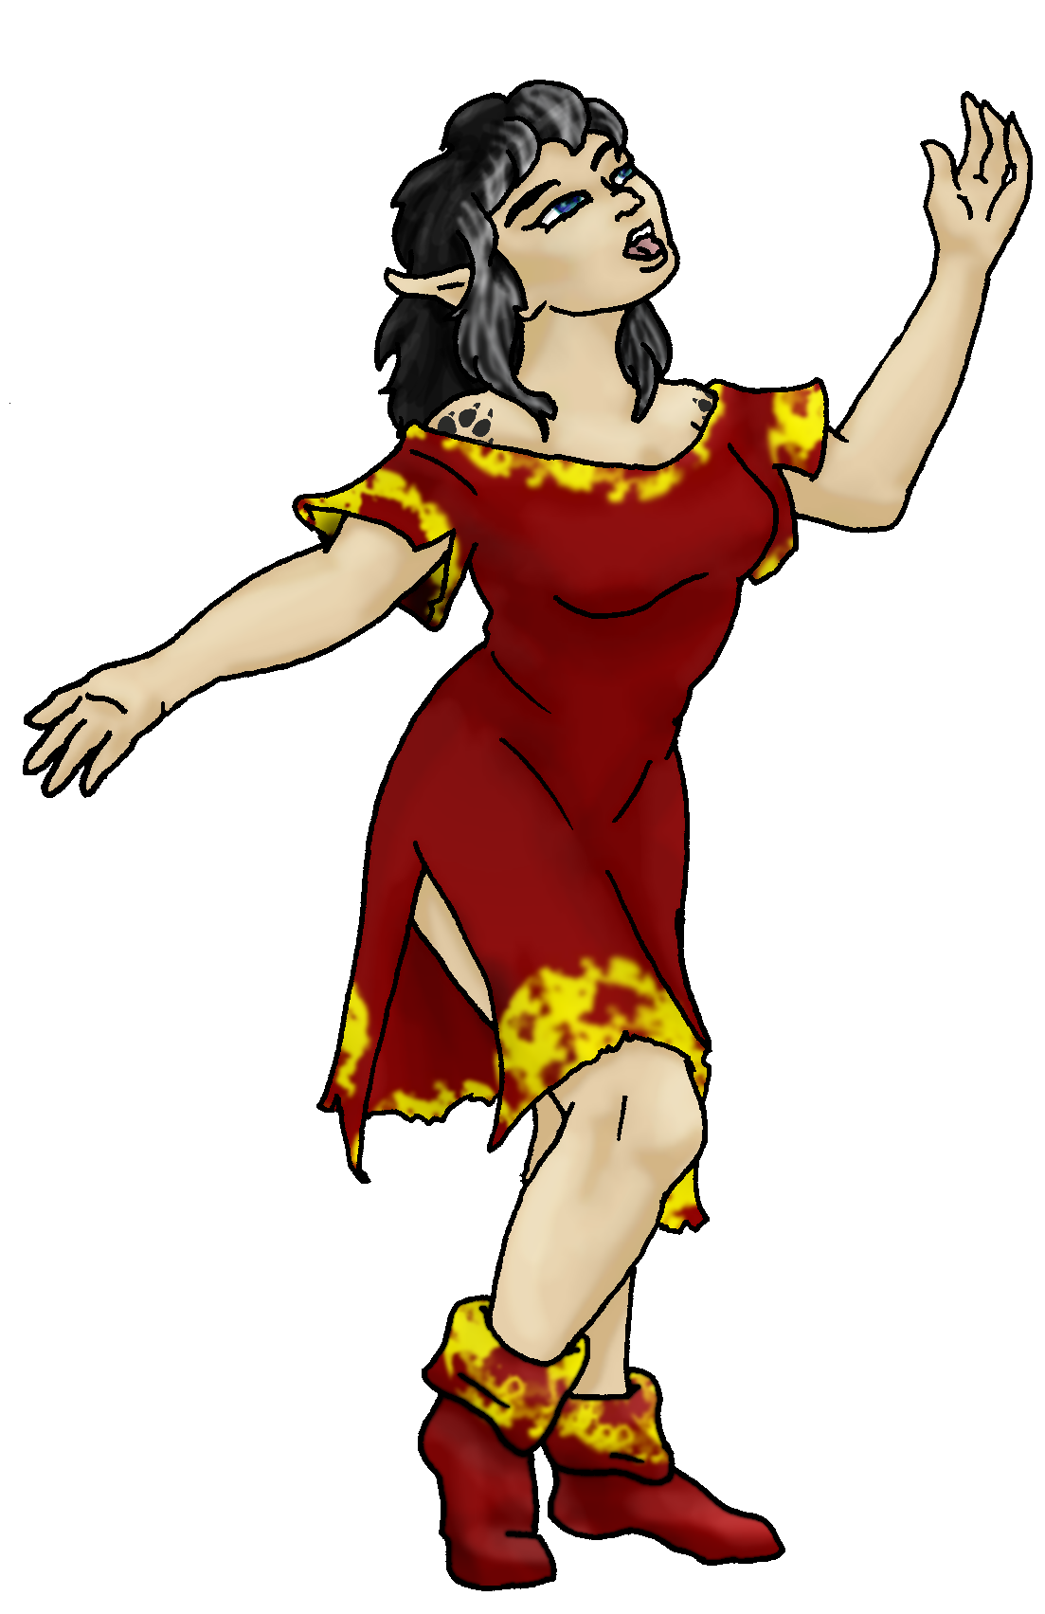
Habits and Places Preferred: Hunting Methods:
Bond Beast Personality:
Character Sketch
Hair: black/white
Eyes: blue-green
Skintone: fair, tats
Bond Beast Habits/etc:
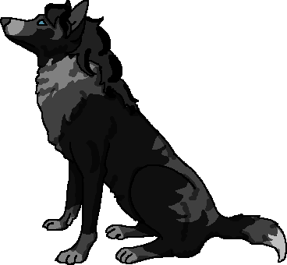 BondAnimal
Fur/Skin: blacks
Eyes: blue

About you as an elf
Your Name Means: Wolfsong is your ‘full’ name, however most people also know you as Howl – for the obvious reason that you and the wolves tend to sing a lot.
Your Appearance Is: fair skinned with two wolf-paw tattoos (one on each shoulder), with vibrant black hair having streaks of white around your face. Your eyes are more blue than green, but always shining. Your preferences for soft leather to be worn in warmish weather has allowed the tanners and dyers in the Holt to produce bold red and yellow dresses, but you’ve also got more sedate brown and red outfits for chillier weather.
You Are Located: In the Protector Holt which is in the south-east corner of the large inhabited continent, your den is situated in the heavy forests to the west of the huge inland sea. Plenty of rivers, streams and ponds dot this area, though the forests lighten up toward the higher hillsides and into the mountain-lion country. However, up in those canyon-laden hills are plenty of cat-elves… They’re fun to chase. Your den is made from living plants, actually not shaped, but instead wound together carefully and set to grow a little faster than normal. A dome of branches keeps the direct sun as well as light rainfall off of your mossy floors, but it’s been known to flood or get too warm to simply lay there. There’s a pond to cool off in, just nearby! While you share this den with your mate, he also has his own den close by.
Your Basic Statistics Mean: You’re just a little taller than average, typical in strength and appearance of most. You’re reasonably healthy, considered smart, though you are not quite as nimble as many others. Your magical power is very strong.
Your Skills Include: as all elves who come from Earth do, you’ve got a vestage of memory from here, however the extent of this for you seems to be inventing foods and sometimes even cooking equipment. Your knowledge is adequate where it concerns elfin relationships, animal life, plants to harvest, and the world itself. Almost all your physical and survival skills are better than average, and you enjoy the challenge of occasionally losing your way around the big Holt. (The holt is over 500 miles to a side…) You track very well, and ride your wolf-friend even better. The weapons you use to hunt, aside from traps and snares, include an axe for large prey, and for range you know how to use a bow pretty well. However, no one would dare approach you if you’ve got your cooking knife in hand – you’ve been known to throw it or slice things at such a rapid pace that it scares even the best swords weilders in the area! You know how to cook meals for just yourself on up to half the population of the Holt – fire cooked meals and steamed items are among your preferred meals. You leave the bread-cooking and such to others, there are plenty around.
Your Magic Powers Are: You have a pretty strong ability with Magic Feeling, allowing you to detect who has shaped an item or flown by using their flight magic recently. Your telepathic Sending power is strong and like your howling voice quite loud! (Each elf’s mental voice carries differently, yours is memorably howl-ish in nature.) Your power to bond to a wolf has brought Nightshine to your side, though hers is more a voluntary partnership than a magical compulsion. (see below) In addition to those things which most if not all elves share, you’ve got several particular other powers. One is fire-starting, which you use to start kindling ablaze, you can cause any dry wood or burnable items to catch fire pretty easily. Based upon that, however, is an ability to produce illusions based on light! Along with those, you can amplify sounds and create noise with magic, this is a weak form of levitation, you cannot actually fly with it. In addition to this, you can use a mild form of plant shaping, Sensing, that can tell you the health of a plant, and whether it’s edible or not.
Your Bond Animal Is: Nightshine is a female Greater Wolf, from, she says, the Coastal Cliffs area of the world (that’s around a thousand miles to the west…). Greater Wolves have strong blood ties to shapeshifting elves, there are several packs of elf-blooded wolves running around, including up in Dare’s Valley where you first met other elves. Nightshine is black with charcoals and greys mixed in, and lovely blue eyes. She’s neither the biggest nor strongest wolf in the pack, but she is quite pretty, and she does have the ability to shapeshift to a small extent: she can form ‘thumbs’ and pick things up, as well as having a very elfin mind.
Special Information: there is at least one or two of the big cats up in the hills nearby that pull their own pranks on you and your mate Perch – hopefully the pranks that go back and forth between you and them don’t escalate too much.
You are known as a Newgreen (Spring/Secondsign) elf, with the star-sign of the Turtle in the night sky. Elves of this ‘sign’ are represented by the newborn Fawn, the colors Green and Brown and the Oak and Flowers elements. Elves of this sign are often into Celebration, Lighthearted, show Passion, Nimbleness. Not every elf of this ‘sign’ shows all traits.

Zek - this is ME and not a toon. I made my answers bigger so they'd stand out from the rest of the text.
Necessary Stuff = * absolutely necessary! Tue, 27 May 2008 20:51:24 -0700 (PDT) "Lynne orr" <lynneinbama2@yahoo.com>
Your Full Name Lynne Orr* Your working E-mail address Lynneinbama2@yahoo.com
* Nickname or Title Wolfie @bamawolfie CoH
Birthday 01.01.1964 Act HOW Old? 35
* Your Gender female And... (CHOOSE)You like it this way You Prefer ... (CHOOSE) The same sex You are: (CHOOSE)in a solid relationship
Appearance Stuff (I need at least a few of these)
You’re about how tall? 5'9"and you’d like to be (CHOOSE)The Same
Your build is? rubenesqueand you’d like to be (CHOOSE) Healthier
Hair Color? black with silver streaks (particularly in front at the part)Change? No Changes
Hair Style? just past shoulder length, I describe it as "permanent bed head" (kinda wavy-ish)Change? (CHOOSE) No Change
Hair Length? Longer
Eye Color? blue/green (leaning toward blue)Off/None
Skin Tone? medium, caucasianChange? (CHOOSE)
Tattoo/Marked (make me a wolfie tattoo maybe? I don't have one for real yet)
Are you ‘Attractive’? so-soChange? nahUnique (maybe? always been told I'm "different" or "march to the beat of my own drummer... but that's behavior, not looks)
Are you ‘Strong’? Physically - no; emotionally/mentally - yesChange? Stronger (slightly)
Are you ‘Smart’? better n' average, I thinkChange? No
Are you ‘Nimble’ or 'Agile'? NoChange? No
You’ll be getting pointy ears!, Elegant, Medium or Long
Where do you like living? (Choose as many as you like)
Fewer People With the Same Old Friends Isolated Village Farm/Ranch Meadow
Chilly - hate the cold Cold - hate the cold Open Ocean - hate this
Seasonal Warm Muggy (sweaty!) Plains Hilly Mountainous Deserted Island
River - I'm a freshwater critter all the way! Heavy/Old Growth Forest
What You Want Out of Life… Rough it/Camp Heal the sick Joke and play Bask in the sun Make music Give advice and listen Cook a mountain of food Retire early and relax
* Favorites:
Colors RED, yellow, black, brown
Animals Wolves, horses
Music/Bands all kinds - rock, heavy metal, new age (enya, yanni), pop, jazz, blues
Foods I am a wolf! MEAT! steaks, potatoes, veggies - camp-cooked/wild-cooked food.
Sports if any bah!
Time of Day Twilight, before it's dark & late into the night.
Season SPRING - summer
Other info (anything left out, anything important you want to share): I'm very wolf-like... I'm fiercely loyal, but can be sneaky when needed. I guard those I love and care about with feirocity - and believe love is not finite.
Do you have any Fears and Hates? I am afraid of bees and please don't put snakes with me - not afraid of them, just don't want them, please.
Any pets you’d like to drag along? PLEASE describe (at least gender, breed, appearance) Perhaps a large, black, wolf? My alter-ego?
Any people you’d like to have with you? (supply them the link!) Sent Hulkers (the big gorilla/ogre/dwarf) the link. Don't necessarily hafta put us together. I'd like to have "my own" picture (if you know what I mean)... but if you want us together, that's fine too!!
Did someone recommend this link to YOU? PLEASE tell me who they are! :D
Thanks, Zek!!!
Lynne

Stock used: forest IV by Fetishfaerie Stock

