NAME: Deluge HOLT: Protector SOUL NAME: (bas) EARTHNAME: Nealson
MATE: CHILDREN/RELATIVES: (coh)
MATURITY:Young adult REAL AGE: 21 YEAR/PORTAL OF ARRIVAL: 122/Hall SEX: male

STR: 15 CON: 14 SIZ: 5 INT: 17 POW: 18 DEX: 21 APP: 14 Total: 104
SKILLS MAGIC POWERS WEAPONS / ARMOR / BOND ANIMAL
language memory: 17 % magic feeling: 36 % attack with long staff (wood) : 72 %
animal lore: 51 % sending: 82 % damage 1d6 smashing parry: 72 %
elf lore: 51 % wolf bonding: 72 % attack with________________________________: ___%
healing lore: 34 % healing: ___% damage_______________________________parry: ___%
mechanical lore: 44 % (anti-heal: ___% missile hunting net (small) : 82 %
mineral lore: 34 % (flesh shape: ___% damage 1d3+ entangle range close
plant lore: 34 % (shielding: ___% missile___________________________________: ___%
world lore: 34 % plant shape: ___% damage___________________range______________
communicate: 72 % rock shape: ___% missiles carried__________________________________
wolf/anim comm: 70 % (metal shape: ___% shield_________________________________use: ___%
perception: 72 % (gem shape: ___% armor type______________elem:___bash:___cut:___othr:___
stealth: 78 % bone shape: ___% supplies carried / other skills / etc
climb: 88 % water shape: * ** 82 %
dodge: 78 % firestart: ___%
jump: 100 % levitation: * 72 %
swim: 100 % finding: ___%
throw: 72 % animal bond: ___% BOND ANIMALname: Wavefoam species: Wolf sex: F
manipulate: 52 % mindsnare: ___% STR:18 CON:10 SIZ:18 INT:10 POW:12 DEX:14 APP:14
ride wolf: 84 % hypnosis: ___% climb: 46 % jump: 60 % swim: 60 %
hunt: 74 % astral projection: ___% stealth: 62 % dodge: 52 % percp: 55 %
aerial navigation: 61 % deep sensing: ___% comm: 30 % ______:___% ______:___%
art/drawing: 63 % self shaping: ___% attack knockdown : 64 % attack bite : 54 %
music/sing: 70 % *stormshape: 64 % disposition
trapping: 63 % **water adaptation: 72 % magic or other abilities
literacy: 61 % :___% natural armor:___________elem:___bash:___cut:___othr:___
Personality Notes: Lives in a...:
Likes and Dislikes: Friends:
Habits and Places Preferred: Hunting Methods:
Bond Beast Personality:
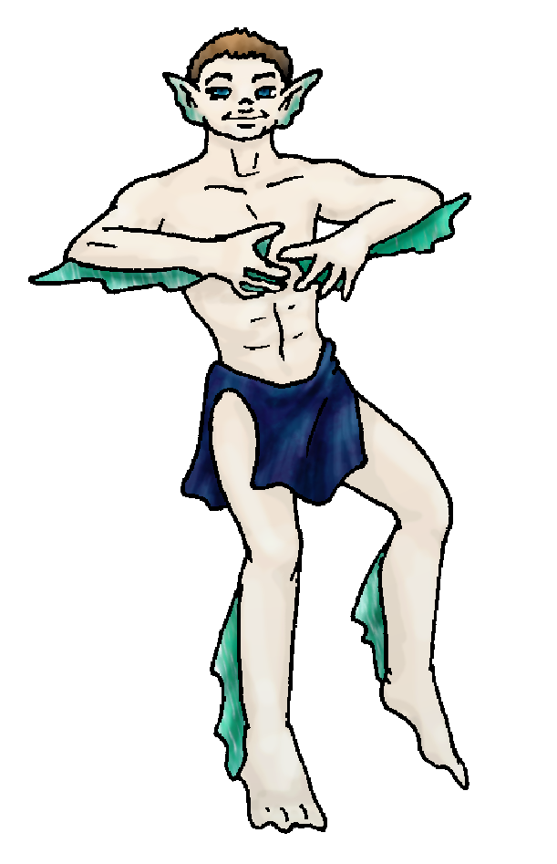 Character Sketch
Hair: med. brown
Eyes: blues
Skintone: fair, fins
Bond Beast Habits/etc:
BondAnimal
Fur/Skin: white
Eyes: blue

About you as an elf
Your Name Means: Deluge is clear from your powers: you are a storm shaper, not to be trifled with! Your power and command over water is great, but you hardly use it to really scare people!
Your Appearance Is: Well-balanced, muscular, fair of skin but you’ve usually got greenish tints to your fingers, face, ears and on occasion you actually sprout fins! Your hair is medium brown, and your eyes are a dark blue-teal shade. Almost always with a smile on your face, you’re always greeted pleasantly by your friends! You’ve usually (almost all the time, even out of water for extended periods) got webbing between your fingers and your toes, giving you better speed in water.
You Are Located: Down in the south-east corner of the continent, the Protector Holt holds a large number of elves. Your den is up in the chilly north peak area, overlooking a steep, deep canyon. High rocky walls surround your home’s area, but down in the cool shade of your pools, it is actually warmer than up top. It almost always freezes over in winter here in this locale, but you don’t care. Your den is shaped from the very stone of the walls of this canyon, there are fissures in the walls with runoff from the snow above on the peak, and a wide area of the den is about 2” deep in water at all times. You do have a nice warm, dry area apart from your pool, where you keep hide scrolls, paper, and drawing equipment. Charcoal artwork decorates the stone directly, you draw constantly when you’re not swimming or hunting.
Your Basic Statistics Mean: Very strong, healthy and sturdy, you’re all around a fit and superior elf. With extremely dexterous hands, as well as a slippery nimbleness in and out of water, you’re physically on a par with the very best in the Holt. Quite smart, you put your mind to the games that others with powers can create – you don’t have a power to defeat their puzzles when you get caught in their mind-traps, but you can almost always work your way out the ‘hard’ way! You’re considered pretty attractive, though your aquatic appearance confuses some folks. Finally, your magical power level is around average, you tend to use it less often consciously, your adaptation power doesn’t drain you.
Your Skills Include: You have almost no recollection of Earth and its ways or language. Other people can sometimes get you to recall things (that’s a ‘car’ you drew! “what’s a car?”) but by and large, you get along fine without even thinking about it. You are adept at knowing people’s ways, as well as those of animals. Also you’re clever with creating traps or useful small items, though you don’t make a job of it. You know which plants to avoid and what’s edible, but that’s about all. You excel at communication, singing and dancing as well as just plain conversation and debate. As far as your survival skills are concerned, your magic helps immensely where jumping, climbing and swimming are concerned. You can simply do those things without really worrying about falling or slipping, drowning or getting lost. You’re good at navigating the Holt overhead, knowing the way each fold of land and hill are shaped, you hardly get lost when you’re traveling over the treetops. Artistry and reading are fun down-time activities for you, you share your thoughts on paper (or hide, or whatever is available) and others can contribute their words too – you’ve developed a little bit of a ‘traveling forum’ by having a scroll with the “eight’s thoughts” (eight fingers, an elfin ‘week’) being passed around to whoever wants to participate. When you hunt, it’s usually either in the water with nets, or on wolf-back with a staff – you are pretty good with knocking long-legged animals down, or even swinging your net at birds in flight.
Your Magic Powers Are: You’ve got average Magic Feeling, the ability to detect where magic has been done, and who shaped something specific. Also your telepathic Sending is pretty good, you must send quite a lot since you spend a lot of time under water and wouldn’t hear a shout or howl above. Your Wolf Bonding power has brought you a companion for your journeys, see below. Outside of those things which every elf has in some form, you’ve got a couple powers which you combine into a more unusual one. Your strongest ability is that of Water Shaping. With it you can sense currents, move them around if need be, purify water in a fairly wide area, and generally not have any issues with breathing under water or out of it. Next in strength is that of Flight, you can lift yourself and another of your weight (not your wolf, but a smaller one or smaller prey you’ve killed) pretty easily for an hour or longer without tiring out. Your Water Shaping combines with that Flight to produce a limited but reasonably impressive Weather Shaping power – you can bring water from the sky, ground or wherever, and throw it around as though a deluge – giving you your name too. This is exhausting, of course, and you can only keep it up a short time. You can splash what feels like a short, hard rainstorm over a narrow stretch of land (probably not more than 20 x 30 meters) for around 10 minutes before you’re too tired to continue. You can cause hail briefly, or just mist for a longer period. This is extremely helpful when there’s been little rain in certain areas, you can effectively ‘summon’ water out of nothing. Your other Water-based power is that of Adaptation – your body alters itself almost constantly, without you having to concentrate on it at all. With it you’ve grown webby hands and feet, fringed ears, fins on arms and legs to help propel yourself, and even when spending time in the water for very extended periods, you’ve grown ‘gills’ to help you breathe. All this happens over time, hours to days, so the longer you spend in the water, the more finny you become.
Your Bond Animal Is: Wavefoam is a beautiful, all-white female wolf, pretty much the middle of the pack for size and strength so she won’t be challenging for the Alpha spot any time soon. She is not too delicate, but suffers injuries pretty easily if you’re riding hard for too long. She’s also not the most physically graceful wolf in the Pack. But she is simply beautiful, her fur is all sparkling white with a faintly grey undercoat, and brilliant sea-blue eyes.
Special Information: Yes, you’re here at least twice. However, no one could possibly guess that your darker half is ‘also’ you! You get the feeling from a couple others that they too have such a weird effect – they existed before, and came here again. Somehow. You’re not quite sure how that works…
You are known as a Longdays (Summer/Thirdsign) elf, with the star sign “Falling Star” in the night sky. Elves of this ‘zodiac’ sign are represented by the quick Rabbit, the color light green, the useful Wide-Boll tree elements. Elves of this type – no matter when they actually arrive, it’s just for personalities not necessarily birth signs – show Humor, Sensuality, Creativity, Generosity.

backalleyscrapper@gmail.com Add to Address BookAdd to Address Book Add Mobile Alert
Subject: Elf Survey Form
Date: Mon, 08 Jan 2007 21:51:54 -0500

Necessary Stuff
Your Full Name: Nickname or Title Nealson Birthday Act HOW Old? 21
Your Gender male, You like it this way
You Prefer both
You are in single and loving it

Appearance Stuff
You're about 5 feet tall, and you'd like to be taller
Your build is average and you'd like to be healthier
Hair Color brown Change? lighter
Hair Style/Curl spikey Change? none
Eye Color blue Change? Glasses? off
Skin Tone tan Change? lighter
Are you 'Attractive'?yes Change? none
Are you 'Strong'? yes Change? stronger
Are you 'Smart'? yes Change? brilliant
Are you 'Nimble'? yes Change? everything
You'll be getting pointy ears - you want them elegant

Circle (likes) or Cross Out (dislikes)
Where do you like living? many people bustling city

Climates you like chilly cold mild snow/sleet mountainous towering cliffs rocky

What You Want Out of Life make noise surf find a soul-mate draw/create raise kids make music fly like an eagle read raise pets and animals learn give advice and listen snuggle in front of a warm fire surround yourself with technology fiddle with toys and tools

Other: Im from City of Heroes. Forum name is _BAS_

Favorites...
Colors crimson, navy
Animals All
Music/Bands All
Foods Spicey
Sports if any Swimming
Time of Day midnight
Season summer

Fears and Hates Dark

Any pets you'd like to drag along? Wolf/Dog
Any people you'd like to have with you? (supply them a sheet!)

