NAME: Cynosure HOLT: Protector SOUL NAME: (fictional) EARTHNAME: Back Alley Scrapper
MATE: CHILDREN/RELATIVES: (coh)
MATURITY: Adult REAL AGE:? YEAR/PORTAL OF ARRIVAL: 122/Hall SEX: Male

STR: 15 CON: 15 SIZ: 6 INT: 15 POW: 19 DEX: 18 APP: 16 Total: 104
SKILLS MAGIC POWERS WEAPONS / ARMOR / BOND ANIMAL
language memory: 0 % magic feeling: 29 % attack with 2 handed wooden staff : 76 %
animal lore: 40 % sending: 86 % damage 1d8 smashing parry: 66 %
elf lore: 60 % wolf bonding: 76 % attack with hand attacks : 66 %
healing lore: 30 % healing: ___% damage 1d4 smash, grappling parry: 33 %
mechanical lore: 45 % (anti-heal: ___% missile small item (rock, stick) : 66 %
mineral lore: 30 % (flesh shape: ___% damage 1d2 smashing range short
plant lore: 30 % (shielding: * 20 % missile___________________________________: ___%
world lore: 30 % plant shape: ___% damage___________________range______________
communicate: 72 % rock shape: ___% missiles carried__________________________________
wolf/anim comm: 68 % (metal shape: ___% shield_________________________________use: ___%
perception: 88 % (gem shape: ___% armor type______________elem:___bash:___cut:___othr:___
stealth: 84 % bone shape: ___% supplies carried / other skills / etc
climb: 66 % water shape: ___%
dodge: 78 % firestart: ___%
jump: 66 % levitation: *,** 20 %
swim: 66 % finding: ___%
throw: 86 % animal bond: ___% BOND ANIMALname: Comet species: Wolf sex: female
manipulate: 54 % mindsnare: ___% STR:20 CON:10 SIZ:24 INT:11 POW:12 DEX:19 APP:16
ride wolf: 72 % hypnosis: ___% climb: ___% jump: ___% swim: ___%
hunt: 72 % astral projection: ___% stealth: ___% dodge: ___% percp: ___%
weaving: 54 % deep sensing: * 20 % comm: ___% ______:___% ______:___%
dancing: 68 % self shaping: ___% attack____________:___% attack________________:___%
music/sing: 66 % * power punch: 76 % disposition
trapping: 74 % ** telekinetic att.: 48 % magic or other abilities
adobe/masonry: 86 % :___% natural armor:___________elem:___bash:___cut:___othr:___
Personality Notes: Lives in a...:
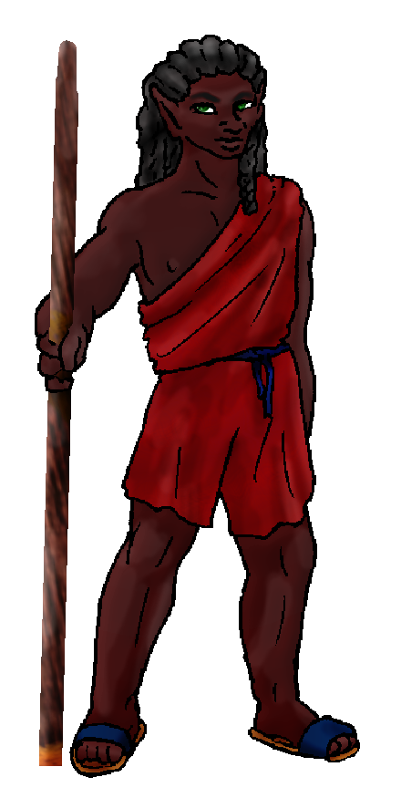
Likes and Dislikes: Friends:
Habits and Places Preferred: Hunting Methods:
Bond Beast Personality:
Character Sketch
Hair: black
Eyes: green
Skintone: dark
Bond Beast Habits/etc:
BondAnimal
Fur/Skin: dark brown, gold mks, long red fringe
Eyes: pale blue

About you as an elf
Your Name Means: Cynosure is the attractive point – something everyone is interested in, something which gathers attention and meaning. Always the center of attention when you’re around, this was an obvious choice of names, if a bit strange at first.
Your Appearance Is: Tall dark and handsome! Aside from the oddly charcoal-black Pirette, you’re probably the darkest of the Protector Elves, and thus stand out in a crowd. With black hair tied into slowly growing dredlocks, it’s much easier to maintain than a pointy-haired ‘do. (Though cut that hair and it’ll stand right back up!) With brilliant green eyes, you attract all the right attention. You choose to wear comfortable cloth garments because in this climate where you live it’s quite warm, anything more would be uncomfortable. Also you choose sturdy sandals, getting you over sharp rocks and hot sand with ease.
You Are Located: In the Protector Holt, which is in the deep south-east of the continent. Your den is situated among dry scrub lands, while there is not a true dune sandy desert in this part of the world there is rough, gritty soil and pale rock outcroppings to live among. Your home was built by your own hands – and not with magic. Using your skill at creating adobe and cutting rocks the hard way (okay maybe you used a little of your magic there) you have assembled a beautiful homestead among the rocks. Since it’s all made from the same materials as nearby, and decorated with dry brush and naturally occuring plants, it’s difficult to locate if you don’t know what you’re looking for. Your home has room for plenty of people to remain after a party, a central courtyard which is where those parties happen, a nice sleep den fit for you (and whoever might be joining you that night), and a work shop where you continue to carve out and create bricks for further construction or repairs.
Your Basic Statistics Mean: While you’re not much taller than typical, your sturdy frame supports a lot more muscle and meat than many others your height! Your exotic appearance makes for what most in the holt claim to be quite ‘hawt’. You’re nimble enough to get around easily but nothing spectacular. Your intelligence is above average, allowing you to think up new things to make. Your magical power is higher than normal by a wide margin.
Your Skills Include: Unlike many in the Holt, you have no ability to recall Earth – because you never were there, truly. Something about you tells others that have a strong intuition that you simply aren’t ‘real’ there. This doesn’t seem to bother them much, everyone’s changed from what they once were. You have faint memories of a bright and shining city, smelly sewers, and bizarre floating islands – but none of those things ever surface entirely to your mind. Your information gathering centers around people and tools – if you can talk to it or use it on something else, you’ve probably got a good idea what to say or how to use it. Your survival skills are very high, you’re able to move almost trackless through your chosen environment, and be unseen as you watch for prey. When you’re on the prowl you tend to use a strong wooden staff or even just throw almost anything (small enough to hold in one hand, you’re gonna be able to hit your target with it). But you also use your magically assisted hands to hunt or spar (with those brave enough). In social settings you’re easily able to dance and play music (prefering as always to smack things – drums and clap-sticks are favored), but also you put yourself to use by doing several constructive things. You are very apt with mushing together the right items to make adobe bricks and put them together with mud mortar, as well as raw stone masonry which allows you to assess a stone for its best breaking point, where it’ll be smooth and even, without stress fractures if you use it to build with. Also, you’re a pretty good hand at large weavings – there are several others who help create tarps, using large looms which you aren’t ashamed to admit is a fine way to relax among friends for an afternoon.
Your Magic Powers Are: You have a fairly low Magic Feeling power, which would give you only the bare hint that magic has been done to an item. You can guess anyway, but others use this power more than you do. Your telepathic Sending power is high, you’re able to converse with a group of people with ease, or one single person very privately at a good distance. Your mental ‘voice’ is, according to some, as heavy and stable as the very boulders which you break apart with your powers. You’ve got a typical wolf-bonding power, which has brought you a gorgeous wolf as a riding partner. You have some unusual powers in combinations that most would never imagine – though your basic abilities to Levitate, to Shield (prevent harm by casting a sort of shell), and to use Deep Sensing are all rather unimpressive apart (and very difficult to actually use in their raw form: you can try to float things, or to pull emotional secrets out of people using deep sense) it’s when you put them together that you’ve got a power you call “Power Punch”. You can summon magical energy and focus it on your fists, hardening them into stone-hard tools, and almost ‘dragonball z-ish’ whatever you strike tends to explode or fall to pieces. You can generally do this a dozen or so times before tiring out magically. Since this is not merely a “mind over matter” thing, you’re actually using magic power to enhance your normal strength. In addition you can also use a more tame Telekinetic power which allows you to batter around small objects as though you’re touching them, without moving a muscle. You can also use this power to help throw dust away from your eyes when you’re working with stone or mixing adobe.
Your Bond Animal Is: Comet is an absolutely stunning female wolf, with a coat in a rich sable brown, dusted with bright gold along her muzzle to her tail tip, and around her face, her ankles and the tip of her tail there are much longer, dark red strands of fur. Wolves of the Otherforest often have much more dazzling colors in their coats, along with this two-textured mix. She is extremely large and very strong, but is not very sturdy, and tires out somewhat quickly. Thus, while she is a high ranking wolf in the pack, she’s not the Alpha.
Special Information: Yes that’s right, you – like some others in the world – are completely ‘fictional’. You’re not really sure what that’s supposed to mean, because you’re absolutely as physically ‘here’ as anyone else in the Holt. Maybe even more so! The fact that you don’t have a ‘home’ to return to doesn’t bother you – your home is here.
You are known as a Leaffall (Autumn/Fifthsign) elf, whose star-sign is that of the “Waterfall and River” in the night sky. Elves of this zodiac sign are represented by the Ram, the colors Red/Orange and the useful Maple elements. Elves of this sort are often seen as Commanding, noisy, filled with Pride, and Social.

backalleyscrapper@gmail.com Add to Address BookAdd to Address Book Add Mobile Alert
Subject: Elf Survey Form
Date: Fri, 22 Dec 2006 19:08:20 -0500

Necessary Stuff
Your Full Name: Back Alley Scrapper Nickname or Title BAS (From City of Heroes)
Birthday August 16, 1984 Act HOW Old?
Your Gender male, You like it this way
You Prefer don't ask that
You are in single and loving it

Appearance Stuff
You're about 6 feet tall, and you'd like to be the same
Your build is Muscular and you'd like to be healthier
Hair Color Black Change? none
Hair Style/Curl Spike Change? none
Eye Color Green Change? Glasses? off
Skin Tone Dark (African) Change? none
Are you 'Attractive'?yes Change? none
Are you 'Strong'? yes Change? stronger
Are you 'Smart'? yes Change? typical
Are you 'Nimble'? sort of Change? none
You'll be getting pointy ears - you want them elegant

Circle (likes) or Cross Out (dislikes)
Where do you like living? alone busy town

Climates you like mild warm foggy desert

What You Want Out of Life fight things/people find a soul-mate draw/create surround yourself with technology

Other:

Favorites...
Colors Crimson, Navy
Animals Wolf, Fox
Music/Bands
Foods
Sports if any Soccer
Time of Day midnight
Season autumn

Fears and Hates

Any pets you'd like to drag along?
Any people you'd like to have with you? (supply them a sheet!)

