NAME: Fire Eyes HOLT: Protector SOUL NAME: (Blazing Blue) EARTHNAME: Kit Cunningham
MATE: CHILDREN/RELATIVES: (coh)
MATURITY: Adult REAL AGE: 8.19.77/31 YEAR/PORTAL OF ARRIVAL: 122/Hall SEX: Male

STR: 15 CON: 13 SIZ: 6 INT: 16 POW: 19 DEX: 20 APP: 14 Total: 103
SKILLS MAGIC POWERS WEAPONS / ARMOR / BOND ANIMAL
language memory: 32 % magic feeling: 39 % attack with long spear (metal) : 80 %
animal lore: 42 % sending: 86 % damage 1d8 impale parry: 60 %
elf lore: 64 % wolf bonding: 76 % attack with________________________________: ___%
healing lore: 32 % healing: ___% damage_______________________________parry: ___%
mechanical lore: 42 % (anti-heal: ___% missile thrown spear/javelin : 90 %
mineral lore: 32 % (flesh shape: ___% damage 1d6 impale range medium
plant lore: 32 % (shielding: ___% missile fire blast (magic) : 80 %
world lore: 54 % plant shape: ___% damage 1d6 burning range short
communicate: 70 % rock shape: ___% missiles carried__________________________________
wolf/anim comm: 70 % (metal shape: ___% shield_________________________________use: ___%
perception: 76 % (gem shape: ___% armor type______________elem:___bash:___cut:___othr:___
stealth: 80 % bone shape: ___% supplies carried / other skills / etc
climb: 90 % water shape: ___%
dodge: 78 % firestart: 102 %
jump: 100 % levitation: 72 %
swim: 60 % finding: ___%
throw: 70 % animal bond: ___% BOND ANIMALname: species: sex:
manipulate: 70 % mindsnare: ___% STR: CON: SIZ: INT: POW: DEX: APP:
ride wolf: 80 % hypnosis: 38 % climb: ___% jump: ___% swim: ___%
hunt: 75 % astral projection: ___% stealth: ___% dodge: ___% percp: ___%
‘magic tricks’: 75 % deep sensing: ___% comm: ___% ______:___% ______:___%
dancing/sing: 60 % self shaping: ___% attack____________:___% attack________________:___%
tinkering: 60 % :___% disposition
trapping: 74 % :___% magic or other abilities
mind puzzles: 64 % :___% natural armor:___________elem:___bash:___cut:___othr:___
Personality Notes: Lives in a...:
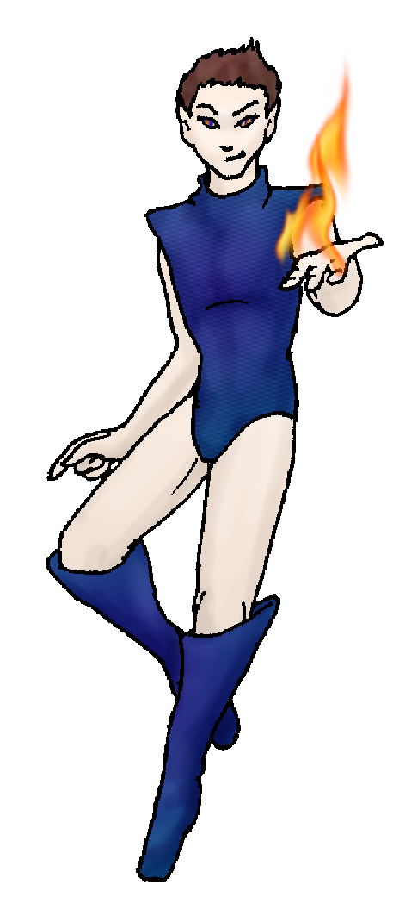
Likes and Dislikes: Friends:
Habits and Places Preferred: Hunting Methods:
Bond Beast Personality:
Character Sketch
Hair: brown
Eyes: red-blue
Skintone: light
Bond Beast Habits/etc:
BondAnimal
Fur/Skin:
Eyes:

About you as an elf
Your Name Means: Fire Eyes, the very words seem to be defined in you: your appearance and your powers. If it doesn’t involve flame, you’re bored with it. But, if it doesn’t involve flames and you’re around – it soon will.
Your Appearance Is: Tall, long-bodied, and very fair skinned. Your dark brown hair is short and wispy like the flames that you love. Your eyes are blue, sometimes, but more often than not when you’re using your flame powers they gain a bright orange-red glow as well, causing them to look very catlike – and somewhat scary! You choose cloth of a dark blue color for your bodysuit and boots, like some around the Holt you take up the mantle of ‘heroic’ often enough to want an outfit that shows it.
You Are Located: In the deep south-east of the continent is the Protector Holt, where mountain, forest, plain and ocean meet. Your den is in the second-highest area of the Holt, the eastern peak where below lay the strange spider-like creatures who are enemies to all. Your home is shaped from stone and formed brick, comfortable on the inside even without a burning fire pit – you warm it up yourself.
Your Basic Statistics Mean: Very strong but not burly, you have wiry muscles and a lean build. Devlishly attractive, and keenly smart, you enjoy the attention you get. You’re swift in the air as on the ground, able to move like fire itself. Your magical power ability is strong, much better than average.
Your Skills Include: You’ve got a typical memory of Earth and things in it, enough to make weird toys and devices that you think might resemble ones in your distant memories. You know the terrain of this Holt very well, mostly from above, and you’re likely to be able to tell just where any given elf living here is at any given time. Your other informational skills aren’t weak, but aside from some mechanical skill they’re nothing special either. Your survival skills are strong, especially anything involving you and the air. Jumping, climbing those are things which you can simply rely upon your magic to aid you. Hunting, trapping and travel through difficult terrain are reasonably strong in you. Though you don’t have a wolf-bond you can ride almost anything with ease. You hunt with a long, slender metal spear – you have several spear heads that other magic-using metal shapers have created for it, some for distance and some for quick kills. You use this spear for both hand held hunting, and throwing from the air. However you also “hunt” with a blast of fire from your hands, magic in raw form. This power is a last-ditch effort, because you know perfectly well that the other hunters don’t want to deal with already-cooked or still-burning animals. Because you do love your showy magic, you’re often found doing tricks with it, as well as more simple and basic sleight of hand tricks. Those, combined with your magic and a certain kind of flair for jokes and storytelling, have made you quite popular.
Your Magic Powers Are: You’ve got a good ability for Magic Feeling, able to tell who’s shaped what nearby by the ‘feel’ of their aura left on shaped items or in the air from flying. You yourself seem immune to seeing your own bright trails of fire and flight – which is good, because otherwise all you’d be able to see is a net of your own magical traces. Your telepathic Sending ability is quite good, you use it close up on many people at once but you also have a strong ability for distance with it. Though you’ve got a reasonable talent for attracting a wolf bond, you do not yet have a riding-partner. Your other magical skills get their work out every day. Your strongest power is that of fire-starting and shaping. You can take any flame, no matter how weak, and turn it into a burning pillar with just a thought. You can ignite anything that’s dry in moments with concentration – and ignite things which normally aren’t flamable with some effort. Your most spectacular use of this ability is to throw long gouts of flame into the air right on target – this is of most use down in the Dark Valley where the spider-creatures live. You do have to watch yourself, however, around dry brush. Casually even just thinking about it, things will burn near you. Your second strongest power is that of flight – you can lift yourself easily, and other objects with concentration though you’re much better at just flying yourself around for hours. You will tire if you use both fire and flight at once, but even that takes a while. Lastly and more weakly – just enough to nab an audience member during your performances – you have the ability to hypnotize animals and people. You use this only in a friendly way, to confound or confuse, throw off the scent, or just plain entertain.
Your Bond Animal Is: You currently do not have a bond-animal.
Special Information: You and several others form a team most frequently to deal with the incursions of the skittering odd web-spitters in the Valley. Some fight with mace and shield, others with hard swords and traps, you do so with fire and burn their webs down as quickly as they can spin them.
You are known as a Leaffall (Autumn/Fifthsign) elf, with the star-sign of Waterfall and River in the night sky, the durable Ram animal, the color Red/Orange and the towering Maple element. Elves of this nature are commanding, noisy, show Pride, and are very Social. This isn’t necessarily a sign from when you arrived, just a vague personality sign.

iamtriplec@yahoo.com Date: Mon, 11 Dec 2006 19:26:52 -0500

Necessary Stuff
Your Full Name: Kit Cunningham Nickname or Title @Blazing Blue Birthday 8/19/77 Act HOW Old?
Your Gender male, You like it this way
You Prefer the opposite sex
You are in a solid relationship

Appearance Stuff
You're about 6 feet tall, and you'd like to be the same
Your build is skinny/average and you'd like to be same
Hair Color brown Change? none
Hair Style/Curl straight Change? none
Eye Color blue Change? Glasses? off
Skin Tone white Change? none
Are you 'Attractive'?yes Change? none
Are you 'Strong'? yes Change? none
Are you 'Smart'? yes Change? none
Are you 'Nimble'? yes Change? none
You'll be getting pointy ears - you want them short

Circle (likes) or Cross Out (dislikes)
Where do you like living? fewer people

Climates you like chilly seasonal mild

What You Want Out of Life see the world joke find a soul-mate slack off fly like an eagle become a celebrity snuggle in front of a warm fire
surround yourself with technology retire early and relax fiddle with toys and tools

Other:

Favorites...
Colors Blue
Animals dogs
Music/Bands
Foods roast
Sports if any
Time of Day evening
Season autumn

Fears and Hates

Any pets you'd like to drag along?
Any people you'd like to have with you? (supply them a sheet!)

