NAME: Fledgling HOLT: Protector SOUL NAME: (boud) EARTHNAME: Boudicia Dark
MATE: CHILDREN/RELATIVES: (coh)
MATURITY: Adult REAL AGE:9.22.66/41 YEAR/PORTAL OF ARRIVAL: 122/Hall SEX: Female

STR: 12 CON: 13 SIZ: 4 INT: 16 POW: 19 DEX: 18 APP: 15 Total: 97
SKILLS MAGIC POWERS WEAPONS / ARMOR / BOND ANIMAL
language memory: 42 % magic feeling: 38 % attack with long knife (metal) : 70 %
animal lore: 74 % sending: 86 % damage 1d4 cutting/impale parry: 60 %
elf lore: 58 % cat bonding: 76 % attack with natural weapons (varies) : 60 %
healing lore: 32 % healing: ___% damage claw 1d4 imp, varies parry: 30 %
mechanical lore: 42 % (anti-heal: ___% missile lasso : 60 %
mineral lore: 32 % (flesh shape: ___% damage entangle range short
plant lore: 48 % (shielding: ___% missile___________________________________: ___%
world lore: 58 % plant shape: ___% damage___________________range______________
communicate: 72 % rock shape: ___% missiles carried__________________________________
animal comm: 70 % (metal shape: ___% shield_________________________________use: ___%
perception: 76 % (gem shape: ___% armor type______________elem:___bash:___cut:___othr:___
stealth: 74 / 84 % bone shape: ___% supplies carried / other skills / etc
climb: 60 / 80 % water shape: ___%
dodge: 76 % firestart: ___%
jump: 100 % levitation: 95 %
swim: 60 % finding: ___%
throw: 60 % animal bond: 76 % BOND ANIMALname: Zena species: big cat sex: f
manipulate: 57 % mindsnare: ___% STR: CON: SIZ: INT: POW: DEX: APP:
ride animal: 76 % hypnosis: ___% climb: ___% jump: ___% swim: ___%
hunt: 74 % astral projection: ___% stealth: ___% dodge: ___% percp: ___%
sculpture: 54 % deep sensing: ___% comm: ___% ______:___% ______:___%
dancing: 76 % self shaping: 105 % attack____________:___% attack________________:___%
music/sing: 80 % :___% disposition
trapping: 74 % :___% magic or other abilities
literacy: 74 % :___% natural armor:___________elem:___bash:___cut:___othr:___
Personality Notes: Lives in a...:
Likes and Dislikes: Friends:
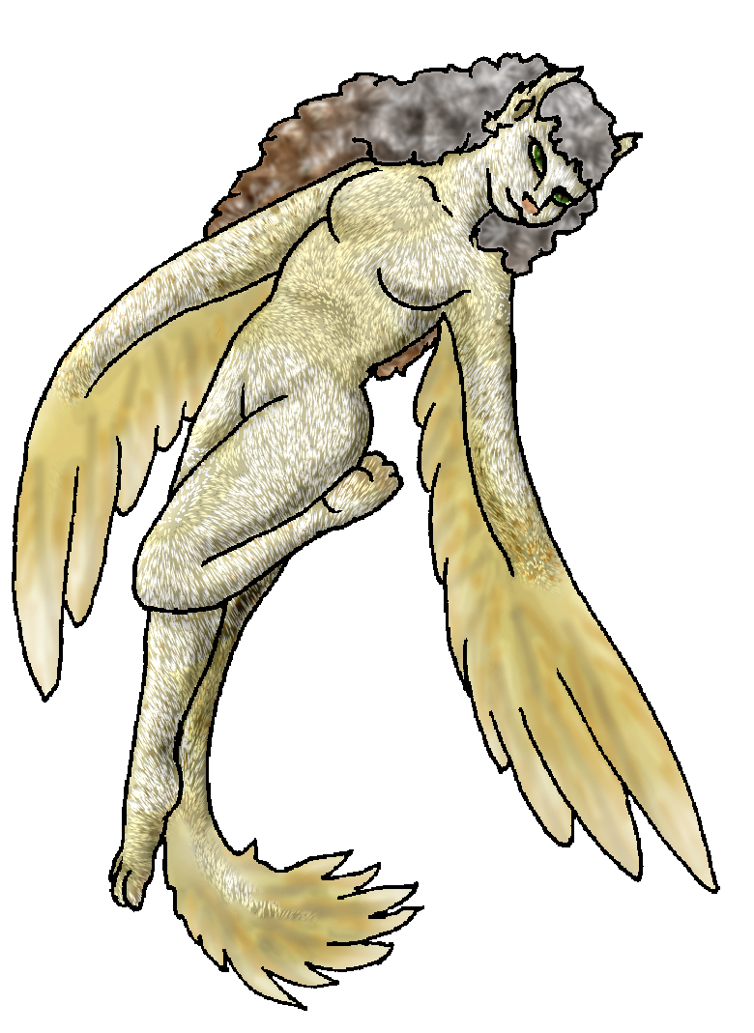
Habits and Places Preferred: Hunting Methods:
Bond Beast Personality:
Character Sketch
Hair: grey, brown
Eyes: hazel-green
Skintone: furry gold
Bond Beast Habits/etc:
BondAnimal
Fur/Skin: ?
Eyes: ?

About you as an elf
Your Name Means: Fledgling is how you came into the world, hardly settling on one shape for very long, but certainly already able to fly!
Your Appearance Is: small, well rounded – you’ve got several ‘stock’ shapes (the most common is shown in the picture). Your elfin self is fair-skinned, with long curly grey-to-brown hair, delicate ears, and often wearing a violet and purple colored woven dress. Your half-animal shape, shown above, is gold and silver furred, and while you can shape yourself fingers, you lose some feathers to do so. You often wander around with fur and a tail, in any case, though your head often maintains a more elf-cat look. You’ve got hazel-green eyes, which also always remain that shade. Your other shapes include a full feline, in a shimmery golden-champagne color, brownish shaded bird, a golden-furred wolf (very small wolf), a sleek silver dolphin for deeper water travel, and even a hooved horse-like creature which has silver dappling over brown fur. You’ve got a spectrum of animals covered.
You Are Located: in the Protector holt lands, in the deep south-east of the continent. Your den is found in a lush, deep forest filled with life. Since the Holt is equatorial, you don’t get much seasonal change here, but there are plenty of places north of your den which do. Your den is shaped from plant and a natural cavern, over a lovely waterfall and pond that’s well stocked with fish – your favored dish when in at least a couple forms! You do have a flatter, drier location on the other side of the cavern, letting out into a less overwhelming portion of the forest, where you can scoop up the heavy clay from the winding riverbed, and sculpt with it.
Your Basic Statistics Mean: Small and hardy, above average in strength for such a small person; you’re considered very pretty regardless of what shape you’ve got on. Your nimbleness is average, though to watch you no one could guess that. Your intelligence and magical power are both above average.
Your Skills Include: You have a fairly strong memory of Earth, but you use that to give you ideas about tools, doodads, things to create with your talented hands. You easily can shapeshift into almost any animal you’ve observed, and can detect not just a species or type of animal but often a specific animal among many; you use those bits of information to help develop your shapeshifting. Elfin relationships come reasonably easy to you, but you’re more interested in just a few rather than everyone out there. The world has been seen from overhead, some day you’ll explore more on foot around this wide Holt. You know essentially what plant life to avoid and what is good for eating, but you leave more complicated plants alone anyway. You communicate your ideas very well to both animals and elves, in different ways of course. You’re apt to be listening in to elves talking, but at the same time hearing all manner of bird talk, howling, grunting and the like, sometimes even going so far as to change your voice/head and shout in their native animal-tongue, “shut up already!” Because you’ve got several shapes, your survival skills might come in differently depending on whether you’re an elf or a beast. But none of them are lacking, and certainly if you need to scale a dense tree from the trunk instead of fly up to it, you can become a squirrel-like creature, or a quick pawed cat. Diving through heavy waterways is no issue, you’ve been a seal, dolphin and even once a real fish – but that shape wasn’t all that appealing to you. You stick with mammals mostly! Of course your ability to leap into the air is strongly aided by your floating magic. You enjoy your time among the beasts, but you still have to eat: and you hunt pretty well as either an elf or another predator. You use a noose to catch bigger animals on the hoof when you’re going to be needing more meat, cutting smaller prey down with a sharp knife, or just using your own natural claws, fangs and protective shape as needed. You trap and fish with ease, but it’s no secret that you love running through the woods in pursuit of your next meal! While you’re not watching or playing with the local wildlife, your visits to other elves give you a lot of things to do too – reading and writing and passing notes, sculpture which you’ve gotten a fire-shaper to ‘kiln’ (without actually needing an oven…), and singing and dancing are your favorite activities with two-footed friends.
Your Magic Powers Are: You’ve got a high-average Magic Feeling, you’re able to detect traces of magic left on shaped items or in the air as people fly by. You don’t like to get distracted by those things, though, concentrating more on what you can actually see with just your eyes. Your telepathic Sending power is strong, you use it well among groups and your mind-voice is said to be a mixture of fluffy, airy and purring. Though you’ve got a strong self-shaping power which usually interrupts the ability to bond to animals, your Cat bonding power certainly worked fine, your pet cat Zena sticking close. However, many with your strength of Self Shaping simply cannot bond, and you’ve got even more than that! Your power over animals is obvious – listening to their communication isn’t just a matter of practice, it’s also magical. You can temporarily bond to an animal to show it how to get out of a bog, down from a tree, or even (though it’s distasteful to do so) to still it’s worries while you hunt it. Almost any creature falls to your whim, but you don’t over-use this ability. Your power of Flight aids your feathery-forms, because it really is difficult to learn to fly when you haven’t been born with wings! That’s also why you don’t seem to need true flight feathers or a bird-like body when you fly – your flight power is active anyway, your wings and tail merely assist your motion through the air. You can also lift fairly heavy items – such as Zena – but not for very long, you’re more used to this power for yourself only. And then… there’s your Self-Shaping. The pinnacle of your abilities, and while some elves with this level of mastery might actually lose their ability to remain an Elf for very long, you haven’t lost touch with your furless side. You slip between shapes so quickly that it’s hard to even see, or with such subtlty that one moment you’re a wolf, the next a cat, and no one is the wiser. These animal shapes come all within about half-bigger or smaller than your normal biomass – so if you want to become a squirrel it’s going to be a large squirrel; a wolf, indeed a wolf smaller than most of the pack by a long shot. But regardless of size, you are able to reproduce the animal in its entirety. *
Your Bond Animal Is: Zena is your earth-cat, who has come in a much larger, more mountain-lion form. Since I don’t know much / anything about the kitty, it’s basically your call – only difference is that she’s big enough to ride, if you need her ☺. In addition, your animal bonding power can give you other, larger riding beasts such as deer or bear, you don’t feel the complete, intimate connection that Zena does with your mind, though – since it’s an “extra” power, and not merely the basic bonding ability that brought you two together.
Special Information: * For this reason, you are also in somewhat constant danger from Fang and his weird people up in the swamps near the Hall of Portals. Any shapeshifter, and particularly female ones, are targeted by mad Fang’s tribe to produce half-elven half-animal offspring. They and others are where the “Greater” animals (mostly wolves, but also some felines, dolphins, even half-bird creatures) come from. There is a small group of Greater Wolves in the pack here at Protector Holt, and you’re pretty sure one or two of the felines have elf-blood. Now, to be fair, Fang has really shaped up recently (pardon the pun) and is only interested in willing partners or pairs to help him. Why he wants all these half-bloods around is a mystery, though he is crazy and has in the past been known to just lose his mind and kill things. Haunted by his old lovemate (who was the first to die… yeah, he’s killed an elf) who is now in the body of a Greater Wolf’s offspring, he might continue to be made crazier by her influence. Whether you really want to get involved in that mess, that’s up to you. But getting away from them and staying down here safe in the Holt is a good idea anyway.
You are known as a Newgreen (Spring/Secondsign) elf, though your favored season is Autumn. Elves of this ‘zodiac’ sign see the star-pattern of the “Turtle” in the night sky. They’re represented by the lovely Fawn, the colors Green/Brown, and blooming Oak/Flowers as elements. Elves of this sign are typically filled with Celebration, Lighthearted, Passion, Nimbleness.

Date: Wed, 03 Jan 2007 15:07:52 -0500

Necessary Stuff
Your Full Name: Boudicia Dark Nickname or Title Boud Birthday 9/22/66 Act HOW Old? 35
Your Gender female, You like it this way
You Prefer the same sex
You are in a solid relationship

Appearance Stuff
You're about 5 feet tall, and you'd like to be taller
Your build is fat and you'd like to be healthier
Hair Color grey /brown Change? none
Hair Style/Curl long, curley Change? none
Eye Color hazel Change? no Glasses? on
Skin Tone pale Change? darker
Are you 'Attractive'?yes Change? none
Are you 'Strong'? yes Change? none
Are you 'Smart'? yes Change? none
Are you 'Nimble'? sort of Change? none
You'll be getting pointy ears - you want them elegant

Circle (likes) or Cross Out (dislikes)
Where do you like living? fewer people alone busy town quiet neighborhood

Climates you like seasonal mild rainy cloudy sunny dry hilly mountainous river rainforest forest

What You Want Out of Life see the world rough it/camp plant a tree joke go fishing draw/create slack off hunt raise kids build and construct make music fly like an eagle read raise pets and animals learn snuggle in front of a warm fire surround yourself with technology retire early and relax fiddle with toys and tools

Other: smoke lots of kind bud

Favorites...
Colors purple, blue, silver, gold, brown
Animals cats, dogs, horses, dolphins, apes, birds, monkeys
Music/Bands grateful dead, indigo girls, joni mitchell, tori amos, annie lennox, blue grass, jazz, eclectic rock, classical
Foods yes
Sports if any I like watching basketball
Time of Day day
Season autumn

Fears and Hates homophobes, most evangelical xtians, republicans, new agers

Any pets you'd like to drag along? my kitty, zena
Any people you'd like to have with you? (supply them a sheet!)my partner, becky

