NAME: Pirate? HOLT: Protector SOUL NAME: bp EARTHNAME:Mike Scofield
MATE: CHILDREN/RELATIVES: (coh)
MATURITY: adult REAL AGE: 6.72 YEAR/PORTAL OF ARRIVAL: 122/Hall SEX: m

STR: 13 CON: 14 SIZ: 6 INT: 16 POW: 18 DEX: 17 APP: 16 Total: 100
SKILLS MAGIC POWERS WEAPONS / ARMOR / BOND ANIMAL
language memory: 26 % magic feeling: 28 % attack with Cutlass : 90 %
animal lore: 48 % sending: 72 % damage 1d6 cutting parry: 60 %
elf lore: 48 % wolf bonding: 72 % attack with Hook : 70 %
healing lore: 48 % healing: ___% damage 1d3 impale parry: 70 %
mechanical lore: 74 % (anti-heal: ___% missile___________________________________: ___%
mineral lore: 48 % (flesh shape: ___% damage___________________range______________
plant lore: 48 % (shielding: ___% missile___________________________________: ___%
world lore: 64 % plant shape: ___% damage___________________range______________
communicate: 74 % rock shape: ___% missiles carried__________________________________
wolf/anim comm: 68 % (metal shape: ___% shield_________________________________use: ___%
perception: 74 % (gem shape: ___% armor type______________elem:___bash:___cut:___othr:___
stealth: 80 % bone shape: ___% supplies carried / other skills / etc
climb: 90 % water shape: 36 %
dodge: 110 % firestart: ___%
jump: 60 % levitation: * %
swim: 70 % finding: ___%
throw: 60 % animal bond: ___% BOND ANIMALname: Salty species: Wolf sex: m
manipulate: 61 % mindsnare: ___% STR: 21 CON: 16 SIZ: 18 INT: 11 POW: 16 DEX: 20 APP: 9
ride wolf: 78 % hypnosis: 64 % climb: ___% jump: ___% swim: ___%
hunt: 70 % astral projection: ___% stealth: ___% dodge: ___% percp: ___%
survival: 70 % deep sensing: ___% comm: ___% ______:___% ______:___%
dancing/music: 72 % self shaping: ___% attack____________:___% attack________________:___%
literacy: 64 % * speed: 72 % disposition
trapping: 70 % :___% magic or other abilities
water navigation: 68 % :___% natural armor:___________elem:___bash:___cut:___othr:___
Personality Notes: Lives in a...:
Likes and Dislikes: Friends:
Habits and Places Preferred: Hunting Methods:
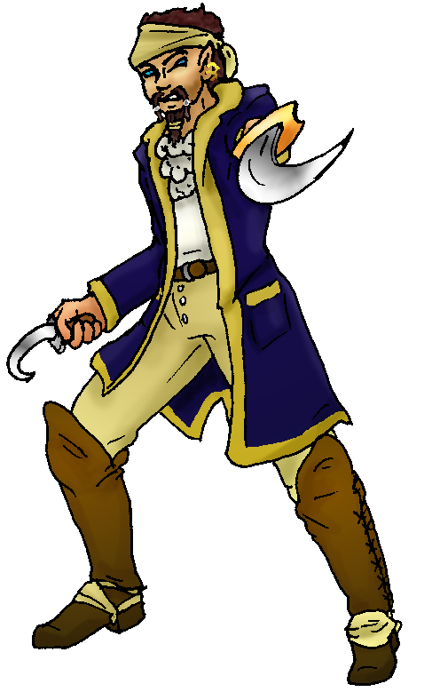 Character Sketch
Hair: brown
Eyes: blue
Skintone: fair
Bond Beast Personality:
Bond Beast Habits/etc:
BondAnimal
Fur/Skin: grey
Eyes: green

About you as an elf
Your Name Means: Well, since that other elf took your name, you’re going to have to work at getting it back! Pirate is YOUR moniker, no matter what she insists! But you answer to arrr, matey, scurveydog, avast, any number of nautical sounding terms. The problem comes when someone actually says your name, and she responds first!
Your Appearance Is: You’re of average height and build, with tanned fair skin that might have equal amounts of sea salt and sunburn on it. Your hair is rich brown, and eyes are a bright blue shade peering over your snarl. Unlike most elves you’ve managed to grow some facial hair which you keep in an immaculate beaded arrangement. Your clothing is mostly cloth, save your belt and boots, as it’s much easier to clean and keep dry. Leather takes forever to dry and shrinks! Ow!
You Are Located: In the Protector holt’s bay, traveling around the waterways there with … Pirate! you make your way through varying pillaging and looting phases. It seems that others have taken to burying stuff for you guys to find, so that’s actually a bonus. The bay is big, you’ve got your own little island that you can row out to whenever you feel like being alone. It has a hut on it, but you really do like living on the ship that Pirate and you have had made. You’re glad other people can help shape the wood and keep the metals from rusting, because with the pair of you it’s a bit of work.
Your Basic Statistics Mean: You’re just above average in size and health, strongly muscled, and reasonably attractive. You actually enjoy the challenge that your average dexterity brings, you never know quite when you’ll slip on deck or manage to miss that rope… You’re smart, and have an average magical power.
Your Skills Include: You have an average ability to recall Earthly things, and that’s good around here because otherwise things like Jibs and Mainsails wouldn’t have names. Or poop decks. Though you’re only a ‘master’ at mechanical skills, your other informational-type skills are all fairly good. You’re knowledgable in just about everything, without being a stunning know-it-all in any. Your ability to communicate, with elves as well as the wolves which hang around you, is pretty strong. You can bark out orders and even someone who’s not part of the crew will follow along. You’ve got fairly typical survival type skills such as climbing and noticing things, you’re best off in the crow’s nest looking out at the horizon. But what you’re really good at is moving around quickly. With your speed based power, you can physically dodge even arrows if you know they’re coming. You have good strong swimming skills, and you have an eye for understanding how to build temporary shelters, what rocks to hang on to and which to avoid, generally surviving in the wild for you is easy. Though you hunt reasonably well, you’re often able to rely on trapping and trading for your meals. You spar and sometimes hunt large prey with a cutlass and you use a hand-held hook to both gouge prey and grapple or even climb rock faces and trees. It’s a useful little tool, that. You use your ability to read and write in Talon’s script to put notes about where you’ve been, helping create maps, and leaving notes in bottles. You know how to party with the best of em, joining in dances and loud songs when you’re in port. Because you spend a lot of time on the ship, you’ve learned nearly every way to navigate on the water – by wind direction and strength, smell, stars, and bumps on the horizon.
Your Magic Powers Are: You’ve got a typical magic Feeling sense, with it you can detect whether an item has been shaped or made by magic. Beyond that you don’t really care a bit who’s done what magic. If they’re doing it while you watch, that’s of interest. Your sending voice is strong, firm, and well used at short range for giving orders to small groups. You can pinpoint an elf and send to them a hundred miles away – across the bay in other words, but that does take some effort. You have a wolf that came to you from your Bonding call, see below. Your other magic powers include a fairly unique (though you’re pretty sure one of the Valley kids has it) ability to move faster than the eye can see. It’s somewhat flight-related, people claim you’ve got the same kind of airy-blue aura when you use it as a flier does. But it keeps you on the ground, yet you move at nearly four times the speed of anyone else around you! This really does help when you’re trying to man the ship! Fortunately this power doesn’t seem to tire you out, it’s more of a natural occurance. If you try and keep it up, like try to run a long long distance at that pace, you will collapse after about half an hour. So keeping it to fits and starts is definitely the better way to do it. You can hypnotize both people and animals, though for you it’s not a matter of establishing eye-contact like it is for everyone else. You actually rely upon not getting eye contact! You distract someone magically and then you can suggest things to them – either implanting brief, fake memories which fade over time, or activities like scrubbing the deck or things not too dangerous. Your hold on people isn’t all that great, though it’s above average and you can keep it up for a reasonable amount of time. Also you can shape water to an extent – usually removing the salt and impurities to drink, and there’s always a barrell on the boat which is filled with sweet, purified water. You also keep yourself clean this way, you can ‘shed water’ pretty easily.
Your Bond Animal Is: Salty is… an ugly animal. He’s gangly but strong, skinny legs and usually a bent, wet tail. His fur is spotty, salty looking shades of grey through white, with a foamy white moustache/markings on his face. (No, fortunately he doesn’t look like he’s rabid, just with a white fringe.) However where he lacks in being pretty and big, he’s fiendishly clever, rather lucky at catching things, and agile enough to actually climb rigging. He loves hanging out in the crow’s nest with you, and he climbs up there by himself. Pretty impressive really. Most other wolves in the pack kind of shy away from him, not in the way of the ‘earth-dog-that-is-now-a-wolf’ way, but more because … well, he’s pretty fugly.
Special Information: Should you really wish to find a new name, it’s your choice. She did get here first, and you both are piratical, there’s a number of words and names you could take should you desire it. Since you hang out together a lot, it hardly matters which of you people are referring to when they say Pirate, it adds to the wonderful confusion anyway!
You are known as a Leaffall (Autumn/Fifthsign) elf, with the starsign Waterfall and River in the night sky, the strong prideful Ram animal totem, the colors Red/Orange and the enduring Maple symbol. Elves of this sign, while they don’t have to have arrived in this season to be named for it, are often Commanding, noisy, filled with Pride, and Social. Not every elf has these features it’s just a vauge zodiac.
reinstag@gmail.com Date: Mon, 27 Nov 2006 14:57:16 -0500
BOARDING PARTY
Necessary Stuff
Your Full Name: Mike Scofield Nickname or Title Pirate Birthday June 1972 Act HOW Old? 40
Your Gender male, You like it this way
You Prefer the opposite sex
You are in a solid relationship

Appearance Stuff
You're about 6 feet tall, and you'd like to be the same
Your build is stocky and you'd like to be healthier
Hair Color dark brown Change? none
Hair Style/Curl slightly wavy Change? none
Eye Color blue Change? no Glasses? on
Skin Tone a bit pale Change? darker
Are you 'Attractive'?yes Change? none
Are you 'Strong'? yes Change? none
Are you 'Smart'? yes Change? none
Are you 'Nimble'? sort of Change? none
You'll be getting pointy ears - you want them short

Circle (likes) or Cross Out (dislikes)
Where do you like living? quiet neighborhood

Climates you like freezing chilly cold mild warm snow/sleet foggy sunny
dry plains mountainous towering cliffs beach river rainforest forest
grassy

What You Want Out of Life see the world rough it/camp make noise read
learn retire early and relax fiddle with toys and tools

Other: Paint

Favorites...
Colors Deep blue
Animals dog
Music/Bands anything/Pelican
Foods noodles
Sports if any snow skiing
Time of Day midnight
Season autumn

Fears and Hates Hate ignorance

Any pets you'd like to drag along?
Any people you'd like to have with you? (supply them a sheet!)

