NAME: Steamer HOLT: Protector SOUL NAME: steam EARTHNAME: Charles Winthrop
MATE: CHILDREN/RELATIVES: (coh)
MATURITY: Adult REAL AGE:31/? YEAR/PORTAL OF ARRIVAL: 122/Hall SEX: male

STR: 13 CON: 12 SIZ: 5 INT: 16 POW: 19 DEX: 18 APP: 14 Total: 97
SKILLS MAGIC POWERS WEAPONS / ARMOR / BOND ANIMAL
language memory: n/a % magic feeling: 29 % attack with metal tool (wrench, hammer, etc): 84 %
animal lore: 32 % sending: 86 % damage 1d6 smashing parry: 64 %
elf lore: 42 % wolf bonding: 76 % attack with________________________________: ___%
healing lore: 32 % healing: ___% damage_______________________________parry: ___%
mechanical lore: 88 % (anti-heal: ___% missile crossbow (metal bolts) : 84 %
mineral lore: 68 % (flesh shape: ___% damage 1d6 impale range long
plant lore: 48 % (shielding: ___% missile steam-powered launcher (stones) : 56 %
world lore: 32 % plant shape: ___% damage 1d8 smashing range long
communicate: 70 % rock shape: 19 % missiles carried__________________________________
wolf/anim comm: 60 % (metal shape: 96 % shield_________________________________use: ___%
perception: 80 % (gem shape: 19 % armor type______________elem:___bash:___cut:___othr:___
stealth: 74 % bone shape: ___% supplies carried / other skills / etc
climb: 62 % water shape:* 19 %
dodge: 74 % firestart: * 19 %
jump: 74 % levitation: ___%
swim: 62 % finding: ___%
throw: 72 % animal bond: ___% BOND ANIMALname: species: sex:
manipulate: 82 % mindsnare: ___% STR: CON: SIZ: INT: POW: DEX: APP:
ride (animal): 46 % hypnosis: ___% climb: ___% jump: ___% swim: ___%
hunt: 74 % astral projection: ___% stealth: ___% dodge: ___% percp: ___%
tanning/weaving: 62 % deep sensing: ___% comm: ___% ______:___% ______:___%
dance/music: 64 % self shaping: ___% attack____________:___% attack________________:___%
teas/brews: 78 % * Steamshape: 76 % disposition
trapping: 74 % ** Timepause: 64 % magic or other abilities
tinkering: 78 % :___% natural armor:___________elem:___bash:___cut:___othr:___
Personality Notes: Lives in a...:
Likes and Dislikes: Friends:
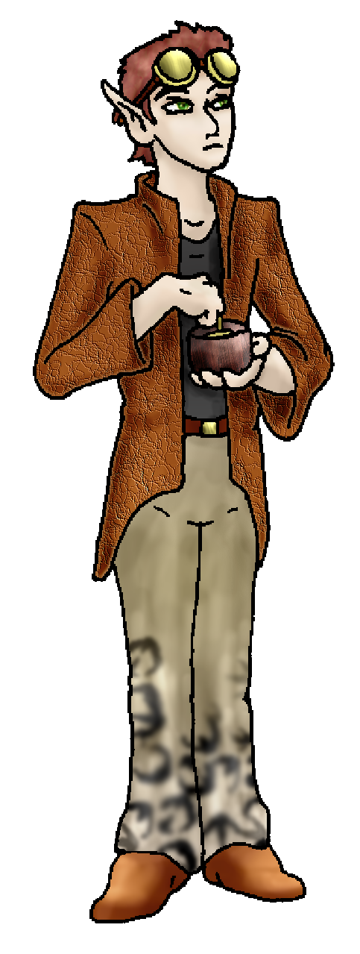
Habits and Places Preferred: Hunting Methods:
Character Sketch
Hair: auburn-brown
Eyes: hazel
Skintone: fair
Bond Beast Personality:
Bond Beast Habits/etc:
BondAnimal
Fur/Skin:
Eyes:

About you as an elf
Your Name Means: Steamer, for lack of any other name, is one of your earliest and easiest powers. The ability to command water vapor to create a blast of hot steam – usually used to power your mechanical creations – is one that extremely few, if any other, elves have.
Your Appearance Is: Average of height and slender in build, you’ve got fair skin that may now and again be smirched by soot, grease, or even explosive dust. Your hair is short, the color of rust, and often held back by brass and leather goggles. Your eyes are a greenish hazel, but are often obscured by those goggles. You choose sturdy leather garments, somehow managing to look tailored by a London shopkeeper rather than an elf.
You Are Located: In the Protector Holt, on the south-east corner of the continent. This land is varied and large, offering many different terrains and climates. Your home is made in a forested area near the ocean, inland just enough to capture plenty of fog every morning, and lose leaves from the trees in the fall and winter time. You live in one of the few constructed homes, created from driftwood, fallen logs and stone with mud and thatch to keep it warm, it houses your living area as well as a large workshop.
Your Basic Statistics Mean: You’re stronger than most elves for your average size, and though you’re healthy enough you wouldn’t want to be stuck out in the wilderness for too long. You’re considered reasonably attractive, using your hands a lot your dexterity is high, and you’re quite a smart elf. Your magical power level is very high.
Your Skills Include: you can count yourself among the more odd elves of the Holt, since you have no recollection of “earth” in so far as the “real thing” is concerned. Your memories of creating machinery and devices, your love and life… those are essentially fabricated from the very internet from which you come. You clearly share language and other interests from the “real” earth, but your’s just isn’t it. A far as your intellectual pursuits go, you tend toward the mechanical and metallurgical lores, with a bit of information about the local plant life and just enough about animals to keep yourself safe from them. Generally speaking, if it’s something that can be built, shaped into an object, or taken apart, you know all about it. You’re adept at discussing things with other elves, less so in understanding the howls and barks or body language of the wolves or cats in the tribe. Your physical skills aren’t shabby at all, you can make your way through the wilderness all right, but generally you only go out to collect ores, work on projects, or set down and pick up trapping equipment. Or of course, gather with your friends. You have a reasonable skill with weaving and hide manipulation, though more often than not you’re going to make it to cover a machine or device, a seat cover and insulation for instance. Your skill with tinkering is aided by your magical powers, and equals that of one or two others in the area – you compete to create steam-driven devices, even including a ridable ‘mount’! You do have the luxury of hot water a lot more often than others (especially since you can create steam or heat without even trying hard) so you’ve developed a taste for different teas and herbal brews. Though you don’t hunt all that often, you use a crossbow with shaped-metal bolts to keep a good distance from your prey in addition to your expertly created and set traps. But you also have been known to be interrupted by a curious tree-climber or aggressive bear – and in the process give them quite a scare with your wrench-weilding (and yelling). Since there are a number of dangers in the Holt that can only be kept at bay by either constant vigilance or extreme violence, you’ve made a device which launches stones at a good clip, powered by steam. It’s rather more like a gatling-gun or cannon than a catapult but it has features of both.
Your Magic Powers Are: You’ve got a typically low ability to detect magic around you – everything elves do with their magic leaves traces of ‘color’ or even ‘scent’ in the air. You don’t really care for the power, it confuses your eyes when you’re working on detailed shaping of your own. You have a strong telepathic Sending power, able to broadcast clearly to many people at once with a good amount of range. The farther away, the fewer people will receive your thoughts. You do have the power to bond to an animal (a wolf, generally) but so far you haven’t found an animal friend. Aside from those things which almost all elves have in common, you’ve got several powers that can be considered unique to you. Like many, you have the power to shape stone. However you use this only to expose the ores within, or move crystal and gems to the surface. You can shape stone into clever shapes, and even difficult gemstones, but it takes a lot out of you to try it. However, once you’ve got metal ores in front of you – there’s no slowing you down. You can create alloys and layered metals, split mixes up easily, and reshape almost anything that’s made of pure metals. A forearm-length bar of ore might take you an hour at most, to shape magically into a tool or weapon. You also have the very minor ability to shape or sense through water, but that power is used in combination with your (equally minor) fire-starting power. With those combined, you have a unique “Steam shape” power, you can cause a gout of extremely hot water, steam, or even slightly cooled into fog or mist, at a reasonable distance. You can also heat up bodies of water very quickly this way, though watch out, because you’ve boiled things by accident that way! With your fire-starting ability you can cause any dry flammable object like leaves, tinder or dry grass to ignite. And with strong concentration, you can summon water to put out small flames too, though again these low-level powers wear you out a lot more than your odder, specific ones. Then… you have the ability to Pause Time. That’s right, you can freeze things in a moment of time, directly around you. It doesn’t actually stop time, but to anyone around outside your sphere of influence, they will see everything as though it’s slowly flickering: like a badly spooled movie frame, or like ‘bullet time’, whatever that is. While other people, creatures, even weaponry in mid-flight are all “paused” you can still think but you cannot really move either. You can hold this up for half an hour or so, before you will become exhausted. In that time however, you can still Send – getting help for someone if they’re falling off the edge of a cliff, for instance; making sure there’s a healer nearby if someone has been mauled, that kind of thing. This power was first used by you when your first experimental engine was about to explode. Parts – everywhere. ☺
Your Bond Animal Is: you don’t currently have a bond-animal, but there are always plenty of chances to find a wolf cub, puma kitten or even a deer or porcupine if you so desire…
Special Information: Mesmer’s concoctions are entertaining to you, but you’ve got a collection of distantly-grown herbs and flowers that some plant-shapers help keep growing for your teas. Though you don’t fancy yourself an herbalist, others have said that your mixes of teas and relaxing soups are quite good!
You are known as a Longdays (Summer/Thirdsign) elf, with the constellation of the Falling Star in the night sky. Elves of this ‘zodiac sign’ are represented by the Rabbit, the color light green, the useful Wide-Boll tree; they also show Humor, Sensuality, Creativity, Generosity. You don’t have to be born or arrive to the Otherforest to have this ‘sign’, it’s just a personality generalization.

"Cuddles" <cuddles@flowerseatshit.com> Fri, 14 Dec 2007 18:04:37 -0500

Still not sure what this is, but I figure, "nothing ventured, nothing gained." I trust I filled this out properly?

Professor Charles Winthrop III, Esquire Steampunk Charlie CoH
July 26, 1852 31 cuddles@flowerseatshit.com

Male Donâ€™t ask weird things!
To keep your sexuality to yourself Donâ€™t ask that!
You are: (CHOOSE) WAS in a solid relationship (if I could just find her again!)

Appearance Stuff (I need at least a few of these) Youâ€™re about how tall? 5'6" The Same
Your build is? Thin unchanged
Hair Color? Auburn No Changes
Hair Style? Slightly wavy No Change

Hair Length? Nape length No Change
Eye Color? Hazel Change to what? No change
Glasses? On/Need em!
Skin Tone? Pale Change? (CHOOSE)No
* Consider how you feel about yourself and how others may view you.
Answer yes or no, and then choose your changes if any.
Are you â€˜Attractiveâ€™? Decently Change?No
Are you â€˜Strongâ€™? FairChange?No
Are you â€˜Smartâ€™? Fairly intelligent.Change?No
Are you â€˜Nimbleâ€™ or 'Agile'? NimbleChange?No
Elegant ears please.
Where do you like living? (Choose as many as you like)Around Many People
Bustling City
Climates you like (choose as many as you like, list what you really
don't like in the 'other' section!):Seasonal Foggy
Terrains you like (choose as many as you like, if you really don't like
something say so too):Sea Level River
What You Want Out of Lifeâ€¦ (choose as many as you like! list what you
really don't like in the 'other' section!) Build and Construct
Learn Give advice and listen Surround yourself with technology
Fiddle with toys and tools
* Favorites:
Colors - Brass and Old Leather

Other info (anything left out, anything important you want to share):
Do you have any Fears and Hates?
Just the fear that I'll never find Mary again.
Any people youâ€™d like to have with you? (supply them the link!) Just Mary.

Stock used: old hut 2 stock by Tuku stock; my pic of time machine; propellar 2 by FoxStox

