NAME: Black Bear HOLT: Protector SOUL NAME: (chris) EARTHNAME: Chris G
MATE: Chinook CHILDREN/RELATIVES: (coh)
MATURITY: Young adult REAL AGE: 4.6.81/27 YEAR/PORTAL OF ARRIVAL: 122/Hall SEX: Male

STR: 14 CON: 14 SIZ: 7 INT: 14 POW: 18 DEX: 19 APP: 15 Total: 101
SKILLS MAGIC POWERS WEAPONS / ARMOR / BOND ANIMAL
language memory: 38 % magic feeling: 36 % attack with long spear (metal) : 86 %
animal lore: 66 % sending: 72 % damage 1d6+4 cutting/impale parry: 66 %
elf lore: 42 % wolf bonding: 72 % attack with knife (metal) : 66 %
healing lore: 38 % healing: ___% damage 1d3 cutting/impale parry: 66 %
mechanical lore: 56 % (anti-heal: ___% missile crossbow/bolts (medium) : 76 %
mineral lore: 64 % (flesh shape: ___% damage 1d6 impale range long
plant lore: 38 % (shielding: ___% missile___________________________________: ___%
world lore: 38 % plant shape: ___% damage___________________range______________
communicate: 68 % rock shape: 64 % missiles carried__________________________________
wolf/anim comm: 64 % (metal shape: 46 % shield_________________________________use: ___%
perception: 72 % (gem shape: ___% armor type______________elem:___bash:___cut:___othr:___
stealth: 74 % bone shape: ___% supplies carried / other skills / etc
climb: 72 % water shape: ___%
dodge: 78 % firestart: ___%
jump: 76 % levitation: ___%
swim: 56 % finding: ___%
throw: 66 % animal sense: 36 % BOND ANIMALname: varies species: cat, wolf sex:
manipulate: 57 % mindsnare: ___% STR: CON: SIZ: INT: POW: DEX: APP:
ride wolf: 76 % hypnosis: ___% climb: ___% jump: ___% swim: ___%
hunt: 86 % astral projection: ___% stealth: ___% dodge: ___% percp: ___%
tinker/weapons: 66 % deep sensing: ___% comm: ___% ______:___% ______:___%
dance/music: 68 % self shaping: ___% attack____________:___% attack________________:___%
tracking: 74 % :___% disposition
trapping: 86 % :___% magic or other abilities
literacy: 52 % :___% natural armor:___________elem:___bash:___cut:___othr:___
Personality Notes: Lives in a...:
Likes and Dislikes: Friends:
Habits and Places Preferred: Hunting Methods:
Bond Beast Personality:
Character Sketch
Hair: dark brown
Eyes: dark brown
Skintone: fair
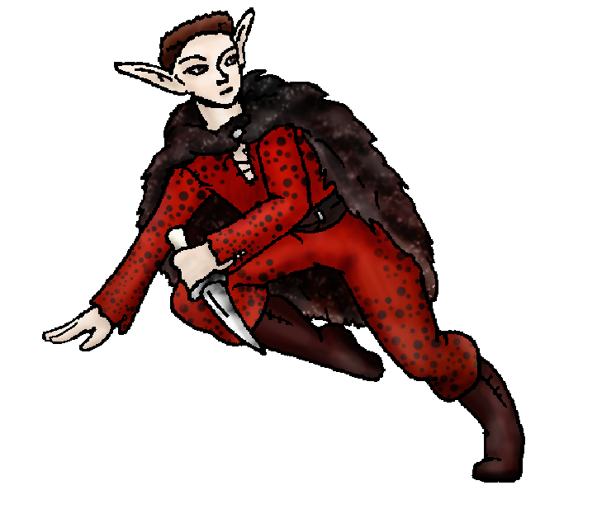
Bond Beast Habits/etc:
BondAnimal
Fur/Skin:
Eyes:

About you as an elf
Your Name Means: BlackBear is your first kill on this world, and more impressively you did it with literally the bone knife that your mate had provided you moments before. Who knew you’d accidentally come across the bear’s cached meal? Well meat and bone would have been all you’d be now, but you stood up to the massive creature. You wear its pelt – others share this fur too but only you have the thickest, heaviest bits.
Your Appearance Is: Very tall, imposing and with the look of someone who means business. You have fair skin, with short, dark brown hair, and intense dark brown eyes. Your cloak is described above, but you also wear a russet-red shaded naturally-spotted leather outfit – from another of your own excellent hunts. Folks wonder why your longer ears don’t get chilly up there where you and Chinook live…
You Are Located: In the Protector Holt, down in the south-east corner of the land; you and Chinook live up in the isolated, chilly North Peak. Under tons of stone, shaped by expert hands – yours included – you know that this tall, wedge-shaped den is safe. It has an entrance for your flying mate up top, but also another back way in through a series of wonderful caverns within the Peak itself. Some of those caverns connect to other dens, but they are quite distant, and it’s utterly dark inside them. Your den has two work spots – one for Chinook and her wicker weavings, and another for you to work with metals and stone equipment.
Your Basic Statistics Mean: Big, tall, healthy and rugged looking! You’re about average in intelligence, and above average with dexterity and magical power.
Your Skills Include: You have a fairly high memory of Earthly things, which you use mainly to create traps, gears and the like – you and several others could probably recreate many items like transportation and engineless carts if you put your work together. Because you enjoy tinkering you’ve got a good grasp of mechanics as well as metallurgy, knowing how to coax metal magically out of the stone is one thing, but putting it to good use is another! You have a strong ability with treating animals and with the respect and care they deserve. Yes, you hunt them, expertly, but you also know when not to hunt them. You hunt well with many different weapons, but your favored hunting tools are a crossbow for large, distant prey, a long metal-tipped spear for close up work, and a small metal and bone knife modified from the original bear-killer you had. Any time you need to hunt, there’s no issue with trekking around the hillsides and caverns; you can escape notice very well too. You are good at making and using traps, prefering small quick-killing traps which allow for different prey during the year. You can easily repair them, and you also enjoy helping repair and create weapons for other people, mostly metal ones. Like many in the Holt you’re literate to a reasonable degree, though you’re often kept more or less busy with tinkering – plans are a good use for this skill. While you might be considered a tough, imposing elf in general, you’ve got a great sense of humor, and can enjoy both mental jokes and physical pranks when they’re harmless.
Your Magic Powers Are: You have an average ability with Magic Feeling, knowing who shaped what item when it’s handed to you. You use this to recall who to give it back to when you’re finished fixing it. Your Sending, telepathic speech, is average, you use it infrequently, prefering one on one mind-speak to big groups though in hunting situations you know it’s vital to send to the group where you are or what you see. While you’re gruff on the outside, you have a warm, friendly mental voice. You have a good ability with wolf-bonding, however you and your mate already have three ‘petlike’ bonds between you, two felines and one dog-wolf. Aside from those things you have the ability to sense animals nearby, this is the weaker of your powers but probably just as useful as any other. You can pinpoint an animal who’s fallen into a trap, provided it’s within your magical range. You tend to search with your mind as well as your senses, while you’re out collecting from traps. You also have two related and reasonably strong powers: Rock Shaping and Metal Shaping. You use the rock shape for larger things like hollowing out natural caves, smoothing walls, and separating ore from stone. Once you’ve got the stone moved away from the valuable metal, you can start shaping it with your metal-shape power. You can shape a fist-sized chunk of stone in around 20 minutes, while a similarly sized bit of metal would take you several hours. Metal is harder to shape, though once it’s been shaped, it does tend to go more easily.
Your Bond Animal Is: You’ve got three animals, two felines and a wolf-dog who isn’t quite part of the Pack down under the towering mountain. I don’t know enough about the animals to describe them – but basically they’re much bigger than they had been (big enough to ride) and essentially look like ‘mountain lions’ and ‘wolf’ versions of their earthly shapes.
Special Information: You and your mate are one of the few pre-existing couples here in Protector Holt. Others might arrive, and certainly other couples may form here and there. But you’re lucky to already have found the right one. ☺
You are known as a Deathsleep (Winter/Seventhsign) elf, who sees the star pattern “Arrowhead” in the night sky during this time of year. Elves of this ‘zodiac’ sign don’t have to be born or arrive to the world in this season, it’s a personality trait thing. They’re represented by the Longtooth cat, the color Black, and the elusive but beautiful Orchid. They tend to be Canny, secretive, Dangerous, Flirtatious.

Date: Mon, 08 Jan 2007 15:57:00 -0500

Necessary Stuff
Your Full Name: Chris ---> Audrey's Hubby Nickname or Title G Birthday 4-6-1981 Act HOW Old? 60!
Your Gender male, You like it this way
You Prefer the opposite sex
You are in a solid relationship

Appearance Stuff
You're about 6 feet tall, and you'd like to be taller
Your build is average and you'd like to be healthier
Hair Color dark brown Change? none
Hair Style/Curl high n tight Change? none
Eye Color blue Change? no Glasses? off
Skin Tone pale Change? none
Are you 'Attractive'?yes Change? none
Are you 'Strong'? yes Change? none
Are you 'Smart'? yes Change? none
Are you 'Nimble'? yes Change? none
You'll be getting pointy ears - you want them medium

Circle (likes) or Cross Out (dislikes)
Where do you like living? fewer people alone old friends isolated village

Climates you like chilly cold snow/sleet dry

What You Want Out of Life rough it/camp joke slack off hunt isolate yourself read raise pets and animals surround yourself with technology
retire early and relax

Other:

Favorites...
Colors Red / Black
Animals All
Music/Bands All
Foods Steak
Sports if any None
Time of Day evening
Season winter

Fears and Hates Dislikes stupid people

Any pets you'd like to drag along? Same as Audrey
Any people you'd like to have with you? (supply them a sheet!)Audrey :)

