NAME: Séance HOLT: Protector SOUL NAME: (cres) EARTHNAME: Crestent
MATE: CHILDREN/RELATIVES: (coh)
MATURITY: Young REAL AGE:5.12.91 YEAR/PORTAL OF ARRIVAL: 122/Hall SEX: male

STR: 13 CON: 14 SIZ: 5 INT: 17 POW: 20 DEX: 21 APP: 16 Total: 106
SKILLS MAGIC POWERS WEAPONS / ARMOR / BOND ANIMAL
language memory: 34 % magic feeling: 60 % attack with long spear (wood) : 68 %
animal lore: 44 % sending: 110 % damage 1d6 impale parry: 58 %
elf lore: 61 % wolf bonding: 80 % attack with________________________________: ___%
healing lore: 68 % healing: 80 % damage_______________________________parry: ___%
mechanical lore: 34 % (anti-heal: ___% missile thrown hand-club (wood) : 78 %
mineral lore: 34 % (flesh shape: ___% damage 1d3 smashing range short
plant lore: 44 % (shielding: ___% missile___________________________________: ___%
world lore: 51 % plant shape: ___% damage___________________range______________
communicate: 76 % rock shape: ___% missiles carried__________________________________
wolf/anim comm: 74 % (metal shape: ___% shield_________________________________use: ___%
perception: 80 % (gem shape: ___% armor type______________elem:___bash:___cut:___othr:___
stealth: 82 % bone shape: ___% supplies carried / other skills / etc
climb: 78 % water shape: ___%
dodge: 82 % firestart: ___%
jump: 100 % levitation: 60 %
swim: 68 % finding: ___%
throw: 68 % animal bond: ___% BOND ANIMALname: Freckle species: wolf sex: m
manipulate: 63 % mindsnare: ___% STR: CON: SIZ: INT: POW: DEX: APP:
ride wolf: 84 % hypnosis: ___% climb: ___% jump: ___% swim: ___%
hunt: 82 % astral projection: 120 % stealth: ___% dodge: ___% percp: ___%
drawing/painting: 73 % deep sensing: ___% comm: ___% ______:___% ______:___%
dance/music: 68 % self shaping: ___% attack____________:___% attack________________:___%
aerial/astral nav: 78 % :___% disposition
trapping: 82 % :___% magic or other abilities
literacy: 51 % :___% natural armor:___________elem:___bash:___cut:___othr:___
Personality Notes: Lives in a...:
Likes and Dislikes: Friends:
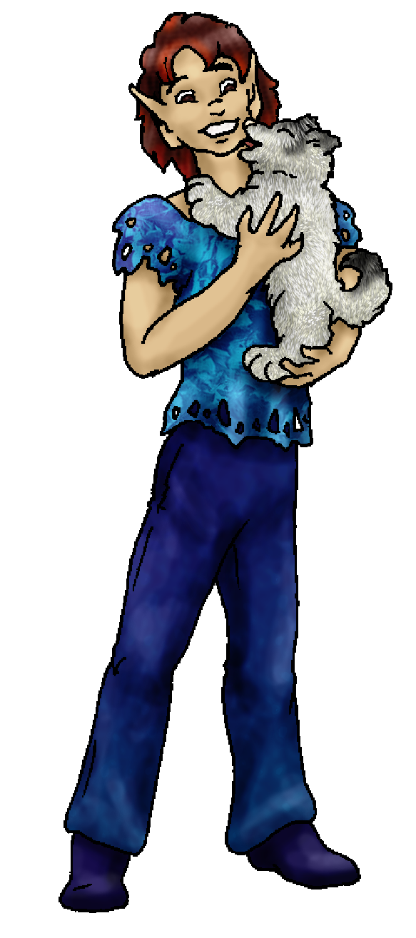
Habits and Places Preferred: Hunting Methods:
Bond Beast Personality:
Character Sketch
Hair: red-brown
Eyes: brown
Skintone: light tan
Bond Beast Habits/etc:
BondAnimal
Fur/Skin: white, bk marks
Eyes: blue

About you as an elf
Your Name Means: Séances are gatherings of ghosts and people who want to see them. In your case, it’s more the other way around – you’re the ghost! See below for more information on your powers.
Your Appearance Is: Average in height and build, you’ve got lightly tanned skin, rich reddish-brown short fluffy hair, and dark brown eyes. Almost always you’re seen with a broad smile on your face. You choose soft finely woven cloth shirts artistically dyed, and soft leather pants to match.
You Are Located: In the Protector Holt which is deep in the south-east of the continent, a wide land filled with many different locations and climates to visit. The location which suits you the best is an outlet of a river, which turns to a broad delta opening out into the big Bay. Though there are a few people right nearby, everyone is so spread out that it takes some work to get everyone together. Your den is an enjoyable half-shaped half-constructed stilt home, its ‘legs’ are living trees which have been shaped to remain at their current height, some two elf-heights above the surface of the water (during the rainy season this goes down to one height above!), while the rest of the home is made from dead driftwood, thatch, and adobe. The interior is decorated by your own hand, and there are a couple other artists in the Holt who contribute – Vellum lives almost directly above your home, high up where the waterfalls start, and she makes thin paper for you and others to draw on.
Your Basic Statistics Mean: You’re average in build and size, though you’re stronger than many, and considered handsome by most. You are talented with both your hands and your mind, but you’re also strongly above the curve in terms of your raw magical power.
Your Skills Include: You’ve got a typical memory of Earthly things, able to remember in fits and starts but largely you don’t concentrate on those things. Instead you’re largely about elves, what they do, how to help them, and where they live. You know enough about the animal life as well as the local plants to avoid the dangerous ones, and eat the good ones. You have learned a lot by flying overhead, about the terrain and particularly how the winds and seasons affect the Holt. You’ve got keen eyesight, able to pick out small details in a busy moment. Your survival and physical skills are strong, particularly your ability to leap and land where you wish to – your flight power helps there. You more prefer to catch prey by trapping it, since hunting brings you into more danger than you care to be in – as a healer however you’ve often attended hunts in order to make sure no one gets harmed. Since your home is over the river, you’ve got easy access to plentiful and varied fish and bird game. However you do hunt with a long spear keeping you at a good distance from prey, and are able to throw small wooden clubs (such as you’d find on a boat, pins – and the pirates have an endless supply of these things) which stun small animals. Like many in the Holt, you’re literate to a reasonable degree, though you don’t spend as much time writing and reading as you do with drawing and painting. Quite skilled with the natural pigments you can distill out of plants, or rocks – but also you trade fish and game for supplies with those who can create them. One thing that you do very well is navigate around the Holt in the air. From overhead the place is stunning, and you do spend a lot of time that way. Both in your body and out of it, you know where to find people by glancing around the lush forests or windblown plains.
Your Magic Powers Are: You’ve got a naturally strong ability with Magic Feeling – it allows you to see auras around people as well as objects which have been magically shaped. You can tell who made something, when, and even if there was another power being used at the time, by looking over an object carefully enough. Your telepathic Sending power is extremely strong, you use this constantly to keep in touch without having to travel a lot. Your mind is not sensed as huge and booming, instead your mind-voice is heard more to be the eerie echo of many voices in unison, ghosts on the wind. Your Sending range is very strong, over one hundred miles. You’ve got a strong power to bond with a wolf, which has granted you a magical companion – or is he something else? See below! In addition to your typical powers, you’ve also got a few that are used. You are a healer, though there are stronger ones in the Holt you’ve got the power to mend broken bones, heal internal injuries, and burns. You often are asked to deal with injuries to people’s heads and skulls – because spiritually you’re more aware of any danger that they might be in outside of the visible. You’ve got a good ability with Flight, able to stay in the air for hours due to your strong raw power. It aids you when you need to get out of the way of an incoming animal or threat, though you tend not to lift other things and aren’t as strong as some when it comes to levitating yourself plus more weight. In a pinch, you could, but it wears you out more than usual. Your strongest power, and by far one of the single most powerful pieces of magic in the whole Holt, is that of Astral Projection, or “Far Sending”. With this power, you throw your spirit outside of your body, and fly freely almost anywhere you wish. Your range is huge, more than a thousand miles easily – you can talk to the other far-senders in both Dare’s Valley to the north, and the Southern Holt which is as far west as the vally is north. Normally your body is vulnerable when people use this power, however you’re actually able to keep closer attention to yours and even spring it to action if something threatens it – even without actually having your spirit anywhere close to it. Also, another thing unique to you is that while others appear only to elves or powered sentient life forms (there are a couple out there), you are able to be seen by any creature, not just ones with magical vision. Thus: you’re a ghost to many as you drift on by. Now, this is something you can concentrate on, not being seen sometimes is more important than being noticed after all. Spying? Well, maybe. But there are people in the swamp and nearby plains that are a threat to your tribe, as well as strange and dangerous spider-things living in the East Peak’s shadow. Spying on them has saved lives.
Your Bond Animal Is: Freckle is apparently a newly born version of your pet from home. Greyish-ivory fur with black markings, he seems very happy to see you. Whether he remembers you from your old Earthly life or not, he’s with you now.
Special Information: With the distance that you can get on your Astral form, you and others made sure that the way south from Dare’s Valley was safe. Since you’ve got such a strong ability people often call upon you to send distant messages, even just among the tribe. All they really have to do is think hard about you, and you’ll know it.
You are known as a Whitecold (Late Winter/Eighthsign) elf, with the star-pattern of the Hunter in the night sky. Represented by the Wolf, the color White, and durable Evergreens, elves of this nature are seen as Eventempered, balanced, and filled with Wisdom, Comfort.

crestent@icqmail.com Add to Address BookAdd to Address Book Add Mobile Alert
Subject: Elf Survey Form
Date: Tue, 20 Mar 2007 11:59:12 -0400

Necessary Stuff
Your Full Name: Crestent Nickname or Title Cres Birthday May 12th 1991
Act HOW Old? 15
Your Gender male, You like it this way
You Prefer the opposite sex
You are in single and loving it

Appearance Stuff
You're about 5.6 feet tall, and you'd like to be taller
Your build is Normal and you'd like to be healthier
Hair Color Brown Change? mixture
Hair Style/Curl Short Change? longer
Eye Color Brown Change? Glasses? off
Skin Tone White Change? darker
Are you 'Attractive'?yes Change? prettier
Are you 'Strong'? no Change? stronger
Are you 'Smart'? yes Change? brilliant
Are you 'Nimble'? sort of Change? everything
You'll be getting pointy ears - you want them elegant

Circle (likes) or Cross Out (dislikes)
Where do you like living? alone old friends quiet neighborhood isolated
village

Climates you like warm foggy cloudy sunny flatland plains hilly beach
river forest grassy

What You Want Out of Life see the world heal the sick find a soul-mate
draw/create slack off fly like an eagle give advice and listen snuggle
in front of a warm fire retire early and relax

Other:

Favorites...
Colors Blue
Animals Dolphines
Music/Bands
Foods Spaghetti and English Fish and Chips
Sports if any
Time of Day evening
Season spring

Fears and Hates Being alone at night in a Cathedral

Any pets you'd like to drag along? My dog Freckles who is a Spitz Mixed with American Eskimo dog I beleive and if you can't find those just think of a white wolf
Any people you'd like to have with you? (supply them a sheet!)

Stock used – midnightstouchstock overhang2

