NAME: Sandfox HOLT: Protector SOUL NAME: (dano) EARTHNAME: Daniel Luedke
MATE: CHILDREN/RELATIVES: (coh)
MATURITY: Adult REAL AGE: 8.17.75/33 YEAR/PORTAL OF ARRIVAL: 122/Hall SEX: Male

STR: 11 CON: 13 SIZ: 6 INT: 15 POW: 18 DEX: 20 APP: 14 Total: 97
SKILLS MAGIC POWERS WEAPONS / ARMOR / BOND ANIMAL
language memory: 25 % magic feeling: 36 % attack with long staff (wood) : 62 %
animal lore: 45 % sending: ** 82 % damage 1d8 smashing parry: 62 %
elf lore: 60 % wolf bonding: 72 % attack with________________________________: ___%
healing lore: 30 % healing: ___% damage_______________________________parry: ___%
mechanical lore: 30 % (anti-heal: ___% missile hand crossbow : 72 %
mineral lore: 40 % (flesh shape: ___% damage 1d4 impale range medium-long
plant lore: 30 % (shielding: ___% missile___________________________________: ___%
world lore: 30 % plant shape: ___% damage___________________range______________
communicate: 68 % rock shape:* 18 % missiles carried__________________________________
wolf/anim comm: 66 % (metal shape: ___% shield_________________________________use: ___%
perception: 74 % (gem shape: ___% armor type______________elem:___bash:___cut:___othr:___
stealth: 76 % bone shape: ___% supplies carried / other skills / etc
climb: 72 % water shape: ___%
dodge: 76 % firestart: 72 %
jump: 62 % levitation: ___%
swim: 54 % finding: ___%
throw: 62 % animal bond: ___% BOND ANIMALname: Burny species: Greater wolf sex: f
manipulate: 60 % mindsnare: ___% STR:19 CON:13 SIZ:20 INT:10 POW:15 DEX:16 APP:14
ride wolf: 80 % hypnosis: ___% climb: ___% jump: ___% swim: ___%
hunt: 76 % astral projection: ** % stealth: ___% dodge: ___% percp: ___%
sand building: 70 % deep sensing: ___% comm: ___% ______:___% ______:___%
dancing: 68 % self shaping: ___% attack____________:___% attack________________:___%
music/sing: 64 % *sand shape: 36 % disposition
trapping: 76 % **sense through: 64 % magic or other abilities firestart 30%, plant shape 15%
literacy: 60 % :___% natural armor:___________elem:___bash:___cut:___othr:___
Personality Notes: Lives in a...:
Likes and Dislikes: Friends:
Habits and Places Preferred: Hunting Methods:
Bond Beast Personality:
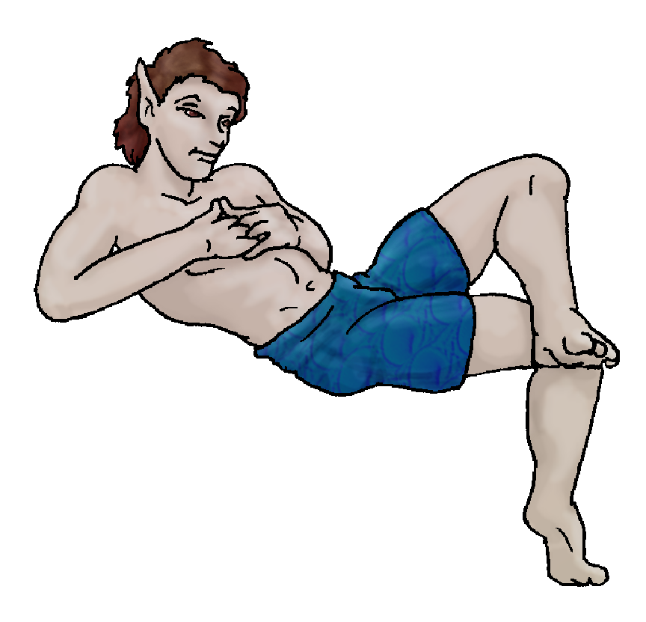 Character Sketch
Hair: brown
Eyes: brown
Skintone: medium-tan
Bond Beast Habits/etc:
BondAnimal
Fur/Skin: Red with cream mks
Eyes: 1 red, 1 green

About you as an elf
Your Name Means: Sandfox is your name because of your enjoyment of dunes, sand and your power over the substance. If you don’t want to be seen among the scrub brush and sandy soil of the surroundings, you simply won’t be seen.
Your Appearance Is: Tall and somewhat bulky, with deeply tanned skin and tussled brown hair. Your eyes are quite dark brown, and you frequently are seen in basically swim trunks to enjoy the warmth of the sun. You have other clothing, but aside from putting on sandals for those extra hot days, you don’t see the point.
You Are Located: In the south-east corner of the continent is the Protector Holt, home to many elves. Your den is in the scrublands near the inland sea, where the warmth of the sun keeps the sticky wet air away easily. Your home itself is shaped from stone, you made it yourself with a bit of effort, and pretty much every day have to move the sand from the entrance (along with the snakes, sand-lizards, and anything else that’s taken up residence in the cool of evening).
Your Basic Statistics Mean: Average in health and strength, you’re a bit bigger than typical for elves, reasonably attractive, and far above average in physical nimbleness. You’re above average in intelligence, and magical power.
Your Skills Include: You’ve got a typically low memory of Earth, enough to start a conversation but hardly more than that. Conversations are where you’re at, enjoying your contact with those around you, but also happy enough to be on your own. You can tell a poison sticker bush from an edible berry but you would more rely upon fresh-cooked meats and food from gatherings. You are geared well to your chosen environment, happy to slide around on fairly even ground rather than leaping around treetops and cliffs. You can hunt adequately well with a staff, but it’s easy to use a small crossbow for quick hunting at a distance. Running in the heat of summer is not the best of ideas, after all. Also you set plenty of small game traps, there are so many little, quickly cooked animals in this area. You enjoy creating interesting things from the loose sand in your den’s area, and occasionally you manage to put together what equates to a massive elfin sand-estate. This is helped by your magic, which serves to keep the loose sand cohesive like it’s wet. Like many of the elves in this Holt you’re literate to a reasonable degree, you keep notes about things you’ve daydreamed, and sometimes share them with those who can visualize or use a power to create images with you, for story telling.
Your Magic Powers Are: Your innate ability to detect where magic has been used is fairly average, Magic Feeling is a power you’d use rarely anyway. Your telepathy, Sending as it’s known, is pretty strong, and used often to initiate another power (see below). You have a good wolf-bonding ability which has attracted a Greater wolf as your bond. Aside from those things, you’ve got an unusual assortment of powers. The strongest of them is Fireshaping, which you use not just to start a cook fire, but to control burns and make sure that huge wildfires don’t go burning the whole Holt down – starting and putting out brushfires to keep the dry brush to a minimum. You’ve got a bare minimum of the ability to shape Rock, which you can concentrate hard upon to get something useful shaped or fix up a stone item which has been shaped before. But a side-power, one which you’re pretty sure is unique to you, is that of ‘Sand Shaping’ which allows you to move volumes of the loose dirt, sand and small particles (dust?) around and create solid shapes which last quite some time. It is as though you magic creates a kind of cement, and makes the sand stick together better. You can carve it almost like soft wood, using almost any tool, and with this you can create some very interesting large constructions! It can’t be used to make weapons or mobile things, but you can use it to create a pit trap and cover it easily with a thin sheet of sand that collapses with whatever weight you choose. You also have an interesting form of Sending that combines a bit with Astral Projection (which you did try once – just once, and it disoriented you so much because it was like losing your body and flying, and that just didn’t make you feel safe). You can Send to someone and with their permission, you can see through their eyes! You can also do this with animals – particularly your wolf-friend who is well-tuned to your thoughts. It’s a little weird, at first, because you have to get used to the distance to the ground depending on whether it’s an elf or animal. But with this power you can detect things that others might miss while in your territory. You cannot use your other powers while doing this, nor use the elf’s that you’re hitching onto, but you’ve gotten pretty good at snapping back to yourself quickly and reacting in a timely way if there’s something coming.
Your Bond Animal Is: Burny is a large, fairly clumsy but reasonably pretty wolf – a Greater Wolf, one who has strong elf-blood in her history. She has one red eye and one green, seemingly showing her two sides. She is among those Greater wolves who can use magic, like her elfin ancestors, and hers are greatly reflected in her eyes: she can shape fire, and plants. Neither to a huge degree but she definitely can assist you when you’re on your fire patrols. She’s mostly red in color, with cream belly and markings on her paws, face and tail tip. Yes, she got her name by accidentally burning things.
Special Information: You’ve heard (and seen on a map or two) that there is a massive dune desert on the other side of the world from here. You’re not sure how, but you would really like to go visit that place, and see what the sand there is like…
You are known as a Hotdays (Late Summer/Fouthsign) elf, with the star pattern “Lightning Bolt” in the evening sky that time of year. Elves of this ‘zodiac’ sign are represented by the burly Bear, the color Yellow/Gold, and the Longstem grass of the season. Elves born or arrived, or just represented by this ‘sign’ often show Laziness, Nettling personalities, but also show Stealth, and give Hope to others.

Date: Fri, 05 Jan 2007 18:25:53 -0500

Necessary Stuff
Your Full Name: Daniel Luedke Nickname or Title Dano Birthday 08-17-1975 Act HOW Old? 31
Your Gender male, You like it this way
You Prefer the opposite sex
You are in single and hating it

Appearance Stuff
You're about 5'9" feet tall, and you'd like to be taller
Your build is Heavy and you'd like to be healthier
Hair Color Brown Change? none
Hair Style/Curl Side part Change? longer
Eye Color Brown Change? No Glasses? off
Skin Tone medium Change? none
Are you 'Attractive'?no Change? prettier
Are you 'Strong'? no Change? stronger
Are you 'Smart'? yes Change? none
Are you 'Nimble'? no Change? everything
You'll be getting pointy ears - you want them elegant

Circle (likes) or Cross Out (dislikes)
Where do you like living? alone busy town quiet neighborhood

Climates you like warm hot sunny dry scrubland grassy desert

What You Want Out of Life joke bask in the sun find a soul-mate slack off raise kids read give advice and listen retire early and relax

Other:

Favorites...
Colors Blue
Animals Dog
Music/Bands Jimmy Buffet
Foods Mexican
Sports if any Baseball
Time of Day midday
Season summer

Fears and Hates Heights

Any pets you'd like to drag along?
Any people you'd like to have with you? (supply them a sheet!)

