NAME: Didgeridoo HOLT: Protector SOUL NAME: (demilion) EARTHNAME: Aaron Hays
MATE: CHILDREN/RELATIVES: (coh)
MATURITY: Young adult REAL AGE: 8.3.84/24 YEAR/PORTAL OF ARRIVAL: 122/Hall SEX: Male

STR: 13 CON: 15 SIZ: 6 INT: 16 POW: 18 DEX: 18 APP: 14 Total: 100
SKILLS MAGIC POWERS WEAPONS / ARMOR / BOND ANIMAL
language memory: 26 % magic feeling: 40 % attack with two handed staff (wood) : 72 %
animal lore: 48 % sending: 82 % damage 1d8 smashing parry: 62 %
elf lore: 48 % cat bonding: 72 % attack with________________________________: ___%
healing lore: 32 % healing: ___% damage_______________________________parry: ___%
mechanical lore: 42 % (anti-heal: ___% missile thrown knife (metal) : 82 %
mineral lore: 42 % (flesh shape: ___% damage 1d3 impale range short
plant lore: 58 % (shielding: ___% missile___________________________________: ___%
world lore: 32 % plant shape: 46 % damage___________________range______________
communicate: 70 % rock shape: ___% missiles carried__________________________________
animal comm: 62 % (metal shape: ___% shield_________________________________use: ___%
perception: 82 % (gem shape: 20 % armor type______________elem:___bash:___cut:___othr:___
stealth: 72 % bone shape: 74 % supplies carried / other skills / etc
climb: 60 % water shape: ___%
dodge: 72 % firestart: ___%
jump: 62 % levitation: ___%
swim: 62 % finding: ___%
throw: 72 % animal bond: ___% BOND ANIMALname: Pawpaw species: mt lion sex: f
manipulate: 74 % mindsnare: ___% STR:19 CON: 12 SIZ: 22 INT: 11 POW: 17 DEX: 19 APP: 13
ride big cat: 72 % hypnosis: ___% climb: 70 % jump: 74 % swim: 38 %
hunt: 72 % astral projection: ___% stealth: 68 % dodge: 72 % percp: 68 %
carving/crafting: 66 % deep sensing: ___% comm: 60 % ______:___% ______:___%
artistry: 72 % self shaping: ___% attack claw, claw, rake: 74 % attack bite : 64 %
music/sing: 74 % :___% disposition
trapping: 72 % :___% magic or other abilities
literacy: 64 % :___% natural armor:___________elem:___bash:___cut:___othr:___
Personality Notes: Lives in a...:
Likes and Dislikes: Friends:
Habits and Places Preferred: Hunting Methods:
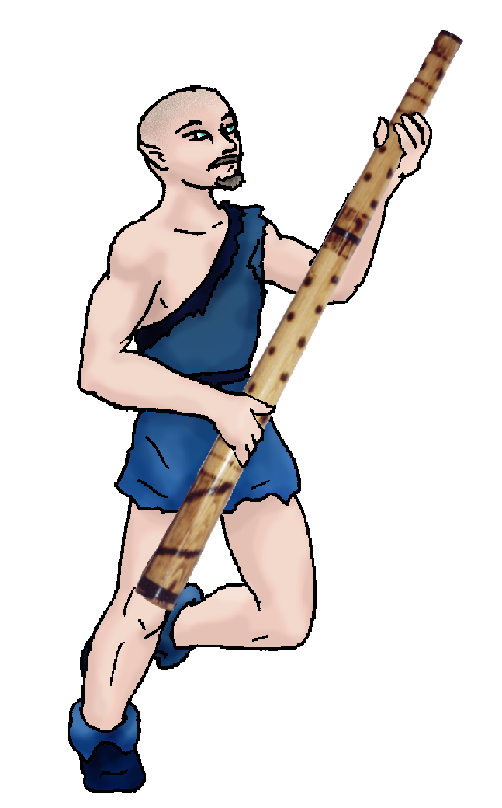
Bond Beast Personality:
Character Sketch
Hair: brown
Eyes: blue
Skintone: fair
Bond Beast Habits/etc:
BondAnimal
Fur/Skin: tan, brown, bk mks
Eyes: yellow

About you as an elf
Your Name Means: It’s fairly hard to miss, your name is extremely odd even for elves. The large, amazingly loud didgeri that you play (and make for others willing to try) is the source of your name as well as most of your talents.
Your Appearance Is: Fair skinned, reasonably burly in size, you choose to keep your brown hair all but gone, however you do sport a short mustache and beard. Your eyes are sky-blue, and you’ve got short ears for an elf. You choose to wear simple dark blue colored leather tunic and soft leather boots in the same shade, it’s warm enough where you are living that you don’t need to worry about bundling up a lot.
You Are Located: In the Protector Holt, far to the south-east in the big continent, your den itself is in a rather wet zone, which is nice because your plant shaping has a field day here. Your den is made near a wetland, though not in it and not soggy either. Created from long, bamboo-like planks and shaped roots, it’s a maze of walls and nooks. Almost every wall has something drawn on or carved into it, the wood having been shaped ‘dead’ by your hand to make sure that it doesn’t harm the plant.
Your Basic Statistics Mean: Strong, large and healthy! No one could mistake you for a weak elf, that’s for sure. You’re considered pretty good looking by most accounts, and smart enough to create some extremely interesting stories. You’re agile enough to get around, and certainly have strong manual dexterity with which you create artistic works as well as craft your instruments. You have an average magical power.
Your Skills Include: You’ve got a typical memory of things from Earth, and though you probably didn’t realize it your name and music comes straight from Australia. The lores which elves use to examine animals, figure out who’s who, get around the world, and understand the world around them are all average, you’re a bit better with plants than some. You can communicate easily whatever you need to convey, and use your artistry to do many things: draw, paint, carve, make larger objects, as well as reading and writing in the language which Talon at Dare’s Valley taught you. In general you’re a ‘creator’ rather than a ‘collector’ – you prefer to make your own tools, using them for the needs of others. Traps and simple weapons are used when you must hunt, from rope nooses and leg-traps all the way to swinging counterweights. You hunt with a staff that had originally begun as another didge, but it just wasn’t cooperating. While you often smash a larger animal down with it, you also hunt with small, quickly tossed knives. Your survival skills such as climbing, swimming and leaping are all more than adequate for you to survive on your own for long periods, but you also like pitting yourself against others in contests just to keep sharp. Though you don’t spend a lot of time with larger groups of people, you do really enjoy the booming sounds you can make with your didge – and with it, you can participate in dances, gathers and festivals. In fact you can do so from a distance if you wish, it’s that loud. Your skill at riding and maintaining the health of your bond-cat is quite strong.
Your Magic Powers Are: You have a good Magic Feeling power, which allows you to distinguish who shaped an item or when someone had passed by using magic which lingers like a scent on the air. Your telepathic Sending power is good, you tend to use it at a distance to communicate quickly when shouting just isn’t gonna cut it. Your mental voice is quite different from your didge’s boom, described by people you think to as soft and precise. You have the ability to attract a feline companion, and that power brought you Pawpaw your mountain cat. Aside from those things, you often use Bone Shaping, taking the bones from dead animals, fallen antlers especially, and shaping them into weapons, carving tools, and the traps which you set. There are plenty of bones, might as well use them! You often create quickly distributed flutes and clap-sticks for people at gathers if they lack an instrument to play, using this power. You can shape a leg bone of an elk – longer than your whole arm – in around an hour, into pretty much whatever you wish, without tiring a lot. Secondarily but often in need of use is your Plant Shaping ability. You use it mainly to hone your home, make homes, traps and tools for others, and craft your instruments. A similarly long piece of wood takes a little more effort, you’re not as good at plant shaping as bone, wearing you out by an hour, but producing an elegant tool in the process. A much more rare, and difficult to use power you have is Gem Shaping, but it’s hard to get raw gems and crystals without crawling around in caverns looking for them. You use these for decoration, mostly, and weapon tips for arrowheads, knife blades and the like. It takes an hour to shape a palm-sized crystal if it’s pure; if it is not pure, you have to concentrate on getting the gunk and dirt out of it first.
Your Bond Animal Is: Pawpaw, a female mountain cat. She’s large, but a bit more delicate than she looks – she’s often wincing from having landed badly or hurt herself in a hunt. However, this dramatically tan and brown cat is intensely curious, very intelligent for her breed, and extremely friendly toward both elves and other animals that are bonded to people. She has dark, strong black markings on her face, around her ankles, and around her tail.
Special Information: http://en.wikipedia.org/wiki/Didgeridoo You might not know it, but the didge is a very impressive instrument indeed. Having been in a small room with one playing, I (Lethe) can say without doubt that they are a religious experience in sound. They can draw more sound through your body than even a big concert amplifier can, and it’s all powered by the user’s lungs!
You are known as a Newgreen (Spring/Secondsign) season elf, with the starsign of the Turtle in the night sky, the newly born Fawn animal representitive, the color Green/Brown, and the element Oak/Flowers . Elves of this nature often favor Celebration, are Lighthearted, show Passion, and Nimbleness. This isn’t a specific time when the elf is born or arrives, merely a personality indicator.

tarhays@actcom.net Date: Mon, 11 Dec 2006 10:09:04 -0500

Necessary Stuff
Your Full Name: Aaron Hays Nickname or Title Demilion Birthday 8/03/84
Act HOW Old? 22
Your Gender male, You like it this way
You Prefer the opposite sex
You are in single and hating it

Appearance Stuff
You're about 6 feet tall, and you'd like to be the same
Your build is Few Extra Pounds and you'd like to be same
Hair Color Brown Change? none
Hair Style/Curl Almost Bald Change? none
Eye Color Blue Change? No Glasses? on
Skin Tone Caucasian Change? none
Are you 'Attractive'?yes Change? none
Are you 'Strong'? yes Change? none
Are you 'Smart'? yes Change? none
Are you 'Nimble'? sort of Change? none
You'll be getting pointy ears - you want them short

Circle (likes) or Cross Out (dislikes)
Where do you like living? fewer people alone quiet neighborhood isolated village

Climates you like freezing cold seasonal warm hot rainy foggy cloudy sunny flatland plains mountainous rainforest forest meadow

What You Want Out of Life rough it/camp plant a tree joke go fishing find a soul-mate draw/create slack off hunt raise kids make music fly
like an eagle read dig for gold raise pets and animals learn give advice and listen surround yourself with technology fiddle with toys and tools

Other:

Favorites...
Colors Blue
Animals Cats
Music/Bands Motley Crue
Foods Anything that taste good
Sports if any
Time of Day early morning
Season spring

Fears and Hates Fear nothing, Hate Stuck Up People

Any pets you'd like to drag along? None
Any people you'd like to have with you? (supply them a sheet!)None

