NAME: Foundit HOLT: Protector SOUL NAME: doc EARTHNAME: Brett Ryan
MATE: CHILDREN/RELATIVES: (coh)
MATURITY: young adult REAL AGE: 6.13. YEAR/PORTAL OF ARRIVAL: 122/Hall SEX: Male

STR: 13 CON: 14 SIZ: 6 INT: 16 POW: 18 DEX: 16 APP: 16 Total: 99
SKILLS MAGIC POWERS WEAPONS / ARMOR / BOND ANIMAL
language memory: 06 % magic feeling: 46 % attack with javelin : 68 %
animal lore: 42 % sending: 82 % damage 1d4 impale parry: 58 %
elf lore: 64 % wolf bonding: 72 % attack with________________________________: ___%
healing lore: 32 % healing: ___% damage_______________________________parry: ___%
mechanical lore: 32 % (anti-heal: ___% missile bow/arrow : 88 %
mineral lore: 32 % (flesh shape: ___% damage 1d6 impale range medium
plant lore: 42 % (shielding: ___% missile___________________________________: ___%
world lore: 48 % plant shape: ___% damage___________________range______________
communicate: 74 % rock shape: ___% missiles carried__________________________________
wolf/anim comm: 68 % (metal shape: ___% shield_________________________________use: ___%
perception: 92 % (gem shape: ___% armor type______________elem:___bash:___cut:___othr:___
stealth: 78 % bone shape: ___% supplies carried / other skills / etc
climb: 79 % water shape: ___%
dodge: 78 % firestart: ___%
jump: 78 % levitation: ___%
swim: 78 % finding: * 100 %
throw: 68 % animal bond: ___% BOND ANIMALname: species: sex:
manipulate: 54 % mindsnare: ** ___% STR: CON: SIZ: INT: POW: DEX: APP:
ride (anything): 64 % hypnosis: ___% climb: ___% jump: ___% swim: ___%
hunt: 72 % astral projection: ___% stealth: ___% dodge: ___% percp: ___%
tanning: 42 % deep sensing: ___% comm: ___% ______:___% ______:___%
dancing/sing: 64 % self shaping: ___% attack____________:___% attack________________:___%
mapmaking: 64 % * Coincidence: 72 % disposition
trapping: 68 % ** Steal Memory: 72 % magic or other abilities
cache-placing: 68 % :___% natural armor:___________elem:___bash:___cut:___othr:___
Personality Notes: Lives in a...:
Likes and Dislikes: Friends:
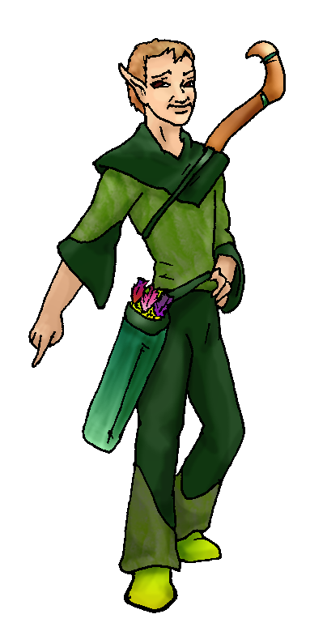
Habits and Places Preferred: Hunting Methods:
Character Sketch
Hair: tan
Eyes: brown
Skintone: tanned
Bond Beast Personality:
Bond Beast Habits/etc:
BondAnimal
Fur/Skin:
Eyes:

About you as an elf
Your Name Means: Well, it’s what you often wind up saying when someone asks where something they’ve lost is. Found it! Almost any item, person, animal, or even locations – you can and have found.
Your Appearance Is: slender and tallish, you’ve got lightly tanned skin, light brown tan hair that is quite short but easy to maintain, and brown eyes. While you’re pretty sure you aren’t conventionally ‘hunkalicious’ you know that lots of people are attracted to you because you’re dead on charming. ☺ Your choices of shades of green sturdy and soft leather clothing allows you to blend in with most of the woodland you patrol.
You Are Located: In the south-east corner of the land, in the Protector Holt. Your den is up on the mountain but not near the peak, instead nestled nicely in a thick, lush forest near several others homes. You have managed to fashion a hut out of bent woods, curled and tied vines, and weighted stone cloth which you use to camoflage your place. It’s out of the elements, but you do have to be careful not to set it afire when you’re cooking, because frankly it’s kind of ‘cozy’ (read: small). But you generally go to other’s dens to party or gather anyway.
Your Basic Statistics Mean: Physically you’re above average in most ways. Your agility leaves a little to be desired, but your skills make up for any broad comparisons. You’re charismatic and intelligent, you have average magical power.
Your Skills Include: Oddly you barely remember Earth in many ways. That said, you have an uncanny ability to laugh at the right time or say a word which just pops into your head, in discussions about the place. You’re not at all sure why, but you can sing almost any song along with someone, whether you’ve heard it or not. You have studied the behavior of the animals in the area, and know the terrain very well, and you can get by without knowing specific names of rocks or whether a poultice would do better on that burn. Someone else can handle those things. Out in the woods, though, you are expert at getting around, looking for signs of motion or following an animal into its den. You can cross streams, climb sheer cliffs, and leap across mossy rocks with ease. To you, making something out of leather or cloth is easy, and you are even trying your hand at tanning your own hides the old fashioned way. You can track and trap, and though you’re not bonded to any specific animal, you ride expertly when you must upon someone else’s wolf or other animal. You have several very interesting skills, cartography or mapmaking is very handy up here where there are tunnels of trees or very particular locations that you cannot even see during full summer but are laid bare in winter. Since you are so good at locating things, you also have a little fun with the others in the Holt by actually hiding things in caches around the holt for them to find. You hunt almost exclusively with a bow and arrows, but you can weild a small slender javelin when you’re faced with something up close.
Your Magic Powers Are: You have a higher than average Magic Feeling ability, which comes into play with other powers you use. With it you sense who has shaped an object or whether someone’s flown by under their own power recently. Your telepathic Sending is clear, loud and to the point, you often direct your sending to a distant person or two, managing to keep up on things without having to show up at every gathering. While you have a reasonably strong wolf-bonding power, you have not currently bonded an animal to be your mount and companion. Your other abilities are all pretty strong, the most easily identified is that of Finding. You can locate something that is lost, or give unerring directions to a place from anywhere else, provided you’ve been there – or, provided you have a good clear image of it in your mind. Now… that’s where your other powers come into play. Your Finding alone can let you locate something as small as a cast off button from a shirt, in the middle of a foggy boggy meadow, and you don’t even have to know what color it is. All you need to know is “button, over there”. But to get the best out of your finding power, you can briefly enter someone’s mind via a form of Mind Snaring, in order to ‘Steal’ their memories. You don’t actually take them, the other elf still has ‘em. But you are able to all but duplicate their experiences in your own mind for a while. The images fade after a few minutes, so you don’t have everyone else’s thoughts and emotions running around in your own noggin. But what happens when you find something… that wasn’t lost so much as not needed yet? Well, there is where your other power, that of ‘Coincidence’ comes in. There is always someone who can use a dry stick about yay long or a piece of stone that would fit onto a hammer… You’re just as good at locating uses for things, as you are useful things. You keep these powers up easily and all but constantly. Though your Power is only average, there’s hardly a time when you really have to strain to find anything. When using your Memory Stealing ability you do get a bit winded, you have to bypass the other elf’s mental defenses and sometimes you’ve come a little close to their Soul Name in the process. You don’t need to go around Finding those, now do you?
Your Bond Animal Is: you are not currently bonded to an animal, though most of the pack likes you enough to let you ride when you’re on a hunting party with their elves.
Special Information: However you do find yourself humming odd tunes now and again- and you’re positive you see someone lurking here and there in the woods. An eerie flute echoes every once in a while, but did you really hear it? Or is it someone’s magic? Or… Even your strong power of Finding never quite leads you in the right direction to follow this mysterious stranger. Yet you really are sure that whoever he is, he’s friendly.
You are known as a Chilldays (Late Autumn/Sixthsign) elf, with the star-pattern of the Viper in the night sky, the ever-working Beaver animal totem, the color Violet, and the Holly vine element as symbols. Elves of this type are often Industrious, dour, Formal, Jealous people but that’s not always the case.

bsryan@hal-pc.org Date: Mon, 04 Dec 2006 23:58:42 -0500

Necessary Stuff
Your Full Name: Brett Ryan Nickname or Title Doc. Ryan Birthday 13jun06
Act HOW Old? 26
Your Gender male, You like it this way
You Prefer the opposite sex
You are in single and hating it

Appearance Stuff
You're about 5'10" feet tall, and you'd like to be taller
Your build is Medium and you'd like to be healthier
Hair Color Brown Change? none
Hair Style/Curl short Change? none
Eye Color Brown Change? Glasses? off
Skin Tone Tan Change? none
Are you 'Attractive'?yes Change? none
Are you 'Strong'? yes Change? none
Are you 'Smart'? yes Change? none
Are you 'Nimble'? no Change? none
You'll be getting pointy ears - you want them elegant

Circle (likes) or Cross Out (dislikes)
Where do you like living? isolated village

Climates you like seasonal rainy mountainous towering cliffs river
forest

What You Want Out of Life see the world rough it/camp find a soul-mate
hunt learn give advice and listen retire early and relax

Other:

Favorites...
Colors Green
Animals none
Music/Bands Jethro Tull
Foods Mexican, Chinese, Tai,Italian
Sports if any cycling, archery
Time of Day midnight
Season winter

Fears and Hates

Any pets you'd like to drag along?
Any people you'd like to have with you? (supply them a sheet!)

