NAME: Lancer HOLT: Protector SOUL NAME: gymli/bp EARTHNAME: joseph
MATE: CHILDREN/RELATIVES: (coh)
MATURITY: adult REAL AGE: 3.6.86 YEAR/PORTAL OF ARRIVAL: 122/Hall SEX: male

STR: 15 CON: 16 SIZ: 6 INT: 17 POW: 17 DEX: 16 APP: 14 Total: 101
SKILLS MAGIC POWERS WEAPONS / ARMOR / BOND ANIMAL
language memory: 17 % magic feeling: 34 % attack with poleaxe (metal) : 82 %
animal lore: 34 % sending: 78 % damage 1d10 impale/cutting parry: 62 %
elf lore: 68 % dragon bonding: 68 % attack with 1 handed sword (metal) : 72 %
healing lore: 34 % healing: ___% damage 1d6 cutting/impale parry: 72 %
mechanical lore: 51 % (anti-heal: ___% missile___________________________________: ___%
mineral lore: 51 % (flesh shape: ** ___% damage___________________range______________
plant lore: 34 % (shielding: 51 % missile___________________________________: ___%
world lore: 51 % plant shape: ** ___% damage___________________range______________
communicate: 72 % rock shape: ** ___% missiles carried__________________________________
wolf/anim comm: 68 % (metal shape: ** ___% shield_________________________________use: ___%
perception: 78 % (gem shape: ** ___% armor type______________elem:___bash:___cut:___othr:___
stealth: 86 % bone shape: ** ___% supplies carried / other skills / etc
climb: 75 % water shape: ___%
dodge: 86 % firestart: ___%
jump: 76 % levitation: ___%
swim: 64 % finding: ___%
throw: 72 % animal bond: ___% BOND ANIMALname: Leeroy species: Dragon sex: m
manipulate: 58 % mindsnare: ___% STR: 24 CON: 16 SIZ: 40 INT: 14 POW: 8 DEX: 14 APP: 16
ride dragon: 84 % hypnosis: ___% climb: ___% jump: ___% swim: ___%
hunt: 76 % astral projection:* 17 % stealth: ___% dodge: ___% percp: ___%
armorfitting/craft: 66 % deep sensing: * 17 % comm: ___% ______:___% ______:___%
dancing: 60 % self shaping: ___% attack____________:___% attack________________:___%
music/sing: 70 % * ‘see stuff’: 44 % disposition
trapping: 64 % ** re-shape item: 51 % magic or other abilities
literacy: 61 % :___% natural armor:___________elem:___bash:___cut:___othr:___
Personality Notes: Lives in a...:
Likes and Dislikes: Friends:
Habits and Places Preferred: Hunting Methods:
Bond Beast Personality:
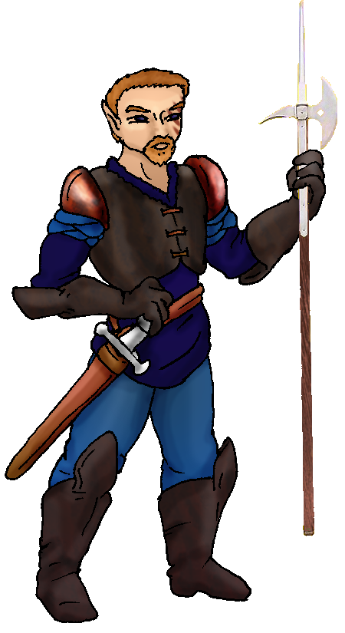 Character Sketch
Hair: tan
Eyes: blue-green
Skintone: medtan, markd
Bond Beast Habits/etc:
BondAnimal
Fur/Skin: pine, silver, beige, grey
Eyes: topaz

About you as an elf
Your Name Means: Lancer comes from your skills with long polearm weaponry. These items are rarely seen in holts, but you’ve become quite adept at using them especially from the back of your flying mount!
Your Appearance Is: Sturdy and tall, with medium toned skin that you’ve allowed to keep certain dramatic scars (and, you admit, having them darkened by shaping into ‘tattoos’ is cool too) from hunts and battles; you’ve got short, light brown colored hair, blue-green eyes and unlike most elves you’ve got a nicely trimmed beard to go with. Your clothing is typically augmented with bits of armor that you’ve had made.
You Are Located: In the Protector Holt, down in the south-east corner of the continent. Your den is near Alloy’s, on a wide meadow valley toward the eastern side of the Holt. You’re there mostly because of the ‘creatures’ living nearby, which you get to fight all too often. Your den is secure, shaped from stone as well as the local wide-boll trees, hooked together to make a kind of small castle or fort. Liana has helped shape these trees so they only allow elves to approach – anything else springs traps. (Thus you often find small animals caught in their grip and have to release them when you wake.) The creatures haven’t yet figured out how to penetrate your home defenses, so you’ve got a nice courtyard, several rooms with weapons, armor and the other trappings of battle – which when others come to join the fight on occasion, you all meet up in this area to suit up. Also, the courtyard serves as a great place to hold feasts.
Your Basic Statistics Mean: you’re above average in size, very strong and very healthy. You’ve got average dexterity (but it’s what you do with it that counts). You’re considered handsome, your magic power is average, and you are quite intelligent.
Your Skills Include: You’ve got an average memory for Earthly things, specializing in your weapons and gadgets. You have a good grasp on this entire portion of the world, including its layout, climates, and the people of your Holt. Other lores you have a basic understanding of plants and animals. Your strengths are in your survival and fighting skills. You’re able to see details on a glance, traverse hard terrain without trouble, and keep food in your belly through almost any conditions. Though you’re good at plain old hunting, you also have skill in trapping when needed. Your hunting weapons are good for large prey, such as bear, deer and boar. You use traps for smaller things. Your lance is an axe with a sharp spear end, and you also use a sword often while in battle with the spider-creatures. You can ride your dragon with ease, and without hands most often. You’re literate with the script that the elves of Dare’s Valley use, and jot things down about the enemy creatures around the Holt. And your visions. >_> When in a party mood, you sing, dance and play a set of flat ‘xylophone’ chimes – they’re almost like a cross between bells and those PVC things that the Blue Man Group ueses… A skill you’ve got that you use almost exclusively with your magic power, is that of armor fitting and design. You can take almost any piece of shaped (magically) armor and rework it to fit pretty much anyone in the Holt. You make sure that things are lightweight, balanced, and protective all at once.
Your Magic Powers Are: You have an above average Magic Feeling power, which you use frequently to detect how much shaping any given item has been under before you got to it. You also are able to tell if something is not shaped, in which case you’re not likely to be able to do much with it. Your sending is above average, you send very well in groups locally, especially good while on hunts or in combat. You are one of the few elves to have bonded a dragon instead of a wolf or other common animal. The dragon egg showed up separately from you, see below. Otherwise you’ve got an intriguing set of powers. One thing you can use fairly well on its own is a variation on Healing, which is Shielding – you can use your magic to syphon the pain off anyone, and keep them from being truly traumatized by any incident. This doesn’t always prevent them from being hurt, but they can function just fine as long as your power protects them from the effects. After you stop, there had better be a proper Healer around to make sure there’s no lasting damage. (For instance, an enemy elf from the Runners tortures someone with a burning mind blast. Your Shielding power can stop the pain from registering in your friend’s mind, and they can move around and fight. Once your shield drops they will collapse if there’s any true damage.) Now comes the hard part about you. You’ve got several powers which combine together, making unique abilities, one of which you’re not able to control. You have Deep Sensing and Astral Projection like powers, however they’re ‘always on’ and cause you to see things very differently from other elves. In fact you see spirits, mind powers, perhaps even ghosts of the dead (there aren’t many) all around. Sometimes they speak to you, which you ‘hear’ in faint magical ways. This ‘seeing stuff’ power is useful in a very important way: the enemy spider-folk are highly magical, but seemingly not always on a ‘wavelength’ that others can see. You see them just fine, you’re the first defense against them. But then again you also see certain people a little ‘off’ – Liana for instance, you think is a little oddly named for a guy! Next up, you’ve been told by others who have strong sensing powers that you’ve ‘got’ flesh shaping, rock and metal, gem and bone, as well as plant shaping magic! But! You can’t actually use them yourself, to start anything. You can use a power which amalgamates those abilities and allows you to use whatever shaping had been done, again under your hands. So a piece of metal that someone’s worked on to make a spear head which breaks, you can easily pick up and shape it back into one piece. However if you were to try just picking up a piece of stone that came from the ground, no magic added, you cannot shape it no matter how hard you try. As mentioned above, this comes in very handy when there is a hunting party or combat going on, so you can keep elves in their armor or with the right weapons in good condition. Fortunately this power doesn’t require much concentration on your part – however it does drain you a bit and you have to rest a little after each piece you shape this way.
Your Bond Animal Is: For absolutely no reason you can recall clearly – but one you know has some basis on Earth – your dragon friend is named Leeroy. He is extremely large, but not remarkably agile nor strong. He’s very good for scaring the crap out of smaller things, landing hard on them in fact. He’s very pretty, with markings ranging from a pine green mottling on his back over a beige color, to silver and grey markings on his underside – rather a lot like a war plane’s camoflage markings… whatever those are. He does not speak in words, but thinks to you in shapes, colors and emotions.
Special Information: That’s right, you think people are a little weird. After all, you see something way different than anyone else does. No matter how many times Liana has sent thoughts to you, you’re pretty well convinced ‘she’ is a he, and no one says otherwise. You do have a bit of a weird weakness, that is to the Mindsnare power. When someone aims an illusion at you, you believe it automatically. Your friends have learned that you can’t distinguish reality from their fantasies, so they are careful to let you go from this state before you get hurt. And oddly enough… when there have been visitors that are elves whose human counterpart has died, you do not see their spirit. You see only their body, it’s kind of like viewing them with one eye closed, there’s no depth to them. Pure spirits, on the other hand, appear to be only colors and shapes, no substance nor voice you hear with proper ears.
You are known as a Thaw (Newyear/Firstsign) season elf, with the star-pattern of the Wolf running in the night sky, the silent Owl animal, the color Silver and the elements Ice/Water as symbols. Elves of this personality sign exhibit Bravery, Hardiness, Patience, Luck.

midnighter36@gmail.com Date: Mon, 04 Dec 2006 20:45:44 -0500

Necessary Stuff
Your Full Name: Joseph Nickname or Title Big Poppa BPJersulem/Gymli? Birthday 3/6/86 Act
HOW Old? 40
Your Gender male, Don't ask weird things, Sara!
You Prefer the opposite sex
You are in single and hating it

Appearance Stuff
You're about 6 feet tall, and you'd like to be the same
Your build is Brickhouse and you'd like to be same
Hair Color Brown Change? none
Hair Style/Curl buzzed Change? none
Eye Color Blue Change? If you Want Glasses? off
Skin Tone lightly tanned caucasian Change? odd
Are you 'Attractive'?yes Change? unique
Are you 'Strong'? yes Change? stronger
Are you 'Smart'? yes Change? brilliant
Are you 'Nimble'? no Change? none
You'll be getting pointy ears - you want them short

Circle (likes) or Cross Out (dislikes)
Where do you like living? alone

Climates you like seasonal mild warm sunny flatland plains grassy

What You Want Out of Life see the world fight things/people make noise
joke find a soul-mate draw/create raise kids read learn give advice and
listen snuggle in front of a warm fire retire early and relax fiddle
with toys and tools

Other: I should be delusional and think Lohr is a dude no matter what

Favorites...
Colors navy
Animals dragon
Music/Bands rock
Foods pasta
Sports if any wrasslin
Time of Day midnight
Season spring

Fears and Hates I fear nothing and I hate stupid people.

Any pets you'd like to drag along? no
Any people you'd like to have with you? (supply them a sheet!)Can they be dead? ---- add a spirit?

