NAME: Mangrove HOLT: Protector SOUL NAME: hoochie EARTHNAME: Keith C
MATE: CHILDREN/RELATIVES: (coh)
MATURITY: Adult REAL AGE: 12.7.77/31 YEAR/PORTAL OF ARRIVAL: 122/Hall SEX: Male

STR: 13 CON: 14 SIZ: 7 INT: 16 POW: 18 DEX: 19 APP: 14 Total: 101
SKILLS MAGIC POWERS WEAPONS / ARMOR / BOND ANIMAL
language memory: 26 % magic feeling: 36 % attack with short spear (bone tip) : 74 %
animal lore: 42 % sending: 82 % damage 1d6 impale parry: 64 %
elf lore: 58 % wolf bonding: 72 % attack with________________________________: ___%
healing lore: 32 % healing: ___% damage_______________________________parry: ___%
mechanical lore: 52 % (anti-heal: ___% missile thrown spear : 64 %
mineral lore: 32 % (flesh shape: ___% damage 1d6 impale range medium
plant lore: 58 % (shielding: ___% missile___________________________________: ___%
world lore: 32 % plant shape: 36 % damage___________________range______________
communicate: 70 % rock shape: ___% missiles carried__________________________________
wolf/anim comm: 68 % (metal shape: ___% shield_________________________________use: ___%
perception: 72 % (gem shape: ___% armor type______________elem:___bash:___cut:___othr:___
stealth: 74 % bone shape: ___% supplies carried / other skills / etc
climb: 74 % water shape: ___%
dodge: 74 % firestart: ___%
jump: 68 % levitation: ___%
swim: 68 % finding: ___%
throw: 84 % animal bond: ___% BOND ANIMALname: Tooty? species: wolf sex:
manipulate: 57 % mindsnare: 72 % STR: CON: SIZ: INT: POW: DEX: APP:
ride wolf: 76 % hypnosis: 36 % climb: ___% jump: ___% swim: ___%
hunt: 84 % astral projection: ___% stealth: ___% dodge: ___% percp: ___%
carving/whittling: 70 % deep sensing: ___% comm: ___% ______:___% ______:___%
dance/music: 66 % self shaping: ___% attack____________:___% attack________________:___%
house-shaping: 68 % :___% disposition
trapping: 74 % :___% magic or other abilities
weaponsmithy: 67 % :___% natural armor:___________elem:___bash:___cut:___othr:___
Personality Notes: Lives in a...:
Likes and Dislikes: Friends:
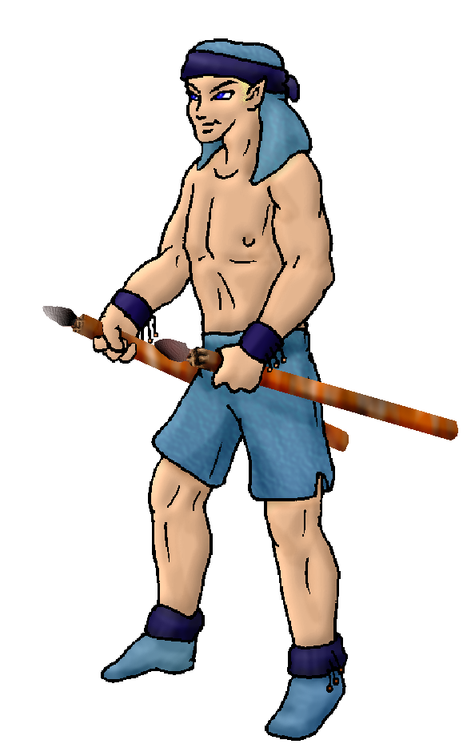
Habits and Places Preferred: Hunting Methods:
Bond Beast Personality:
Character Sketch
Hair: blond
Eyes: blue
Skintone: tan-fair
Bond Beast Habits/etc:
BondAnimal
Fur/Skin:
Eyes:

About you as an elf
Your Name Means: Mangrove is a type of marshland tree with huge roots that soar in and out of the water. They’re found in the Otherforest as well – but also they’re very magic-sensitive and shape easily with elfin power. This is your chosen locale as well as the type of tree you use most often for projects. There is another reason your name is Mangrove, the complicated knots of root systems and branches aren’t just physical for you – they also appear in your magical mind scape!
Your Appearance Is: Tall strong and lightly tanned, you’ve got very short-cropped pale blond hair that’s covered by a blue head wrap most times. You have dark blue eyes, and tend to wear light cloth instead of heavy leathers.
You Are Located: In the south-east corner of the continent, where the Protector Holt rests. Your den is made on the marshy flood plain near the inland sea, where tides slowly rise and fall each day – there are no moons here so the tides are smoother than you recall from Earth. The plant life however is very similar, in this area where salt water meets fresh. Your den can be spotted for miles because it’s a massive twist of half a dozen large mangrove trees, shaped to your whim but often left to grow wild in places. The ships which enter the inlet pass by your den.
Your Basic Statistics Mean: As above, you’re tall and strong, nicely muscular and ruggedly handsome. You’ve got a keen mind able to grasp ideas quickly, and your hands are deft enough to produce amazing works of art and weapons. Your magic power is about average.
Your Skills Include: You’ve got a typically low memory of Earth, but it’s enough to remind you how to make carvings, weapons and the like. Your information lores are well rounded, with emphasis on knowing people pretty well, as well as mechanics and plant life. Since you use those things often, you can be relied upon for tools and exploration without trouble. You can get your point across in any discussion, be it with an elf or a wolf, understanding body language, sounds and words are easy for you. Survival and physical skills are strong for you, but nothing stands out except perhaps your ability to throw things unerringly well. You hunt and harvest often, using traps but also a pair of short, wooden bone-tipped spears which you rely upon almost entirely. Skilled in the art of weaponsmithy, you use your plant-shaping but also combine it with carving bone and whittling dead wood for pointed things such as spears, javelins, arrows and sharp tips. Generally if you can pin something to the ground or a tree with it, you’re skilled with its use and creation. However your whittling skill is not limited to merely putting a point on a bone tool! With it you can make clever carvings of animals, people, and events on larger pieces of shaped wood. With this also, you combine your home-shaping ability with a kind of artistic flair to make entirely decorative additions to otherwise bland tree homes.
Your Magic Powers Are: You have a typical Magic Feeling sensation, you can reliably tell that a piece of wood, bone or stone has been shaped by an elf – but that’s about the extent of this power’s use for you. Your telepathic Sending power is sharp, you’re used to sending long distance messages across the big inland sea’s shore or waiting for word from those passing by on the other side of the hills, where the open ocean holds other ships. You have a wolf-bonding power that’s typical – however I don’t know anything about your animal Tooty, assume (as below) that Tooty is now a wolf-sized creature drawn to you by magic! Your strongest other power is that of Mind Snaring – where you can use your Hypnosis ability to catch the eye of an elf (or an animal) to freeze them up for a moment. Then, you can snag their mind and literally place it inside your own for a time. A complicated visual setting makes them try solving puzzles you’ve laid for them – things like knotwork which they must untie or traveling the length of a twisted root just like those of your tree-home. This is something you don’t practice often, but you are pretty good at it, equal with several others and often you’ll have competitions trading off who can break free of one another’s mind-games most quickly. Your other power is that of Plant Shaping, a modest power but these plants here in the marsh land on the inlet accept your shaping requests with ease – almost eagerly. There are a couple kinds of trees which are known to be very ‘friendly’ toward elf-magic, and you’ve chosen these water-dwellers. You can shape a piece of living tree from a sapling into an elf-tall and bushy wide tree in around an hour of exhausting work. You also can shape dead wood, an arm’s length chunk of wood can be moved into a smooth, pale colored strip more easily carved, in around half an hour. The ship-born Pirates in the bay have a lot of your work decorating their ship!
Your Bond Animal Is: Tooty, see above, I don’t know much about it, like its gender or anything, so… Imagine it’s big enough to ride, and howls with the pack!
Special Information: There’s always the chance that someone will wind up being the right elfess for you – there are very few children here, even though the Holt’s full of people. If I knew who Val is (hint hint, if plays coh, or sent in a form?) I could hook you up lol.
You are known as a Chilldays (Late Autumn/Sixthsign) elf, though perhaps only because you’re almost always busy like the animal totem this season has: the Beaver. The color Violet and the seasonal Holly vine are symbols of this season as well. Elves of this type, though not necessarily born nor arrived to the world at this time, are often seen as Industrious, dour, Formal, Jealous. But not every feature applies to everyone in this odd ‘zodiac’. The star-sign of the Viper is in the night sky at this time.

keith_camferdam@hotmail.com Add to Address BookAdd to Address Book Add Mobile Alert
Subject: Elf Survey Form
Date: Fri, 12 Jan 2007 00:04:57 -0500

Necessary Stuff
Your Full Name: Keith Nickname or Title hoochie Birthday Dec 7th, 1977 Act HOW Old? 21
Your Gender male, You like it this way
You Prefer the opposite sex
You are in a solid relationship

Appearance Stuff
You're about 6'2" feet tall, and you'd like to be the same
Your build is muscular and you'd like to be same
Hair Color blonde Change? none
Hair Style/Curl military Change? none
Eye Color blue Change? Glasses? off
Skin Tone tan Change? none
Are you 'Attractive'?yes Change? none
Are you 'Strong'? yes Change? none
Are you 'Smart'? yes Change? none
Are you 'Nimble'? yes Change? none
You'll be getting pointy ears - you want them short

Circle (likes) or Cross Out (dislikes)
Where do you like living? farm/ranch

Climates you like warm hot blistering muggy sunny dry really dry sea level plains mountainous beach marsh river rainforest grassy desert

What You Want Out of Life raise kids

Other:

Favorites...
Colors blue
Animals dogs
Music/Bands Mudvayne
Foods pizza
Sports if any body building
Time of Day midnight
Season summer

Fears and Hates hate ho's

Any pets you'd like to drag along? my dog Tooty
Any people you'd like to have with you? (supply them a sheet!)Val

