NAME: Tigercat HOLT: Protector SOUL NAME: kitty EARTHNAME: ken paliga
MATE: CHILDREN/RELATIVES: (coh)
MATURITY: young adult REAL AGE: YEAR/PORTAL OF ARRIVAL: 122/Hall SEX: m//f

STR: 14/14/20 CON: 13/14/18 SIZ: 6/7/13 INT: 14 POW: 21 DEX: 20/21/24 APP: 15 Total: 103/106/127
SKILLS MAGIC POWERS WEAPONS / ARMOR / BOND ANIMAL
language memory: 04 % magic feeling: 31 % attack with 1 handed spear : 78 %
animal lore: 62 % sending: 94 % damage 1d6 impale parry: 68 %
elf lore: 62 % bonding: n/a% attack with natural weapons (claw, bite): /70/88 %
healing lore: 38 % healing: ___% damage claw 1d5C/1d10C, bite 1d3I/2d6I parry: n/a %
mechanical lore: 42 % (anti-heal: ___% missile___________________________________: ___%
mineral lore: 42 % (flesh shape: ___% damage___________________range______________
plant lore: 62 % (shielding: ___% missile___________________________________: ___%
world lore: 42 % plant shape: 63 % damage___________________range______________
communicate: 68 % rock shape: ___% missiles carried__________________________________
animal comm: 80 % (metal shape: ___% shield_________________________________use: ___%
perception: 70/80/90 % (gem shape: ___% armor type______________elem:___bash:___cut:___othr:___
stealth: 82/84/90 % bone shape: ___% supplies carried / other skills / etc
climb: 66/76/82 % water shape: ___%
dodge: 82/84/90 % firestart: ___%
jump: 68/69/88 % levitation: 42 %
swim: 66/70/84 % finding: ___%
throw: 78 % animal bond: ___% BOND ANIMALname: species: sex:
manipulate: 60/42/ % mindsnare: ___% STR: CON: SIZ: INT: POW: DEX: APP:
ride: n/a % hypnosis: ___% climb: ___% jump: ___% swim: ___%
hunt: 82/84/90 % astral projection: ___% stealth: ___% dodge: ___% percp: ___%
large weaving: 60 % deep sensing: ___% comm: ___% ______:___% ______:___%
dancing: 85 % self shaping: 147 % attack____________:___% attack________________:___%
artistry/carving: 60 % gendershift (elf): 42 % disposition
trapping: 68 % :___% magic or other abilities
home shaping: 70 % :___% natural armor:___________elem:___bash:___cut:___othr:___
Personality Notes: Lives in a...:
Likes and Dislikes: Friends:
Habits and Places Preferred: Hunting Methods:
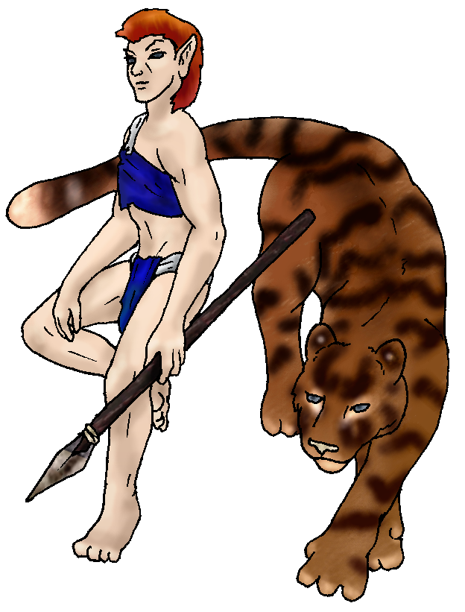 Character Sketch
Hair: red orange
Eyes: slate blue
Skintone: fair - furry
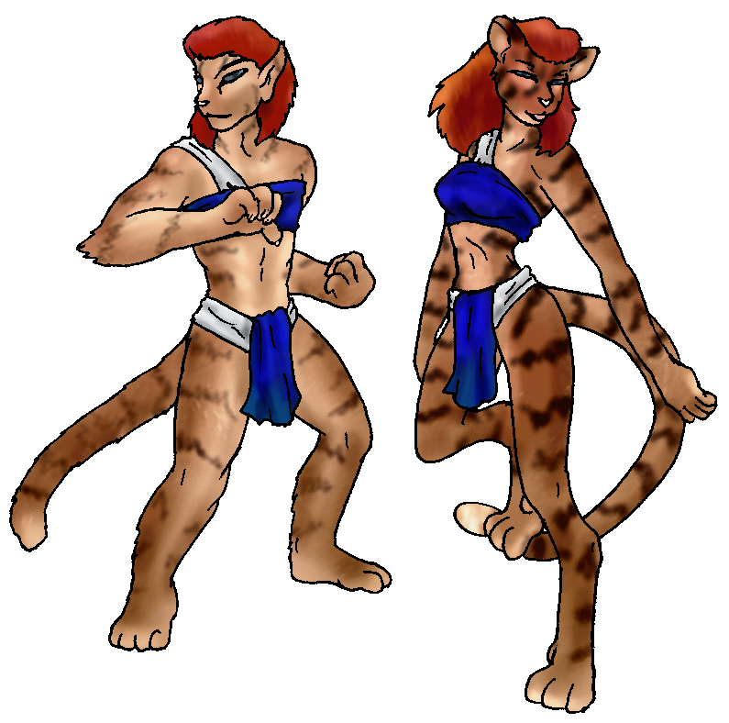

About you as an elf
Your Name Means: Tigercat that’s who you are. Not just what you like to look like, but as wild as you wish to be. Now, of course, you don’t mind just laying by a fire with some friends, that’s always good. It was obvious from the first moment that you were a shapeshifter, however it took a while to learn your ‘secret’.
Your Appearance Is: As in the images – you’ve got a fair skinned, red-headed and orange-red haired elf shape. You’re hardly ever in it. It’s nice for weaving and other fine finger things, but you prefer to have fur! You range from male to female, elf to full cat, growing darker and more vivid markings on your thick fur, though up until you’re actually four-footed, you’ve still got that shaggy toss of red hair. You’ve got unisex leathers which look good in any humanoid shape – and you honestly don’t know where they go when you’re not elfin.
You Are Located: In the Protector Holt lands, on the south-east corner of the continent. Your den is below a wide, slow moving waterway that meanders through a canyon – the tops of the canyon walls are covered in thick woods, while the bottom of the area is growing a thick grass that you love to hide in. You have an elfin den that is reached by a narrow fissure behind one stone, and though you’re a plant shaper by nature you have chosen a stony home for yourself. Prefering it to be more natural, at least for sleeping, there is very little but spare furs and a weapon or two here. But you do have a workshop which supports all your other habits. Shaping, weaving, and designs for new homesteads for others. This is in a sheltered grotto which might flood now and again, you can see a high-water mark. But you keep your projects high enough off the floor when you’re not using them, that even if you leave for a while they won’t get damaged by any rising waters from the river. You hunt frequently in the river as well as on the top of the canyon flats.
Your Basic Statistics Mean: You have essentially three sets of scores. The first of each is your Elf form – average in size and health, strong, and attractive. Your elfin shape is dexterous with finger-work, though you tend to do more physical things in other forms. You’re smart in either case, and have a very high magical power. The middle stat is your Half-cat shape. Either male or female, doesn’t much matter – it’s a bit more dexterous / agile, slightly more durable, but not much bigger nor stronger. The third stat is your fully Feline shape, which is much larger, much stronger and healthier and of course far more agile – but losing any skills for finger-dexterity. You can also only speak in words, in the humanoid shapes. You can always use your sending to telepathically speak.
Your Skills Include: You have a practically nonexistant Earth memory, words which might mean things to others like Thursday or Electricity mean exactly nothing to you. You’re almost too well-adjusted to this world! You have a strong attachment to both elves and animals, and you communicate with either quite well. Plants are things you observe as well as the fauna of the locale, you have a good idea of what plant to use in what situation for shaping. In your elfin or half-cat shapes you are able to use whittling tools, weaving on a large scale (for baskets, floor mats and that kind of thing) as well as for trapping. Using your plant shaping (see below) you can design and make homes for other elves, and this is something you devote some time and brain power to. You can dance particularly well in your female halfcat shape – and you’re quite popular that way too. For your more physical skills, however, you vary from shape to shape how well you can do certain things. Climbing, swimming, and prowling around hunting for prey are generally things that your full cat does best, while jumping and using weapons must be a bit on the elfin side. You use a spear in your elf shape to hunt (which obviously can be held by your half-cat shapes as well) but you also have the ability to deliver a hard claw swipe and a bite in your half- and fully feline shapes. Your full feline shape has a huge bite, impaling and holding on to prey while your instincts keep you safe. The damage amounts (c = cutting, i = impale) are for half and full feline shapes. You do not ride an animal, since you’re quite good at running as your own four-pawed creature, and among the pack of both wolves and cats, you’re often found right up front.
Your Magic Powers Are: You’ve got an average magic Feeling power which allows you to detect who has shaped something, or what powers they have by the color of their aura. You don’t much concentrate on this ability. Your telepathic sending power is strong, though you do have a bit of a problem – sometimes you will send to the wrong person, or a group when you meant for something to be private! (mistell anyone?) But this is something that’s rarely if ever gotten you into trouble, most of the time people just send back ?? or !?lol!! (or the mental equivalent) and move on. You do not have an animal or wolf bonding power – frankly, many of the animals that typically bond elves (the wolves, cats, birds and deer) don’t like to compete with shapeshifters. There are exceptions to this, but you’re not among them. Instead you choose to *raise* animals, more as pets than anything else, and you hardly need a magical power to do so, your ability to understand and communicate normally with small animals is good enough for that. Now… your other powers… You’re one of the strongest self-shapers on the planet. Period. Let that sink in for a minute. You know that at least a couple of the people at the Valley are very strong, and even among your tribe there are others with this power. But you! You’ve heard a story about someone else who did what you chose to do: become another gender, but you’ve taken it to another step. While you can and sometimes have changed merely from one gender elf to another, looking approximately the same, you normally shift from a full elfin male, into a fully feline female shape. You can stop almost anywhere between, including multiple genders in the same body – you’re only limited to your imagination after all. Others have speculated whether you’re fertile or not – of course you are. Both ways, in fact. You could *possibly* (though very unlikely) fertilize yourself. But that’s weird even for you… So you’ll stick with being a furry catgirl. Noticably your shape gets more feline when you’re more female, though it’s harder to detect if one’s just looking at your feline aspects. (The male half cat is lighter and less furry, straighter in build, and has flat feet. The female half cat is darker, furrier, has a slightly smaller head in proportion, and is far more flexible, with digitigrade feet.) You have other powers, believe it or not. Your plant shaping is strong, good enough for you to be asked to help shape and create any number of things. Your spear is mostly your own doing, and you occasionally coerse the grasses to grow slightly higher or slightly more orange to blend in easier with you stalking around in them… You can shape a living plant with ease, though you can shape dead wood it’s quite hard. You can also fly, though this power is somewhat weaker and leaves you exhausted more easily. You can stay up in the air for about half an hour without tiring, or carry objects weighing up to your size (while you walk) for an hour or so. This makes carrying prey back to your den or to a community dinner a lot easier. (Because they tend not to like all those bite marks and slobber. fine. whatever.)
Your Bond Animal Is: You are not bonded, nor can you truly be to an animal. If they choose to be near you it’s because they want to, not because of magic. You are however part of Cimmie’s pack, she loves to surround herself with other cats…
Special Information: what about kittens? There are already large felines up here on the mountainside. You know that Tabby’s cat-friend is elfin in her background. It’s not completely taboo to think about it, though it certainly squiks some people – sometimes even you.
You are known as a Newgreen (Spring/Secondsign) elf, with the star pattern of the Turtle in the night sky, the delicate and nimble Fawn animal totem, the colors Green and Brown and the sturdy Oak and beautiful Flowers as symbols. Elves of this season are not necessarily born in this time or even arrived then, but they are considered to be by personality traits apt for Celebration, Lighthearted, Passionate, Nimbleness.

RKenshin982@adelphia.net.or.RKenshin982 -- Storm Tiger Date:Tue, 28 Nov 2006 01:01:09 -0500

Necessary Stuff
Your Full Name: Kenneth C Paliga Nickname or Title Kitty Birthday 9-22-1982 Act HOW Old? mid 20s
Your Gender male, You wouldn't mind changing it
You Prefer the opposite sex
You are in single and hating it

Appearance Stuff
You're about 6 feet tall, and you'd like to be the same
Your build is a bit husky and you'd like to be healthier
Hair Color red Change? mixture
Hair Style/Curl short Change? longer
Eye Color slate blue Change? no Glasses? off
Skin Tone pale Change? darker
Are you 'Attractive'?yes Change? none
Are you 'Strong'? yes Change? none
Are you 'Smart'? yes Change? none
Are you 'Nimble'? sort of Change? everything
You'll be getting pointy ears - you want them elegant

Circle (likes) or Cross Out (dislikes)
Where do you like living? old friends new friends quiet neighborhood

Climates you like seasonal mild warm snow/sleet cloudy sunny dry
flatland plains hilly mountainous beach river rainforest forest meadow grassy

What You Want Out of Life plant a tree joke bask in the sun find a
soul-mate draw/create raise kids fly like an eagle raise pets and animals
learn give advice and listen snuggle in front of a warm fire fiddle with
toys and tools

Other:
Favorites...
Colors blue, white
Animals big cats (tigers, panthers, etc), dragons, wolves, dolphins
Music/Bands 80s, JPop, rock
Foods don't really have a favorite
Sports if any paintball, tuner racing (think The Fast and the Furious)
Time of Day night
Season spring

Fears and Hates Fears: being lonely, needles - Hates: assholes (pardon my language)

Any pets you'd like to drag along? Don't have any
Any people you'd like to have with you? (supply them a sheet!)

