NAME: Aphelion HOLT: Protector SOUL NAME: Korith EARTHNAME: A²WMacKay
MATE: CHILDREN/RELATIVES: (coh)
MATURITY: Adult REAL AGE: 8.21.81/27 YEAR/PORTAL OF ARRIVAL: 122/Hall SEX: male

STR: 13 CON: 15 SIZ: 7 INT: 17 POW: 20 DEX: 18 APP: 15 Total: 105
SKILLS MAGIC POWERS WEAPONS / ARMOR / BOND ANIMAL
language memory: 17 % magic feeling: 60 % attack with 2 Handed Staff (wood) : 72 %
animal lore: 34 % sending: 120 % damage 1d6+2 smashing parry: 62 %
elf lore: 61 % bonding: 80 % attack with dagger (metal) : 62 %
healing lore: 51 % healing: ___% damage 1d3 cutting/impale parry: 31 %
mechanical lore: 68 % (anti-heal: ___% missile___________________________________: ___%
mineral lore: 34 % (flesh shape: ___% damage___________________range______________
plant lore: 51 % (shielding: ___% missile___________________________________: ___%
world lore: 51 % plant shape: ___% damage___________________range______________
communicate: 84 % rock shape: ___% missiles carried__________________________________
wolf/anim comm: 74 % (metal shape: ___% shield_________________________________use: ___%
perception: 94 % (gem shape: ___% armor type______________elem:___bash:___cut:___othr:___
stealth: 86 % bone shape: ___% supplies carried / other skills / etc
climb: 82 % water shape: ___%
dodge: 86 % firestart: ___%
jump: 100 % levitation: 110 %
swim: 62 % finding: ___%
throw: 62 % animal bond: ___% BOND ANIMALname: Moptop species: dragon sex:m
manipulate: 72 % mindsnare: ___% STR: 16 CON: 14 SIZ:16 INT: 9 POW: 8 DEX:24 APP:11
ride dragon: 82 % hypnosis: ___% climb: ___% jump: ___% swim: ___%
hunt: 76 % astral projection: 80 % stealth: ___% dodge: ___% percp: ___%
tinker/construct: 70 % deep sensing: 40 % comm: ___% ______:___% ______:___%
cooking: 76 % self shaping: ___% attack____________:___% attack________________:___%
music/sing: 86 % :___% disposition
trapping: 76 % :___% magic or other abilities
literacy: 61 % :___% natural armor:___________elem:___bash:___cut:___othr:___
Personality Notes: Lives in a...:
Likes and Dislikes: Friends:
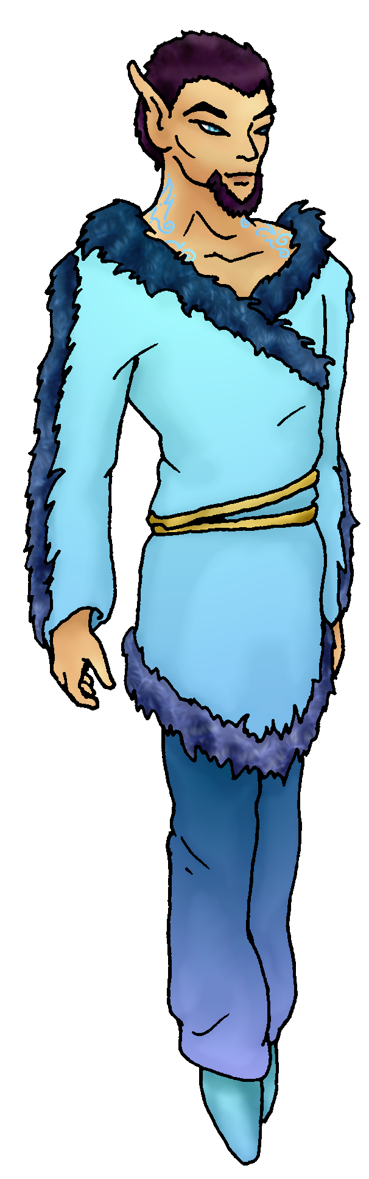
Habits and Places Preferred: Hunting Methods:
Bond Beast Personality:
Character Sketch
Hair: violet-brown
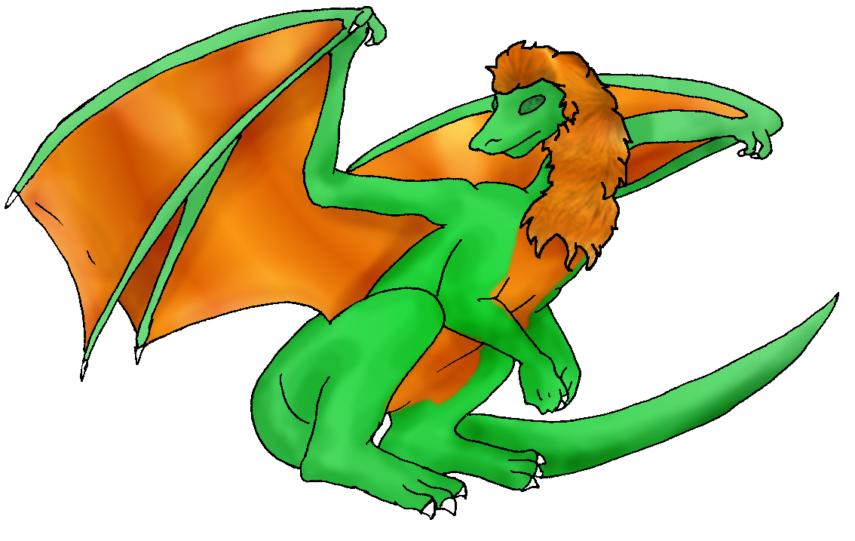 Eyes: blue
Skintone: fair, tattooed
Bond Beast Habits/etc:
BondAnimal
Fur/Skin: leaf green, saffron belly/mane
Eyes: green

About you as an elf
Your Name Means: Aphelion is the most distant point from the sun – and while you do get up close and personal with people, your typical flights around the Holt give you this name. You’re more often than not found up in the sky either riding your dragon, or simply soaring with your magic.
Your Appearance Is: Well-muscled and tall, with fair skin that has intricate colorful tattoo designs from neck to ankles. (the colors vary but they’re generally light in shade.) You’ve got short, straight hair that’s equal parts dark brown and violet, with a snappy looking goatee. Your sky-blue eyes tend to be matched in the leather and silk clothing you wear.
You Are Located: In the Protector Holt, to the far south-east of the continent. You spend a lot of time soaring over the huge land that you call home, but you come to roost near the north side of the east peak – where there is a heavy forest, but tall trees mean that you can den high up where others can’t bother you unless you really want them to. There are cliffs on the southern side of this area where Moptop generally rests, though there are places where he can literally land on the canopy of huge trees and be in no danger of falling. Your den is absolutely camouflaged, having been shaped from the branches of the tallest of the nearby trees, and really the only way to know that it’s yours is the fact that it is the tallest around…It’s got room for you and perhaps one other to sleep comfortably, but also a nice airy spot below the ‘floor’ where you can enjoy drawing, creating and reading.
Your Basic Statistics Mean: You’re taller than many but not all elves here, on the stronger end of the scale, and quite healthy. Your nimbleness in the air is not always echoed when you’re on the ground. You’re considered quite handsome and exotic with the delicate tattoo work on your skin, and are known to be a smart-as….as smart as ever! ;) Your magical power is very strong, you can perform your magical feats for hours if not indefinitely.
Your Skills Include: Like all arrivals, you have some kind of memory of Earth, but yours is very washed out, so far as you know, this world is and has always been your home. You have a good grasp on lots of information – gossip through mechanics. You’ve studied enough other people’s work, such as plans for weapons, construction equipment, gears, and the like, and enjoy trying to work up your own items. As far as your survival and physical skills go, you’re inherently good at most things such as leaping, climbing and tracking. You have the near-unique pleasure of knowing how to ride a dragon – it’s like riding a giant bird, but then again, you can fly too! Your keen senses can spot things from the skies, you hardly need to be up close to locate prey animals. Though you do a lot more trapping because it’s just easier (and you get to fiddle with making and repairing them to pass the time), you’re also reasonably good with a wooden staff to smash large prey, plus a hefty cooking-type knife that you more often use after you’ve got a fresh kill. You are one of the cooks of the Holt, with a bent toward ‘accessorizing’ – you like collecting cheeses, herbs, creating sauces and flavorful additions to main dishes. Like most of the holt’s inhabitants, you’re literate to a good degree, and keep your own notes in the script you learned at Dare’s Valley.
Your Magic Powers Are: With your magical Power being so strong, you cannot help but be intensely magical. You have a strong Magic Feeling ability, with it you can sense all manner of magical effects, even from a distance. From flying overhead, you can spot someone on the ground who is shaping a plant or stone, and in fact you can distinctly tell the difference between magically-shaped items and those which have been merely manufactured by hand. You can also detect within each elf what their powers can be –this is aided by another power, see below. Your telepathic Sending power is certainly among the strongest in the world, and very few here in Protector Holt have the ability to match your distance, strength or broadcast ability. But you can also pry into closed minds to a certain extent as well, trying not to do this is kind of an effort. You’ve got a strong animal-bonding power, which has brought you your dragon friend. In addition to those things, you’ve got several strong powers that you use every day. The most obvious and strong of these is your power of flight. You can lift yourself as well as two others up to your size (which is saying a lot) for a time, but you alone, you can fly all day long without tiring. Sometimes you are floating without even trying to do so. Beyond that, you can also send your mind out of your body to explore with just your spirit-eyes. Doing so requires that you be in a safe place, because your body would be vulnerable to attacks or the elements. You can extend your already-wide Sending range by almost ten times this way, you can actually reach the edge of the nearest other elfin Holt, the Coastal Cliffs holt – which is over two thousand miles away! It’s a weak connection, but when you and others far away decide to chat, the world isn’t nearly as big as it might seem… Lastly you have the ability to use your Magic Feeling power in conjunction with a ‘Deep Sensing’ power that is a lot like empathy: you can sense weariness or elation, anger or other moods, but also magically you can see the mix of potential powers within each elf. Every power seems to have a ‘color’ or ‘smell’ to it, and once you see someone performing their power, you know for sure what ‘color’ goes with which one.
Your Bond Animal Is: a dragon named Moptop. Dragons are not common at all in this part of the world, typically going to their bond-elves in the Dragonclan all the way on the other side of the world. But there are one or two, and simply put, when a dragon is needed on the Otherforest, an egg will show up out of nowhere. You tended this egg all the way from Dare’s Valley to the Protector Holt, where it finally hatched. He’s quite dramatically two-toned, a bright, light-shaded green body with brilliant saffron-orange belly, and fluffy ‘hair’ in a mane/mop on his head and neck. While he’s intelligent enough to converse with you mentally, generally speaking he doesn’t communicate well with other bond animals or elves. His wingspan is quite large, and he sails on the same thermals that you often use.
Special Information: Sometimes you have weird dreams of another world – Earth – and they often involve fiddling with a machine that writes for you, spreading words you cannot read across a glowing piece of glass. They’re pretty weird dreams. … Yup, that’s the extent of your memory of Earth…
You are known as a Deathsleep (Winter/Seventhsign) elf, with the star-sign of the Arrowhead in the evening skies. Elves of this ‘sign’ are represented by the Longtooth cat, the color Black, and the elusive and beautiful Orchid element. Though elves don’t have to be born or arrive during this season to have this ‘sign’, they’re often thought of as Canny, secretive, Dangerous, Flirtatious.

Your Full Name: Andrew Arthur William MacKay Nickname or Title: Korith I know you from... City of Heroes
Birthday: August 21, 1981 Act HOW Old?: Some days 4, others, 40 Your working E-mail address: dj-korith@kjsr.net
Your Gender: Male And... (CHOOSE) -> You like it this way You Prefer ... (CHOOSE) -> The opposite sex You are: (CHOOSE) -> Single and Looking
Appearance Stuff (I need at least a few of these)
You’re about how tall?: 5'11" and you’d like to be (CHOOSE) -> Bigger than a breadbox
Your build is? Let's put it this way..."big" and you’d like to be (CHOOSE)-> unchanged
Hair Color? Mild-to-darkish Brown Change? (CHOOSE)-> Weirder
Hair Style? Straight, combed back, unparted Change? (CHOOSE)> Don't care
Hair Length? Why yes, I did recently get my hair cut! :) (Short) Change? (CHOOSE) -> No Change
Eye Color? Blue Change to what? Blue Glasses? -> Off/None
Skin Tone? Light Change? (CHOOSE) -> Odd
* Consider how you feel about yourself and how others may view you. Answer yes or no, and then choose your changes if any.
Are you ‘Attractive’? Yes, from the neck up. Change? -> Beautiful
Are you ‘Strong’? Not extraordinarily, but I can do 60 reps of 60 lbs on a weight machine (using my arms), and have something to spare. Change? -> No
Are you ‘Smart’? Without a modicum of doubt. Change? -> No
Are you ‘Nimble’ or 'Agile'? Um..no. Change? -> Everything
You’ll be getting pointy ears! Choose from these examples please, Short, Elegant, Medium or Long -> Elegant ears
Where do you like living? (Choose as many as you like)
-> Fewer People -> Alone -> Quiet Neighborhood -> Farm/Ranch
Climates you like (choose as many as you like, list what you really don't like in the 'other' section!):
-> Freezing (Winder wonderland) -> Chilly -> Cold -> Seasonal -> Mild -> Warm -> Hot -> Snow -> Rainy -> Cloudy -> Sunny -> Dry
Terrains you like (choose as many as you like, if you really don't like something say so too):
-> Sea Level -> Flatland -> Plains -> Canyons -> Hilly -> Towering Cliffs -> Open Ocean -> Deserted Island -> Beach -> River -> Rainforest -> Forest -> Heavy/Old Growth Forest -> Meadow -> Grassy -> Rocky -> Desert
What You Want Out of Life… (choose as many as you like! list what you really don't like in the 'other' section!)
-> See the world -> Rough it/Camp -> Make noise -> Heal the sick -> Joke and play -> Bask in the sun -> Find a Soul-mate -> Draw/Create -> Slack off -> Raise kids -> Build and Construct -> Make music -> Fly like an eagle -> Isolate yourself -> Read -> Compete in a triathalon -> Learn -> Give advice and listen -> Snuggle in front of a warm fire -> Build an igloo -> Cook a mountain of food -> Surround yourself with technology -> Retire early and relax -> Fiddle with toys and tools
* Favorites:
Colors: Mild Blues, soft reds or yellows
Animals: Cat, Iguana, Eagle
Music/Bands: Stuff composed between 1000 and 2050 AD
Foods: Pasta, Veggies and dip
Sports if any: Basketball (but I suck at it)
Time of Day: Afternoon
Season: Fall
Other info (anything left out, anything important you want to share): Close and deep friendships >>>> Dispersed and shallow friendships, Quality >>>>> Quantity
Do you have any Fears and Hates? Not that spring to mind.
Stock used: Foggy_rocky_hill – DruidWuStock

