NAME: Pirate! HOLT: Protector SOUL NAME: EARTHNAME: kythorn
MATE: CHILDREN/RELATIVES: (coh)
MATURITY: young adult REAL AGE: 4.14.85 YEAR/PORTAL OF ARRIVAL: 122/Hall SEX: f

STR: 11 CON: 13 SIZ: 5 INT: 18 POW: 17 DEX: 16 APP: 17 Total: 97
SKILLS MAGIC POWERS WEAPONS / ARMOR / BOND ANIMAL
language memory: 18 % magic feeling: 34 % attack with cutlass : 81 %
animal lore: 36 % sending: 78 % damage 1d6+1 cutting parry: 61 %
elf lore: 54 % bonding: 68 % attack with harpoon (thrust) : 71 %
healing lore: 36 % healing: ___% damage 1d10 impale parry: 61 %
mechanical lore: 74 % (anti-heal: ___% missile harpoon (fired) : 101 %
mineral lore: 64 % (flesh shape: ___% damage 1d10 impale range long (water)
plant lore: 36 % (shielding: ___% missile___________________________________: ___%
world lore: 64 % plant shape: ___% damage___________________range______________
communicate: 80 % rock shape: 17 % missiles carried fortunately, only one.
wolf/anim comm: 61 % (metal shape: 51 % shield_________________________________use: ___%
perception: 78 % (gem shape: 34 % armor type______________elem:___bash:___cut:___othr:___
stealth: 76 % bone shape: ___% supplies carried / other skills / etc
climb: 66 % water shape: ___%
dodge: 86 % firestart: ___%
jump: 90 % levitation: 105 %
swim: 66 % finding: ___%
throw: 74 % animal bond: ___% BOND ANIMALname: Cap’n species: minicow sex: m
manipulate: art 42 % mindsnare: ___% STR: CON: SIZ: INT: POW: DEX: APP:
pilot ship/navigate: 72% hypnosis: ___% climb: ___% jump: ___% swim: ___%
hunt: 71 % astral projection: ___% stealth: ___% dodge: ___% percp: ___%
fashion sense: 68 % deep sensing: ___% comm: ___% ______:___% ______:___%
dancing: jigs 66 % self shaping: ___% attack____________:___% attack________________:___%
music/sing: 68 % :___% disposition
rigging/sails: 64 % :___% magic or other abilities
mapmaking: 82 % :___% natural armor:___________elem:___bash:___cut:___othr:___
Personality Notes: Lives in a...:
Likes and Dislikes: Friends:
Habits and Places Preferred: Hunting Methods:
Character Sketch
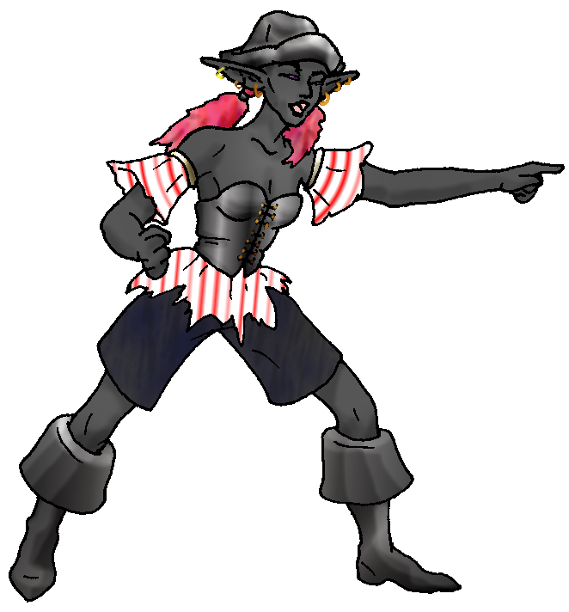 Hair: pink
Eyes: violet
Skintone: black
Bond Beast Personality:
Bond Beast Habits/etc:
BondAnimal
Fur/Skin: black/pink
Eyes: purple

About you as an elf
Your Name Means: Pirate! of course, is your name because you aarrrrr a pirate! Begarr! If it wasn’t for the land in the way, you’d probably have joined up that rowdy bunch called the ‘Runners’ in the forest, but you’ve heard tales about them that make even your sun-blackened skin crawl. You prefer to pillage – well, loot… well, okay, trade, in ports where your ship is able to dock.
Your Appearance Is: With oddly black skin (not just ‘tanned’, it’s actually a rich shade of charcoal black) and brightly flame-pink hair, dark violet eyes and a noisy demeanor, no one’s going to be forgetting you after setting eyes on ya! You’ve a collection of fashionable fabrics that the Ice Traders love to see you play with, those big folks are some of your biggest fans. You do of course claim the hat, because when Hammock brought it from wherever it was he found it in the Hall, it was clearly for you.
You Are Located: In the Protector Holt lands in the south east corner of the land. However you use the big bay as a base of operations, it’s more than a hundred-fifty miles across after all, so why not? It’s got lots of tiny islands to strand on, deeps that have monsters, and best of all miles and miles of shoreline to pillage! Loot! … Trade!
Your Basic Statistics Mean: though you’re of average dexterity, size and strength, slender in form, you’ve got to be one of the prettiest elves around, even with your exotic appearance. People do double takes – but not because they think you’re bizarre, rather because once they get around the color scheme you really are gorgeous. Your magical Power is average, but you use it very specifically for flight and for your gold digging – so you hardly ever wear it out. And what people don’t expect at all, is that behind your piratey exterior and arr-begarring, you’ve got a mind that can run circles around most in the holt. Those maps that Talon makes in the Valley? pfah – you can read the ones that the Ice Traders give you, as well as make your own detailed codes!
Your Skills Include: To start, let’s say that your memories of Earth are… um, a bit mixed up. Where other people see flashes of their old life and blurt out things about cars, desktops and TPS reports, you’re very likely to have flashbacks to what must actually be movies or dreams at best. There are some hot pirate guys in your dreams, let’s say that… Your intellect-based lores are largely centered around building, materials and goods. You know a bunch of elves, and you like to shout orders from your ship at them, but mainly you’re around to take stock of what tree trunks might make good replacement masts, and which metals you’d like the shapers to pound out for reinforcements on your ship. You’ve actually got … gunpowder. Which is saying a lot, because other than a couple Ice Traders way up north, you’re the only one. It’s in very short supply though, so you’re careful to use it only when necessary. Your physical skills are adequate, you don’t much care for hunting on land, prefering the shallows or open sea, where your ship is your best asset. But you can swim, leap, and climb well enough to get around. You’ve got a reasonable ability with art, mostly you’ve cycled that into your fashion sense and ability to put together outfits like the one you’re wearing. Cartography and ship building as well as maintenance are skills you alone among elf kind seem to thrill in. Your hunting skills more on the sea include the use of a harpoon which you fire from the deck, one big fish can feed almost the whole holt for several days, and you land some nice ones. But you can take the spear itself out and use it on land, you feel safer with the thing under your arm (it’s pretty big). You fight and spar using a traditional cutlass, of course.
Your Magic Powers Are: Your magical Feeling is average, you can sense who shaped something or if someone was flying around nearby. As for your telepathic Sending, you’ve got a strong, direct voice which you use more frequently to speak to a number of people at once, and close range you’re able to command nicely. You don’t have a traditional ‘wolf bonding’ ability, instead a simple bond with your little cow, Cap’n. Other powers that you excell in, you first used your Fight ability to spring off the marble floor of the Hall, onto the pillar like walls. Your ability to fly is extremely strong, in fact you have a hard time staying on the ground when you’re not concentrating. It’s very likely that if you hook up with someone who can enhance your powers (they are out there), you might even be able to get the whole ship to fly. It would take a lot of work though. You can lift yourself and two similarly sized people (objects, animals, whatever) with ease for several hours. After about three hours you’d begin to tire at that rate – but without anyone else to hinder you, you can literally fly all day. Aside from that, there’s your ability with stones! You’ve a rudimentary ability to shape the rock around gems or ore, and enough shaping power to pull those ores and stones from their stone nests. After that, they’re yours to do with as you please! With this power too, you can sense nearby gems, gold, and the like – so you know when you’re getting close to a treasure!
Your Bond Animal Is: though you aren’t sure what it is, because it simply appeared nearby the ship you commandeered, Cap’n is a little tiny cow. He’s male, but how could that matter, he’s like, the size of a miniature poodle. (And even at your elfin height, that’s still only about up to your hip at most.) In your same color scheme, Cap’n doesn’t answer to anyone but you. And you’re not sure what he does, but there he is. He indeed has his own hat, too, not sure were he got it from though.
Special Information: Because you got here first, you claimed the name Pirate. But here’s an upstart who came days and days later, who also thinks he deserves it! That scurvey rascal! Well, you can fight for it, share it, give each other new nasty names, but essentially he’s also your only real crew member for most of your travels… so you better get used to him… Also, you know the coast like the back of your hand, there’s gold out there that actually someone else mined and minted, not shaped… You want to know where it was from, who pressed it, and if there’s more somewhere.
You are known as a Deathsleep (Winter/Seventhsign) elf, with the star-sign Arrowhead in the night sky, the Longtooth cat animal totem, the color Black and the beautiful exotic Orchid element. Elves of this ‘sign’ are known as Canny, secretive, Dangerous, Flirtatious. This doesn’t necessarily mean you’ve arrived in this season, it’s a loose personality zodiac instead.
thekythorn@hotmail.com Date: Sun, 26 Nov 2006 16:10:46 -0500

Necessary Stuff
Your Full Name: Kythorn (@Kythorn in game) Nickname or Title Birthday
April/14/85 Act HOW Old? 21
Your Gender female, You like it this way
You Prefer to keep your sexuality to yourself
You are in single and loving it

Appearance Stuff
You're about 5'6 feet tall, and you'd like to be the same
Your build is thin and you'd like to be same
Hair Color Pink Change? none
Hair Style/Curl Like the in game pigtails option Change? none
Eye Color purple Change? Glasses? off
Skin Tone Jet Black Change? none
Are you 'Attractive'?yes Change? prettier
Are you 'Strong'? no Change? none
Are you 'Smart'? yes Change? evil genius
Are you 'Nimble'? no Change? none
You'll be getting pointy ears - you want them medium

Circle (likes) or Cross Out (dislikes)
Where do you like living? alone old friends bustling city isolated
village

Climates you like chilly cold mild snow/sleet rainy foggy muggy cloudy
sea level towering cliffs beach river forest grassy desert

What You Want Out of Life see the world fight things/people joke
draw/create slack off build and construct make music fly like an eagle
isolate yourself create clothing order people around dig for gold retire
early and relax
Other: Being a Pirate! I wana be a fashionable Pirate who Captins a
kick ass pirate ship and I sail around doing pirate stuff

Favorites...
Colors Pink/Black
Animals Cow
Music/Bands everything that sounds good, doesnt matter what
Foods meat and potatoes, and fruit I love fruit
Sports if any walkin' the plank
Time of Day early morning
Season autumn

Fears and Hates people, fire
Any pets you'd like to drag along? pink and black mini cow that wears a captins pirate hat
Any people you'd like to have with you? (supply them a sheet!)Tulare
(if he makes one, and my fericly loyal pirate crew)

