NAME: Teller HOLT: Protector SOUL NAME: (Mardun) EARTHNAME: Steve
MATE: CHILDREN/RELATIVES: (coh)
MATURITY: Adult REAL AGE:5.23 YEAR/PORTAL OF ARRIVAL: 122/Hall SEX: Male

STR: 12 CON: 14 SIZ: 6 INT: 16 POW: 20 DEX: 20 APP: 16 Total: 104
SKILLS MAGIC POWERS WEAPONS / ARMOR / BOND ANIMAL
language memory: 32 % magic feeling: 60 % attack with 1 handed spear : 64 %
animal lore: 42 % sending: 100 % damage 1d6 impale parry: 60 %
elf lore: 64 % cat bonding: 80 % attack with________________________________: ___%
healing lore: 54 % healing: * ___% damage_______________________________parry: ___%
mechanical lore: 32 % (anti-heal: ___% missile thrown spear : 64 %
mineral lore: 32 % (flesh shape: ___% damage 1d6 impale range short
plant lore: 42 % (shielding: ___% missile___________________________________: ___%
world lore: 32 % plant shape: ___% damage___________________range______________
communicate: 74 % rock shape: ___% missiles carried__________________________________
wolf/anim comm: 62 % (metal shape: ___% shield_________________________________use: ___%
perception: 80 % (gem shape: ___% armor type______________elem:___bash:___cut:___othr:___
stealth: 80 % bone shape: ___% supplies carried / other skills / etc
climb: 64 % water shape: ___%
dodge: 80 % firestart: ___%
jump: 64 % levitation: ___%
swim: 66 % finding: ___%
throw: 64 % animal bond: ___% BOND ANIMALname: Bough species: big cat sex: f
manipulate: 60 % mindsnare: 80 % STR:14 CON:13 SIZ: 16 INT:13 POW: 12 DEX:18 APP:13
ride big cat: 80 % hypnosis: 60 % climb: 88 % jump: 66 % swim: 44 %
hunt: 60 % astral projection: ___% stealth: 60 % dodge: 66 % percp: 60 %
mental design: 72 % deep sensing:* 80 % comm: 50 % ______:___% ______:___%
dance/sing: 72 % self shaping: ___% attack knockdown/above: 64 % attack bite/claw: 64 %
instruction: 72 % *mind healing: 40 % disposition
trapping: 60 % :___% magic or other abilities
storytelling: 72 % :___% natural armor:___________elem:___bash:___cut:___othr:___
Personality Notes: Lives in a...:
Likes and Dislikes: Friends:
Habits and Places Preferred: Hunting Methods:
Bond Beast Personality:
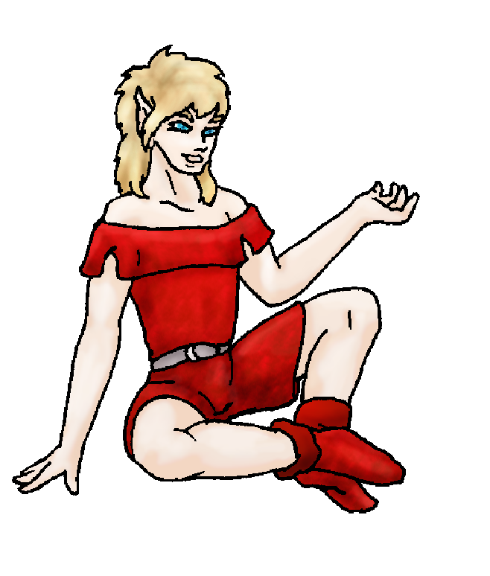 Character Sketch
Hair: Golden
Eyes: blue
Skintone: fair
Bond Beast Habits/etc:
BondAnimal
Fur/Skin: brown, grey marks
Eyes: yellow

About you as an elf
Your Name Means: Teller is your name, short for Storyteller of course. Your magic powers as well as your gift for speaking and understanding people gives you a strong spot in the Holt for keeping everyone’s stories together.
Your Appearance Is: Tall, pale and handsome. Your choice of red shaded leather clothing brings out the golden color of your hair, and bright blue, intense eyes.
You Are Located: In the Protector Holt, in the south-east corner of the continent, where plenty of different terrains and climates are found. Your den is placed in a meadow that has a stream running past it, plenty of sunlight and lots of space for elves to visit. Your den is built from shaped trees, tiered above one another with branch walkways between them.
Your Basic Statistics Mean: You’re about average for strength and health, taller than many elves; your nimbleness gives you an advantage when you have to hunt or root around for foods. You’re definitely considered quite handsome, and are well above average in intelligence. Your raw magical power is quite strong, and is used most often.
Your Skills Include: You’ve got an average ability to recall Earth, nothing that will get in the way when you start daydreaming, but enough that you do sometimes suddenly remember weird things like ‘hatchback pinto’ and ‘energizer bunny’. You don’t really concern yourself much with odd lores, you don’t really need to know what kind of rock is under your feet nor whether a pulley can be made … But you can certainly tell a friendly animal from a hostile one, and which berries and plants are good to eat apart from the poison ones. Where you excel is in communication and understanding people – there’s never been a time when you forgot a name or location of where an elf lives, or whether they enjoy certain activities. With this in mind you also are able to create stories about your friends here, some merely reliving their actual adventures, but others entirely fabricated. You’re not a remarkably physical elf but you do have strong survival and hunting skills essentially because you’re quite nimble. While you wouldn’t want to compete against some of the others in ways, you can certainly keep up running through the territory. You hunt with a spear, either hand held or thrown, easier to do when you’re riding your Cat. Your further interactions with the Holt’s population include dancing and singing, of course storytelling, and using your magic to create imaginary places in your mind suitable for those bizarre fabricated adventures to occur. Others depend upon your memory and storytelling ability to keep their records of hunts, scrapes and combat with the unusual spider-people alive.
Your Magic Powers Are: With a very strong raw magical ability like yours it’s only fitting that your Magic Feeling power be quite strong. Nearly twice as strong as most others, in fact, with this power you can detect not only what magics have shaped the objects around you, but who made them, when, and if they’re still around. You can ‘see’ visible traces of magic almost everywhere, glowing auras with colors shining in the spectrum of the elf’s magic powers. You can also detect what powers a young, or even unborn elf will be able to use! And because you’ve got a stunning memory for such things, you can help teach young elves to use powers you yourself don’t even have! All you need is for that power to have been shown to you, you can recall them and grasp how it’s done. Of course, your telepathic Sending ability is also extremely strong. You can contact any nearby elf within ten or twelve miles, as though they’re right next to you. Your mind-voice has been described as full, rich, and warm. You’ve got a strong ability to bond with a feline, see below. Beyond those powers which are essentially found in every elf, you have several others which you use almost daily. The more flexible one, Deep Sensing, you use to determine more subtle things about people’s moods, a group’s powers, it’s a more specific, concentrate-to-use version of Magic Feeling. This however you can use to sense emotions and deception, surface thoughts, and the like. It’s ‘empathy’ where Sending is ‘telepathy’, and ‘psychology’ where Magic Feeling is more ‘evaluation’. You have a form of Healing which only is useful when you’re sensing people, you can heal Mind-hurts and emotional trauma. Generally, a bad injury or a terrible fright while hunting will cause those, so it’s not something that comes up a lot. You have an above average ability to Hypnotize things and people – you can use this on animals while hunting, to calm them or cause them to stop attacking, but the main use you have is to capture the attention of an audience and keep their minds from wandering. And well beyond that: you have a Mind Snare power which can compete for the strongest in the Holt – with it, you can concentrate your efforts on placing another’s mind directly into an imaginary world of your own creation. It can be as simple as a blank, featureless expanse, or as complicated as a fairy-tale castle full with moat and dragon and princess to rescue! The point behind these things is mostly for entertainment – but you can also lock-send with someone to draw out their memories, and relive a valiant hunt or battle – and share those memories with those around you fully, as though they were the ‘star’ of the hunt! This tool is key for your instruction skills, you can simply draw from other’s experiences to teach the young or someone who is trying to learn something new. Normal skills such as wood-crafting and swimming can also be taught this way but physical skills must also of course come with actual training.
Your Bond Animal Is: Bough is a feline which came to you to be your companion. She is a slate-brown color, with dark grey markings on her face, paws and tail like a mountain lion’s. She is fairly average in many ways, a bit smaller and less strong than some of the cats in the Pride, but still gives the Wolf-pack something to think about. She enjoys lounging in trees, hence her name. She does hunt from that place as well, enjoying pouncing on things from above.
Special Information: There are precious few children in this world – they come about only when there’s a ‘Recognition’ between two elves, ones who are genetically compatible with one another. Thus your wait for any children to teach is kind of a few-and-far-between thing. (Mostly, out of character, because I don’t like pairing up people randomly knowing they might not think it’s cool in real life ☺ ) But there are (let’s just say there will be, anyway) children to come, and to teach.
You are known as a Longdays (Summer/Thirdsign) elf, with the star pattern “Falling Star” high in the night sky. Elves of this ‘zodiac’ sign have symbols: the quick Rabbit, the color light green and the extremely useful Wide-Boll tree element. Elves of this type often show Humor, Sensuality, Creativity, Generosity.

Subject: Elf Survey Form MAR DUN
Date: Sun, 24 Dec 2006 21:08:37 -0500

Necessary Stuff
Your Full Name: Steve Nickname or Title Birthday May 23 Act HOW Old? 35
Your Gender male, You like it this way
You Prefer the opposite sex
You are in a solid relationship

Appearance Stuff
You're about 6'2 feet tall, and you'd like to be the same
Your build is athletic and you'd like to be same
Hair Color blonde Change? none
Hair Style/Curl medium Change? longer
Eye Color blue Change? no Glasses? off
Skin Tone light Change? none
Are you 'Attractive'?yes Change? none
Are you 'Strong'? yes Change? none
Are you 'Smart'? in between Change? none
Are you 'Nimble'? yes Change? none
You'll be getting pointy ears - you want them elegant

Circle (likes) or Cross Out (dislikes)
Where do you like living? old friends

Climates you like sunny

What You Want Out of Life raise kids

Other:

Favorites...
Colors red
Animals cat
Music/Bands prince
Foods thai food
Sports if any soccer
Time of Day day
Season summer

Fears and Hates fake people

Any pets you'd like to drag along?
Any people you'd like to have with you? (supply them a sheet!)

