NAME: Taproot HOLT: Protector SOUL NAME: EARTHNAME: Mezzan
MATE: CHILDREN/RELATIVES: (coh)
MATURITY: Adult REAL AGE:12.5.71/36 YEAR/PORTAL OF ARRIVAL: 122/Hall SEX: Female

STR: 11 CON: 13 SIZ: 6 INT: 16 POW: 18 DEX: 17 APP: 15 Total: 96
SKILLS MAGIC POWERS WEAPONS / ARMOR / BOND ANIMAL
language memory: 26 % magic feeling: 28 % attack with knife (metal) : 66 %
animal lore: 74 % sending: 82 % damage 1d3 cutting/impale (defense) parry: 56 %
elf lore: 48 % animal bonding: 82 % attack with________________________________: ___%
healing lore: 32 % healing: ___% damage_______________________________parry: ___%
mechanical lore: 58 % (anti-heal: ___% missile boomerang (wood, small) : 76 %
mineral lore: 48 % (flesh shape: ___% damage 1d4 smashing range medium
plant lore: 84 % (shielding: ___% missile___________________________________: ___%
world lore: 32 % plant shape: 120 % damage___________________range______________
communicate: 72 % rock shape: ___% missiles carried__________________________________
wolf/anim comm: 88 % (metal shape: ___% shield_________________________________use: ___%
perception: 72 % (gem shape: ___% armor type______________elem:___bash:___cut:___othr:___
stealth: 80 % bone shape: ___% supplies carried / other skills / etc
climb: 64 % water shape: ___%
dodge: 70 % firestart: ___%
jump: 76 % levitation: ___%
swim: 56 % finding: ___%
throw: 66 % animal control: 72 % BOND ANIMALname: varies species: varies sex:
manipulate: 61 % mindsnare: ___% STR: CON: SIZ: INT: POW: DEX: APP:
ride any animal: 78 % hypnosis: ___% climb: ___% jump: ___% swim: ___%
hunt: 70 % astral projection: ___% stealth: ___% dodge: ___% percp: ___%
cloth weaving: 86 % deep sensing: ___% comm: ___% ______:___% ______:___%
dance/music: 56 % self shaping: ___% attack____________:___% attack________________:___%
home-design: 78 % :___% disposition
trapping: 70 % :___% magic or other abilities
literacy: 48 % :___% natural armor:___________elem:___bash:___cut:___othr:___
Personality Notes: Lives in a...:
Likes and Dislikes: Friends:
Habits and Places Preferred: Hunting Methods:
Bond Beast Personality:
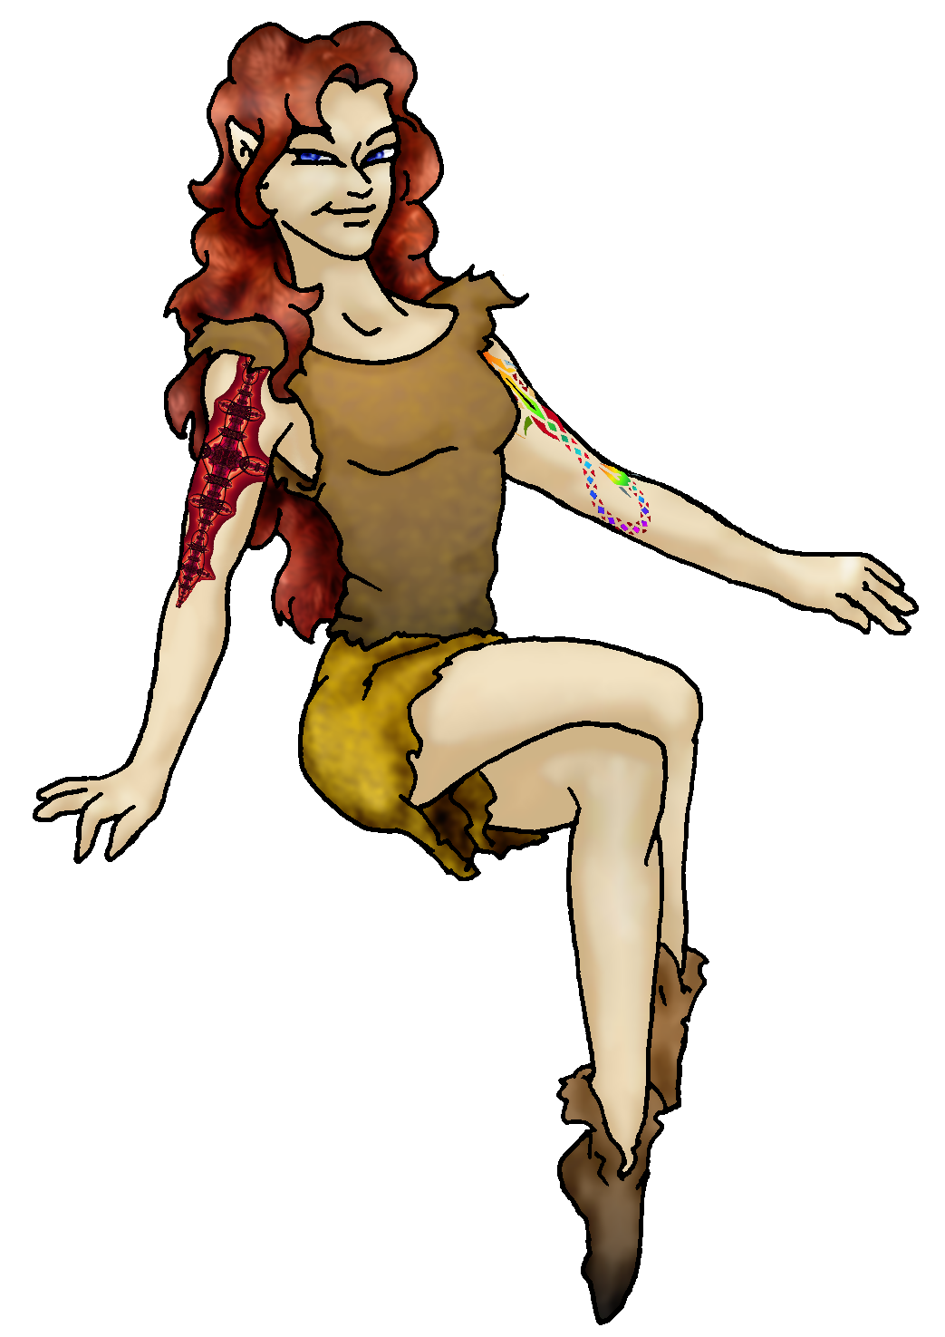 Character Sketch
Hair: Auburn red
Eyes: Blue
Skintone: fair, tats
Bond Beast Habits/etc:
BondAnimal
Fur/Skin:
Eyes:

About you as an elf
Your Name Means: Taproot gets a whole new meaning when you are around. Generally, it’s the big root that forms the basis for any tree or plant, sending out smaller roots for support and nutrient gathering. When you first decided to try your hand at shaping plants, you created a massive stalk straight out of almost nothing. Your plant shaping prowess is hardly matched around the world.
Your Appearance Is: Slender and elegant looking, you’ve got fair skin but like many in the Protector Holt you’ve decided to have some of the artists begin work doing tribal-type tattoos on your arms and back. You’ve actually helped make some of the dyes that they use! Your hair is long, flexibly curly and a rich autumn-leaf shade of red-gold. Your eyes are blue, and you most often are found wearing naturally-colored simple leather clothing that blends in with most of the rocky terrains you like to live on.
You Are Located: In the south-east portion of the continent, is the Protector Holt. It is a wide, varied land with a lot of space between elf-dens. Your home is shaped from a natural fissure in the mountainside, up near the snow line where even though it’s an equitorial locale, ‘Winter’ still means something. The den itself could have been called ‘natural’ before you got to it – but you noticed the roots of trees from above and expanded them until the very ground shook. Beyond the sturdy (and magically shaped, by someone else) dirt walls, rests a webbing of plant roots that keeps everything quite warm and safe from collapse. You have space for your weaving and spinning area, plus a nice snug sleep den, and then a bit of a wide spot where you can gather your animal friends for hunting and play just outside.
Your Basic Statistics Mean: You’re of average strength and health, slightly taller than others, and are typical in your athletic agility. You’re considered smart and pretty, and are of above average magical power.
Your Skills Include: Typical of an Otherforest elf, you have some scraps of memory from your ‘real life’ on Earth, but also typically, this memory is neither strong nor reliable. You can for instance remember enjoying the air conditioning in a long car trip – but have absolutely no idea what a car is, why it needs air conditioning, nor where you were going on that trip… As far as your ‘lores’ or theoretical knowledge, there’s hardly an animal, bird or insect that’s escaped your notice. You know the ins and outs of what is hybernating and what comes out to breed during the year. Your other area of expertise is of course trees and greenery. You can tell at a glance, even without your magic, what condition any given plant is in, plus what it might be useful for, and when it flowers or blooms. When a healer needs herbs, you can easily direct them to where they are likely to be growing; spices? You’ve got em. Otherwise you’re also reasonably talented at fixing up physical gadgets such as your loom and weaving and spindling equipment. You know enough about the stones around you to have someone else shape them, and while you do know pretty much everyone in the Holt by their appearance or their mental voice, you hardly concentrate on gossip. As far as your survival skills go, you’re very good at remaining quiet and stealthy, understanding the sounds and body language – and even scents – of the animals around you. You can hunt with a small wooden boomerang, it’s easier to throw than just a plain stick, but basically you’ve got animal friends to go get your food for you – and you can ride nearly any animal that is big enough to sit on. You’re more expert at trapping and setting up small snares than going out and actually roughing it, so one of your typical days will include riding out with a wolf or cat and checking a couple traps. You can use a knife in defense, but unless it’s a falling rock you can either shape your way out of a broken branch, or delay an attack by an animal. Where you really start to shine, however, is when you get to be creative. You collect fibers from plants and weave a very nice cloth – you hand it off or trade it for other goods, to those who create the actual pieces of clothing, but as far as you’re concerned a drape works just as well as a fitted piece if you’re cold. You also enjoy the ability to not only shape trees but design them as homes for elves (or wolves, cats, birds… whoever enjoys them). Like most elves in this Holt, you are reasonably literate, though you know only one of the three distinct alphabets of the planet – the one found at Dare’s Valley where you started your journey.
Your Magic Powers Are: As all elves have, you’ve got the ability to sense where magic has been performed, such as shaping a tree branch or a piece of metal. Your skill in Magic Feeling is low, you can sense that something’s been shaped, but not clearly who did it or when. Also typically, you’ve got a reasonable skill at telepathy, or Sending. You are better at small, intimate groups or singly, than big bunches of people, but are quite adept at thinking to someone farther away than most. Your animal-bonding skill is strong, having gotten you several semi-permanent animal bonds, but unlike many others in the Holt, you can also use your magic to actively control more than just your bond-beasts. From birds and lizards to deer and bear, if it’s a critter, you can generally make it change its mind about chasing you – or lead it into an area where it’s more safe. No sense in letting animals die in a fire or mudslide, right? With this power, it strongly depends on how agitated the animal is, how many there are, and how far away they are. A single charging bear you can focus your energies upon and escape harm if you know it’s nearby – but an angry herd of mudboar (a large, tusked wild pig) would give you a run for your money. You can also use this power to soothe other people’s bond animals if they’ve been injured – though you cannot heal them, you can keep them calm until someone who has that power arrives. In addition to this, your much stronger power is that of Plant Shaping. You’ve got an almost ridiculous ability to mold plants to your whim, grow seeds into trees, make plants flower and drop fruit out of season, remove or change toxins… all of it. If it has to do with something that’s a plant, even a spore or fungus, it’s in your domain. You have a very strong sense of what plants are around you at all times, plus what they’re generally good for: if they’re toxic or edible, if they’re willing to be shaped easily (some trees want to be shaped, you know this to be true…) or if they are diseased. With this power, you’ve got a steady collection of silken fibers, hemp, sisal and cotton that you then create thread to make cloth out of. Dyes that come from flowers or parts of plants are also easily in your ability to coax out of a leaf or flower. You can cause a seed to grow into a 10 foot tall tree within an hour, provided it’s got enough healthy soil and water around to give it the nutrients. As for dead plant matter, you can take an arm-length branch and turn it into any given item (from a simple smooth walking stick, to an ornately detailed musical instrument) in about fifteen minutes.
Your Bond Animal Is: as above, you’ve got several bond animals that come when you call for them (mentally or vocally). These include a pair of felines which, while they’re accepted by the mountain lion pack nearby, are clearly not the same as those big cats, as well as a wolf which seems very, very familiar to you… Other animals come and go, but those three remain on most of the time. With them and the others, you hardly have to hunt by yourself: they go and fetch ducks, rabbits, whatever they can get their fangs around. There have been times when you’ve had to subdue a dangerous animal long enough to get away from it, but you’d never use your powers to outright kill an animal. You let nature take its course, but it’d be wrong to just make them want to be hunted down…
Special Information: The plants which you shape can send messages to distant places. Believe it or not, the roots of the FogCatcher trees which are the biggest anywhere, are connected together around the world. Some places the connection might be thin, one root touching barely at the edge of another’s spread, but through this network a consciousness has developed. You can send ideas or even cause a distant tree to shape into something (such as a symbolic piece of art appearing on the bark showing a hunt), and it will happen. There is one other plant-shaper who is as powerful as you, and he lives all the way on the other side of the world – but you can still share information (albeit not quickly) through the very trees!
You are known as a Deathsleep (Winter/Seventhsign) season Elf, while the star-sign of the Arrowhead is in the night sky. Elves of this ‘sign’ are represented by the Longtooth cat, the color Black, and the beautiful Orchid. They’re often known as Canny, secretive, Dangerous, Flirtatious.

"Luvvums" luvvums@yahoo.com
Your Full Name Nickname or Title: Mezzan (Lori)* I know you from... CoH

Birthday 12/05/71 Act HOW Old? 30
* Your working E-mail address Luvvums@yahoo.com
* Your Gender Female You like it this way You Prefer ... (CHOOSE) To keep your sexuality to yourself The same sex
You are: (CHOOSE) in a solid relationship Dating Someone (... Kind of, sort of)

Appearance Stuff (I need at least a few of these)
You’re about how tall? 6 foot and you’d like to be (CHOOSE) Shorter
Your build is? Skinnier and you’d like to be (CHOOSE) Fatter
Hair Color? Blonde Change? (CHOOSE) I like red hair.
Hair Style? Very long, kinda curly Change? (CHOOSE) No Change
Hair Length? Very long Change? (CHOOSE) No Change
Eye Color? Blue Change to what? Glasses On/Need em!
Skin Tone? Pale Change? (CHOOSE) Tattoo/Marked

* Consider how you feel about yourself and how others may view you. Answer yes or no, and then choose your changes if any.
Are you ‘Attractive’? Yes, kind of average but not ugly Change? No
Are you ‘Strong’? No Change? Stronger
Are you ‘Smart’? Yes Change? No
Are you ‘Nimble’ or 'Agile'? No Change? No
You’ll be getting pointy ears! Choose from these examples please, Short

Where do you like living? (Choose as many as you like)
Alone Quiet Neighborhood Isolated Village

Climates you like (choose as many as you like, list what you really don't like in the 'other' section!):
Freezing Snow Sleet Foggy Cloudy

Terrains you like (choose as many as you like, if you really don't like something say so too):
Canyons Rocky Underground/Caves

What You Want Out of Life… (choose as many as you like! list what you really don't like in the 'other' section!)
Plant a tree Slack off Build and Construct Isolate yourself Create clothing Raise pets and animals Learn Snuggle in front of a warm fire
Build an igloo Retire early and relax

* Favorites:
Colors Yellow
Animals Dogs or cats, varies by day
Foods Itallian type food, pastas
Sports if any None!
Time of Day Evening
Season Winter
Other info (anything left out, anything important you want to share):
Do you have any Fears and Hates? Afraid of people

Any pets you’d like to drag along? PLEASE describe (at least gender, breed, appearance)

My dog, kind of a mutt, dark hair. My cat, Black and white, and my other cat, lynx colored and fat.

Any people you’d like to have with you? (supply them the link!) Nope.
Did someone recommend this link to YOU? PLEASE tell me who they are! :D Zek did! Zek did it!

Stock used: tattoo 1- darkprincedemian, tattoo 2 – final-flight (both off da now); background MFWT_03by M3_productions; green vines lill-vines2 by lill-stock; live vines vines_stock_1, vines_stock_5 by nekrosys

