NAME: Quicken HOLT: Protector SOUL NAME: Nylonus EARTHNAME: James Guertin
MATE: CHILDREN/RELATIVES: (coh)
MATURITY: adult REAL AGE: 1.17.67 YEAR/PORTAL OF ARRIVAL: 122/Hall SEX: Male

STR: 13 CON: 12/18 SIZ: 5 INT: 16 POW: 19 DEX: 18 APP: 17 Total: 100
SKILLS MAGIC POWERS WEAPONS / ARMOR / BOND ANIMAL
language memory: 19 % magic feeling: 29 % attack with 1 handed staff (wood) : 62 %
animal lore: 42 % sending: 86 % damage 1d6 smashing parry: 62 %
elf lore: 48 % wolf bonding: 76 % attack with________________________________: ___%
healing lore: 32 % healing: ___% damage_______________________________parry: ___%
mechanical lore: 32 % (anti-heal: ___% missile line and hook (fishing) : 82 %
mineral lore: 32 % (flesh shape: ___% damage 1d3+entangle range medium (water)
plant lore: 32 % (shielding: ___% missile hooked whip/lasso (land) : 72 %
world lore: 58 % plant shape: ___% damage 1d4+entangle range medium
communicate: 76 % rock shape: ___% missiles carried__________________________________
wolf/anim comm: 67 % (metal shape: ___% shield_________________________________use: ___%
perception: 86 % (gem shape: ___% armor type______________elem:___bash:___cut:___othr:___
stealth: 84 % bone shape: ___% supplies carried / other skills / etc
climb: 62 % water shape: 76 %
dodge: 96 % firestart: ___%
jump: 82 % levitation: * ___%
swim: 80 % finding: ___%
throw: 62 % animal bond: ___% BOND ANIMALname: species: sex:
manipulate: 56 % mindsnare: ___% STR: CON: SIZ: INT: POW: DEX: APP:
ride (animal): 72 % hypnosis: ___% climb: ___% jump: ___% swim: ___%
hunt: 72 % astral projection: ___% stealth: ___% dodge: ___% percp: ___%
fishing: 70 % deep sensing: ___% comm: ___% ______:___% ______:___%
dancing/music: 70 % self shaping: ___% attack____________:___% attack________________:___%
water-sports: 70 % * speed (self): 96 % disposition
trapping: 68 % * speed (other): 38 % magic or other abilities
literacy: 74 % :___% natural armor:___________elem:___bash:___cut:___othr:___
Personality Notes: Lives in a...:
Likes and Dislikes: Friends:
Habits and Places Preferred: Hunting Methods:
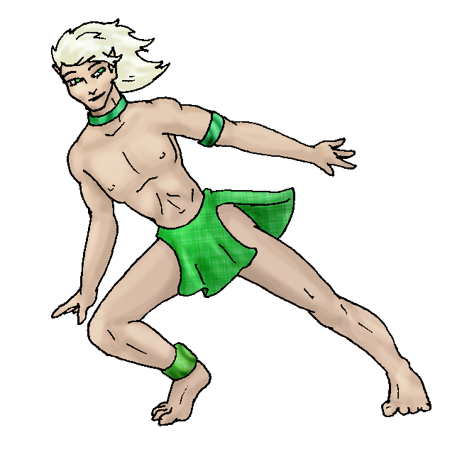
Bond Beast Personality:
Character Sketch
Hair: silver-white
Eyes: green
Skintone: fair-tan
Bond Beast Habits/etc:
BondAnimal
Fur/Skin:
Eyes:

About you as an elf
Your Name Means: Quicken is not just what you do, it’s what you cause! Whenever you’re out and about, running from one part of the Holt to the next, it’s at full tilt – and if anyone wants to join you, they can. You have that ability, to create speed in someone else. (See below)
Your Appearance Is: Muscular and sleek, with fair skin (how do you not just burn when you’re out there wearing just that?) and shining silver-white hair, bright green eyes. Eyes often follow you when you’re not Quickened.
You Are Located: In the Protector Holt lands, south-east corner of the continent. Your den is almost dead center in the Holt, around 5 thousand feet up in the woodland hills, with the big mountain peak to the north-west, and all kinds of ways to get to the inland sea to the south-east. You follow those waterways to get around. Your den itself is a long, twisty wooden corridor of shaped and hand-tied plants, with a sort of ‘blind’ feature that lets you see out onto the wide, slow moving river just outside, and keeps unwanted predators or people away. However, you’ve got all kinds of room for parties, people to stay over, and even a smoke-house on the north end for the delicious fish that comes from that same river.
Your Basic Statistics Mean: You’re average in size and strength, healthy and just over average for dexterity and agility. The second score in Constitution is for your Speed power which you’re absolutely amazing in endurance. You’re pretty smart, able to figure out things and play with word games or even the little card-games which others invent. You’re considered one of the most attractive in the Holt, and your magic power is above average.
Your Skills Include: You have a typical memory of Earth, you’re able to pick out words or ideas, but they don’t concern you much. You have a basic understanding of most of the surroundings, including people, plants, animals and the terrain. Especially the terrain – actually you know most of the Holt like the back of your hand. You’re literate to an excellent degree and you’re able to deliver notes to folks around the Holt. When it comes to physical things you enjoy a lot of obsticals in your way if anything to challenge your powers to dodge them. Otherwise you use trapping and fishing to occupy your time. You’re a great dancer, but you also love playing in the water. From the beaches to the south all the way up to the frozen ponds on the mountain, you’ve got some kind of game plan for how you’re going to get in there and play. When you’re hunting with others, you tend to use a staff to smack things around. But when you’ve got time to yourself, you take out the fishing line and somehow have the patience to stand for hours in the chill river. No one else can figure that out either, for someone who’s on the move so much, you sure do stand perfectly still for a long time. You have a variation on the fish hook theme for land animals, kind of a whip with hooks on the end which snag small animals or birds. You prefer the fish, they’re much easier to clean and eat… You do not bother much with riding animals, but you’re competent enough to sit on some wolf’s back while they walk.
Your Magic Powers Are: Your Magic Feeling power is average, you’re able to sense the presence of magic on an item or a person, that’s about all you need to worry about. Your telepathic Sending is strong and used to direct you toward people when you need to deliver something. The feeling they get is of a weird doppler-shift in your thought sounds, while you’re far away it’s slower and lower, then you speedily get close and the pitch of your mind raises. Though you do carry Bonding magic, you’re not currently attached to an animal. There aren’t really any that could keep up with you anyway. Of your other powers, the main one you use all the time is that of Speed. You travel up to six times faster than anyone else, and don’t tire anywhere near that fast. When you’re just walking around, you might tire out after two hours, but on your speed jaunts, you could go for half a day without getting a cramp. Your reaction time is so fast, you can catch arrows or flies out of the air, and let them go again without bothering their flight path. Along with this power is the ability to grant it to others for a short period. You actually supply the energy for this, so when you’re paired up with someone, you will tire at a more normal rate. But they can keep up with you for a while and that’s pretty fun. You can speak and breathe normally but most often you’ll be Sending to save your breath. Once the power wears off, some people stiffen up and need a healer to help their muscles relax, but you don’t have that problem. Your other, stronger ability is that of water shaping. You can purify water that’s gone stagnant, breathe under the water indefinitely while using the power, and even shape it a little into wobbly objects. Ice is easier to shape, but water’s much more fun since people don’t expect a sculpture out of liquid.
Your Bond Animal Is: You’re not currently bonded to an animal.
Special Information: You’re ‘always done’. You do things quickly and efficiently, so far from being a ‘slacker’ you’re pretty much just already done with whatever task you needed to do. That’s why it’s nice to be able to sprint around, look like you’re in a hurry, and when people catch you snoozing by the lake or standing in freezing water with nothin but a loincloth on and a fishing pole in one hand, they’re so amazed. You aren’t really a creature of extremes, you enjoy every part of the day’s activities.
You are known as a Hotdays (Late Summer/Fouthsign) elf, with the star-pattern of Lighting Bolt in the night sky, the burly Bear animal totem, the colors Yellow and Gold, and the ubiquitous Longstem grass symbol. Elves of this perceived ‘season’ (it’s not based on time of arrival or birth) are sometimes seen with Laziness, Nettling personalities, though they are also given to Stealth, Hope. These things aren’t found in every elf, it’s just a guideline – and also one that’s purely ‘perception’ on the part of others, not necessarily the ‘true’ you.

big_jim_91602@yahoo.com Date: Tue, 05 Dec 2006 11:37:59 -0500

Necessary Stuff
Your Full Name: James Guertin Nickname or Title Nylonus Birthday Jan 17, 1967 Act HOW Old? 39
Your Gender male, You like it this way
You Prefer the same sex
You are in single and loving it

Appearance Stuff
You're about 5ft 5inches feet tall, and you'd like to be taller
Your build is average and you'd like to be same
Hair Color greying Change? lighter
Hair Style/Curl short Change? longer
Eye Color brown Change? yes Glasses? off
Skin Tone light Change? none
Are you 'Attractive'?yes Change? none
Are you 'Strong'? yes Change? none
Are you 'Smart'? yes Change? none
Are you 'Nimble'? yes Change? none
You'll be getting pointy ears - you want them short

Circle (likes) or Cross Out (dislikes)
Where do you like living? busy town

Climates you like seasonal mountainous forest

What You Want Out of Life see the world surf joke go fishing slack off
read

Other:

Favorites...
Colors Green
Animals
Music/Bands Alternative / Classical
Foods
Sports if any anything with motorcycles
Time of Day early morning
Season autumn

Fears and Hates snakes

Any pets you'd like to drag along?
Any people you'd like to have with you? (supply them a sheet!)

