NAME: Rufus HOLT: Protector SOUL NAME: OJ EARTHNAME: Rob O
MATE: CHILDREN/RELATIVES: (coh)
MATURITY: adult REAL AGE:9.9.74/34 YEAR/PORTAL OF ARRIVAL: 122/Hall SEX: Male

STR: 10 CON: 13 SIZ: 6 INT: 15 POW: 20 DEX: 18 APP: 14 Total: 96
SKILLS MAGIC POWERS WEAPONS / ARMOR / BOND ANIMAL
language memory: 30 % magic feeling: 60 % attack with hand/claw : 66 %
animal lore: 45 % sending: 100 % damage 1d4 cutting parry: 33 %
elf lore: 70 % cat bonding: 80 % attack with wooden club : 86 %
healing lore: 30 % healing: ___% damage 1d6 smashing parry: 66 %
mechanical lore: 30 % (anti-heal: ___% missile net (dropped) : 76 %
mineral lore: 30 % (flesh shape: ___% damage 1d3 smashing / entangle range short
plant lore: 45 % (shielding: ___% missile___________________________________: ___%
world lore: 30 % plant shape: ___% damage___________________range______________
communicate: 78 % rock shape: ___% missiles carried__________________________________
animal comm: 70 % (metal shape: ___% shield_________________________________use: ___%
perception: 80 % (gem shape: ___% armor type______________elem:___bash:___cut:___othr:___
stealth: 86 % bone shape: ___% supplies carried / other skills / etc
climb: 76 % water shape: ___%
dodge: 86 % firestart: ___%
jump: 76 % levitation: 20 %
swim: 56 % finding: ___%
throw: 66 % animal bond: ___% BOND ANIMALname: Stump species: big cat sex: male
manipulate: 64 % mindsnare: ___% STR:19 CON:10 SIZ:18 INT:10 POW:12 DEX:22 APP:10
ride cat: 72 % hypnosis: ___% climb: 82 % jump: 80 % swim: 44 %
hunt: 76 % astral projection: ___% stealth: 78 % dodge: 68 % percp: 68 %
cooking: 76 % deep sensing: ___% comm: 44 % ______:___% ______:___%
dancing: 64 % self shaping: 80 % attack claw : 82 % attack bite : 72 %
music/sing: 58 % :___% disposition
trapping: 76 % :___% magic or other abilities
artistry: 66 % :___% natural armor:___________elem:___bash:___cut:___othr:___
Personality Notes: Lives in a...:
Likes and Dislikes: Friends:
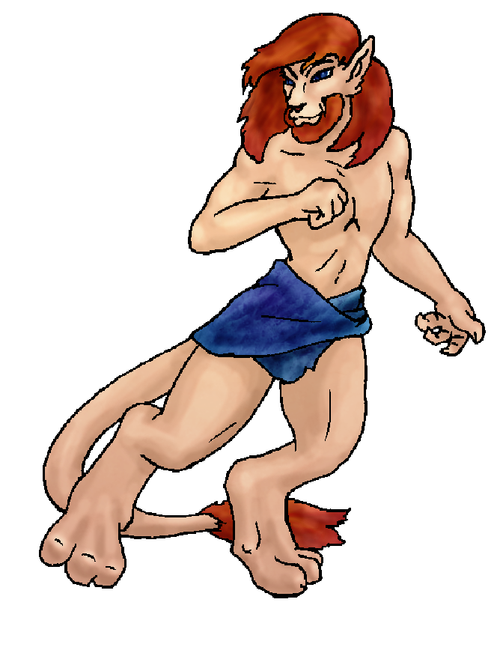
Habits and Places Preferred: Hunting Methods:
Bond Beast Personality:
Character Sketch
Hair: red
Eyes: blue
Skintone: furry (light)
Bond Beast Habits/etc:
BondAnimal
Fur/Skin: dk brown, black mks
Eyes: grey-blue

About you as an elf
Your Name Means: Rufus is a word meaning ‘red’ and that’s definitely what you have in spades. Red mane, beard and tail-tip, when you’re in your half-cat shape – but more than that, while you shift into your fully feline form, your fur covering is entirely red.
Your Appearance Is: In your elfin shape, you’re fair skinned (almost mushroom pale) with red hair, dark blue eyes, and a simple choice of blue loincloth as clothing. But that’s not where you end, by a long shot. Your ears change shape and get fur tips, you grow a long tail, and your hands and feet turn to nimble paws! The half-elf half-cat shape that is quite popular among Protector Holt elves is one you normally wander around in, mainly because it provides you with a bit more skin protection with the slight fur covering – and you can still talk and use a weapon. But you’ve got another shape too, that of your four-footed red-cat shape. While you look a lot like many of the cougar-type felines in the area your cat shape is a little smaller than they are, but more like a lion in that you have a distinct furry tip to your tail and more of a mane/shaggy beard on your neck and head in that shape.
You Are Located: In the Protector holt lands, in the deep south-east of the continent. This area has a lot of different terrains and climates to choose from! Your den is kind of hard to pin down, since it is basically “wherever you land for the day”. However, you do have a series of nooks and hideaways around the flatter section toward the middle-altitude area of the holt. This place has a wide praire of grasses, short trees, brooks and marshes, and is surrounded on one side by tall cliffs and the others by craggy canyons that lead down toward lower areas of the holt. You often stick around to sleep in other people’s dens – welcome because you’re fun to be around, and plus you keep them warm with your furry self!
Your Basic Statistics Mean: You’re fairly average in many ways, size and strength, health and appearance. But you’ve got a strong dexterity to your hands and body, you’re considered pretty smart, and you have a very high magical power.
Your Skills Include: As with many elves, you’ve got a fairly poor ability to remember things about Earth, your old home. But you use it only to jog your hand to draw something unique or to solve a problem that otherwise seems insurmountable. Your intellectual lores are reasonably average – though you concentrate on knowing elves inside and out. Certianly you know your way around what rocks to use for sparks on a fire, what plants are poisonous, and where exactly in the world you are, but you don’t really much depend on those things, you’re more social and don’t worry that anyone like you would have to heal a group or lead them into a strange place. Your survival skills are all strong, though nothing stands out particularly you do have a very quiet step in the woods, sneaking around and observing are easy for you. You hunt and trap adequately well, often using a net from above as you perch on a branch, then coming down with a hard wooden club to do the beast in – but you can also hunt with your feline shape quite easily. Mostly for small prey there. But it’s what you do with the prey after you’ve gotten it down that’s important! You’re an excellent cook, if there are a bunch of leftover bits you throw em in a pot and make a great spicy stew. You’ve got a steady, artistic hand and can draw using charcoal sticks – often upon flat rocks or smooth hides.
Your Magic Powers Are: With a very strong Magic Feeling power, you can sense detailed information about the magic that’s been used around you. From a distance, you can see auras of bright color and subtle shade, each of them particular to a specific person. So if you’re looking at a gathering of shaped trees and rocks, you know excatly which branch was made by whom, what stone reaches up to be used as a stool, and how long ago this was done to each piece. With this power, also, you can somewhat detect the minds of those around you more easily, so if someone’s hiding or is injured and cannot call out, you can cast around to detect them. Your telepathic Sending power is very strong – your mind is excellent at distance thought, you can snatch a stray mental conversation from several miles away. Your mental voice is pleasantly deep, with what others describe as a distinct purr to it. You have a strong cat-bonding power, which led your animal-friend to come to your side. Beyond those things, you’ve got two other powers. The more obvious is your Shape Shifting or self-shaping power. With it you can change what you look like, down to your genetics, into a feline shape. Some others use this power to change into other things, but you concentrate on only one alternate shape. You spend so much time between cat and elf that you do actually have to concentrate to be “fully” elfin. This power allows you to move on four feet when two would be difficult – climbing and hiding, pursuing small, quick prey, and dealing a hard blow with a clawed paw hand if you need to get away from larger animals. Other elves have paired up with their bond cats (or wolves, or dolphins or birds… there are a few weirdoes out there) but you doubt that you’d really want to go that far… would you? Lastly but not least is your ability to float in the air with Levitation. However, this power is not really all you’d imagine it could be: for you, it’s more like “hovering” when you really need it to. Because you’ve got such a strong basic Power, you can keep this hovering up almost indefinitely, but if you actually need to do anything interesting with it, like spin around or catch multiple objects, lift anyone else, etc – you’re not going to be able to do it easily. It is very handy for when you’re leaping across a wide gap, trying to climb something you ought not, or keeping yourself from smashing against sharp stones if you fall. The moment you really start thinking about it, is usually when it cuts out, so you’d best be prepared for a few scrapes. Better than a bunch of broken bones!
Your Bond Animal Is: Stump, a male big cat from the local pride, is not much to write home about. He’s dark brown with black markings, he looks like a tree stump when he’s curled up in a cat-ball. He’s not big or strong enough to challenge for a leadership role, but he is quite nimble. Nimble enough to get himself up into places that he ought not to be, and that’s often what causes you to use your power of hovering to get down yourself, once you’ve prodded him to get down…
Special Information: If there’s an elf in the holt who hasn’t been pranked by you, they’re rare indeed. Since you take time with everyone you can, knowing when they’re up, what seasons they like, who they hang out with, etc. You have a really good grip on what you can do to throw a burr into things. If it’s dunking a fire-shaper with water, having an angry nest of hornets go after the leather-worker, or even putting a tiny hole in a drinking glass to watch someone get a bit doused… you’ve probably done it. Fortunately there are others in the Holt who practice these jokes – and you aren’t always the only one doing them to people. You aren’t always the first on their hit list, afterwards…
You are known as a Hotdays (Late Summer/Fouthsign) elf, with the star-sign of the Lightning Bolt in the night sky. Elves of this nature are represented by the burly Bear, the colors Yellow/Gold, and Longstem Grass which grows almost everywhere this time of year. Elves in this ‘zodiac sign’ sometimes are equated with Laziness, Nettling, but also Stealth, Hope.

pvtosterman@yahoo.com Add to Address BookAdd to Address Book Add Mobile Alert
Subject: Elf Survey Form
Date: Wed, 10 Jan 2007 10:34:27 -0500

Necessary Stuff
Your Full Name: Rob O Nickname or Title OJ Birthday Sept 9 1974 Act HOW Old? 45
Your Gender male, You wouldn't mind changing it
You Prefer the opposite sex
You are in a solid relationship

Appearance Stuff
You're about 5 feet tall, and you'd like to be taller
Your build is average and you'd like to be same
Hair Color Red Change? none
Hair Style/Curl Long Change? none
Eye Color Blue Change? Glasses? off
Skin Tone Pale Change? none
Are you 'Attractive'?no Change? prettier
Are you 'Strong'? no Change? none
Are you 'Smart'? yes Change? none
Are you 'Nimble'? sort of Change? none
You'll be getting pointy ears - you want them elegant

Circle (likes) or Cross Out (dislikes)
Where do you like living? many people old friends bustling city

Climates you like chilly seasonal mild warm foggy flatland plains river forest meadow

What You Want Out of Life make noise joke find a soul-mate draw/create slack off raise kids fly like an eagle cook a mountain of food

Other:

Favorites...
Colors Blue
Animals Cats
Music/Bands None
Foods None
Sports if any
Time of Day evening
Season autumn

Fears and Hates

Any pets you'd like to drag along? Serendipity
Any people you'd like to have with you? (supply them a sheet!)

