NAME: Coop HOLT: Protector SOUL NAME: proton chicken EARTHNAME: Tim Kirchhoff
MATE: CHILDREN/RELATIVES: (coh)
MATURITY: Adult REAL AGE:6.12.73/35 YEAR/PORTAL OF ARRIVAL: 122/Hall SEX: M

STR: 13 CON: 15 SIZ: 6 INT: 14 POW: 17 DEX: 18 APP: 15 Total: 98
SKILLS MAGIC POWERS WEAPONS / ARMOR / BOND ANIMAL
language memory: 28 % magic feeling: 34 % attack with 1 handed spear (wood) : 62 %
animal lore: 48 % sending: 78 % damage 1d6 impale parry: 60 %
elf lore: 52 % bird bonding: 68 % attack with________________________________: ___%
healing lore: 38 % healing: ___% damage_______________________________parry: ___%
mechanical lore: 52 % (anti-heal: ___% missile bolos (leather/metal) : 72 %
mineral lore: 28 % (flesh shape: * ___% damage 1d2 smashing + entangle range medium
plant lore: 64 % (shielding: ___% missile___________________________________: ___%
world lore: 52 % plant shape: 17 % damage___________________range______________
communicate: 68 % rock shape: ___% missiles carried__________________________________
wolf/anim comm: 62 % (metal shape: ___% shield_________________________________use: ___%
perception: 78 % (gem shape: ___% armor type______________elem:___bash:___cut:___othr:___
stealth: 70 % bone shape: ___% supplies carried / other skills / etc
climb: 62 % water shape: ___%
dodge: 70 % firestart: ___%
jump: 72 % levitation: ___%
swim: 51 % finding: ___%
throw: 78 % bird command: 68 % BOND ANIMALname: Yeller species: … chocobo? sex: m
manipulate: 64 % mindsnare: 51 % STR:12 CON:16 SIZ:16 INT:5 POW: 9 DEX:11 APP:12
ride bird thing : 72 % hypnosis: ___% climb: ___% jump: ___% swim: ___%
hunt: 70 % astral projection: ___% stealth: ___% dodge: ___% percp: ___%
tanning hides: 46 % deep sensing: ___% comm: ___% ______:___% ______:___%
dancing: 66 % self shaping: ___% attack kick : 66 % attack giant peck: 46 %
music/sing: 56 % *leather-shape: 34 % disposition
trapping: 78 % :___% magic or other abilities
literacy: 52 % :___% natural armor:___________elem:___bash:___cut:___othr:___
Personality Notes: Lives in a...:
Likes and Dislikes: Friends:
Habits and Places Preferred: Hunting Methods:
Bond Beast Personality:
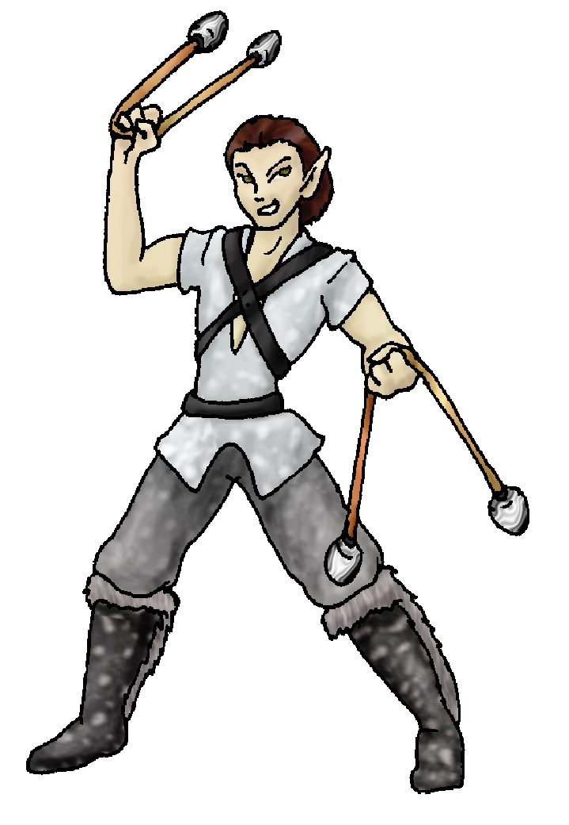 Character Sketch
Hair: browns
Eyes: hazel
Skintone: olive
Bond Beast Habits/etc:
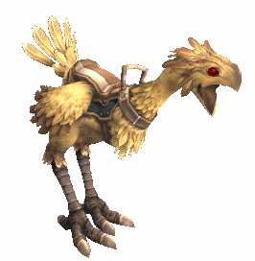 BondAnimal
Fur/Skin: yellow feathers
Eyes: eerie red

About you as an elf
Your Name Means: Coop is only the latest of names you’ve had. It indicates your ability to control birds, of course, but so have all the others… The first of which was, shortly after you started using bolos to hunt, “Fowlsnatch”. That one didn’t last too long. Everyone kept laughing.
Your Appearance Is: Tall, fair-skinned with a bit of that olive-tan thing going. Your hair is kept pretty short and is shiny brown, your eyes, very expressive hazelgreen. You wear shades of grey and silver, natural colors found on some of the animals you’ve managed to take down.
You Are Located: in the Protector Holt, on the south-east corner of the continent where elves live. Your den is down all the way by the big bay, you have a view of the huge inner sea, but also you’re within a long-day’s walk to the actual ocean and many other places. The den you have is made from trees, living ones, which you’ve been able to gently hollow out using the barest of your Plant powers. You have quite a sprawl of dens, really, some for your leather work and others for weapons, and a warm soft nook for sleeping as well.
Your Basic Statistics Mean: You’re above average in size, health and strength, pretty good looking, average in intelligence, agility and magical power.
Your Skills Include: an average memory of Earthly things, you probably use some of those weird flashbacks you get to inspire your work. You’ve got a good ability with people, not just talking but understanding body language and moods. You can create objects well enough such as harnesses, bridles and riding gear for animals which aren’t intelligent enough to allow you to ride without. Your knowledge of plants is good, you chose your home dens after a lot of deliberation about the trees in the area. While you enjoy hunting you’re more of a trapper at heart, it’s easier for you to nab something in a net or spring loaded box than to race around with your spear or bolos – though you’re pretty good with bolos on the back of your bird-creature. You can survive in the wild with relative ease, though you don’t concentrate too much on roughing it, prefering to remain near civilization. You are responsible for creating basic cured hides for others to make into more artistic things, there are plenty of hides to go around out there, so you’ve usually got a den full of half-cured stiff hides you’re working on. Your magic helps with that too. Like many elves here in the Protector holt, you’re literate enough to read, but you use a kind of chickenscratch writing that few people can understand.
Your Magic Powers Are: Your Magic Feeling ability, to see which items have been shaped or whether an elf has done some other kind of magic nearby is average, you keep note about who shaped what, so you know who to give items back to when you’ve borrowed them. Your telepathy, Sending, is above average and you frequently use it to communicate to people who are on the water of the bay nearby. You don’t have a wolf-bonding power, instead it’s changed to allow you to befriend a certain … odd… bird thing. Aside from those powers, you have some others which you use more or less often. Strongest is your ability to control and summon birds of nearly any type and size. They won’t fly into your nets voluntarily, right? Well they will if you give them a nudge. You don’t over-use this ability, because you also have a kind of emotional sensitivity to them – and you don’t really care to feel the deaths of too many birds. You have a strange power that is fairly rare, that of ‘leather shaping’ – you’ve been told that this is a variation on a healing-type power, but it only works on hide, leather and dead flesh. You can make a stiff hide soft enough to work again, and also to help infuse colored dyes into furs. You’ve got a touch of Plant Shaping, it’s more of an innate comfort around certain plants, your dens ‘respond’ to you, though you can consciously shape them shut or open during storms – they’re usually just conforming to your needs (if you want a soft place to sit and read, or if you need a little ledge for something, it’s there pretty quickly). Lastly but strongly, you’ve got the ability to ensnare minds of other elves – this is a power which can entertain as much as confuse. Some folks use it to merely distract, or aid in their story telling. You, like others, create imaginary ‘places’ inside your mind when using this power, and captivate another elf’s mind – while sending, or if they want to challenge themselves, they go ‘in’ your mind voluntarily. You can keep this up for about 3 hours, before you really have to rest.
Your Bond Animal Is: Yeller … is named because he’s yellow. Very yellow. And, because that noise he makes is hardly as ‘cute’ as you’d think coming from a bird which as apparently straight out of a video game. With long, tall legs, a teardrop-shaped body, and a thick, long neck, this bird looks a lot more like an overstuffed ostrich than anything else, but it is unique around here. It’s huge beak is capable of snapping heavy branches in two, but he usually just roots around in loose dirt for his meals. You can ride this weird beast only with the use of a saddle and harness, which you had to develop yourself. Otherwise you’d pretty much slip off the moment he moved. He can’t fly, thank goodness, his short wings provide a little balance but no lift at all.
Special Information: You really enjoy it when one or more of the ‘ice shapers’ in the holt comes down to the beach and freezes up a spot for you and some others to play ice-sports on. You don’t really feel like trekking all the way up to the peaks to play a little hockey, after all.
You are known as a Whitecold (Late Winter/Eighthsign) elf, one whose ‘zodiac’ sign shows the star pattern of the Hunter in the night sky. Represented by the animal Wolf, the color White and the long-lived Evergreens as symbols. Elves of this ‘season’ are often Eventempered, balanced, and show Wisdom, Comfort.

PROTON CHICKEN
Date: Fri, 15 Dec 2006 00:07:36 -0500

Necessary Stuff
Your Full Name: Tim Kirchhoff Nickname or Title Birthday 6/12/1973 Act HOW Old? 40
Your Gender male, You like it this way
You Prefer the opposite sex
You are in a solid relationship

Appearance Stuff
You're about 6 feet tall, and you'd like to be the same
Your build is athletic and you'd like to be same
Hair Color brown Change? none
Hair Style/Curl pushed back Change? none
Eye Color hazel Change? no Glasses? off
Skin Tone olive Change? none
Are you 'Attractive'?yes Change? none
Are you 'Strong'? yes Change? none
Are you 'Smart'? in between Change? none
Are you 'Nimble'? sort of Change? none
You'll be getting pointy ears - you want them elegant

Circle (likes) or Cross Out (dislikes)
Where do you like living? farm/ranch

Climates you like seasonal rainy foggy cloudy sea level beach meadow

What You Want Out of Life see the world plant a tree read learn give advice and listen surround yourself with technology retire early and
relax fiddle with toys and tools

Other:

Favorites...
Colors silver
Animals chickens
Music/Bands Tool
Foods Steak
Sports if any hockey
Time of Day dawn
Season winter

Fears and Hates gnomes, stupidity

Any pets you'd like to drag along?
Any people you'd like to have with you? (supply them a sheet!)

