NAME: Mesmer HOLT: Protector SOUL NAME: (rasta) EARTHNAME: Rastafariman
MATE: CHILDREN/RELATIVES: (coh)
MATURITY: Adult? ☺ REAL AGE:6.23.76/32 YEAR/PORTAL OF ARRIVAL: 122/Hall SEX: male

STR: 9 CON: 15 SIZ: 7 INT: 16 POW: 18 DEX: 18 APP: 14 Total: 97
SKILLS MAGIC POWERS WEAPONS / ARMOR / BOND ANIMAL
language memory: 26 % magic feeling: 36 % attack with mace (wood/bone) : 64 %
animal lore: 42 % sending: 102 % damage 1d6 smashing parry: 54 %
elf lore: 64 % wolf bonding: 72 % attack with________________________________: ___%
healing lore: 42 % healing: ___% damage_______________________________parry: ___%
mechanical lore: 32 % (anti-heal: ___% missile boomerang (small) : 74 %
mineral lore: 32 % (flesh shape: ___% damage 1d4 smashing range medium
plant lore: 84 % (shielding: ___% missile___________________________________: ___%
world lore: 32 % plant shape: 36 % damage___________________range______________
communicate: 70 % rock shape: ___% missiles carried__________________________________
wolf/anim comm: 68 % (metal shape: ___% shield_________________________________use: ___%
perception: 72 % (gem shape: ___% armor type______________elem:___bash:___cut:___othr:___
stealth: 72 % bone shape: ___% supplies carried / other skills / etc
climb: 64 % water shape: ___%
dodge: 68 % firestart: ___%
jump: 64 % levitation: ___%
swim: 54 % finding: ___%
throw: 64 % animal bond: ___% BOND ANIMALname: Mohawk species: greater wolf sex: f
manipulate: 72 % mindsnare: 82 % STR:19 CON:17 SIZ:19 INT:11 POW:17 DEX:15 APP:12
ride wolf: 72 % hypnosis: 72 % climb: ___% jump: ___% swim: ___%
hunt: 72 % astral projection: 72 % stealth: ___% dodge: ___% percp: ___%
cooking/spices: 74 % deep sensing: ___% comm: ___% ______:___% ______:___%
dancing: 74 % self shaping: ___% attack____________:___% attack________________:___%
music/sing: 64 % :___% disposition
trapping: 72 % :___% magic or other abilities
mind games: 68 % :___% natural armor:___________elem:___bash:___cut:___othr:___
Personality Notes: Lives in a...:
Likes and Dislikes: Friends:
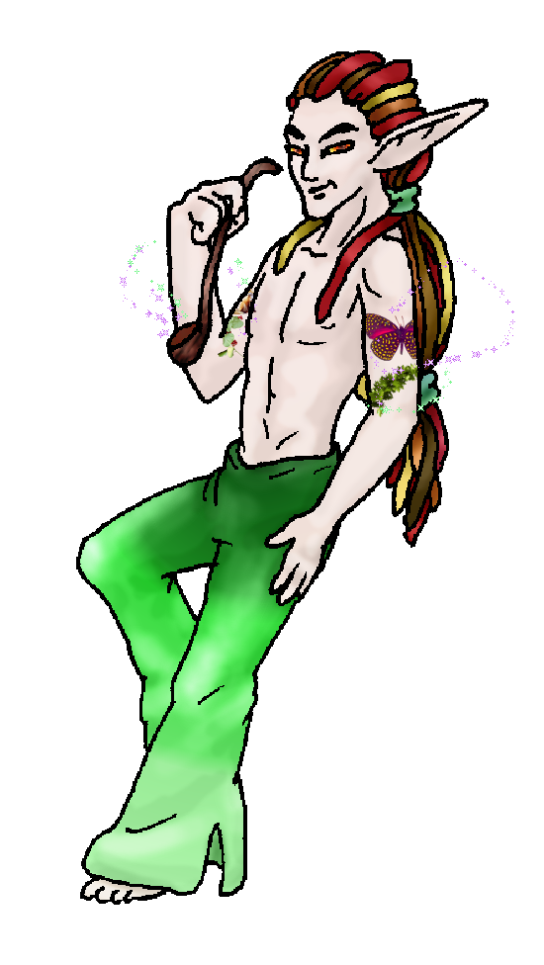
Habits and Places Preferred: Hunting Methods:
Bond Beast Personality:
Character Sketch
Hair: multi-redbrown
Eyes: autumn
Skintone: fair, tats
Bond Beast Habits/etc:
BondAnimal
Fur/Skin: grey, silver mks, gold neckruff
Eyes: red-gold

About you as an elf
Your Name Means: Mesmer clearly refers to your powers of hypnosis, you’re able to put almost anyone into a trance. Your herbal concoctions also seem to have the same effect when you want them to!
Your Appearance Is: Very tall, towering over almost every other elf in the holt, you’ve got fair skin with odd tattoos – no one applied them, they’re just there, and when you want them to come ‘alive’ it seems they really do fly right off your arms! Your hair is long, pulled into ‘dredlocks’ and is multicolored from a rich brown through red, orange and golden-yellow, how it got that way you’ll never guess, it was like that when you got here. Your eyes too are multicolored, the colors of autumn, your favorite season. You wear comfortable, extremely soft brightly-green dyed leather pants, though you do have more suitable snug or lightweight items for different occasions such as hunting, swimming or partying more formally. You carry with you a distinct pipe, and with or without it you smell of spices and herbs – not all ‘intoxicating’ ones, but curries, cinnamon, and more exotic things only found here in the Protector Holt.
You Are Located: In the south-east corner of the continent, the wide Protector Holt is your home. Your den is situated down in the middle of everything, shortly up from the big inland sea, and straight down from the big peak. A slow moving river is beside your den, and rocks tumble here and there from the hills nearby, but there is a good covering of all manner of trees, bushes and grasses as well. Your den is made from stones worn by the river long ago, a hollow below two slabs which has a pool of fresh water collected in it from the river, and while it’s a bit low for entertaining in, your whole home area is trampled well with friends feet. Near your stone den is a wide, sandy area beyond which the river swells. Next to the stony outcrops of your home, there is a log hut which you have for smoking and curing both meat and plants.
Your Basic Statistics Mean: Very tall, but fairly average in health and strength, you’re quirky looks make you stand out. You’ve got an average agility, you tend to concentrate your dexterity on small things; you have well above average intelligence, and use that to your advantage when telling stories, partying, or even just shooting the breeze. Your magical power is around average, just above.
Your Skills Include: You have a typical memory of Earth, giving you just a little flash here and there to weird things you can confuse people with. You’re more of a magic-and-information kind of guy, rather than a physical one, though you have enough ability to survive in the wild, hunting with a mace to smash things, or even a small set of boomerangs for mobile prey. You do more trapping than hunting, however. Your abilities to move through your own territory aren’t hindered by trees, rocks or streams – much at least. However your stronger suits are in cooking, herbalism and understanding people. You know way more than most about any given plant, helped by your magic, but largely it’s an innate skill to recognize the health or type of tree. Anything from small fungi to huge evergreens, you know what they can do for anything: that one’s best used for fire wood, this other one for shaping weapons, another is excellent when ground up and cooked as a mash. And certainly, your penchant for intoxicating plants doesn’t stop with what you have nearby. Everywhere in the Holt there are unique little bio-zones, and you’ve got samples of everything the place can offer drying in your smoke-hut. Once you pull out those tiny grey-blue colored dried plants, a good number of elves know what’s coming next: party! Singing, dancing and sometimes even playing skill games (juggling, while toasty!) but also a lot of effort goes into your magically aided mind games. You have all kinds of ways to trick people into thinking they’re a chicken, or that they’re on a beach instead of a forest, deep underground, or whatever your mood strikes you. You can compete with many others using your creative mind.
Your Magic Powers Are: Though your raw power isn’t much stronger than average, your use of it is certainly well-honed. Your Magic Feeling power is average, you’re able to sense whether an item was shaped and sometimes you can pair up the aura of who did it as well. You don’t need that one much though because your telepathic Sending power is superb. Your range is almost a third of the whole Holt’s distance (that’s over 100 miles without using your further power) and your mind voice has been called ‘sweet-tart and tangy’ by some. You have a fairly typical power to bond to a wolf, see below. Beyond those things, you’ve got a selection of other magic powers which you put into use a lot. Though it’s not as strong as some, your ability to shape Plants comes in handy enough. You don’t use it to alter anything much, just plant seedlings and make sure they’re going to grow, keep nearby berry bushes healthy, and make sure that there’s no rot on those big trees overhead. You can also use this power to sense where a specific plant is, in case you’ve forgotten quite where that last patch of dreamberries went. Along with your tremendous Sending power, you’ve got the ability to send your mind ‘out’ and Astrally project yourself to even greater distances. Over a thousand miles easily, before you start to tire, you can ‘fly’ over the land and visit distant Holts if you try. Since you’re at the very southern tip of this part of the world, it’s a little harder, but there are plenty of other Projectionists in the world who can also stretch out and meet you halfway. In this manner, you can also keep up with gossip in other parts of the world. Every Holt has a good couple of Astral elves, for this reason. No one is ever left out of the loop too long. Then for more conventional use, you have a pair of powers which some others also use: Hypnosis and Mind Snaring. With the Hypnosis power you can entrance, entertain and keep attention focused on you, plus you can use this power on animals as well as elves. Then, once you’ve got their attention, you can Snare a mind into your own private magical hideaway. You build locations or puzzles with your mind, and it’s the goal for the other elf to try and figure out how to escape. While some can simply force their way out because they’ve either got a stronger raw power, or a much more highly tuned skill, they often stick around because your ‘fantasy’ worlds are quite colorful and fun! You can also use this power to help people who have bad reactions to any of the weird and occasionally dangerous plants around the Holt – if they start hallucinating you can generally calm them by giving them a more generic, softer world to perceive. Someone else can help them lose the toxicity, but you can definitely handle their bad trip.
Your Bond Animal Is: You’ve got the coolest Greater Wolf in the pack, at least according to her. Greater wolves are those which have elf-blood, from those weirdoes in the swamps north of here who shapeshifted themselves and had litters with wolves. Some of them are quite elf-like, you met a couple in Dare’s Valley before heading south. But this one is pretty clearly all four-paws. She’s silly, enjoyably so, and her appearance is kind of odd, but lots of fun too – she’s got dark smokey grey fur with bright silver paws and muzzle, tailtip and belly – but she’s also got longer, silkier fur in gold running from her forehead to shoulders in a kind of mane, ruff or even, as her name implies, a mohawk. Her red-gold eyes show that she’s from Fang’s line, one of the first to breed outside of his species, but she doesn’t carry any magic that you know of – some do. She’s big enough to be a highly ranked wolf in the Pack, though she’d much rather remain a semi-outsider so she can watch you dig up stuff and play with your hair.
Special Information: Everyone must contribute to the Holt’s well being, and there’s a challenge waiting in the valley by the East Peak. Of course – the spiderling creatures are terrifying to most of the elves here, not just you (creepy! Just freaking creepy). But even with the fear of them casting their weird webbing all over everything, you’ve created a web yourself: one which constricts and pulls down at whatever touches it – it was known as Strangleweed elsewhere, but didn’t grow wild here until you planted some. Other plant shapers can sense this stuff from a mile away, and know to keep clear of it – you’ve only planted it near the Valley, so if something wanders into those traps, hopefully it’s a spiderling thing.
You are known as a Leaffall (Autumn/Fifthsign) elf, with the star-pattern “Waterfall and River” in the night sky, represented by the sturdy Ram, the colors Red/Orange and the helpful Maple tree elements. Elves of this ‘zodiac’ sign don’t necessarily have to be born nor arrive to the Otherforest to have the association, elves of this nature are often Commanding, noisy, have strong Pride, and are Social.

mishramtg@hotmail.com Add to Address BookAdd to Address Book Add Mobile Alert
Subject: Elf Survey Form
Date: Mon, 01 Jan 2007 18:06:28 -0500

Necessary Stuff
Your Full Name: Rastafari Man Nickname or Title Rasta Birthday 6/23/1976 Act HOW Old? 18
Your Gender male, You like it this way
You Prefer the opposite sex
You are in single and loving it

Appearance Stuff
You're about 6'5 feet tall, and you'd like to be the same
Your build is Husky and you'd like to be skinnier
Hair Color Brown Change? weirder
Hair Style/Curl Straight Change? longer
Eye Color Brown Change? Maybe Glasses? on
Skin Tone White Change? tattoo/marked
Are you 'Attractive'?no Change? average
Are you 'Strong'? no Change? none
Are you 'Smart'? yes Change? smart
Are you 'Nimble'? no Change? athletic agility
You'll be getting pointy ears - you want them medium

Circle (likes) or Cross Out (dislikes)
Where do you like living? fewer people alone busy town quiet neighborhood isolated village

Climates you like chilly cold seasonal mild warm foggy cloudy sunny hilly river forest grassy

What You Want Out of Life joke slack off surround yourself with technology fiddle with toys and tools

Other:

Favorites...
Colors Blue, Green
Animals Dogs
Music/Bands Rock, Heavy Metal
Foods Any
Sports if any Football, Baseball, Basketball
Time of Day night
Season autumn

Fears and Hates SPIDERS

Any pets you'd like to drag along? no
Any people you'd like to have with you? (supply them a sheet!)

Rasta’s Little Story for the Season! (Yes, I’ll have your elf up colored and sent shortly! ☺)

Your favored time of year was passing pretty quickly. The leaves of the trees high up on the hills were all dropping, if not brightly colored and festive in and of themselves. The winds were busy blowing them around, too, even collecting down by the river side where you live. The darkening skies tonight have a bright streak of color, the clouds lit from below by the setting sun.

With a long slow draw on the pipe you carry, you decide that tonight is an excellent night for a gathering. Just a little one, nothing huge. But it’s easy for you to plot where and when – your centrally located den is a great place. Now, why not?

The trees around your own den are still vivid with life, but one or two have turned brilliant red and orange. Some just outright refuse to turn colors, even those which aren’t evergreens. Hanging from almost ever branch near the ground, however, are vines, mosses, and plentiful weird growing herbs which you collect and shape.

From the river, occasionally comes a batch of dead wood. Up in the mountain side there are often brief rains, fires, even lightning that strikes here and there, causing the logs to fall and eventually some wind up on the sandy shore here.

With a few of these cast-off logs, and a number of them from the nearby forest you’ve always got a collection growing. For such things as tonight’s gather: a bonfire? Surely. That’ll make things lively!

You begin contacting people. Mentally, this is as easy as … what was it? Sending an email? Whatever an email is, your mind can do it and even make sure that the person you want to talk to is there at the time. Your mental range is greater than most, even without using any of your more specialized powers.

Vintner, Nightdive, Mink, others. They’ll all be here, come dark evening. There’s time, it’ll be long enough for people to walk or ride slowly. That’s time enough for you to set up the fire. Dragging logs around isn’t all that difficult, it’s good physical work that you would otherwise disdain.

You’re one of those ‘magic types’, so different from some. They devote their life to sharpening their bodies and their swords. Of course, it’s really entertaining to spar with some of em! You’re handy with weapons but you’re more likely to be found with little tools and traps.

And the gardens, of course. Your idea of ‘gardening’ involves a day long journey around your territory. There’s a flower blooming with a specific pollen you need? You’ve got a small tool that collects it into a glass vial. A long, dripping frond that has spores on it? You can scrape the spores off with another little tool. Each plant around your den grows wild – though you’ve encouraged some to grow a little more rapidly or in conditions that it’d rather not (there’s a snow-born blossom sure to come out in the next few nights, it normally only lives up on the top of the peaks! But here down by the river, it can survive if not thrive due to your magical tending).

The logs assembled into a big triangular heap, you’ll have someone else start the flames, while you’re busy creating a food-cooking pit. A couple of the visitors will be bringing their fresh-caught prey, you might as well start looking for a good bunch of flavorful herbs to season them with!

