NAME: Critter HOLT: Protector SOUL NAME: EARTHNAME: David Rizzo
MATE: CHILDREN/RELATIVES: (coh)
MATURITY: youth REAL AGE: 14/10.1.92 YEAR/PORTAL OF ARRIVAL: 122/Hall SEX: M

STR: 12 CON: 13 SIZ: 5 INT: 15 POW: 18 DEX: 19 APP: 15 Total: 97
SKILLS MAGIC POWERS WEAPONS / ARMOR / BOND ANIMAL
language memory: 30 % magic feeling: 38 % attack with long staff (wooden) : 62 %
animal lore: 70 % sending: 90 % damage 1d8 smashing parry: 72 %
elf lore: 60 % wolf bonding: n/a % attack with________________________________: ___%
healing lore: 40 % healing: * ___% damage_______________________________parry: ___%
mechanical lore: 40 % (anti-heal: ___% missile thrown dart/knife : 62 %
mineral lore: 30 % (flesh shape:** ___% damage 1d3 impale+poison range short
plant lore: 40 % (shielding: ___% missile___________________________________: ___%
world lore: 30 % plant shape: ___% damage___________________range______________
communicate: 70 % rock shape: ___% missiles carried__________________________________
wolf/anim comm: 66 % (metal shape: ___% shield_________________________________use: ___%
perception: 72 % (gem shape: ___% armor type______________elem:___bash:___cut:___othr:___
stealth: 74 % bone shape: ___% supplies carried / other skills / etc
climb: 62 % water shape: ___%
dodge: 74 % firestart: ___%
jump: 62 % levitation: ___%
swim: 62 % finding: ___%
throw: 72 % animal bond: 72 % BOND ANIMALname: species: varies sex:
manipulate: 77 % mindsnare: ___% STR: CON: SIZ: INT: POW: DEX: APP:
ride animal: 76 % hypnosis: ___% climb: ___% jump: ___% swim: ___%
hunt/trap: 74 % astral projection: ___% stealth: ___% dodge: ___% percp: ___%
tanning/weaving: 40 % deep sensing: 72 % comm: ___% ______:___% ______:___%
dancing: 60 % self shaping: ___% attack____________:___% attack________________:___%
music/sing: 55 % *animal-heal: 36 % disposition
tinkering: 68 % ** animal-shape: 54 % magic or other abilities
literacy: 60 % :___% natural armor:___________elem:___bash:___cut:___othr:___
Personality Notes: Lives in a...:
Likes and Dislikes: Friends:
Habits and Places Preferred: Hunting Methods:
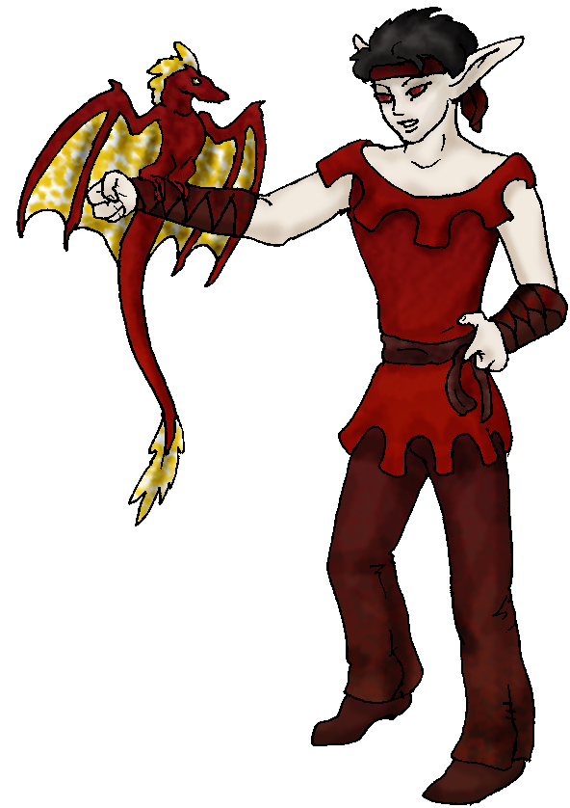
Bond Beast Personality:
Character Sketch
Hair: black
Eyes: red
Skintone: fair
Bond Beast Habits/etc:
BondAnimal
Fur/Skin:
Eyes:

About you as an elf
Your Name Means: Critter is more like a question, often asked around you, “what is that critter you have there?” Your penchant for collecting and occasionally altering the animal life around you is well known. There’s rarely a time when you don’t have a creature of some kind either draped over your shoulders, being ridden by you, or circling around you in some way.
Your Appearance Is: Slender, light skinned with dark short hair and shocking dark-red eyes. You choose to accentuate your eerie eyes with leathers that almost match them in shade, and are sturdy – your arm bracers are there for a reason, talons of many birds, lizards and animals perch on you and you can’t heal yourself.
You Are Located: In the Protector Holt’s land, deep in the south-east corner of the continent almost at equatorial latitude. Your home is situated right overlooking the inland Sea, up on dry land but within easy reach of the waterway, as well as several other elves nearby (Pirates, Anchor, Faceplant, even Aggro and others are within at most 2 days walking). Your den is a built-home, like the one that Anchor put together – though your individual home is not as ambitius as his. Made from shaped dead wood, artistically put together somewhat like a log cabin, but with more intertwining branches (those shapers, always like to keep things looking ‘natural’). There is a fire pit, near the sleep den, which also serves for cooking food, a smoke room above it for meats to be dried and smoked in, and a wide porch where animals are welcome to sit around and watch while you’re doing whatever you’re doing.
Your Basic Statistics Mean: You are average in many physical ways, size, health, strength and attractiveness. Your manual dexterity is high, able to manipulate small items easily. You’re clever, clearly shown by your desires to work on things other elves don’t. Your magical power is above average, though you don’t constantly use any given power.
Your Skills Include: You have an average memory of Earthly things – just enough to give you glimpses at items (such as your home) and inspire you to do something new. While some of your ‘theoretical’ skills could be better (you couldn’t name most rocks nor spot your location on a map perfectly) most are at least average (you can patch your own wounds, but you wouldn’t want to try it on someone else, get a real healer) including your ability to use mechanical laws to your advantage, and identify plants which make for good useful items. Where you shine however is in your communication skills with both animals and people. You know who’s arguing with whom, what’s for dinner at someone else’s place, as well as all the local wildlife and then some. You can identify a single bird by its call, unique from other birds of its breed. You also can communicate in kind with a good success rate. Your physical and survival skills are all fairly good, you won’t be drowning or falling to your doom any time soon but you have no doubt that there are better climbers or quiet elves out there. Your manipulation ability with small or large items is very strong, rare is it indeed that nothing’s in your hands or being worked somehow in your home. You use a minimal amount of knowledge about weaving and leatherworking to aid your general plans, but you wouldn’t want to be depended upon to make a true weaving or a piece of clothing for someone. You can ride almost any sizable creature to a good extent, though some get away from you. At parties you’re a reasonably good dancer, enjoying clapping along or briefly singing. You’re literate to a good degree with the language given to you by Talon of the Valley upon arrival to this world, and therefore can make good notes to yourself at least, about what you’ll be making or drawing up next. You can also tinker pretty well, you make small items like traps for hunting purposes, but also build desks, storage areas, smoke flues, and the like. Practical things that people appreciate. You hunt most often with your traps, taking along a staff to smash bigger prey, or a blow dart or thrown knife to subdue smaller ones (using a poison collected from … well, see below!).
Your Magic Powers Are: You’ve got an average Magic Feeling ability, sensing that someone shaped a stone or item, but you’re never blinded by it like others are – you know their feelings but you can fortunately tune this feature out. Your telepathic Sending power is strong, well aimed, and more often than not very private with someone. However you can broadly send to a big group, with confidence. You have no innate wolf-bonding power, instead this has transferred to being fully animal-based so most animals are open to your magical suggestions. You have no permanent bond for this reason, but you always attract some kind of creature to you. Your other powers include Deep Sensing, a form of sending that allows you to detect the feelings and overall wellbeing that your subject has. You’re quite good at this, and good at expressing it verbally so if someone is having issues they cannot seem to convey, you might be able to help get it out. You also wisely know when not to blurt out someone’s inner feelings. With this power, you can also sense directly what other elves magic powers are, and should anyone come up with a child you’ll easily be able to predict at least, if not tell exactly, what theirs will be. This does have a downside, in that you are often subject to strong emotions around you – this power is not truly telepathy, more empathy, so sometimes you might get swept up in a sad song, or angry tirade that someone else is having. You must be on guard for this. Your other powers are what many people consider unusual though they’re not completely unique in the world. You can heal – but only animals (any animal, from a tadpole to a lion and everything in between that’s not an elf, though you’re not sure whether the burly Ice Traders would take this healing as well?), and you can flesh-shape, but also only animals. With this power, you can attract an animal to you, and should it be okay with your ‘requests’ (you don’t force this power on any animal, that would just be cruel) you can actually make it into something else. The ‘wyvern’ on your arm in your picture for instance, started out as a lizard-like creature with a head crest and four basic limbs. It is usually your most constant companion, though … it has proven that your flesh-shaping power is genetic: its offspring also have wings almost half the time! Most flesh-shapers know that this is unique, there is only one other flesh-shaper that you have been told of who pulled this feat off, and she created the massive four-armed upright ‘bears’ called Urai that live in the woods west of this Holt. They are the ones who have warned against such manipulations for frivolous purposes. Animals in general like you though, you heal them and have a pleasant aura. Yes, you hunt them, but mostly if they’re not weak or too old to get around, they have nothing to fear from your hands. If you’re hunting, you do have to ‘turn off’ your animal bonding power so that you don’t get a mind-full of animal grief.
Your Bond Animal Is: as above, you have no permanent animal friend, but instead have a series of many, many temporary ones. The wyvern on your arm is an exception, though he is not truly mentally bonded to you – he just loves what you’ve done for him. Wings are so much better, he sends-feels-emotes to you, than crawling on the ground!
Special Information: The Urai are a scary bunch. But sadly they do have a point. They were created by a woman who only wanted a challenging hunt. They turned out way more intelligent than she expected them to, though, so in addition to being creatures that stand on two feet at over three times an elf’s height (they’re about the size of a polar bear and a half), have four massive arms with thumbs that they use to physically manipulate, no scent, so they can’t be detected except for sound…. They can breed true too, but sadly their population is too proud to inbreed, and badly in need of new blood if they’re to survive. You might make an offer to them: you can alter the existing young if they so desire, to have different traits than others, producing a new strain of badly needed genetics.
You are known as a Whitecold (Late Winter/Eighthsign) elf, with the star-sign of the Hunter in the evening sky, the strong willed Wolf animal, the color White, and lasting Evergreens as totems. The elves of this ‘sign’ though they don’t have to have arrived or been born on the world during this seaason, often are Eventempered, balanced, and offer Wisdom, Comfort to those around them. You certainly seem to fit the bill there!

Sun, 10 Dec 2006 00:25:02 -0500

Necessary Stuff
Your Full Name: David W. Rizzo Nickname or Title Birthday 10/1/1992
Act HOW Old? 14
Your Gender male, You like it this way
You Prefer the opposite sex
You are in single and hating it

Appearance Stuff
You're about 5 feet tall, and you'd like to be taller
Your build is thin and you'd like to be healthier
Hair Color black Change? none
Hair Style/Curl mess Change? none
Eye Color Grenn Change? Red Glasses? off
Skin Tone plae Change? darker
Are you 'Attractive'?yes Change? none
Are you 'Strong'? no Change? stronger
Are you 'Smart'? yes Change? none
Are you 'Nimble'? sort of Change? everything
You'll be getting pointy ears - you want them medium

Circle (likes) or Cross Out (dislikes)
Where do you like living? many people bustling city

Climates you like cold warm

What You Want Out of Life joke find a soul-mate draw/create raise kids
read become a celebrity raise pets and animals surround yourself with
technology fiddle with toys and tools

Other:

Favorites...
Colors Red
Animals Wyverns
Music/Bands Any
Foods Hamburgers
Sports if any none
Time of Day midnight
Season winter

Fears and Hates Elhapo

Any pets you'd like to drag along? Nope
Any people you'd like to have with you? (supply them a sheet!)no

