NAME: Vellum HOLT: Protector SOUL NAME: (8r) EARTHNAME: Rita
MATE: CHILDREN/RELATIVES: (coh)
MATURITY: Adult REAL AGE: 7.14.04 YEAR/PORTAL OF ARRIVAL: 122/Hall SEX: female

STR: 11 CON: 13 SIZ: 6 INT: 17 POW: 22 DEX: 19 APP: 15 Total: 103
SKILLS MAGIC POWERS WEAPONS / ARMOR / BOND ANIMAL
language memory: n/a % magic feeling: 44 % attack with 2-handed staff (wood) : 60 %
animal lore: 51 % sending: 108 % damage 1d8 smashing parry: 30 %
elf lore: 68 % cat bonding: 88 % attack with long sword (1handed, metal) : 50 %
healing lore: 78 % healing: 88 % damage 1d6 cutting parry: 30 %
mechanical lore: 34 % (anti-heal: 44 % missile hunting net : 70 %
mineral lore: 34 % (flesh shape: 44 % damage 1d3 entangle range close
plant lore: 44 % (shielding: ___% missile___________________________________: ___%
world lore: 34 % plant shape: ___% damage___________________range______________
communicate: 84 % rock shape: ___% missiles carried__________________________________
wolf/anim comm: 78 % (metal shape: ___% shield_________________________________use: ___%
perception: 88 % (gem shape: ___% armor type______________elem:___bash:___cut:___othr:___
stealth: 92 % bone shape: 22 % supplies carried / other skills / etc
climb: 60 % water shape: ___%
dodge: 82 % firestart: ___%
jump: 60 % levitation: ___%
swim: 70 % finding: ___%
throw: 60 % animal bond: ___% BOND ANIMALname: Black Gold species: BigCat sex:m
manipulate/art: 67 % mindsnare: ___% STR:20 CON:18 SIZ: 15 INT: 9 POW:10 DEX: 17 APP: 10
ride big cat: 72 % hypnosis: ___% climb: ___% jump: ___% swim: ___%
hunt/trapping: 70 % astral projection: * % stealth: ___% dodge: ___% percp: ___%
tanning/dyes: 57 % deep sensing: 22 % comm: ___% ______:___% ______:___%
dance/music: 68 % self shaping: ___% attack____________:___% attack________________:___%
literacy: 61 % * teleportation: 88 % disposition
psychology: 51 % :___% magic or other abilities
papermaking: 82 % :___% natural armor:___________elem:___bash:___cut:___othr:___
Personality Notes: Lives in a...:
Likes and Dislikes: Friends:
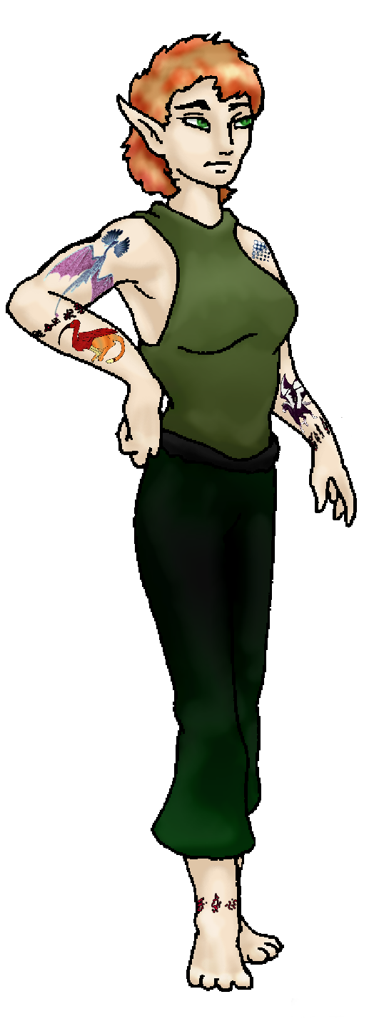
Habits and Places Preferred: Hunting Methods:
Bond Beast Personality:
Character Sketch
Hair: red-gold
Eyes: green
Skintone: fair, tattoos
Bond Beast Habits/etc:
BondAnimal
Fur/Skin: gold, black mks
Eyes: green

About you as an elf
Your Name Means: Vellum is a form of very thin calfskin leather, made into a thin paper-like sheet for drawing and writing. Your ability to shape leather allows you to make this substance as well as create colorful clothing.
Your Appearance Is: tall and well balanced, with fair skin that has intricate tattoos – some of which are magical sigils that one or two elves recognize, red-gold short hair, and green eyes. You choose darker greens and black to wear, blending in with shadows, but you also have a good number of colorful items for parties.
You Are Located: in the Protector Holt, to the south-east of the continent, your den overlooks a river that cascades into the wide bay to the south. Formed from shaped stone and covered in furs, leathers and carved or shaped objects, it’s stuffed to the brim with ‘things’. Below the waterfall is another elf in a stilt-legged hut, trading paper for fish is a favored activity.
Your Basic Statistics Mean: tall and well balanced, average in strength, and reasonably good looking. Your dexterity shows in artwork and projects, if not in balance and dancing; you’re considered very intelligent and cleverly work your way through things. Your magical power is extremely high, better than most of the Holt.
Your Skills Include: Since you’re not from Earth, originally, you have no memory of things Earthly. Rather, you do have a strong connection to the weird world of the Intarwebz from which several others have arrived. You concentrate on people, animals, healing and how to organize. While your magical healing allows for most wounds to be sealed and fixed near instantly, you also have a strong talent with identifying injuries, treating illness, and even boosting normal traits (speed, perception, stealth, etc) with meddling with things genetically. Communication and knowledge of people are very strong for you, and have actually extended to a psychology skill that allows you to judge people’s state largely by looking them over and asking one or two pointed questions. Most of your survival and physical skills are average, however you’re quite stealthy and remain hidden extremely well, and you’ve got a great eye for movement and detail. You hunt more often than trap, however you use both freely – a long staff to smash big prey from cat-back, a dramatic katana-like sword mostly for show, and a hunting net are your normal weapons. Like most of the Holt, you’re literate to a good degree, using Dare’s Valley script for your work. Which work? Well that would be artistry – tattooing, designs on leather or wood, anything colorful and evocative of a plant, person, animal or event. While you’re not necessarily the chronicler of the Holt’s activities, many times your work will reflect its history. You make leather colorful, using your Flesh Shaping power on dead hide more than living flesh. You can locate dyes and use minerals to infuse with color, plus you make vellum, a very thin substance from softer leathers of the right size. Using those papers, you can decorate to your hearts’ content. Also, fliers. Not the levitating types, but written invitations and letters.
Your Magic Powers Are: You’ve got a gift for auras, but don’t always concentrate on them, you can see traces of elf magic around almost everything, which is a bit distracting. You mainly use this to sense specific people. Your telepathic Sending power is extremely strong, your mind can sense and send thoughts almost eighty miles away with great precision. This is good, because of another of your powers listed below. Your high bonding ability has given you a cat-bond below. In addition to those typical powers, you’ve got several unique to you. You’re a healer, using not only the power to give life but that to take it away – Anti-healing as well as Healing. You can deliver a soft, soothing touch, or when needed a sharp painful sting. You utilize Flesh Shaping for several projects, not the least of which is your leather works. Having learned from others at Dare’s Valley that this was possible, you immediately took to coloring leather with magic instead of waiting forever and a day for normal tanning, plus you can also use this power to alter the colors, textures or sensation of living skin. This is painful, but you’re a healer – that comes with the territory. Your own tattoos appeared to be part of you from your arrival. You use a small amount of Bone shaping to aid in your overall healing ability, as well as an equal amount of Deep Sensing – you know when you’ve done your job, by the relief from the elf you’re working on. While you don’t have an outright ability with Far-sending, you claim it’s of use when you use your extremely rare power of Teleportation. Being where you need to be, within your Sending range, instantly. This power is a bit draining but you can and have teleported whole hunting parties out of danger on occasion. Leaving you exhausted, certainly, but safe. Thus, it takes you about half an hour to get from one corner of the Holt to the other – a feat which on wolf-back takes a hand of days at the least. You can bring people to you as well as move them without being near, as long as you have a good fix on where they are, and where they need to be, you’re good. Others have a power you can tap into to sense through their eyes – you don’t even have to be there to port someone to safety if they’re nearby.
Your Bond Animal Is: Black Gold is obviously how he looks, this healthy, strong cat. His fur is a burnished golden shade with a black undercoat and markings on face, paws and tail. He’s not all that big, and he’s also not all that deft in the paw. But he is attentive, and very tolerant of other animal bonds around him. He spends far more time with you than with the Pride.
Special Information: When Snowdrift saw you arrive, you knew exactly what she was going to say, and why. “Oh not another one.” She said. You just nodded and grinned. You know this is weird, but… Snow and you are the same person, along with that other one – Blackbuck in the Dragonclan. The Intarwebz are a very strange place indeed, and you’re no exception. You don’t share any of Snow’s knowledge, really, but you do have the kind of raw power that she’s known for, if tempered a bit in one direction and certainly ones she hasn’t gone in herself. You pride yourselves on being individuals. And at least, she doesn’t outright hate you like she did Blackbuck.
You are known as a Longdays (Summer/Thirdsign) elf, with the constellation Falling Star in the night sky. Elves of this type are represented by the Rabbit, the color light green and the useful Wide-Boll tree. This elfin zodiac sign indicates Humor, Sensuality, Creativity, Generosity.

Stock used – stock229 by breedstock

