NAME: Shellback HOLT: Protector SOUL NAME: (ruenshock) EARTHNAME: Dusty Taylor
MATE: CHILDREN/RELATIVES: (coh)
MATURITY: young adult REAL AGE: 3.16.84/24 YEAR/PORTAL OF ARRIVAL: 122/Hall SEX: male

STR: 15 CON: 16 SIZ: 7 INT: 15 POW: 18 DEX: 19 APP: 15 Total: 105
SKILLS MAGIC POWERS WEAPONS / ARMOR / BOND ANIMAL
language memory: 25 % magic feeling: 28 % attack with Metal-tipped mace : 78 %
animal lore: 55 % sending: 82 % damage 1d8 smashing parry: 68 %
elf lore: 45 % wolf bonding: 72 % attack with________________________________: ___%
healing lore: 60 % healing: 36 % damage_______________________________parry: ___%
mechanical lore: 45 % (anti-heal: ___% missile thrown club (small) : 66 %
mineral lore: 30 % (flesh shape: ___% damage 1d3 smashing range short
plant lore: 30 % (shielding: ___% missile___________________________________: ___%
world lore: 40 % plant shape: ___% damage___________________range______________
communicate: 70 % rock shape: ___% missiles carried__________________________________
wolf/anim comm: 66 % (metal shape: ___% shield tortoise shell, small use: 74 %
perception: 72 % (gem shape: ___% armor type shell elem:___bash: x cut: x othr: can throw
stealth: 74 % bone shape: ___% supplies carried / other skills / etc
climb: 66 % water shape:* 36 %
dodge: 74 % firestart: ___%
jump: 96 % levitation: 18 %
swim: 68 % finding: ___%
throw: 68 % animal bond: ___% BOND ANIMALname: Tolk species: wolf-dog sex: m
manipulate: 57 % mindsnare: ___% STR: 6 CON: 10 SIZ: 3 INT: 6 POW: 11 DEX: 18 APP: 11
ride wolf: 76 % hypnosis: ___% climb: ___% jump: ___% swim: ___%
hunt: 66 % astral projection: ___% stealth: ___% dodge: ___% percp: ___%
crafting (homes): 68 % deep sensing: 36 % comm: ___% ______:___% ______:___%
dance/music: 68 % self shaping: ___% attack____________:___% attack________________:___%
literacy: 60 % *cold/ice shape: 72 % disposition
trapping: 68 % :___% magic or other abilities
weaponsmithy: 60 % :___% natural armor:___________elem:___bash:___cut:___othr:___
Personality Notes: Lives in a...:
Likes and Dislikes: Friends:
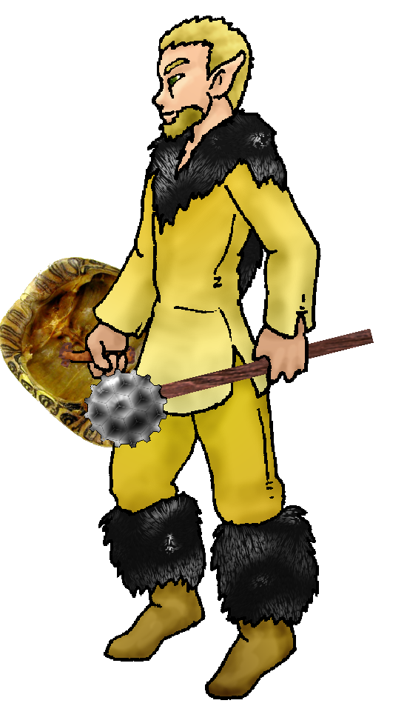
Habits and Places Preferred: Hunting Methods:
Bond Beast Personality:
Character Sketch
Hair: golden brown
Eyes: hazel gold
Skintone: lt tan, mks
Bond Beast Habits/etc:
BondAnimal
Fur/Skin:
Eyes:

About you as an elf
Your Name Means: Shellback, you located a weird pile of long-dead skeletal carcases, including one which you were drawn to immediately because of its coloration. The brilliant yellow and black design aside, you use shells, bones and all manner of other things to produce not only weapons but armor, and even items and dens!
Your Appearance Is: Very tall for an elf, almost half a head taller than many others, you choose to wear yellow-buckskin leathers trimmed in a rich black fur, warm for the cold areas you live in. Your skin is lightly tanned, and unseen by any but the artist who did it for you, you’ve got a bright black and yellow design on your back that you continually have work done on, it’s slowly growing. Your hair is short, golden brown, and you sport a beard. Your eyes are a hazel-gold, brown-yellow tinted with green.
You Are Located: Down in the south-east corner of the continent, the Protector Holt is your home. Your den is on the chilly north-end of the area, in the higher peaks – only two or three elves live all the way up here in the eternal snow-bound area. Your den is formed from a natural cave, heated like others in this area by the dormant but nearby volcanic magma below the surface on this mountain. Both hot and cold water flow near your den, from snowmelt and hot springs. The den has a ledge but you’ve had to have a mage shape the overhang above so that you can work outside where there is good light and not get dumped on by the heavy layer of snow. Inside, you’ve got plenty of tools – made for you by shapers, and lots of supplies such as hard leather, bones, wood and even metal pieces. Though you don’t shape any of those things yourself with magic, you can use them expertly for both small and large items.
Your Basic Statistics Mean: You’re a tall, very strong and healthy elf! Good looking and expert with your hands, clever enough to create without aid things that would stump others. Your magical power is average.
Your Skills Include: You have a low memory of Earthly things, however your mechanical engineering probably flashes back to having seen interesting devices or drawings from there. Otherwise you don’t recall much – occasionally a word or two. You have a good grasp on who is where, named what. Animals, people and places stick in your mind strongly. Even though you’ve got magic to aid you, you’ve also got a very good grasp on healing wounds and diseases without magic – binding wounds, fixing breaks, treating fevers. You’re very good with talking to people, making them laugh and entertaining guests. While you’re extremely adept at almost all outdoors skills, you don’t really have to work at it – you’re just strong and deft enough to get around the wilderness without aid. You hunt and trap equally to provide yourself with food, but also for trading with others who can keep your supplies of crafting items up. You hunt with a mace, shaped wood with a magically added casing of hard metal. Also you throw small whittled pieces of wood, not sharp enough to pierce skin, but instead thrown hard and direct to stun prey. You’d rather smash the skull of any given food animal, because aside from trading beautifully intact furs and leather, you prefer to keep all the bones intact so you can work with them. You are one of the few elves who uses a shield, the shell which you found way back before even arriving at Dare’s Valley. Aside from using those things, you’re also quite good at making weapons and armor. When it comes time to battle with the weird spider-creatures in the eastern valley, it’s best that everyone have some kind of protective armor – you have found that the smallest tortoise shells and turtle carcasses give excellent shoulder and knee protection, while reinforced leather and long bones can make an intimidating breast and back plate. You also use larger – much larger – pieces to create art and shelter for elves, traveling dens for hunters who like to move a lot, assembly is easy if you just know how to do it. A pile of shells and wood suddenly becomes a nice warm hut! You, like many of the elves here, are literate to a good degree in the language which was taught to you by Talon in Dare’s Valley. With it, you make notes on pressed hide sheaves, for new items to build.
Your Magic Powers Are: You’ve got a low Magic Feeling power, you know most if not all the things you work with are shaped, but aside from that it’s not important to you who has made what. You remember what you need to know when they give them to you. Your telepathic Sending power is good, used mostly at a distance because you’re so far off from most folks when you’re up in your den. You do enjoy coming down to where gathers and hunts and dances are held, and people describe your mental voice as somewhat booming, like a hollow drum in a canyon. You have a wolf-bonding power, which keeps your ‘dog-wolf’ near you, though the bond itself is tenuous and if a ‘true-wolf’ (one which didn’t come from your world, instead having come from the Otherforest packs) came along you’d be able to pair up and ride one of those. Beyond the typical powers elves all share, you have several which you use to mix and match. You have a moderate but useful ability with Healing, you can quickly cauterize, take away pain, or make sure that no life-threatening wounds exist – but beyond that you’re a bit less adept with the power than some. Your techniques are often paired with your skills, so you know how to magically aid someone at the same time as you’re physically binding a break. More like a trauma technician, than a doctor. Along with this, is an equally moderate power that you can use to sense within an individual or group their mood and general well-being. If someone is injured and doesn’t speak up, this power will detect it. Or, if someone is very angry, scared, or other strong emotions but masking it well, you’ll know. You use this power in conjunction with your healing sometimes, to soothe the mental anguish along with the actual pain of an injury. Though you can shape Water with magic, it’s largely to the degree that you can easily purify it from being stagnant, or get something that’s drifted deep with a current – you can cause the current to drift right back to you. Handy for if something’s dropped into a swiftly moving river. But this power allows you to also shape and create cold and ice! There’s plenty of snow, ice and water around your den, and often in the coldest part of the year (which isn’t saying much, it’s equatorial but your den’s at almost 9 thousand feet) you decorate your den’s entrance with fancy carvings made with your Cold Shape. It takes you around half an hour to shape an elf-sized chunk of ice, however while you’re working, the ice tends to melt. So you have to keep re-“colding” it. Lastly and weakly, you’ve got a tiny bit of Flight magic – this is enough to keep you from falling, regaining your balance is easier but you have been able to stop your fall from a distance (only once, and you try not to get into that situation again!) but you wouldn’t want to try relying upon this power to lift off and float. You can actually levitate small items, up to about a third of your own weight. You can’t keep that up for long, around 15 minutes at most, and then you’re beat.
Your Bond Animal Is: Tolk, your dog from home (I don’t know much about this dog ☺ ). However, as a ‘dog’ he’s hardly accepted by the wolf pack. He’s nowhere near big enough to ride, like the wolves are, so he’s much more of an animated pet – he does follow around and aid in finding those forgotten traps, never let it be said he’s not handy! But the magical bond which holds him to you is mostly a vestage of him being your Earthly pet, and there are a lot of other wolves around the place who would probably accept you as their bond-friend to ride eventually.
Special Information: You’re working on a big musical instrument for Drumdance and the others who often provide people with songs and tunes during gathers. It involves a number of differently sized shells, hollow branches, and the like. A big marimba…or more accurately, a big “Blue Man Group” device capable of making some truly unique sounds…
You are known as a Longdays (Summer/Thirdsign) elf, even though your more favorite season is Winter. Elves bearing this ‘zodiac’ sign are represented by the quick Rabbit, the color light green, the useful Wide-Boll tree element. The star-sign “Falling Star” is high in the night sky during this time. Elves of this sign show Humor, Sensuality, Creativity, Generosity.

Date: Sat, 16 Dec 2006 22:40:49 -0500

Necessary Stuff
Your Full Name: Dusty Taylor Nickname or Title Ruen Shock Birthday 03/16/1984 Act HOW Old? 22
Your Gender male, You like it this way
You Prefer the opposite sex
You are in single and hating it

Appearance Stuff
You're about 5'8" feet tall, and you'd like to be taller
Your build is Thick and you'd like to be same
Hair Color Brown Change? lighter
Hair Style/Curl Spiked Change? none
Eye Color Hazel Change? No Glasses? off
Skin Tone Slight Tan Change? tattoo/marked
Are you 'Attractive'?yes Change? none
Are you 'Strong'? yes Change? stronger
Are you 'Smart'? yes Change? none
Are you 'Nimble'? no Change? athletic agility
You'll be getting pointy ears - you want them elegant

Circle (likes) or Cross Out (dislikes)
Where do you like living? busy town

Climates you like freezing chilly cold cloudy canyons hilly mountainous towering cliffs beach river forest

What You Want Out of Life see the world rough it/camp heal the sick joke find a soul-mate build and construct fly like an eagle read become a
celebrity raise pets and animals learn build an igloo surround yourself with technology retire early and relax fiddle with toys and tools

Other:

Favorites...
Colors Black/Yellow
Animals Bear, Wolf, Dog
Music/Bands Tenacious D, 30 Seconds to Mars, 3 Doors Down, Powerman
5000, Sublime, Soggy Bottom Boys, Blood Hound Gang, Johnny Cash, Big and Rich
Foods Chicken, Oreos, Pie, Oreo Pie, Ice Cream, Pizza, Pasta
Sports if any Womens Beach Volly Ball :D
Time of Day midnight
Season winter

Fears and Hates

Any pets you'd like to drag along? Tolk (Jack Russell Terrier)
Any people you'd like to have with you? (supply them a sheet!)

