NAME: Shorecast HOLT: Protector SOUL NAME: (sentaisage) EARTHNAME: Shane Crockett
MATE: CHILDREN/RELATIVES: (coh)
MATURITY: Young adult REAL AGE: 7.28.86/22 YEAR/PORTAL OF ARRIVAL: 122/Hall SEX: Male

STR: 13 CON: 14 SIZ: 6 INT: 15 POW: 17 DEX: 21 APP: 14 Total: 100
SKILLS MAGIC POWERS WEAPONS / ARMOR / BOND ANIMAL
language memory: 20 % magic feeling: 27 % attack with spear 1handed wood : 68 %
animal lore:fish+ 45 % sending: 88 % damage 1d6+2 impale parry: 60 %
elf lore: 40 % cat bonding: 68 % attack with________________________________: ___%
healing lore: 30 % healing: ___% damage_______________________________parry: ___%
mechanical lore: 40 % (anti-heal: ___% missile 1 handed spear, thrown : 100 %
mineral lore: 30 % (flesh shape: ___% damage 1d6 impale range close-med
plant lore: 40 % (shielding: ___% missile bolos : 88 %
world lore: 30 % plant shape: ___% damage 1d3+entangle range medium
communicate: 68 % rock shape: ___% missiles carried__________________________________
animal comm: 64 % (metal shape: ___% shield_________________________________use: ___%
perception: 88 % (gem shape: ___% armor type______________elem:___bash:___cut:___othr:___
stealth: 76 % bone shape: ___% supplies carried / other skills / etc
climb: 56 % water shape:** 50 %
dodge: 86 % firestart: ___%
jump: 66 % levitation:* ___%
swim: 68 % finding: ___%
throw: 88 % animal bond: ___% BOND ANIMALname: Rock species: big cat sex: m
manipulate: 73 % mindsnare: ___% STR: 22 CON:15 SIZ:23 INT: 8 POW: 12 DEX:17 APP: 15
ride big cat: 84 % hypnosis: ___% climb: 61 % jump: 78 % swim: 17 %
hunt: 51 % astral projection: ___% stealth: 68 % dodge: 68 % percp: 60 %
art / drawing: 63 % deep sensing: ___% comm: 40 % ______:___% ______:___%
dancing: 70 % self shaping: ___% attack claw/rake: 75 % attack bite: 60%
music/sing: 64 % *telekinesis/aim: 71 % disposition
trapping: 66 % ** water sense: 81 % magic or other abilities
fishing (all types): 86 % :___% natural armor:___________elem:___bash:___cut:___othr:___
Personality Notes: Lives in a...:
Likes and Dislikes: Friends:
Habits and Places Preferred: Hunting Methods:
Bond Beast Personality:
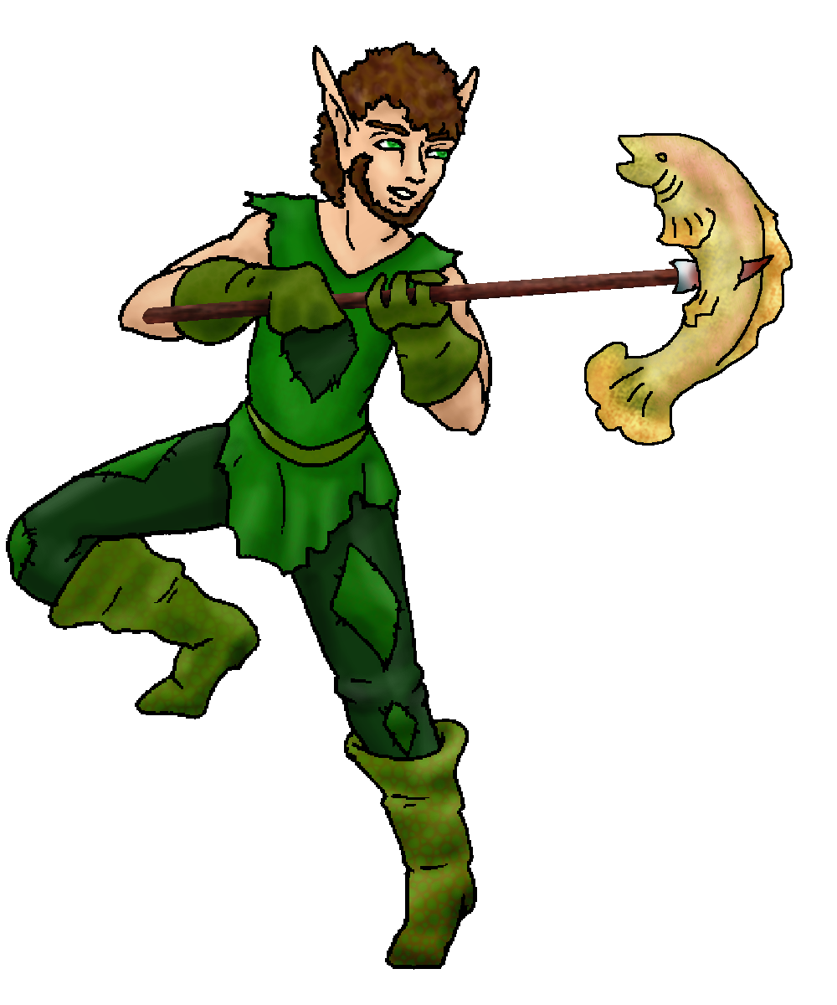 Character Sketch
Hair: brown
Eyes: leaf green
Skintone: lt tan
Bond Beast Habits/etc:
BondAnimal
Fur/Skin: pale cream, white
Eyes: green

About you as an elf
Your Name Means: Shorecast is what you do to fish – generally you’re on the shore or in very shallow water, when you line-fish, net cast, or spear hunt. While you often have to drag nets from deeper waters, you prefer to remain on the dryer side of things.
Your Appearance Is: Tall and healthy looking, with tanned skin from being outside a lot; short, curly hair in a dark brown shade, including a short reasonably tame beard. Your eyes are brightly leaf-green, and your clothing reflects that color in many shades and textures. Your outfit is made of cloth, leather, and hide – boots and gloves made of sturdy, softly lined lizard skin.
You Are Located: In the Protector Holt, south-east corner of the continent where, though it’s all but equatorial, the mountain peak which you reside upon is often snowbound during winters. Your den is situated in a high, well-forested area near a large, tumbling river. Since you prefer a more easy climb than one which pits your balance against a cliff, the den you’ve made of stone and branches is in a reasonably flat area, but the river runs from far above, and then heads into a ravine quite close to you. There is ample fishing in this wide river, with nooks, ponds and a broad lake on this section of hillside. Your den is functional, though not particularly great to have people stay over. You have a variety of baskets, racks, and a smoke den nearby for the fish you catch – mostly to trade to others for the variety of foods they’re able to grab. Seasonally you’ve also got some other meats in the smoke house, and fruits on the drying racks.
Your Basic Statistics Mean: You’re a strong, healthy and extremely nimble elf. Taller than many, but not huge, you’ve got balanced strength and health. You’re reasonably attractive, though you hardly spend time with too many people. Quick witted, you can pit your mind against most in the holt. Your magic power is not spectacular, but you do not rely upon magic for everyday things. Where you really shine is your dexterity and agility.
Your Skills Include: All in all, you’re a relaxed but physically-apt elf. You have a low memory of Earth and its language, you’re not burdened by too many weird flashbacks to things that don’t exist here in the Holt. You’ve got a rounded grasp on all manner of lores from mechanics to healing, people and places, but nothing special in any given one of them save for your knowledge of fish and water plants. You can generally convey what you need to to either animals or people, again you’re not hanging out with crowds too often so this isn’t put to the test. Among your physical skills, you are very easily able to detect the slightest movement or sound and this goes for under water as well as in the woods. You can swim and climb but you wouldn’t want to have to go rescue anyone cliffside or in deep current. Your combat and hunting skills are varied – you prefer to fish, and therefore your grounded hunting skill isn’t all that special. However you can avoid being hit by most things (be it paw, falling branch or sparring weapon), and you throw almost anything you can lift with great accuracy. You hunt with a short fishing spear, which can be used by hand or thrown; as well as using thrown bolos to catch small legged prey in the woods. Trapping is fairly easy and you enjoy the walk in the woods as you check the traps you’ve laid out. You can ride your big cat very well, though he is quite large and a bit difficult for anyone else to stay on. Artistically you have a strong drawing and design bent, as well as being able to make those baskets, things with folded wood and carvings. You enjoy a good romping dance, and often sing along with the music that is made during gathers. Having tried several instruments out, you like strumming a simple guitar-like one, or playing a 3-reeded flute. When you fish, you’ve got everything you need with you, at all times. A basket woven from nearby reeds carries collapseable poles, line, nets and even easily-assembled basket-trap equipment.
Your Magic Powers Are: You’ve got a low Magic Feeling, you sense that someone’s got magic going, but rarely worry about detecting if something’s been shaped (you assume it has been, that’s how many elves spend their time). Your telepathic Sending power is strong, best at a distance and best toward one or two targets instead of a group. Your mental voice is, so your friends have said, ‘like shouting under water, only clearly understood’. Unlike some prior elves, you have a cat-bonding power instead of one which brought a wolf to others. Your feline is detailed below. As far as actual magic powers, you get worn out a bit by exertion, so you more rely upon physical skill. However, you have two powers which are quite handy. The more used of them, is the ability to Sense Water – you can use this to detect motion in the lake or river, see where fish are by looking ‘through’ the water itself, and to a lesser extent Shape the water around you to urge the fish to come closer to the lures or nets. You can also purify water that’s been stagnant, but that does wear you out a little. Your other ability is that of Telekinesis – you can adjust the flight of any given projectile, be it rock, arrow, or even fishing line. Perhaps you use this in addition to your physical skill to dodge things thrown at you, but it’s a rare day that someone can toss something at you and hit! You lack the strength in this power to truly levitate anything bigger than half your size, so that basket with fishing gear is about your limit. Things that are tiny, like bugs and falling spray, often just bounce right off you without ever impacting you, because of this power. You hardly have to concentrate on this ability, and it doesn’t really wear you out because aside from holding something up for a long period, it turns on and off so quickly that you barely notice.
Your Bond Animal Is: Rock is a huge, burly and strong mountain-cat. He is at least as large as Cimmeron the big cat who leads the Protector Pride. He’s got a gorgeous coat of beige and white, hardly a marking on him except the white tip of his tail and the white markings on his muzzle. Huge green eyes peer out … and aren’t that bright. While he’s big, he’s also occasionally quite clumsy, and is comparitively sedate for brains. While he really loves fish, he really hates water, and will almost entirely avoid contact with it except to drink. He knows his favorite food comes from the water. He’ll let you fish for him. Rock is aptly named, plenty of the stones in this area where you den are the same almost-white shade, and he can easily be mistaken for a stone. That, and some folks call him dumb as a rock… He’s also almost immobile when he doesn’t want to be moved, you try getting a 300 lb cat to move!
Special Information: You’re one of the few elves who came almost alone into the Hall of Portals, ‘between’ times when bigger groups arrived. Even then, though, you easily found your way to the rest of the group.
You are known as a Thaw (Newyear/Firstsign) season elf. Those who show personality traits but aren’t necessarily born nor arrive during that season. Thaw elves are represented by the silent Owl, the color Silver, the element of Ice/Water, and the starsign Wolf is high in the night sky at that time. Elves of this type show Bravery, Hardiness, Patience, Luck.

Necessary Stuff
Your Full Name: Shane Alan Crockett Nickname or Title Sentai Sage on
the CoH Boards, (Global is @ Forgotten Guardian) Birthday 07-28-86 Act HOW Old? 20? 20-ish? Wiser then my years?
Your Gender male, You like it this way
You Prefer the opposite sex
You are in single and loving it

Appearance Stuff
You're about 5'10" feet tall, and you'd like to be the same
Your build is stocky and you'd like to be skinnier
Hair Color brown Change? none
Hair Style/Curl A step abouve buzz cut Change? longer
Eye Color Brownish-green Change? Very green Glasses? off
Skin Tone light tan Change? none
Are you 'Attractive'?yes Change? none
Are you 'Strong'? yes Change? none
Are you 'Smart'? yes Change? none
Are you 'Nimble'? no Change? everything
You'll be getting pointy ears - you want them medium

Circle (likes) or Cross Out (dislikes)
Where do you like living? fewer people old friends quiet neighborhood

Climates you like chilly seasonal mild rainy foggy cloudy hilly mountainous river forest

What You Want Out of Life joke go fishing draw/create slack off make music retire early and relax

Other: Enjoy myself, above all else. I can be relied on, but not a lot of responcibility.

Favorites...
Colors Green
Animals Cats, Foxes
Music/Bands Some Rock (Incubus, Likin Park) Some Country (Alablama, Calin Raye) And some Jazz
(As heard form Cowboy Bebop)
Foods Fruits of all kinds.
Sports if any Basketball and Tennis (High school Leters)
Time of Day dawn
Season spring

Fears and Hates Shots (like the flu shot) and Hights... I can't depend on something other then myself when I'm in a High spot

Any pets you'd like to drag along? I got 9 cats.. but they can stay home >_>
Any people you'd like to have with you? (supply them a sheet!)They'd give my a funny look >_>

