NAME: Tailor HOLT: Protector SOUL NAME: (saint) EARTHNAME: Cam Doell
MATE: (snowkitten) CHILDREN/RELATIVES: (coh)
MATURITY: young adult REAL AGE: 7.8.79 YEAR/PORTAL OF ARRIVAL: 122/Hall SEX: m

STR: 14 CON: 14 SIZ: 6 INT: 16 POW: 16 DEX: 19 APP: 15 Total: 100
SKILLS MAGIC POWERS WEAPONS / ARMOR / BOND ANIMAL
language memory: 32 % magic feeling: 36 % attack with 1handed spear : 66 %
animal lore: 42 % sending: 74 % damage 1d6 impale parry: 66 %
elf lore: 58 % cat bonding: 64 % attack with metal knife : 56 %
healing lore: 32 % healing: 16 % damage 1d3 cutting parry: 66 %
mechanical lore: 64 % (anti-heal: ___% missile___________________________________: ___%
mineral lore: 42 % (flesh shape: 64 % damage___________________range______________
plant lore: 32 % (shielding: 48 % missile___________________________________: ___%
world lore: 42 % plant shape: ___% damage___________________range______________
communicate: 72 % rock shape: ___% missiles carried__________________________________
animal comm: 62 % (metal shape: ___% shield_________________________________use: ___%
perception: 78 % (gem shape: ___% armor type______________elem:___bash:___cut:___othr:___
stealth: 70 % bone shape: 48 % supplies carried / other skills / etc
climb: 66 % water shape: ___%
dodge: 70 % firestart: ___%
jump: 54 % levitation: ___%
swim: 66 % finding: ___%
throw: 76 % animal bond: ___% BOND ANIMALname: Kitten species: feline sex: f
tanning: 67 % mindsnare: ___% STR: CON: SIZ: INT: POW: DEX: APP:
literacy: 58 % hypnosis: ___% climb: ___% jump: ___% swim: ___%
hunt: 70 % astral projection: ___% stealth: ___% dodge: ___% percp: ___%
tailoring: 80 % deep sensing: ___% comm: ___% ______:___% ______:___%
dancing/music: 68 % self shaping: ___% attack____________:___% attack________________:___%
dyes/colorings: 58 % :___% disposition
trapping: 80 % :___% magic or other abilities
tinkering: 48 % :___% natural armor:___________elem:___bash:___cut:___othr:___
Personality Notes: Lives in a...:
Likes and Dislikes: Friends:
Habits and Places Preferred: Hunting Methods:
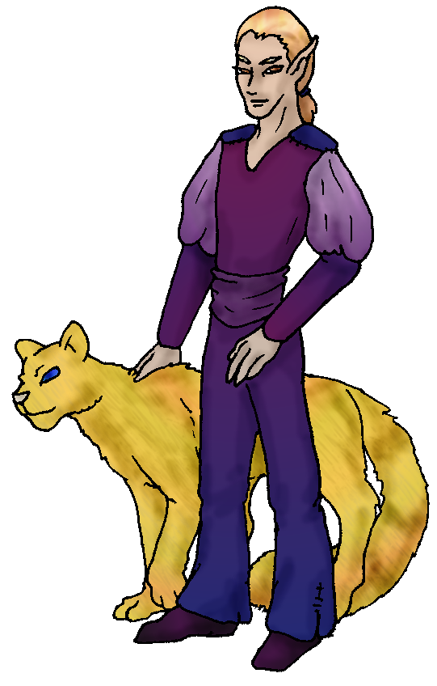 Character Sketch
Hair: gold
Eyes: change
Skintone: lt tan
Bond Beast Personality:
Bond Beast Habits/etc:
BondAnimal
Fur/Skin: orange
Eyes: blue

About you as an elf
Your Name Means: Tailor is not only your profession but your passion. Ever since seeing the types of leather, cloth and silks available here, you’ve become adept at making them all into sturdy, functional or even frivolous outfits for everyone who asks. Usually you take something in trade for the work, food or items. You were known as ‘Eight’ for a little while because you were the last of the original group of 8 to arrive.
Your Appearance Is: You have light tanned skin which you allow Blazon to help tattoo on occasion, you can shape flesh – even your own – but he does it a little better. Your hair is a very shining metallic golden color, coming to your shoulders and kept back in a tail. Your eyes are often a shade of brown, but change to orange or yellow, dark brown or red depending on what magic powers you’re using or what mood you’re in. Your clothing varies but often is in colors of violets and purples, and are always quite nice. After all, you woudn’t make yourself wear sub-par clothing!
You Are Located: In the Protector Holt in the south-east corner of the continent, with the others of your group. Your den is located in a hilly, forrested terrain that overlooks the main river leading down to the big Bay. This river and its trails lead many folks from up on the mountains down to the beach, and therefore this is an excellent trading zone. People on hunts can reach you quickly with their kills, bringing you fresh hides which you then place in your storage room back in a cavern beyond the main shaped area. Your den is a stone cave with a lot of shaping done to it. It looks a lot like the front of a standard ‘castle’ type place, and the inside has many nooks and shelves for your dyes, projects, and supplies. The back of the place has a hollowed tree which has old, thick roots keeping the natural cave open. In it, you place hides, and eventually bury them with chemicals and dyes in order to tan them the old fashioned way. You use your powers to make quick work, but you know how to do this messy, smelly and time consuming tanning as well. The forest above is quiet, but you know there are some predators and a herd of deer-like creatures which call it home too. You share this den and another, with your lovemate.
Your Basic Statistics Mean: You are taller than average, strong, and pretty healthy. You’re attractive, and like to attend to yourself with care; you use your high dexterity to aid your tailoring skills. You’re known as intelligent, and your magical power is fairly low-average (though truth be told you don’t rely upon it much either).
Your Skills Include: You have an above-average ability to recall Earthly things, though this has served you fairly well in some ways, other times it’s a bit of a bother when you start gibbering on in a language none of your elfin friends remember. Your skills relate largely to physically manipulating objects – you know enough about people and animals to get by more than enough, plants and minerals are there to aid you in finding colors to dye your projects! You are able to construct both small scale things like spring traps and nail clippers, and also looms and canvas stretching devices. Your physical skills are perhaps not the best in the Holt, but they’re adequate for you to hunt with a group or survive on your own, you prefer not to. You’ve excellent skill with creating items of clothing, from the simple toga like design you put on a couple of your friends, to full frilly ‘costume’ clothing for special events. You like to utilize whatever cloth or materials come your way – including trading for the exotic and very strong silks from the Hive people to the north. Their goods work their way around the land slowly but with trading parties going out you get a supply every turn of the seasons. You are able to distill dyes and colors from plants and minerals, the old fashioned way by grinding, cooking, baking or mixing. With them, you add your magic or time spent packed underground, and viola – colored leathers! You tend to hunt by traps, because it leaves you more time to do your tinkering and tanning. But you can hunt, usually with a spear and a knife for smaller prey. You are literate in the language that Talon uses in the Valley.
Your Magic Powers Are: You have a stronger magic Feeling than others of your level of power, but it’s still fairly average. You can detect who has shaped something, or wandered by with the feel and color of their magic aura. Your telepathic sending voice is soft, but precise and secure, best used to one or two targets and generally at close range. You don’t have a wolf-bonding power, instead your bond is a feline. Your other powers include Healing, which is hardly used alone – if you hurt yourself you can generally heal it up quickly enough and move on. Mainly you wouldn’t use this on others because there are plenty of stronger healers in the Holt. What you do have is the ability to specifically shape flesh – either living or dead. You don’t like shaping live flesh, like Blazon does, because you lack a stronger healing ability – and this power hurts without it. So you’re more given to use this power on hides and leathers that need repair. They all but come to life in your hands, the fur shines, any rips and tears mend as though they’re alive. But you can also use this to infuse the chemicals and colors directly into the hides, making them soft and supple and less smelly than the old fashioned tanning method does. You can also use this to fuse two different hides into one seamlessly – fur trim on reptile scale hide for instance. As a joke of course, you have been known to make an entire outfit seamless, how one gets out of something like that is a bit difficult to describe! Along with your healing ability you have the power to shield someone from an attack – there are other less scrupulous ways to use healing, you prevent psionic injuries and mental pain with this power, fortunately you don’t have to use it very often. Related to these abilities is that of Bone shaping, you can use it to hollow out small bones (for flutes, needles, and other such things), you primarily use it for your own sewing needs rather than for sharing with the holt members. You have used this power only once on a living thing – yourself – and never again. It hurts too much (you just wondered… what would a sharp spine be like? maybe it would help to shape a finger bone into a leather punch? noooope!) and you’ll stick to using traded in animal bones for your tool kits!
Your Bond Animal Is: Kitten, who somehow is here even though she obviously doesn’t play video games… She’s not big enough to ride, but she is quick and smart, and has the strength to keep up with the smaller of the wolf pack when they hunt. She does prefer to hunt alone – and usually from your traps. Kitten is also sometimes on her own, wandering away to the mountainside to confer with the feline pride.
Special Information: You are one of the few elves to have a love mate arrive, others are often looking for a roll in the furs but you’ve already got a partner! You did have to wait for her to arrive, time has a way of being a little weird between worlds. But she’s well worth the wait. Is it possible that you’ll lifemate? That you might even Recognize and be among the very few here to have a child? Only time will tell…
You are known as a Whitecold (Late Winter/Eighthsign) elf, with the star pattern of the Hunter in the night sky, the Wolf animal totem, the color White and hardy Evergreens as an element. Elves of this ‘sign’ are often Eventempered, balanced, showing Wisdom, Comfort to others.
darius_saint@hotmail.com Date: Sun, 26 Nov 2006 23:02:31 -0500

Necessary Stuff 
Your Full Name: Cam Doell Nickname or Title Saint Birthday July 8, 1979 Act HOW Old?
Your Gender male, You like it this way
You Prefer both
You are in a solid relationship

Appearance Stuff
You're about 6 feet tall, and you'd like to be the same
Your build is Average and you'd like to be healthier
Hair Color brown Change? weirder
Hair Style/Curl Shortish Change? longer
Eye Color Variable Change? No Glasses? off
Skin Tone Mildly tanned Change? tattoo/marked
Are you 'Attractive'?yes Change? none
Are you 'Strong'? yes Change? none
Are you 'Smart'? yes Change? none
Are you 'Nimble'? yes Change? none
You'll be getting pointy ears - you want them elegant

Circle (likes) or Cross Out (dislikes)
Where do you like living? many people old friends busy town quiet
neighborhood

Climates you like

What You Want Out of Life see the world joke draw/create slack off
build and construct make music isolate yourself create clothing read give
advice and listen snuggle in front of a warm fire surround yourself with
technology fiddle with toys and tools

Other:

Favorites...
Colors Purple
Animals Cats
Music/Bands Audioslave
Foods
Sports if any
Time of Day midnight
Season winter

Fears and Hates Dogs

Any pets you'd like to drag along? My pet cat named Kitten
Any people you'd like to have with you? (supply them a sheet!)

