NAME: Batwing HOLT: Protector SOUL NAME: (tim) EARTHNAME: Timothy D
MATE: CHILDREN/RELATIVES: (coh)
MATURITY: Young Adult REAL AGE: 10.17.87/21 YEAR/PORTAL OF ARRIVAL: 122/Hall SEX: Male

STR: 13 CON: 13 SIZ: 7 INT: 14 POW: 19 DEX: 17 APP: 15 Total: 98
SKILLS MAGIC POWERS WEAPONS / ARMOR / BOND ANIMAL
language memory: 14 % magic feeling: 38 % attack with 2 handed mace (wood/metal) : 70 %
animal lore: 38 % sending: 76 % damage 1d10 smashing parry: 35 %
elf lore: 52 % cat bonding: 76 % attack with long spear (pike, metal) : 60 %
healing lore: 38 % healing: ___% damage 1d8 impale parry: 30 %
mechanical lore: 28 % (anti-heal: ___% missile throwing sticks (metal) : 70 %
mineral lore: 28 % (flesh shape: ___% damage 1d3 smashing range short
plant lore: 42 % (shielding: ___% missile___________________________________: ___%
world lore: 56 % plant shape: ___% damage___________________range______________
communicate: 68 % rock shape: ___% missiles carried__________________________________
animal comm: 66 % (metal shape: ___% shield_________________________________use: ___%
perception: 86 % (gem shape: ___% armor type______________elem:___bash:___cut:___othr:___
stealth: 82 % bone shape: ___% supplies carried / other skills / etc
climb: 80 % water shape: ___%
dodge: 72 % firestart: 57 %
jump: 70 % levitation: ___%
swim: 60 % finding: ___%
throw: 70 % animal bond: ___% BOND ANIMALname: Fallfrost species: big cat sex: f
manipulate: 51 % mindsnare: ___% STR:17 CON:10 SIZ:21 INT:12 POW:11 DEX:19 APP:11
ride big cat: 78 % hypnosis: ___% climb: ___% jump: ___% swim: ___%
hunt: 88 % astral projection: ___% stealth: ___% dodge: ___% percp: ___%
tracking: 66 % deep sensing: ___% comm: ___% ______:___% ______:___%
dancing: 64 % self shaping: 86 % attack____________:___% attack________________:___%
music/sing: 58 % :___% disposition
trapping: 72 % :___% magic or other abilities
mapmaking: 52 % :___% natural armor:___________elem:___bash:___cut:___othr:___
Personality Notes: Lives in a...:
Likes and Dislikes: Friends:
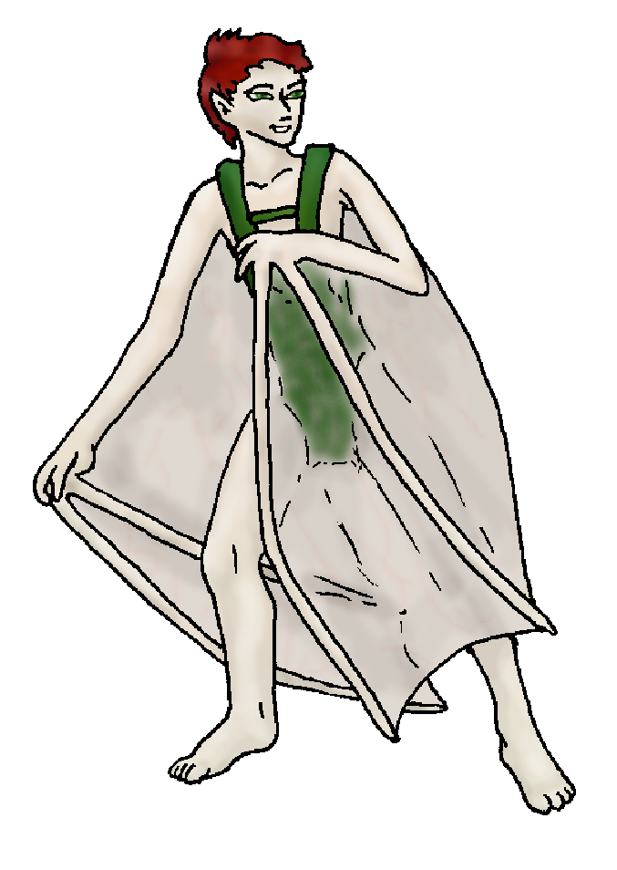
Habits and Places Preferred: Hunting Methods:
Bond Beast Personality:
Character Sketch
Hair: russet-red
Eyes: green-hazel
Skintone: lt tan
Bond Beast Habits/etc:
BondAnimal
Fur/Skin: brown, silver mks
Eyes: blue

About you as an elf
Your Name Means: Batwing is your most common alter-shape, it’s one which elves have hardly seen! Most folks change into wolves or cats or deer or birds… You can do that too, but you were inspired by your pet on arrival. (See below for more info.)
Your Appearance Is: quite tall, imposing, but slender and muscular. Your lightly tanned skin is often either burnt/peeling or needs-to-see-some-sun, depending on whether you’re spending time in or out of your den. You’ve got short, wild red-brown hair, and your eyes are a shade of hazel green. You often wear a kind of overall, which makes it easier for you to shape your arms if you need them. You have other clothing, but you need to keep whatever you’re wearing in mine, when you shapeshift.
You Are Located: In the south-east corner of the continent sits the Protector Holt. A varied place with plenty of different climates, terrains and weather. Your den rests under the North Peak, in a rich woodland that has a wide, slow river at one end and plenty of fan-rooted water-trees on the shore. The den itself is a mixture of stone, plant and dirt, right over the water’s edge but with enough clearance that even if the water rises a lot, it’ll miss your den mostly. You have a more dry portion out near the back entrance, which is under a pair of trees mixed roots, where you store your thin hide scrolls and drawing equipment for the maps you make.
Your Basic Statistics Mean: You’re bigger than many elves, but not much stronger or healthier than normal. Your dexterity is average, your intelligence is above average, and you’re known as an exotic but reasonably handsome elf. Your magical power is above average.
Your Skills Include: you barely remember your time on Earth, you’ve no use for those things here! You know your way around the Holt and can easily recognize places you’ve been, either from above or on the ground, and you typically devote energy to memorizing coastlines, shores of lakes, rivers and when you’re really wandering, altitudes and the like. You have a strong skill in map making, and while you’re not much better than typical in a lot of lores, you know a poison berry from a good one, and which animals to hunt without getting hurt. You track very well, through almost any terrain. Your physical skills are strong, aided by your ability to shape your limbs or body into something more useful if you need it. Hooked hard fingers for digging into a sheer rock face? You got it. Padded feet for moving quietly over dry leaves? Done. You’re an excellent hunter all around, using both traps and weapons to take down prey. You trap more in the winter time (such as it is here in Protector…) but in other seasons you enjoy several kinds of weapons to kill an assortment of aggressive or difficult prey. You have a metal-headed mace which you swing hard enough to break boar skulls, and a long, extremely sharp pike for hunting the weirdly armor-skinned deer that are native only to this region. When you’re up in the trees or spotting things from a perch, you also have a set of metal throwing sticks – they’re long enough to give a good solid whack, and made from metal so they’re much easier to spot on the forest floor when you’re done. Though you’re not remarkably social, you certainly enjoy a good party with friends – food and wines, story telling and dancing.
Your Magic Powers Are: You have a typical Magic Feeling ability, you can sense magical traces on items which have been shaped by elves, and this is extremely useful for you to locate your throwing sticks – they glow, in addition to having a specific smell of metal (which is a bit harder to locate when you’re also smelling a freshly killed rabbit…). You don’t use it too often, save to find things you know are nearby. Your telepathic Sending power is average, you can send to numerous people at once and gather information from them – you use this group-sending often for making changes or details to your maps. You also have a typical ability to bond to a feline, and you’ve got a bond-cat from this power. In addition to those things, you are able to Shapeshift! You actually move your flesh and bones around – painlessly and quickly – into an assortment of different things. However, you’re far more likely to adopt only parts of an animal: the eyes of a feline for night-vision, the nose of a wolf for tracking, monkey fingers for climbing, and your characteristic bat arms for the occasional flight. Now, that said, you’re not big on flying. Far from it. However, these wings have saved you from falling a number of times! They are simply your hands, arms and a bit of your torso skin stretched out thin as can be. You would be very hard pressed to actually change into a bat, cat, wolf or whatnot, but parts are very simple for you! Because you live near the water, and in a location in the Holt where it’s fairly wet all year round, you use your ability to Firestart to keep yourself and your den warm. You often have a collection of fallen logs, sticks and branches that you dry out over time, for fires – but you usually start them with a touch of magic from your mind, rather than hunting around for tinder, flint and something to spark it.
Your Bond Animal Is: Fallfrost is a big cougar-like feline from the Pride which is led by the huge and stately Cimmeron. Fallfrost is large, but not terribly strong, and kind of fragile. You can ride her easily, but she tires out quick. She is very nimble, but also she’s known as quite intelligent for her type – she can keep up with most elfin conversations. Whether she cares or not… that’s up to her. She’s got a rich brown colored coat, with markings in frosty silver on her face, paws and tail, with a faintly silverish belly, and bright blue eyes. In addition, you have a special pet which followed you from Earth, a large bat who resides in the dim corner of your den. He does fly around at night enjoying the bounty of insects that gather over the river nearby. You take your physical form from knowing how he looks, but modified because of your size and the number of fingers you’ve got…
Special Information: Your Self-shaping attracts the attention of others around the world, because some people are known to shape fully while others are only able to change their appearance or their colors. Your sort of ‘half shifting’ is almost unknown – other shifters often find they can shift parts that they usually go – like a bird-shifter can make their feet into talons or grow a feathery hair-do, a feline shifter gains a tail or claws. But then they shift the rest of the way. You merely select what’s best for your current action, and that’s something that you could try and teach to others with the power. Most elves only take on one single form by heart. And while you’re not completely able to master lots of them – you can mix and match better than most.
You are known as a Deathsleep (Winter/Seventhsign) elf, with the star-pattern of the “Arrowhead” in the evening sky. Elves of this ‘zodiac’ sign are represented by the Longtooth cat, the color Black and the hard-to-find Orchid elements. Those who carry this sign are often Canny, secretive, Dangerous, Flirtatious.

Date: Mon, 08 Jan 2007 17:02:32 -0500

Necessary Stuff
Your Full Name: Timothy Nickname or Title tim Birthday Oct 17 1987 Act HOW Old? my age
Your Gender male, You like it this way
You Prefer the opposite sex
You are in single and hating it

Appearance Stuff
You're about 6.5 feet tall, and you'd like to be the same
Your build is slim and you'd like to be same
Hair Color redish brown Change? none
Hair Style/Curl whatever it looks like in the morning Change? none
Eye Color hazel Change? Glasses? off
Skin Tone slightly tanned Change? none
Are you 'Attractive'?yes Change? none
Are you 'Strong'? yes Change? none
Are you 'Smart'? in between Change? none
Are you 'Nimble'? no Change? none
You'll be getting pointy ears - you want them short

Circle (likes) or Cross Out (dislikes)
Where do you like living? fewer people isolated village

Climates you like mild sunny mountainous marsh

What You Want Out of Life see the world slack off snuggle in front of a warm fire

Other:

Favorites...
Colors red, Forest green
Animals cougers
Music/Bands ill Scarlett
Foods lazagna RIBS
Sports if any hockey
Time of Day dawn
Season autumn

Fears and Hates height

Any pets you'd like to drag along? My pet bat 6 foot wing span
Any people you'd like to have with you? (supply them a sheet!)

