NAME: Hawthorn HOLT: Protector SOUL NAME: (Al) EARTHNAME: Tom Martin
MATE: CHILDREN/RELATIVES: (coh)
MATURITY: Adult REAL AGE:9.5.70/38 YEAR/PORTAL OF ARRIVAL: 122/Hall SEX: Male

STR: 14 CON: 14 SIZ: 6 INT: 16 POW: 17 DEX: 19 APP: 15 Total: 101
SKILLS MAGIC POWERS WEAPONS / ARMOR / BOND ANIMAL
language memory: 32 % magic feeling: 27 % attack with short staff (wood) x2 : 76 %
animal lore: 32 % sending: * 78 % damage 1d4 smashing parry: 66 %
elf lore: 64 % wolf bonding: 68 % attack with________________________________: ___%
healing lore: 42 % healing: ___% damage_______________________________parry: ___%
mechanical lore: 64 % (anti-heal: ___% missile shortbow/arrows : 86 %
mineral lore: 42 % (flesh shape: ___% damage 1d6 impale range med-long
plant lore: 64 % (shielding: ___% missile net launcher (large/heavy) : 66 %
world lore: 48 % plant shape: 61 % damage 1d4 smashing, entangle range medium
communicate: 82 % rock shape: ___% missiles carried__________________________________
wolf/anim comm: 66 % (metal shape: ___% shield_________________________________use: ___%
perception: 78 % (gem shape: ___% armor type______________elem:___bash:___cut:___othr:___
stealth: 72 % bone shape: ___% supplies carried / other skills / etc
climb: 66 % water shape: ___%
dodge: 72 % firestart: ___%
jump: 76 % levitation: ___%
swim: 76 % finding: ___%
throw: 66 % animal bond: ___% BOND ANIMALname: Nightstar species: Wolf sex: f
manipulate: art 67 % mindsnare: ___% STR:15 CON:11 SIZ:16 INT:13 POW:11 DEX:22 APP: 10
ride wolf: 76 % hypnosis: ___% climb: ___% jump: ___% swim: ___%
hunt: 72 % astral projection: ___% stealth: ___% dodge: ___% percp: ___%
tinkering: 70 % deep sensing: ___% comm: ___% ______:___% ______:___%
dancing: 68 % self shaping: ___% attack____________:___% attack________________:___%
music/sing: 70 % *coersion/group: 78 % disposition
trapping: 76 % :___% magic or other abilities
literacy: 74 % :___% natural armor:___________elem:___bash:___cut:___othr:___
Personality Notes: Lives in a...:
Likes and Dislikes: Friends:
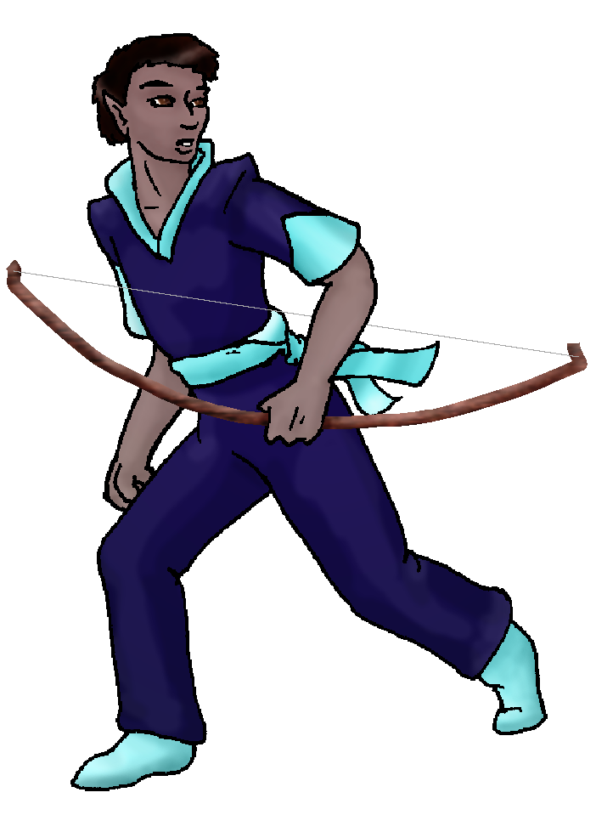
Habits and Places Preferred: Hunting Methods:
Bond Beast Personality:
Character Sketch
Hair: black
Eyes: brown
Skintone: dark
Bond Beast Habits/etc:
BondAnimal
Fur/Skin: black and white
Eyes: grey

About you as an elf
Your Name Means: Hawthorn is a species of thorny, flowering plant that grows in your part of the world, edible berries and very useful wood for elves to make weapons, toys and devices from. Your ability to shape plants has helped you allowed you to make many things from this very useful tree.
Your Appearance Is: Tall dark and handsome! With an even, muscular build and vibrantly colored leathers you cut an impressive figure among elves. Your hair is short and black, and you have dark brown eyes.
You Are Located: in the south-east corner of the continent, you live with others in the Protector Holt. This part of the world is equatorial but there are two mountains, one very tall indeed, both of which collect snow seasonally. Your den is situated between two zones of plant life: high, dry ground with evergreens and other mountainous plants, and riverside meadow where it occasionally floods to bring marshy spots. High in a tree, shaped by your own magic, you have a home which is a large bulb atop others – almost like an antenna ball whatever that is… But it’s a strong tree you chose for its height, and have shaped the inside to be hollow with climbing handholds. In your den you’ve got enough room to stand and even to entertain maybe two others – closely. The tree is quite large, really, this isn’t just like a ‘telephone pole’ with a knot at the top. Climbing in and out is easy, and you’ve shaped knotholes thin enough to see light while you’re in the trunk.
Your Basic Statistics Mean: You’re steadily above average in all physical ways, from size, to health, strength and dexterity. You’re considered attractive, and pretty smart. Your magical power is average, but you tend not to be really using it much anyway.
Your Skills Include: Your memory of Earth is weak but you’d get the ‘telephone pole’ joke if only to recall what one looks like (but what exactly is a telephone and why would you need a pole for it?) however you do seem to scheme and make ‘acme-like’ blueprints for large scale devices. You know other elves have done these before, and frankly you need some kind of big assault items to fight the spider-creatures in the East Valley. Because of that, your skill in artistry, mechanics and even your knowledge of what plants are good for things come into play. You can easily create things using your tinkering skill, though many of your items have to stay outside near the bottom of your tree den. Outside of those lores and knowledge skills you’re pretty adept at communicating, in fact you’ve got a magic power to deal with ordering people around – but you can also give encouraging words and dictate where hunters should be if you’re in charge of a hunt. Your physical and survival skills are all very well rounded, you can trek through many different terrains without slowing down or getting injured. From the back of your wolf, you can hunt or pick up your traps that you scatter around your area for smaller prey. You use a pair of short staves – baton length heavily shaped sticks – to smash bone and stun big prey; but also you can use a bow – you’re most fond of it, because it keeps you from immediate danger. However you have also developed a large-scale net launcher. This thing has to be carried or floated in to an area, and preferably set on high ground. It flings a heavy net rope, or can be fitted to propel stones, sacks of dung… whatever. It’s used when the spiderlings are acting up, keeping them at bay. They have yet to figure out where these big burning droppings are coming from… In your down time while not hunting or fiddling with new weapons, you love to dance and enjoy others’ company.
Your Magic Powers Are: While you’ve got an average raw power, you do have a selection of magic skills which come in handy. Your ability to sense with Magic Feeling is fairly low, which is quite typical. You can if you try hard enough, ‘see’ auras around things which have been shaped, but it’s not really that big a deal to you. Your telepathic Sending power is reasonably strong, you concentrate your efforts on groups mainly, reserving one-on-one for speech alone. Your power to bond a wolf has brought you Nightstar, below. Aside from those things, you’ve got two powers which you use pretty well. The stronger of the two is based on your ability to Send, Coersion, you sometimes use to gather the wits of a group together and make them all act as one, or at least stop people from wanting to wander off and do something else, until you’re done with them. You wouldn’t consider using this power on a single person alone, prefering to chat with them instead, even if it means a long debate. This power is excellent for keeping people involved with a story telling session as much as an intense hunt. Your other power is that of Plant Shaping, and as above you use it to create your den, weapons, and even extremely detailed small items from dead wood. Not every elf can shape dead matter, but you can shape living and dead plants equally well. You make gears, pulleys, complex shapes which ropes and metal parts can be inserted into or wrapped around. Also, you can strengthen dead wood in the same manner as a living branch, which is something that comes in handy for those big machines.
Your Bond Animal Is: Nightstar is a small to average wolf, she’s almost entirely typical, middle of the Pack worthy, except that she’s quite smart, and extremely nimble. Probably her smaller size allows her to leap generous distances over water, scrabble up hills that other bigger wolves couldn’t make, or even tree herself now and again… You didn’t think canines did that… She’s dramatically black furred with white spots, including one larger marking on her face, but she looks like the velvety night sky filled with stars. Her grey eyes only serve as further star markings.
Special Information: You’re very fit, physically, and though there are stronger or more nimble elves in the Holt you can usually spar with the best of them for a while. You encourage others to get up and roam around the Holt, not just to one another’s distant dens (the Holt is five hundred miles to a side, so there is plenty of room – probably too much room between for an organized group…) but through territory they haven’t walked. Yourself, you’ve been almost all the way across and down the place at least once, from ocean to play in the surf, on up to the chilly North Peak, and out past the East peak’s valley where those scary spider-creatures live.
You are known as a Leaffall (Autumn/Fifthsign) elf, with the star-pattern “Waterfall and River” in the evening sky. Elves of this ‘zodiac’ sign are represented best by the stunning Ram, the colors Red/Orange and the useful Maple element. Though you don’t have to be born, arrive or anything in this time of year for this personality to apply, elves of this nature are often Commanding, noisy, filled with Pride, and quite Social.

Date: Sat, 06 Jan 2007 14:31:24 -0500

Necessary Stuff
Your Full Name: Tom Martin Nickname or Title Al Birthday September 5, 1970 Act HOW Old? 35
Your Gender male, You like it this way
You Prefer the opposite sex
You are in single and loving it

Appearance Stuff
You're about 5'11" feet tall, and you'd like to be taller
Your build is Medium and you'd like to be healthier
Hair Color Black Change? none
Hair Style/Curl Short Change? none
Eye Color Brown Change? No Glasses? off
Skin Tone Dark Change? none
Are you 'Attractive'?yes Change? none
Are you 'Strong'? yes Change? stronger
Are you 'Smart'? in between Change? smart
Are you 'Nimble'? no Change? athletic agility
You'll be getting pointy ears - you want them short

Circle (likes) or Cross Out (dislikes)
Where do you like living? quiet neighborhood

Climates you like seasonal mild warm hot rainy cloudy sunny dry sea level flatland plains mountainous beach river forest grassy

What You Want Out of Life see the world plant a tree surf find a soul-mate draw/create slack off build and construct read order people around do a triathalon give advice and listen surround yourself with technology retire early and relax fiddle with toys and tools

Other:

Favorites...
Colors Blue
Animals Dalmations, Huskies, Hedgehog
Music/Bands Folk, Celtic, Alternative
Foods Pizza, Chicken & Rice
Sports if any Running, Baseball
Time of Day midnight
Season summer

Fears and Hates Injustice, Haughtiness, Failure

Any pets you'd like to drag along? Dog
Any people you'd like to have with you? (supply them a sheet!)

