NAME: Spotter HOLT: Protector SOUL NAME: trickshooter EARTHNAME: Tim Wallace
MATE: CHILDREN/RELATIVES: (coh)
MATURITY: young adult REAL AGE: 10.7.84 YEAR/PORTAL OF ARRIVAL: 122/Hall SEX: Male

STR: 14 CON: 14 SIZ: 6 INT: 16 POW: 20 DEX: 16 APP: 15 Total: 101
SKILLS MAGIC POWERS WEAPONS / ARMOR / BOND ANIMAL
language memory: 26 % magic feeling: 60 % attack with bone knife : 60 %
animal lore: 68 % sending: 100 % damage 1d4 impale/cutting parry: 60 %
elf lore: 58 % wolf bonding: 80 % attack with________________________________: ___%
healing lore: 32 % healing: ___% damage_______________________________parry: ___%
mechanical lore: 48 % (anti-heal: ___% missile Bow/Arrow : 90 %
mineral lore: 32 % (flesh shape: ___% damage 1d6 impale +extras range medium
plant lore: 32 % (shielding: ___% missile Crossbow/Bolt : 70 %
world lore: 32 % plant shape: ___% damage 1d10 impale +extras range long
communicate: 72 % rock shape: ___% missiles carried__________________________________
wolf/anim comm: 72 % (metal shape: ___% shield_________________________________use: ___%
perception: 100 % (gem shape: ___% armor type______________elem:___bash:___cut:___othr:___
stealth: 72 % bone shape: ___% supplies carried / other skills / etc
climb: 68 % water shape: ___%
dodge: 72 % firestart: ___%
jump: 104 % levitation: *, ** 80 %
swim: 60 % finding: ___%
throw: 60 % animal bond: ___% BOND ANIMALname: Gusty species: Greater Wolf sex: f
manipulate: 64 % mindsnare: ___% STR: 22 CON: 18 SIZ: 20 INT: 15 POW: 11 DEX: 15 APP: 13
ride wolf: 74 % hypnosis: ___% climb: ___% jump: ___% swim: ___%
hunt: 72 % astral projection: ___% stealth: ___% dodge: ___% percp: ___%
fletching/bowery: 64 % deep sensing: ___% comm: ___% ______:___% ______:___%
dancing: 62 % self shaping: ___% attack____________:___% attack________________:___%
music/sing: 80 % * Telekinetics: 40 % disposition
trapping: 82 % ** Soundshape: 60 % magic or other abilities flight 22%, fire start 11%
literacy: 64 % :___% natural armor:___________elem:___bash:___cut:___othr:___
Personality Notes: Lives in a...:
Likes and Dislikes: Friends:
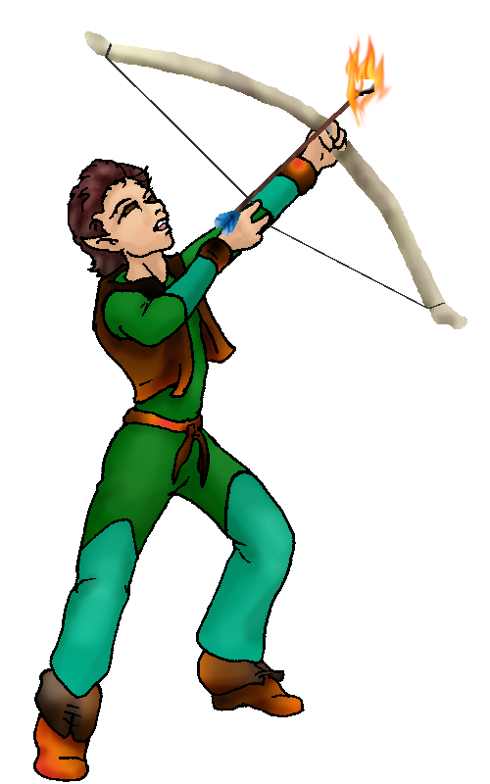
Habits and Places Preferred: Hunting Methods:
Bond Beast Personality:
Character Sketch
Hair: dark brown
Eyes: brown
Skintone: medium-fair
Bond Beast Habits/etc:
BondAnimal
Fur/Skin: grey & white
Eyes: red

About you as an elf
Your Name Means: Not only are you great at seeing little details on first glance, but your ability to do so extends into the magical realm as well. Spotter is your name because you can spot prey, as well as hit it dead on with whatever missle you’ve got at hand.
Your Appearance Is: With fair to tan skin, dark brown hair that’s short and reasonably stylish, and brown eyes to match. You choose shades of forest green and blue, browns and wood tones that allow you to blend in with your surroundings.
You Are Located: In the Protector Holt at the south-eastern edge of the continent. Your particular den is up in the mountains, where the weather of this equatorial area is affected by ‘seasons’. Your place is south-east of the highest peak, several thousand feet up, and yes, that means you’ve got a great view of the whole Holt. There are two large waterfalls nearby which lead to a wide, somewhat shallow lake, and then tribute to the rivers heading into the big bay. Your den is near both, between them, and nestled in a shallow cavern where you have lots of woven mats, furs and mosses keeping the place warm. Practically no one who’s never been to your place can see it from the outside, but once they’ve been there it’s easier to see through the branches and stone outcroppings. You’ve largely kept the interior of the cavern natural, prefering not to shape the stone around you – for your sense of magic would be tingling all too much then.
Your Basic Statistics Mean: You’re above average in height and health, as well as strength, able to pull even difficult bows with ease. You’re considered quite attractive as well as rather intelligent, and though you’ve mastered the bow your other dexterity issues leave a little room for improvement. Your magical power is very strong, stronger than many in the Holt.
Your Skills Include: You have a fairly average memory of Earth things, which gives you a bit of an edge when deciding what to create or how to make a pulley for a bow. You study animals as well as people, knowing individuals in any species you see frequently, and the habits of elves are fascinating. Your skill with mechanics is pretty good, and the rest of your theoretical knowledge is average. You excell in certain physical duties, perception and leaping in particular. Others are average. You enjoy hunting for smaller prey, using a bow which you’ve also developed ‘trick’ arrows such as grapples, net firing devices and burning ended arrows for. You hunt in groups on wolf-back using your crossbow, preferring to remain at a distance from more dangerous prey. Also since you’re a flier, you sometimes fling yourself into the air for a better angle. You are literate to a reasonable degree, able to read and write in the language that Talon taught you in Dare’s Valley. In social times, you enjoy creating music and dancing, your powers assist you in both. You are however known as a fletcher and bower, producing nice hand-made, non-magical items for hunting.
Your Magic Powers Are: You have a very high Magic Feeling ability, possibly among the highest in the Holt. With it, you can narrow down not only who shaped an item, but when, and how long it took them. With it, you read people’s auras easily and instantly, able to tell what powers they’re using from even a mile away. You can spot people at even greater distances, all the way down the mountainside. Their auras become more and more faint to your magical ‘eyes’ past perhaps 30 or 40 miles but you can still somehow detect them even then. It’s almost impossible for a person – or a magically shaped creature or item – to hide from you. This is why you choose not to use shapers for your everyday items and home! You’d be constantly bombarded by magic tingly-feelings. Your telepathic Sending power is quite strong as well, and you have an excellent ability to ‘lock-send’ or talk with one person very privately so no one can pry in to your conversation. Your range is farther than most, but not all the way across the holt like some. When you need to pinpoint someone and send an emergency message distantly, you know you can always do it – but you’re gonna have a headache. You also have reasonably high Wolf Bonding, and that’s given you a Greater Wolf companion, see below. All your other powers are centered around air, flight and its effects. First off you’re an incredible flier. Not as ‘always off the ground’ like some folks are, you are very precise in the air, and never fall even if there’s a strong wind or complicated branches to move around. For some reason, your physical dexterity has nothing to do with your magical flight! You can keep flying for a good while, usually all the way from the peak where Jolly lives, down to the thick forests some 6 thousand feet below, before taking a break. You can also lift another elf with ease, but not for more than half an hour or so. This helps for taking your prey back to your den of course. But you’ve also got two related powers – those of Telekinesis, and Sound Shaping. With your TK, you can alter the flight of an arrow, or cause small motion in the wind around you. This power is very precise and specific, you do require some concentration to do it, though you can manage it while in midair. If you know an arrow’s going to miss its target you can nudge it before it fails – and since you’re well known to be able to see such slight deviations in an arrow’s path, you can do this before it misses! The useful power of Sound Shaping allows you to emulate noises such as animal calls, breaking branches, sharp cracking and low rumbles – but you use it to make music like some others in the Holt! Among the group of you, you rather enjoy making ‘thumpy’ noises, a pretend drumming for all to hear, as well as amplifying a singer’s voice so everyone nearby can hear. This ability takes a bit out of you, but you can usually keep doing it for a few songs before needing to rest up.
Your Bond Animal Is: Gusty is a female Greater Wolf of the pack that ‘belongs’ to Fang. Her red eyes and strong magical power (for a wolf) prove that she’s part of his elfin blood, but she’s all wolf in shape. She has mostly grey fur with white billowy markings – and she like you, is a flier! Her power is much weaker than yours, but she can lift herself off the ground to scale a sheer cliff or leap across a wide river without getting wet. She also has a very minor ability with starting fires, and sometimes if you startle her the right way she actually bursts nearby leaves into flames (it’s a party gag even she thinks is funny). She’s quite large and strong, as well as ridiculously sturdy. That said, she has never been interested in being an Alpha in the pack, prefering your company and that of one or two companions, to a big rolling pack action.
Special Information: Though you’re apt to prefer looking at the males in the Holt, rather than the females, you sense that there are several compatable females who’d make good partners – at least for one very important thing: creating children. There are no children in the Holt just now, and never let it be said that elves care who raises their kids – the tribe raises them, in other Holts, very rarely do parents take a too-protective stance about them. So perhaps, someday, you’ll be able to have a family.
You are known as a Whitecold (Late Winter/Eighthsign) elf, with the star-pattern of the Hunter in the night sky, the animal Wolf, the color White and the element of stately Evergreens as symbols. Elves of this ‘sign’ though they don’t have to be born or arrived during the season, are known to be Eventempered, balanced, and graced with Wisdom, Comfort.

devilducky84@msn.com
Date: Tue, 28 Nov 2006 22:03:41 -0500

Necessary Stuff
Your Full Name: Timothy Wallace Nickname or Title Trickshooter Birthday 10/07/1984 Act HOW Old? Younger than 22!
Your Gender male, You like it this way
You Prefer the same sex
You are in single and loving it

Appearance Stuff
You're about 6 feet tall, and you'd like to be the same
Your build is Burly and you'd like to be same
Hair Color Dark Brown Change? none
Hair Style/Curl Curls up in the front Change? none
Eye Color Brown Change? Nope Glasses? off
Skin Tone Lighter tan Change? none
Are you 'Attractive'?yes Change? none
Are you 'Strong'? yes Change? none
Are you 'Smart'? yes Change? none
Are you 'Nimble'? no Change? none
You'll be getting pointy ears - you want them short

Circle (likes) or Cross Out (dislikes)
Where do you like living? old friends quiet neighborhood

Climates you like cold snow/sleet beach

What You Want Out of Life find a soul-mate draw/create raise kids make
music fly like an eagle read raise pets and animals learn surround
yourself with technology retire early and relax fiddle with toys and tools

Other:

Favorites...
Colors Green
Animals Rat
Music/Bands MC Chris, Guster, Imogen Heap
Foods Spaghetti
Sports if any Archery
Time of Day evening
Season winter

Fears and Hates Failure

Any pets you'd like to drag along?
Any people you'd like to have with you? (supply them a sheet!)

