NAME: Scout HOLT: Protector SOUL NAME: (tsukiyomi) EARTHNAME: Travis Byrd
MATE: CHILDREN/RELATIVES: (coh)
MATURITY: adult REAL AGE:2.22.83/25 YEAR/PORTAL OF ARRIVAL: 122/Hall SEX: Male

STR: 14 CON: 14 SIZ: 5 INT: 15 POW: 18 DEX: 19 APP: 14 Total: 99
SKILLS MAGIC POWERS WEAPONS / ARMOR / BOND ANIMAL
language memory: 40 % magic feeling: 46 % attack with 2 handed staff (wood) : 76 %
animal lore: 70 % sending: 102 % damage 1d8 smashing parry: 66 %
elf lore: 60 % cat bonding: 72 % attack with 1 handed sword (metal) : 66 %
healing lore: 45 % healing: * ___% damage 1d6 cutting/impale parry: 33 %
mechanical lore: 30 % (anti-heal: ___% missile bow / arrow (bone/sinue) : 66 %
mineral lore: 30 % (flesh shape: ___% damage 1d4 impale range med-long
plant lore: 40 % (shielding: ___% missile sling / shots (stone, bone) : 66 %
world lore: 30 % plant shape: ___% damage 1d2 smashing range short
communicate: 78 % rock shape: ___% missiles carried__________________________________
animal comm: 66 % (metal shape: ___% shield_________________________________use: ___%
perception: 72 % (gem shape: ___% armor type______________elem:___bash:___cut:___othr:___
stealth: 84 % bone shape: 72 % supplies carried / other skills / etc
climb: 76 % water shape: ___%
dodge: 84 % firestart: ___%
jump: 76 % levitation: ___%
swim: 66 % finding: ___%
throw: 76 % animal *sense: 92 % BOND ANIMALname: Silvershadow species: big cat sex:m
manipulate: 76 % mindsnare: ___% STR: 13 CON:13 SIZ:15 INT:12 POW:16 DEX:21 APP:10
ride big cat: 76 % hypnosis: ___% climb: 68 % jump: 84 % swim: 78 %
hunt: 72 % astral projection: ___% stealth: 74 % dodge: 74 % percp: 64 %
weaponsmithy: 78 % deep sensing: ___% comm: 66 % ______:___% ______:___%
dance/music: 66 % self shaping: ___% attack claw/rake : 68 % attack bite : 58 %
literacy: 60 % *self-survival: 36 % disposition lazy as all getout, always comfortable
trapping: 72 % :___% magic or other abilities
tracking: 72 % :___% natural armor:___________elem:___bash:___cut:___othr:___
Personality Notes: Lives in a...:
Likes and Dislikes: Friends:
Habits and Places Preferred: Hunting Methods:
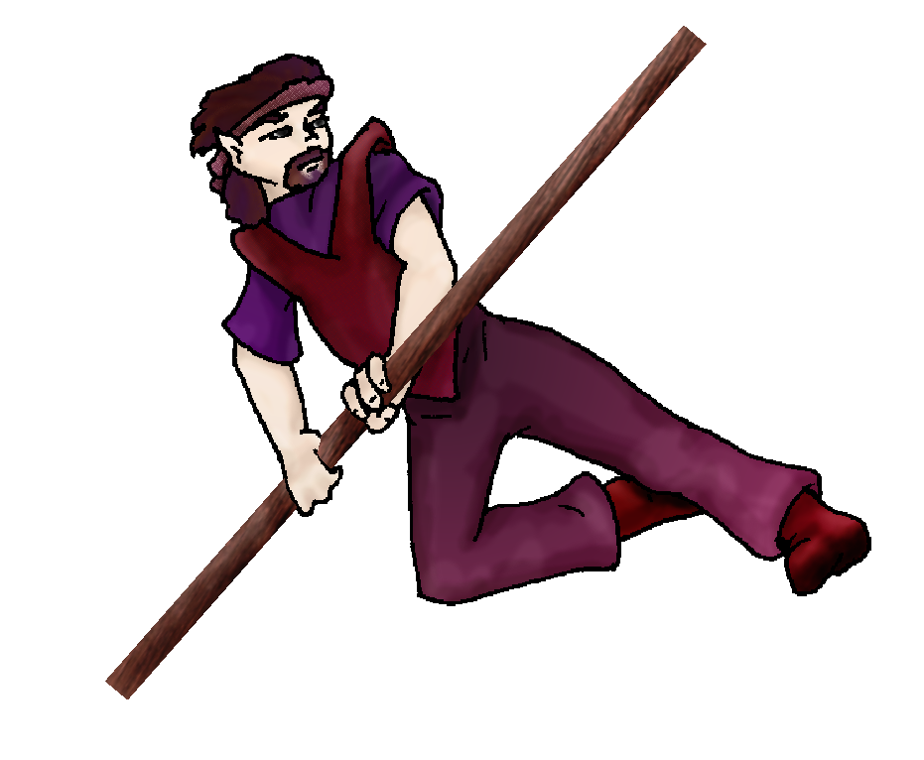
Bond Beast Personality:
Character Sketch
Hair: violet-brown
Eyes: grey
Skintone: fair
Bond Beast Habits/etc:
BondAnimal
Fur/Skin: black / silver marks
Eyes: blue

About you as an elf
Your Name Means: Scout is your name for a fairly obvious reason: you scout a lot. Almost always on the move, you have a self-appointed round of places where you make sure that the hideous spider-things in the eastern valley aren’t approaching, and if they are, you are the first one to warn the others about them. Otherwise you’re running for the pure joy of it, moving through hard landscapes with ease and making mental notes about what you see.
Your Appearance Is: Average height, nicely built, you’re a fair-skinned elf with short ears, hair that’s a mixture of violet and brown strands, complete with a fuzzy beard, and dark grey eyes. You choose muted violet colors, excellent for keeping to the shadows but also smartly cut for interaction with other elves – you can’t help but look good.
You Are Located: In the Protector Holt, which is in the south-east corner of the huge continent. Your den is situated on the northern face of the east peak, craggy and rocky, shorter trees and stiff winds dominate this land. Beyond it, lush forests and groves, you know all the terrains in the area well. Your den is shaped out of the stone of a broken hill, an old, dead tree which had forced the stones apart sits above it, clearly having been struck by lightning long ago. Your den underneath it is spacious, a small underground stream having formed in it. You have room for weapons in progress, comfortable sleep furs, and baskets with other supplies and goods in them. You don’t much entertain in this den, in fact it’s likely very few other elves actually know where it is. You prefer to go to them, keeping your private den private.
Your Basic Statistics Mean: You’re average in size, but quite strong and sturdy, attractive, and nimble. You’re above average in intelligence, able to pit your mind against others in the Holt, and your magic Power is average.
Your Skills Include: A fairly strong memory of Earth and its busy ways, you can joke about things compared to it, and only a few others ‘get it’. You’re able to understand the language and traces of animals very well, in both behavior and tracking them for hunting purposes. The contact you have with elves is strong, you get gossip now and then and keep notes to yourself about it, since you’re not always around everyone. You’ve got adequate knowledge of healing and keeping healthy that you hardly need to worry if you hurt yourself, other lores are suitable for basic survival only and you don’t really depend on them every day. All your physical survival skills are quite strong, all you seem to do is use them every day! Leaping over rocks, climbing trees, extracting yourself from ground-holes… You’re quite good at all of that, and more. Tracking, trapping and navigating the Holt’s grounds are all second nature to you. You’re a good weaponsmith, using bone tools and your magic to shape mostly arrows, bows and smaller weapons. The big sturdy staff you have was shaped by someone else for you. For your own hunting needs, you use the staff to get around and leap over things, but also to great effect smashing prey animals. You’re also adept with a sword, though you don’t use it for much unless you somehow lose your staff. For distant prey, you are good with a bow and arrows, shaped by your own magic, so you know this weapon inside and out. And for closer, but less easily caught animals, you’ve got a sling you load with either smooth stones, or sharp shaped bone pellets. Never discount the value of a ‘child’s toy’ such as a sling, you’ve scored small elusive prey during tough Whitecold seasons that others might have missed with their bigger weapons. Like many in the Holt you’re literate to a reasonable degree, you keep personal notes and drawings for new weapons.
Your Magic Powers Are: you’ve got a very strong Magic Feeling power, with it you can sense where other elves are nearby as you race through the Holt, telling who is where by the colors and depths of their magical auras. The whole place kind of shines with a magical quilt of people and shaped items – from a high spot overlooking any given set of dens, you see soft colored traces of everyone there. Your telepathic Sending power is very strong indeed, it’s your main form of communication, and thus you have become expert at it. Your mind can touch elves at longer distances than many, and since you’re always on the move, this is very helpful. Others have described your mind-voice as being like a strong wind, not howling, but intense. You’ve got the ability to magically tie yourself to an animal, in this case a feline, which has brought you a bond in the form of Silvershadow (below). Aside from those things which almost all elves have in common, you’ve got other powers that get a workout all the time. Strongest of these is your ability to sense animal life near you. You can focus your attention on big animals, small ones, birds, insects or whatever you need to, though this power doesn’t allow you to control them to any extent it can warn you when they’re angry or if something’s frightened them. This power is essentially always working, you can concentrate to shut it down or ignore it, or focus keenly on something specific within a distance of around 2 miles from where you stand (this includes air and ground too). You have a strong Bone Shaping ability, using it only on already-dead materials – some folks can heal as well as shape bones, but you cannot heal them. Something the size of a leg bone of a deer (which would be around half your height in length) can be shaped into a useful bow or tool in around half an hour. Antlers are also easily shaped by this power, and you have a seasonal trip around the Holt where you collect whatever you can find and bring them home to shape. Weakest but surely important in your selection of powers, is that of ‘survival’. This is a healing-based power, which allows your body to recover from lengthy abuse such as day-long full-tilt running, tumbling down rocky hillsides, and preventing you from suffering from sheer exhaustion. It helps you heal everyday injuries like scrapes and cuts or bruises very quickly, though not consciously. This power, like your Animal sense, is essentially always ‘on’ and working when you need it to. You shouldn’t depend on it to save your life in a very bad accident or injury, however, the self-healing ability doesn’t work fast enough to prevent much blood loss. But it will help you get from one corner of this very large Holt to another, without collapsing at your finish line.
Your Bond Animal Is: Silvershadow is a male ‘mountain lion’ like cat, pretty large but more bulky than strong. Lazy beast, he is the color of night and his markings are a weak silver shade on his face, paws and tail. While he’s not very strong at all, he is quite smart, and extremely nimble for a flabby cat. He likes to catch birds in flight, always surprising from this cat who sleeps nearly as much as you run all day…
Special Information: Yes it’s true, there are spider-creatures living by the hundreds (milllllions! According to any given campfire story) in the valley on the other side of the peak where you den. It’s a matter of self-control that you pass by their lairs on a regular basis, you must keep the Holt safe from them, though you far prefer to simply pass by, spot one and alert another more aggressive elf to their presence and location.
You are known as a Deathsleep (Winter/Seventhsign) elf, your personality ‘zodiac’ sign represented by the Longtooth cat, the color Black and the sultry Orchid. Elves of this nature (though they don’t have to follow every bit of this description, nor be born/arrive in this season to qualify) are often Canny, secretive, Dangerous, Flirtatious. The star-sign of the “Arrowhead” is in the night sky at this time.

Date: Mon, 25 Dec 2006 23:55:51 -0500

Necessary Stuff
Your Full Name: Travis Byrd Nickname or Title Tsukiyomi Birthday 2-22-1983 Act HOW Old? 30ish
Your Gender male, You like it this way
You Prefer the opposite sex
You are in dating someone

Appearance Stuff
You're about 5' 9" feet tall, and you'd like to be the same
Your build is Athletic and you'd like to be same
Hair Color Brown Change? weirder
Hair Style/Curl Random Change? shorter
Eye Color Grey Change? No Glasses? on
Skin Tone Caucasian Change? none
Are you 'Attractive'?yes Change? unique
Are you 'Strong'? yes Change? none
Are you 'Smart'? yes Change? none
Are you 'Nimble'? yes Change? none
You'll be getting pointy ears - you want them short

Circle (likes) or Cross Out (dislikes)
Where do you like living? fewer people isolated village

Climates you like freezing chilly cold snow/sleet rainy foggy muggy cloudy towering cliffs rocky

What You Want Out of Life fight things/people rough it/camp joke go fishing find a soul-mate slack off build and construct isolate yourself
read do a triathalon raise pets and animals learn give advice and listen

Other:

Favorites...
Colors Purple
Animals Cats
Music/Bands Daft Punk
Foods None
Sports if any Running
Time of Day dawn
Season winter

Fears and Hates Spiders Spiders Spiders

Any pets you'd like to drag along? Nope
Any people you'd like to have with you? (supply them a sheet!)Nope

