NAME: Sharpshot HOLT: Protector SOUL NAME: EARTHNAME: V Belle
MATE: CHILDREN/RELATIVES: (coh)
MATURITY: young adult REAL AGE: YEAR/PORTAL OF ARRIVAL: 122/Hall SEX: F

STR: 9 CON: 13 SIZ: 6 INT: 16 POW: 16 DEX: 20 APP: 16 Total: 96
SKILLS MAGIC POWERS WEAPONS / ARMOR / BOND ANIMAL
language memory: 36 % magic feeling: 26 % attack with 2handed Spear : 68 %
animal lore: 58 % sending: 74 % damage 1d10 parry: 48 %
elf lore: 48 % wolf bonding: 64 % attack with________________________________: ___%
healing lore: 32 % healing: ___% damage_______________________________parry: ___%
mechanical lore: 26 % (anti-heal: ___% missile Bow and Arrows : 108 %
mineral lore: 26 % (flesh shape: ___% damage 1d6 range medium
plant lore: 32 % (shielding: ___% missile Longbow : 98 %
world lore: 42 % plant shape: ___% damage 1d6+2 range long
communicate: 84 % rock shape: ___% missiles carried__________________________________
wolf/anim comm: 64 % (metal shape: ___% shield_________________________________use: ___%
perception: 94 % (gem shape: ___% armor type______________elem:___bash:___cut:___othr:___
stealth: 92 % bone shape: ___% supplies carried / other skills / etc
climb: 78 % water shape: ___%
dodge: 84 % firestart: 90 %
jump: 68 % levitation: ___%
swim: 68 % finding: ___%
throw: 68 % animal bond: 46 % BOND ANIMALname: Benny species: wolf (?) sex:
manipulate: 70 % mindsnare: ___% STR: CON: SIZ: INT: POW: DEX: APP:
ride Wolf: 80 % hypnosis: ___% climb: ___% jump: ___% swim: ___%
hunt: 82 % astral projection: ___% stealth: ___% dodge: ___% percp: ___%
cooking: 82 % deep sensing: ___% comm: ___% ______:___% ______:___%
dancing: 72 % self shaping: ___% attack____________:___% attack________________:___%
music/sing: 72 % :___% disposition
tracking: 60 % :___% magic or other abilities
Sharpshooting: 100% :___% natural armor:___________elem:___bash:___cut:___othr:___
Personality Notes: Lives in a...:
Likes and Dislikes: Friends:
Habits and Places Preferred: Hunting Methods:
Character Sketch
Hair: Blond
Eyes: Blue
Skintone: tan
Bond Beast Personality:
Bond Beast Habits/etc:
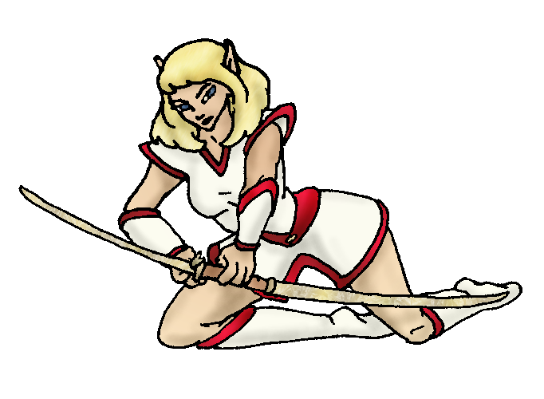
BondAnimal
Fur/Skin:
Eyes:

About you as an elf
Your Name Means: Sharpshot is your name due to your amazing aim with a bow and arrow. You know how to use several different kinds of bow, whatever is suitable for your prey or the activities. But almost no matter what, you can make a shot where no one else can. (see your skills for more)
Your Appearance Is: Tall and slender, with medium length blond hair, sky blue eyes, and skin tanned from your time in the outdoors. Your choice of blood red trimmed clothing reminds people that you’re able to hit a bullseye unerringly.
You Are Located: In the Protector Holt, your den rests in a hollowed cavern in a thickly forested area overlooking one of the rivers that lead to the great Bay. Most of the caves here have a warm ‘furnace’ provided by the old lava flow that drifts far below, yours is no exception but you also have a hearth shaped from the very stone of the cave by one of the others, and often there is a warm fire in it. You also use this hearth to cook up some great meals!
Your Basic Statistics Mean: Though you’re not spectacularly strong nor healthy, you are tall and lithe, considered attractive by most in the holt. Your magic power is not very strong, but you tend to use your physical skills more than magic anyway. You’re often found in intellectual discussions, but it’s your physical dexterity and nimble body that impresses people. Athletic to a point, but precise in your fine balance and aim.
Your Skills Include: Your memory of time on Earth is typical, though a bit sharper than some – you can remember bits and pieces, especially when you’ve got time to think about it. You’ve got names for local wildlife and can share information about the creatures living near by, but you don’t know everything about them. Your other ‘lore’ skills are reasonable but not what you concentrate on. Adept at particular feats such as shooting and balance, you can track easily and your hunting ability is quite good. Most impressive among your skills are your abilities with bow and arrow. While others are responsible for making your weapons, you’re adept at picking up almost any bow – regardless of who it is for – and using it to great effect. Those made for you only seem to intensify this – and you have a skill with shooting that even if the conditions are very poor (bad weather, darkness, on the run, etc) you may still make a shot or trick shot that causes your aim to work just right. Some people call it magic – but you know it’s just skill! You’re able to cook well, and it’s extra good when you have brought down the meal yourself.
Your Magic Powers Are: With a lowish Power score, you’re not able to put up a lot of magic for very long, but you know how to conserve energy. Your Magic Feeling power is average, you can tell when someone’s shaped an object or done some large magic recently. Your Sending, telepathic communication, is good for close communication and that to specific people nearby, but not so great at a distance. Your Wolf bonding power reassures you that even if you don’t quite recognize your Benny sometimes, he’s there for you. As for other powers that you do use, the ability to start and manipulate Fire is strongest in you. You can cause almost any flamable substance to instantly burn, and even start green wood with a bit of concentration. You can also use this power to put out fires and make sure they only burn in specific ways. Your other power is that of Animal bonding – with it you can not only find your hunting prey more easily, but you can ‘scare off’ larger predators. This is the primary use you put it to, keeping the weird creatures found out here at bay.
Your Bond Animal Is: Benny used to be a dog. Now, it seems, he’s a fairly large sized dark brown and black colored wolf! Was he always like this? You’re not sure. The other wolves are a bit stand-offish toward him, which means it’s very likely he wasn’t ‘one of them’ (ie: born on this world and waiting for you to arrive). But he hunts with them just like any other bond predator, and spends a lot of time sleeping by you near the hearth.
Special Information: You are the first of the Protector elves to arrive. Though others might take on more important or visible roles in the Holt, you know you’re always going to be the first here.
You are known as a Newgreen (Spring/Secondsign) elf, though you and the others all arrived about the same ‘season’ the Turtle is your ‘star sign’. The nimble Fawn is the sign’s animal avatar, the colors Green/Brown and the mighty Oak as well as bright Flowers are the sign’s other symbols. Those with this sign are often fans of Celebration, Lighthearted, and Passion, Nimbleness are their features.
ospivey@yahoo.com Date: Sun, 26 Nov 2006 08:31:38 -0500

Necessary Stuff
Your Full Name: Virginia Belle Nickname or Title Belle Birthday 1959 Act HOW Old? 24?
Your Gender female, You like it this way
You Prefer the opposite sex
You are in a solid relationship

Appearance Stuff
You're about 6 feet tall, and you'd like to be the same
Your build is slim and you'd like to be same
Hair Color Blonde Change? none
Hair Style/Curl Medium Change? none
Eye Color Blue Change? No Glasses? off
Skin Tone Tanned Change? none
Are you 'Attractive'?yes Change? none
Are you 'Strong'? no Change? none
Are you 'Smart'? yes Change? none
Are you 'Nimble'? no Change? athletic agility
You'll be getting pointy ears - you want them elegant

Circle (likes) or Cross Out (dislikes)
Where do you like living? isolated village

Climates you like mild warm sunny hilly mountainous

What You Want Out of Life see the world joke slack off raise kids make music read raise pets and animals learn snuggle in front of a warm fire

Other: Target shoot

Favorites...
Colors Red
Animals Dogs, guinea pigs
Music/Bands Jimmy Buffett
Foods Hot dogs, hamburgers, steak (umm... steak...), pizza
Sports if any Target shooting
Time of Day evening
Season spring

Fears and Hates Snakes, somebody trying to kill me or my loved ones

Any pets you'd like to drag along? My dog, Benny
Any people you'd like to have with you? (supply them a sheet!)No, but
you know me from Protector (CoH) :-)

