NAME: Allegory HOLT: Protector SOUL NAME: Xander EARTHNAME: Andrew Kenoyer
MATE: CHILDREN/RELATIVES: (coh)
MATURITY: adult REAL AGE: 8.3.?? YEAR/PORTAL OF ARRIVAL: 122/Hall SEX: m

STR: 14 CON: 15 SIZ: 5 INT: 16 POW: 20 DEX: 19 APP: 14 Total: 103
SKILLS MAGIC POWERS WEAPONS / ARMOR / BOND ANIMAL
language memory: 32 % magic feeling: 40 % attack with 2 handed wooden staff : 99 %
animal lore: 74 % sending: 100 % damage 1d10 smashing parry: 89 %
elf lore: 64 % wolf bonding: 80 % attack with 1 handed staff (handstaff) : 66 %
healing lore: 64 % healing: * % damage 1d4 smashing parry: 86 %
mechanical lore: 32 % (anti-heal: ___% missile___________________________________: ___%
mineral lore: 32 % (flesh shape: ___% damage___________________range______________
plant lore: 42 % (shielding: ___% missile___________________________________: ___%
world lore: 42 % plant shape: ___% damage___________________range______________
communicate: 80 % rock shape: ___% missiles carried__________________________________
wolf/anim comm: 60 % (metal shape: ___% shield_________________________________use: ___%
perception: 80 % (gem shape: ___% armor type______________elem:___bash:___cut:___othr:___
stealth: 76 % bone shape: ___% supplies carried / other skills / etc
climb: 66 % water shape: ___%
dodge: 78 % firestart: ___%
jump: 78 % levitation: 80 %
swim: 67 % finding: ___%
throw: 66 % animal bond: * % BOND ANIMALname: Stringer species: wolf sex: m
manipulate: 57 % mindsnare: ___% STR: 20 CON: 16 SIZ: 18 INT: 9 POW: 10 DEX: 20 APP: 10
ride wolf: 86 % hypnosis: ___% climb: ___% jump: ___% swim: ___%
hunt: 78 % astral projection: 80 % stealth: ___% dodge: ___% percp: ___%
storytelling: 90 % deep sensing: ___% comm: ___% ______:___% ______:___%
dancing/music: 60 % self shaping: ___% attack____________:___% attack________________:___%
literacy: 64 % * Animal Heal: 60 % disposition
trapping: 60 % ** Join Powers: 60 % magic or other abilities
aerial navigation: 72 % :___% natural armor:___________elem:___bash:___cut:___othr:___
Personality Notes: Lives in a...:
Likes and Dislikes: Friends:
Habits and Places Preferred: Hunting Methods:
Bond Beast Personality:
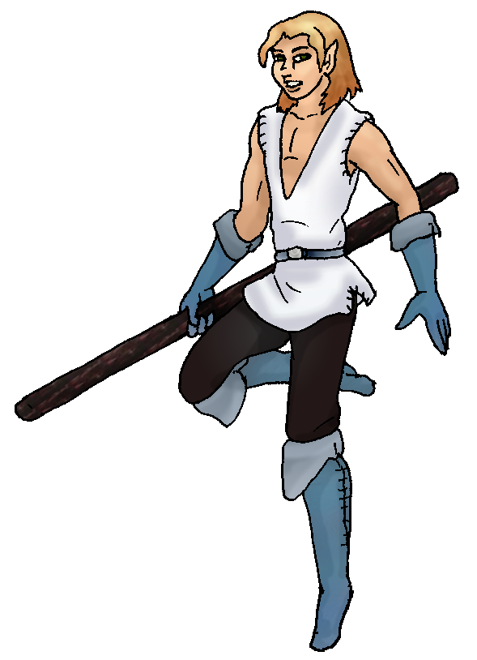 Character Sketch
Hair: tan brown
Eyes: hazel
Skintone: fair
Bond Beast Habits/etc:
BondAnimal
Fur/Skin: red-brown
Eyes: grey

About you as an elf
Your Name Means: Allegory refers to multiple pieces of your personality – your ability to tell a story, as well as your faithfulness to Earthly religion. You can in fact ‘relate’ many things, tying stories together and keeping others with the same (or at least a) faith happy with occasional advice.
Your Appearance Is: Light skinned and with honey-golden tan hair, your happy hazel-brown eyes smile even when your lips don’t. You have a set of leathers for hunting and general outdoors stuff (shown in picture) but also you like to have comfortable cloth robes and tunics for lounging around in your home or while telling stories.
You Are Located: In the Protector holt of the south-east corner of the continent, your den is up in the higher, cooler mountaintops. Though the whole Holt is equatorial, you’ve found the windy, seasonally chill mountains to be as close to ‘home’ as you could find. Your den is squared away in a heavily wooded and rocky area, shaped with stones and live woods. You have a three room place, the first entrance area is where people are all welcome to drop their hunting gear and relax near the hearth, the middle one is where you tell stories and gather for worship, and the other side of the main hearth is where your private sleeping den is. The whole thing is a semi-circle (like… a pacman shape!) based around your fireplace. The stones you picked by hand are colorful and blend in with one another from the shapers magic, and the flat, smooth stone floor is covered with furs and woven mats. The ceiling is all living wood, occasionally having to be re-shaped because it does actually grow and sometimes tries to push a new branch right where you like to stand up in the morning… You have a number of small oil lamps and candle holders scattered everywhere, giving the dark interior of the place a very comforting, starry-sky feel while it also remains warm and dry from the elements outside.
Your Basic Statistics Mean: You are average of size, but quite strong and healthy for your build. Considered above average in appearance, you use your keen wits and strong memory to entertain. You’re of high average dexterity, but it’s your strong magical power which you use a lot every day.
Your Skills Include: you have a higher than average memory of Earthly things, often you’d find yourself wondering at a phrase or event which you’re not sure if you participated in or just read about. You’ve got strong personal and animal based intellectual lores, able to understand animal behaviors and calls, at the same time communicate with elves very well. While you don’t have true elfin healing, you’ve got a stronger physical ability to bind wounds and stop ailments, though it only works when you can quickly help out. Once a magical healer arrives your work is done. Your physical survival and hunting skills are all above average though none really spectacular. You’re able to run, jump, hide and swim or climb with anyone though you’re not planning on challenging anyone to marathons! You hunt well, prefering to be on wolf-back and with your staff in your hands, to go after medium to large prey. Hunting is a social event, so you use this time to bond with friends as well. Your staff and handstaves are prized posessions, shaped for you by Liana and kept in good condition by yourself. Since you fly quite often and very well, you’ve become used to navigating in the air and can spot where animals are or where a hunting party has been just by glancing down. Though all those things keep you alive and safe, your true skill is in storytelling. You keep attention in verbal stories with both words and magic, but you can also write down these tales and are collecting more and more, eventually you’ll want to bind your words into a book or two. Or three. To a general group, you tell stories of hunts and fabulous escapes, but to a more private group you’ve also got a worship gathering every few hands of days.
Your Magic Powers Are: Your magical Feeling ability is stronger than average by a fair bit, you can detect smaller amounts or older traces of magic on items, and with some accuracy determine who’s nearby by just the feel of their magic near yours. Your telepathic sending ability is very strong, yet complicated. Hearing your mind is a little like talking in a clock shop – there’s always something else going on, ticking in the background. You’re always thinking about something, if not actually discussing it with someone. Because you’ve got a strong bit of magic to your mind, you can pinpoint thoughts to people quite far away, more than one hundred fifty miles, and then your Astral Projection power takes over. With this, you have almost a seven hundred mile ‘simple’ sending range, covering the whole Holt easily – but you can also literally leave your body for a time and ‘travel’ with just your mind out to other Holts. You can communicate with other far-senders on the coasts to the west and north, this is an excellent way to make sure that distant friends are okay or pass new information to places. But you must be careful with this power: even though you’re quite good at it and can keep up a long distance communication for hours on end, your body is unprotected. Still breathing, but unable to move or think for itself, your wolf companion Stringer keeps guard over you until you come back. This is not something you’d want to do in a hunt or during some stressful event. Your other strong power is that of flight. You love to be up in the air, and since you don’t have to really ‘climb’ on things to reach high places, you have little fear of falling. Standing on a cliff side, maybe, but not while you’re up in the air. You can fly for hours without tiring, but if you press yourself you will have to sleep pretty hard that night to recover. While you don’t heal elves or bond other animals particularly, you do have a combined power that allows you to seek injured animals (which you weren’t hunting at least) and heal them. You can fix broken bones or bad burns in a short period of time, but rarely do these wild animals stick around to ‘thank’ you. A wild cat nearly took off your hand when you went to pat it and send it on its way, so you know that this power doesn’t actually endear animals to you. The other power you have, which you know of in others but is very rare, is to be able to ‘Join’ other elves’ powers together. Combining flight and fire shaping can create a gout of flames, while stone and deep sensing (an odd combination) might allow you to read the ancient history of the stones themselves. You use this power carefully and rarely because it does take a lot out of you. And, you’ve learned that one or another of the folks with it, can actually create things using it and her own ability! You’re not sure if you’re ready for that kind of alchemy! But it might be helpful, some day, to create something for the Holt this way. You’re able to join up to four total (yourself included) elves’ powers, picking and choosing as though they are yours. You can keep this up for only a few minutes at a time, but that’s usually enough to do what ever needs to be done – often during hunts you’ll use a sensing power and a command, bring a boar here! Just to quicken things up.
Your Bond Animal Is: Stringer is a medium-to large sized wolf, average in most ways, but able to keep to the front of a pack hunt rather than straggle along. He’s called Stringer because he’s fond of dragging things in, once he brought an entire ball of yarn from another elf’s home, wrapping it around almost everything along the way. He’s got reddish brown fur with a pale belly and darker paws, nothing special to look at but he’s happy being your partner. He really loves resting by the big round hearth.
Special Information: While far-sending to the Coastal Cliffs holt to the west, you’ve discovered there is another group who continues to worship in earthly ways! This somewhat surprised you, but in any case this is a strong source for your faith to continue, even though you’re not sure ‘who or what’ created this world, you feel secure knowing that it was placed here for a reason.
You are known as a Longdays (Summer/Thirdsign) elf, though your favored season is Autumn, the star-sign of the Falling Star, quick Rabbit animal totem, the color light green and the useful Wide-Boll tree symbolizes your personality best. Elves of this ‘sign’ are filled with Humor, Sensuality, Creativity, Generosity. It doesn’t indicate when you arrived, but instead defines personality traits often found in people.

xanderak@hotmail.com Date: Mon, 27 Nov 2006 16:09:36 -0500

Necessary Stuff ALLEGORY
Your Full Name: Andrew Kenoyer Nickname or Title @Xander. Birthday August Third Act HOW Old? Mature most of the time, but games tend to bring out my crazy/wild side. I love to have fun and to laugh, but I tend to act rather seriously.
Your Gender male, Don't ask weird things, Sara!
You Prefer the opposite sex
You are in single and loving it (meh)
You're about 5' 10 1/2 feet tall, and you'd like to be the same
Your build is Athletic-ish and you'd like to be same
Hair Color Brown Change? none
Hair Style/Curl Medium length, straight. Change? none
Eye Color Hazel Change? No thanks. Glasses? off
Skin Tone Pale Change? darker
Are you 'Attractive'?no Change? average
Are you 'Strong'? yes Change? none
Are you 'Smart'? yes Change? none
Are you 'Nimble'? sort of Change? athletic agility
You'll be getting pointy ears - you want them short
Where do you like living? old friends
Climates you like chilly cold rainy cloudy sunny mountainous river forest
What You Want Out of Life see the world find a soul-mate draw/create fly like an eagle read raise pets and animals learn give advice and listen snuggle in front of a warm fire
Other: I never cuss, I don't see the point in it, but I don't mind when other people do. My imagination tends to go wild, and I'm almost always happy, even if I don't look it. I rarely get angry, opting to try to
work out the situation instead of make it worse. Horrible with making decisions. I'm shy, but try to be outgoing even though it usually doesn't work. Perfectionist. I've been known to go from joking to serious at
the drop of a hat when the situation warrants it. Having someone to talk to is a necessity to me, whether it's being open and vulnerable about life, or just chatting, I don't like feeling alone. I despise heat, warm
is fine, but anything about 80 degrees fahrenheit I don't feel comfortable in(Though I live in El Cajon, heh.). I love people, but the people that lead us need a better grasp on the basic concepts of life, balance, and nature.
Favorites...
Colors Blue, Black, Silver, and White.
Animals All animals.
Music/Bands Religious Pop/Rock, otherwise it depends on the song.
Foods All food. Can't resist potatoes and chicken though.
Sports if any Playing sports is fun to me. Though I'm not very good most of the time, but I have my moments.
Time of Day dawn
Season autumn

Fears and Hates Spiders(Poisonous or unknown). Ladders and rooves(I love heights, absolutely love them, but don't feel safe on ladders or rooves, yet I'm fine sitting on top of a fence, go figure..)
Any pets you'd like to drag along? Chloe. She's a dark Tabby-Calico mix, house-cat. Sweet but very independent. If she wants attention she'll get it no matter what you're doing, the same with if she wants to be
alone she will be.
As you may(or may not) know, I've been threatening to write a story that my characters are based off of. (I just can't seem to sit down and put it into physical form...It's still in my head. ) So I can see where you'd love this, and I love the idea too! I'm definitely going to sign up, but I have afew questions about the survey. Okay, afew may be an understatement...
So here goes:
1)Nickname or Title - Would it be appropriate to put my global handle here? Not sure where exactly to put it and Xander. is pretty much my in-game nickname anyway.
2) Act HOW Old? - Does this mean how old you act, are, or what? I'm a stickler with details, and don't want to answer without knowing exactly what it means.
3) Relationship - I'm single, yes, but not really loving it, and not hating it either. I'm not really dating at all, and it seems like "Single and loving it" wouldn't be quite appropriate here, but I don't hate being single either. Some guidance from the creator would be helpful.
4) Climates - I pretty much love all terrain and I'm just wondering if you have a certain number of them you'd like me to keep it at(Or under), if you'd prefer me stick to just the favorite favorites, or just follow my heart's content into the check farm that it will be.
5) What you want out of life - Same basic question as number four.
6) Other - Guidance. Needed. Please. Help! Is this still referring to "What you want out of life", or is it just a general, "what did I miss, and you feel is important" question?
7) Music/Bands - This one is a problem. I don't have any particular song genre I like more than another(Or band). It really all just depends on the song, and can seem really random. I guess the genre that I'd most likely listen to a song from that someone just told me the name of it, would be Christian Pop/Rock. Okay, ya caught me! I'm a "Jesus Freak". Though obviously, it would be difficult to put something like that into a fictional story out of our own world(or any story for that matter). THus my problem.
8) Pets - This is the last one! I promise! Is the pet just the name, the pet's personality, the actual species of the pet, or are we going to eventually choose(For those that love our pets enough to put them through this ) the extent at which they're incorporated, and the species we think would fit them best?
I just wanted to make sure I got everything(And obviously, I'm not joking ) just right. Woo! I'm a perfectionist! Go me! Once again, great idea Zek, and I look forward to anything you come up with.
P.S. If you put up with this, you deserve five stars on anything you can come up with. I'm picky. What can I say?

