NAME: Fudoshin HOLT: Protector SOUL NAME: (bladeofnorthedge) EARTHNAME: Yumii
MATE: CHILDREN/RELATIVES: (coh)
MATURITY: young adult REAL AGE: 4.28.84/24 YEAR/PORTAL OF ARRIVAL: 122/Hall SEX: Female

STR: 14 CON: 14 SIZ: 4 INT: 16 POW: 18 DEX: 19 APP: 15 Total: 100
SKILLS MAGIC POWERS WEAPONS / ARMOR / BOND ANIMAL
language memory: 26 % magic feeling: 46 % attack with shinai (wooden sword) : 76 %
animal lore: 42 % sending: 92 % damage 1d6 smashing parry: 66 %
elf lore: 58% cat bonding: 72 % attack with kick/chop : 86 %
healing lore: 42 % healing: ___% damage 1d4 smashing (may damage self) parry: 76 %
mechanical lore: 48 % (anti-heal: ___% missile longbow : 88 %
mineral lore: 32 % (flesh shape:* 18 % damage 1d6 impale range long
plant lore: 48 % (shielding: ___% missile___________________________________: ___%
world lore: 58 % plant shape: ___% damage___________________range______________
communicate: 72 % rock shape: ___% missiles carried__________________________________
wolf/anim comm: 68 % (metal shape: ___% shield_________________________________use: ___%
perception: 82 % (gem shape: ___% armor type______________elem:___bash:___cut:___othr:___
stealth: 74 % bone shape: ___% supplies carried / other skills / etc
climb: 66 % water shape: ___%
dodge: 74 % firestart: 18 %
jump: 76 % levitation: ___%
swim: 66 % finding: ___%
throw: 76 % animal bond: ___% BOND ANIMALname: Flashburn species: greater cat sex: m
manipulate: 57 % mindsnare: ___% STR:20 CON:22 SIZ:18 INT:10 POW:13 DEX:23 APP:12
ride big cat: 76 % hypnosis: ___% climb: ___% jump: ___% swim: ___%
hunt: 74 % astral projection: 72 % stealth: ___% dodge: ___% percp: ___%
tailoring: 70 % deep sensing: ___% comm: ___% ______:___% ______:___%
dance/music: 68 % self shaping: ___% attack____________:___% attack________________:___%
cooking: 70 % *leathershape: 36 % disposition
trapping: 76 % :___% magic or other abilities bone shape attack 45%
tactics: 64 % :___% natural armor:___________elem:___bash:___cut:___othr:___
Personality Notes: Lives in a...:
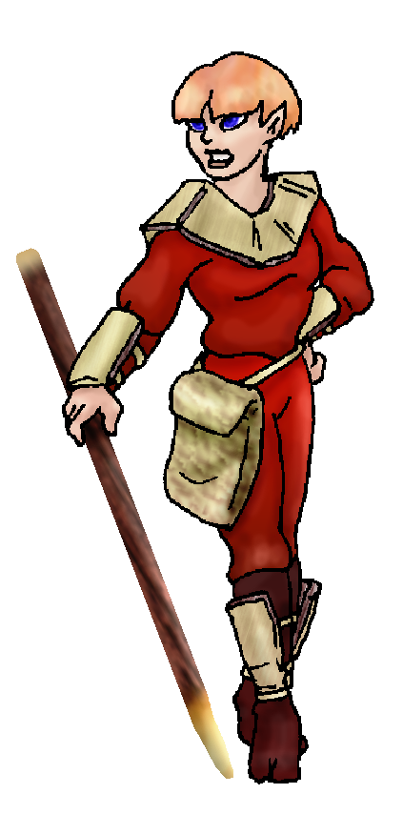
Likes and Dislikes: Friends:
Habits and Places Preferred: Hunting Methods:
Bond Beast Personality:
Character Sketch
Hair: strawberry blond
Eyes: blue
Skintone: medium
Bond Beast Habits/etc:
BondAnimal
Fur/Skin: white w/ brown mks
Eyes: red

About you as an elf
Your Name Means: Fudoshin is a Japanese word, meaning essentially “unmoving mind” – the way you can remain steadfast in the face of not only danger, but of lies, deception or confusion. While it’s unusual to have a ‘foreign’ word as a name, the elf-language would have its own term, and this is merely a translation.
Your Appearance Is: Small and compact, strong looking, and very dramatic in a dark red leather and bamboo armored outfit. You have medium tanned skin, very short strawberry blond hair and bright, large blue eyes. You do not always appear in the armored portions of your outfit, generally those are for practice and sparring, and instruction purposes. You also have more festive dresses, pants and whatever you make that someone else hasn’t claimed yet.
You Are Located: In the Protector Holt in the deep south-east corner of the continent. Your home is near the center of things, between the two Peaks and up higher than the lowest portion of the valley there. While it’s forrested it’s also got a lot of beautiful rocky outcrops, meadows and a wide, quick moving river leading down to the inland sea. Your den itself is shaped from stones near one stream, with a wide workshop for your tanning and cloth making supplies, as well as a big open space for fires and cooking. The rest of the den is set into two rooms, one for sleep and relaxing, the other for your weapons, supplies and extra items which just don’t fit anywhere else.
Your Basic Statistics Mean: You are small but hardly weak, it would probably take others by surprise the first time you shake their hand. You are healthy, very nimble, and quite smart. You’ve got a pretty face and an above average magic power.
Your Skills Include: You have a low memory of Earth, but enough to know what kinds of weapons and armor you’d like to wear here! Also your mental conditioning is a holdover from your Earthly life. Your lores and knowledges are all well rounded but nothing much sticks out save your ability to communicate and understand people, as well as the depth of your knowledge of the local surroundings all the way back up to the Hall of Portals. You understand animal behavior well enough to stay clear of danger, but you prefer trapping and huntingn over sitting around watching critters all day. Your survival and physical skills are quite good, though you like to be prepared when facing an enemy be it a cliff side or a sparring partner. You hunt with a long bow, prefering to use just a ranged weapon or a trap to catch fish or deer. You do however spar very well with shinai the bamboo-pole (along with a bokken which would have the same basic score), and are one of the few elves who practice a strong form of hand to hand martial arts. Finding anyone to spar with you that way is somewhat difficult! Your other skills are enjoyed by all – you are a good cook, but more you are an exceptional tailor! The clever things you can stitch into a cloth or leather outfit are pleasant to look at, and keep you occupied while there is too much snow or it’s too hot out to hunt or play. Your magic plays a strong role in your ability to work with leather. Lastly you are able to formulate strong tactical methods – since there are enemies in the area you must combat on a regular basis, you and the others have to keep a level head.
Your Magic Powers Are: You have a very strong Magic Feeling ability, which you use more often than not to understand those around you during hunting or attacks on the eerie spider-people in the East valley. If you can organize everyone’s abilities and magic – which you see clearly as though a layer of bright colors in and around people (and their shaped objects, anything they use magic on) – you know you can keep folks alive. Your telepathic Sending power is also quite strong, your mental voice is clear and not quite stern but very commanding. You can think to many people easily at once, or one at quite a distance away. You’ve got a pretty standard power to bond an animal, in this case a big cat. Additionally, your other powers include the power to “Farsend” or project yourself over greater distances than even your already-strong mind can. With this, you are able to bring together everyone at the edges of the Holt (Protector Holt is over five hundred miles wide!) when there is something happening. You can use this to ‘float’ out of your body, you must be safe and protected while this is being used, because it leaves your meditating form vulnerable. If you leave it too long, it may begin to starve. You appear as a ghostly version of yourself, to others with a good Sending ability, or those who you are speficially contacting. To aid your cooking and health you have a small power to start or keep fires going. Not much, but enough to ignite dry wood or keep yourself just warm enough if you fall into an icy pond. Your other power is twofold – you have a power over living flesh, which you can alter it carefully over time. This is very painful to the subject so you really don’t practice it much! For instance you could ‘shape’ fingers to have webbing between them in an hour or so, but since you technically have no ability to “Heal” as well, this would pretty much be like putting someone’s hand in boiling water for half that time. What you do use this for, however, is to shape unliving flesh – not just to preserve meats for the winter or keep them from rotting in hot weather (which is very handy, and not many flesh-shapers think of using it this way!) – but also to shape leathers. You know that at least a couple others do this, including one back at Dare’s Valley, where you first heard about it. You can embue leathers with color, dyes, and even put textures into thin leather; also you can ‘stretch’ it so that a heavy bit of leather can be cut more easily or sewn into, without a huge amount of fuss and broken needles. Also this stretching can take a smaller pelt or skin, and give it almost twice as much surface area. These things you can only do for a short while, but you never really need to continue shaping them for long. Long enough, when you’re tired, you move on to something more physical.
Your Bond Animal Is: Flashburn is a male ‘Greater’ cat, a large, cougar-like feline which has elf blood due to breeding in cat-form with a shapeshifter somewhere back in its line. (There are half a dozen shapeshifters you can think of just here in Protector who could have done it, but he’s older than your group and had clearly been here before the elves arrived, so you know he’s from another tribe’s area.) He is brightly white, with faded brown markings on his face and shoulders, and tip of his tail. His bright red eyes say he might be albino but he’s really just white. He is quite healthy, extremely strong, and reasonably nimble, but he’s not so huge that he would easily challenge for a top spot in the Pride. He has a pretty strong ability to shape Bone, a magical power held over from his elfin heritage, with it he can cause a deer’s leg to snap mid-stride, or make an aggressive horn-nose lose it’s horn (even if it’s not ‘bone’, it acts that way). While his name might imply he has a fire power, he doesn’t – it’s because he is so bright, and his eyes are so fire-red.
Special Information: A few elves around come to practice with you, including those who are interested in clearing their minds and meditating on things other than weapons or fighting. Some from other Holts and tribes might also drift through and enjoy a challenging sparring match with you – west of here in the Coastal Cliffs holt, there is a shapeshifter called Kestrel who is quite good with his own martial arts, and has visited here.
You are known as a Whitecold (Late Winter/Eighthsign) elf, even if your favorite season is Spring. The star sign “Hunter” is high in the night sky at this time. Elves who are represented by this ‘zodiac’ of the personality, are shown by the brave Wolf, the color White, and the unchanging Evergreens. Elves of this sort don’t have to have been born or arrived during this season. They are often Eventempered, balanced and able to give Wisdom, Comfort to others.

Date: Mon, 08 Jan 2007 18:31:52 -0500

Necessary Stuff
Your Full Name: Yumii Nickname or Title Blade of Northedge Birthday 4/28/84 Act HOW Old? 17ish
Your Gender female, You like it this way
You Prefer the opposite sex
You are in a solid relationship

Appearance Stuff
You're about 4' 11" feet tall, and you'd like to be the same
Your build is ever so slightly stocky and you'd like to be same
Hair Color orangey-pink Change? none
Hair Style/Curl basically the CoH "wedge" style - but even length both
in back and up front, and not so sharply pointed forward. Change? none
Eye Color Blue Change? No Glasses? off
Skin Tone Tannish Change? none
Are you 'Attractive'?yes Change? none
Are you 'Strong'? yes Change? none
Are you 'Smart'? yes Change? none
Are you 'Nimble'? yes Change? none
You'll be getting pointy ears - you want them short

Circle (likes) or Cross Out (dislikes)
Where do you like living? quiet neighborhood isolated village

Climates you like freezing chilly cold seasonal mild warm hot snow/sleet rainy foggy muggy cloudy sunny dry sea level flatland plains canyons scrubland hilly mountainous beach marsh river forest meadow grassy

What You Want Out of Life see the world slack off raise kids create clothing learn give advice and listen snuggle in front of a warm fire cook a mountain of food fiddle with toys and tools

Other:

Favorites...
Colors Red or Blue
Animals Cats
Music/Bands
Foods Chicken! Fish! Mmm...
Sports if any Kendo, Karate, Baseball
Time of Day day
Season spring

Fears and Hates Fear - Lonliness, Hate - Domineering people, sexism, racism, violence without purpose

Any pets you'd like to drag along?
Any people you'd like to have with you? (supply them a sheet!)

